1. Write a java generic program to create class that takes one type parameter to print the different data type value and its class name.

Ans: class Gen <T>{

T x;

Gen(T g)

{

x=g;

}

String Display(){

return(x.getClass().getSimpleName());

}

public T getx()

{

return x;

}

}

class Main{

public static void main(String[]args){

Gen < Integer> a = new Gen<>(85);

int g =a.getx();

System.out.println("Class Name is: "+a.Display());

System.out.println(g);

Gen < Double> b = new Gen<>(88.35);

Double t =b.getx();

System.out.println("Class Name is: "+b.Display());

System.out.println(t);

Gen < String> c = new Gen<>("GTR");

String r = c.getx();

System.out.println("Class Name is: "+c.Display());

System.out.println(r);

}

}

Output:

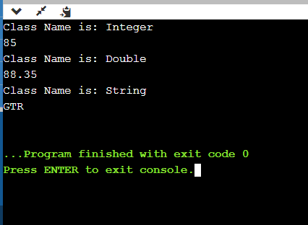

1. Write a java generic program to print greatest of two numbers.

Ans:

import java.util.Scanner;

class Gen<T>{

public static <T extends Comparable<T>> T max(T x1, T x2){

T max = x1;

if(x2.compareTo(max)>0){

max = x2;

}

return max;

}

}

class Main{

public static void main(String args[]){

Scanner sc = new Scanner(System.in);

System.out.println("Enter the two numbers:");

Integer a=sc.nextInt();

Integer b=sc.nextInt();

Gen < Integer> obj = new Gen<Integer>();

System.out.println("Maximum of given two numbers is: ");

System.out.println(obj.max(a,b));

}

}

OutPut: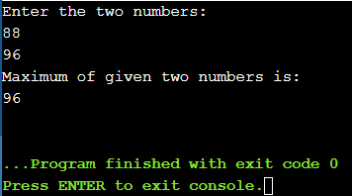

1. Write a java generic program to print the ArrayList of different data types.

Ans:

import java.util.\*;

public class Main{

static <T> void printArray(T[] a){

for(int i=0;i<a.length;i++){

System.out.print(a[i]+" ");

}

System.out.println();

}

public static void main(String[] args) {

Integer [] a={1,2,3,4,5,6,7,8,9};

String [] str = {"guru","Bhuvanesh","manish","ramesh","manas"};

printArray(a);

printArray(str);

}

}

Output: 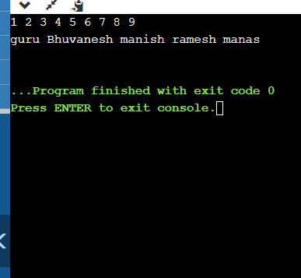

1. Create a class “CountFreqEven” with two generic static method. One is “count” to find the frequency of a value in an array of any type with duplicate elements and the other is “Counteven” to check the number of even numbers in the list whose type is bound to Integer value. Create two arrays of Integer and String with duplicate elements and print the frequency of a “value” passed to method “count” along with array elements. Pass an integer array to method “Counteven” and print the number of even numbers in an integer array.

Ans:

class CountFreqEven{

public static <T> int[] count(T[]a){

int count;

int freq[]=new int[a.length];

for(int k=0; k<a.length; k++)

{

count = 0;

for(int j=0; j<a.length; j++)

{

if(a[k]==a[j])

{

count++;

}

}

freq[k] = count;

}

return freq;

}

public static int countEven(Integer []a){

int n=0;

for(int k=0;k<a.length;k++){

if(a[k]%2==0){

n++;

}

}

return n;

}

public static void main(String[]args){

Integer []g={1,2,5,6,88,88,44,42};

int[]b =new int[g.length];

b=count(g);

int h=countEven(g);

System.out.println("Frequencies of each element in array are: ");

for(int y=0;y<b.length;y++){

System.out.print(b[y]+" ");

}

System.out.println("\nNumber of even numbers in array is: "+h);

}

}

Output:

