1. Write a java program to demonstrate ArithmeticException, NullPointerException, ArrayIndexOutOfBoundsException and NumberFormatEception using throws.

Ans:

class Main{

public static void method1()throws ArithmeticException

{

int x=68/0;

System.out.println(x);

}

public static void method2()throws ArrayIndexOutOfBoundsException

{

int a[]={1,2,3};

System.out.println(a[3]);

}

public static void method3()throws NullPointerException

{

Object ref = null;

ref.toString();

}

public static void method4()throws NumberFormatException

{

int data = Integer.parseInt("hello");

}

public static void main(String[]args){

method1();

method2();

method3();

method4();

}

}

Output:

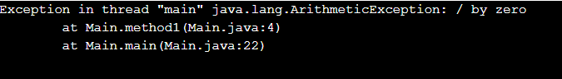

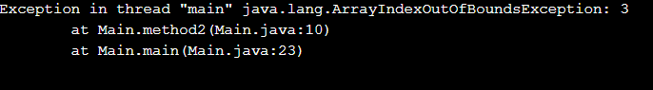

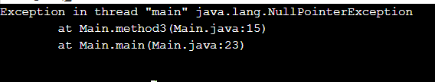

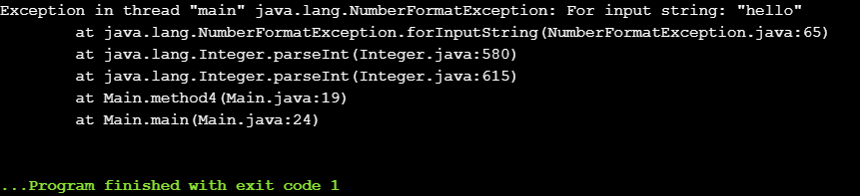

2. Write a java program by considering your own example to show the working of nested try catch and finally

class Main{

public static void main(String[]args){

try{

int x=68/0;

System.out.println(x);

try{

int a[]={1,2,3};

System.out.println(a[3]);

}

catch(ArrayIndexOutOfBoundsException e)

{

System.out.println("Can't access element out of the array");

}

}

catch(ArithmeticException e)

{

System.out.println("ArithmeticException can't divide number by zero");

}

finally

{

System.out.println("Final statement is executed");

}

}

}

OutPut:

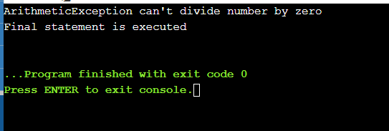

3. Write a program to get the details of voter and check whether age is >18 if not raise an exception “check18”. Create your exception in the name ”check18”.

Ans:

import java.util.Scanner;

class check18 extends Exception{

public check18(){

System.out.println("Age of the voter is less than 18, votting not allowed ");

}

}

class Main {

public static void main(String[] args) {

Scanner in=new Scanner(System.in);

System.out.println("Enter the age of voter");

int n=in.nextInt();

try

{

if(n<18){

throw new check18();

}else{

System.out.println("Voter is valid for votting");

}

}

catch(Exception e)

{

System.out.println("Exception "+ e);

}

}

}

Output:

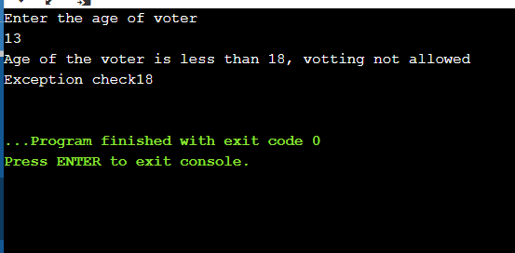

4. Create a class “stud” and two sub class “studA” an “studB” which has a constructor to set all the variables in class stud. Create a generic class “student” and two methods, one is “getaverage()” to get the average and method “maxavg to compare the average of two students. Create a class “test” and create two objects S1 and S2 for the generic class student whose type is bound to “stud”, S1 is of type “studA” and S2 of type “studB”. Pass the details of each student via the constructor and compare their average mark. If the average mark of S1 >S2 it returns 1 and print “Student S1 has got High Average” else return 2 and print “Student S2 has got High Average”.

Ans:

import java.util.Scanner;

class Stud {

String name, regno;

int mark1,mark2;

}

class StudA extends Stud {

public StudA(String name,String regno,int mark1,int mark2)

{

this.name=name;

this.regno=regno;

this.mark1=mark1;

this.mark2=mark2;

System.out.println("Name "+name);

System.out.println("Registration number "+regno);

System.out.println("mark1 "+mark1);

System.out.println("mark2 "+mark2);

}

}

class StudB extends Stud{

public StudB(String name,String regno,int mark1,int mark2)

{

this.name=name;

this.regno=regno;

this.mark1=mark1;

this.mark2=mark2;

System.out.println("Name "+name);

System.out.println("Registration number "+regno);

System.out.println("mark1 "+mark1);

System.out.println("mark2 "+mark2);

}

}

class Student<T extends Stud>{

public int getAverage(int x,int y){

int z = (x+y)/2;

return z;

}

public void maxAvg(int a1,int a2){

if(a1>a2){

System.out.println("Student S1 has got High Average");

}else{

System.out.println("Student S2 has got High Average");

}

}

}

class Main{

public static void main(String[]args){

Scanner sc=new Scanner(System.in);

Student s1=new Student<StudA>();

Student s2=new Student<StudB>();

System.out.println("Enter details of Student-1");

System.out.println("Enter Name : ");

String name1= sc.nextLine();

System.out.println("Enter Registration number: ");

String regno1=sc.nextLine();

System.out.println("Enter mark1: ");

int m11= sc.nextInt();

System.out.println("Enter mark2: ");

int m22=sc.nextInt();

sc.nextLine();

System.out.println("Enter details of Student-2");

System.out.println("Enter Name : ");

String name2= sc.nextLine();

System.out.println("Enter Registration number: ");

String regno2=sc.nextLine();

System.out.println("Enter mark1: ");

int m31= sc.nextInt();

System.out.println("Enter mark2: ");

int m32=sc.nextInt();

System.out.println("Student-1 Details: ");

StudA st1=new StudA(name1,regno1,m11,m22);

int a1=s1.getAverage(m11,m22);

System.out.println("Student-2 Details: ");

StudB st2=new StudB(name2,regno2,m31,m32);

int a2=s2.getAverage(m31,m32);

System.out.println("");

s1.maxAvg(a1,a2);

}

}

