1. . Create a class addMatrix to read two matrix of r1Xc1 and r2Xc2 to perform matrix addition. Check the condition for matrix addition if not possible raise an user defined exception “MatrixAdditionNotPossible” and print the message ”Matrix addition is not possible”.

Ans:

import java.util.Scanner;

class MatrixAdditionNotPossible extends Exception{

public MatrixAdditionNotPossible(){

System.out.println("Matrix addition is not possible");

}

}

class Main{

public static void main(String[]args){

Scanner sc=new Scanner(System.in);

System.out.println( "Enter number of rows in matrix1" );

int r1=sc.nextInt();

System.out.println( "Enter number of columns in matrix1" );

int c1=sc.nextInt();

System.out.println("Enter elements of matrix1");

int [][]a=new int[r1][c1];

for(int i= 0;i<r1;i++){

for(int j=0;j<c1;j++){

a[i][j]=sc.nextInt();

}

}

System.out.println( "Enter number of rows in matrix2" );

int r2=sc.nextInt();

System.out.println( "Enter number of columns in matrix2" );

int c2=sc.nextInt();

int [][]b=new int[r2][c2];

System.out.println("Enter elements of matrix2");

for(int k=0;k<r2;k++){

for(int h=0;h<c2;h++){

b[k][h]=sc.nextInt();

}

}

int c[][]= new int[r1][c1];

try

{

if(r1!=r2 ||c1!=c2)

throw new MatrixAdditionNotPossible();

else

{

for(int i=0;i<r1;i++)

{

for(int j=0;j<c1;j++)

{

c[i][j]=a[i][j]+b[i][j];

}

}

System.out.println("Elements of the resultant matrix are ");

for(int i=0;i<r1;i++) {

for(int j=0;j<c1;j++)

System.out.print(c[i][j]+" ");

System.out.println();

}

}

}

catch(MatrixAdditionNotPossible e)

{

System.out.println(e);

}

}

}

Output:

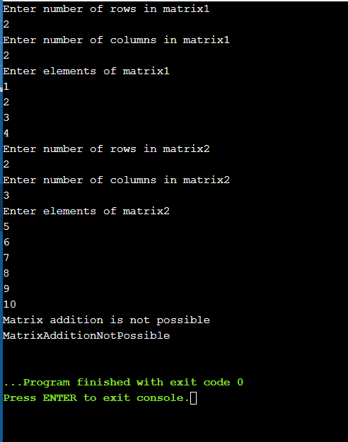

2. Create a class “Student” which is the super class for the class “Mark”. Read the details of a students and calculate the entrance mark to raise a user defined exception using “Throws”.

Class : Student

Variable: Name (String)

Regno (int)

Course (String)

Method: getdetails() (\* either read the input or store it directly)

Class: Mark

Variable: Part1(int) (max 50)

Part2(int) (max 50)

Core(int) (max 100)

Total (int)(Part1+Part2+Core)

Method: getmarks() (\* either read the input or store it directly)

CalcEntranceMark

If the total is less than 100 raise a “NotEligibleException” and print “NOT ELIGIBLE”

If the total is >=100 and <150 raise a “WaitingListException” and print “WAITING LIST”

If the total is >=150 and print “ELIGIBLE”

Ans:

import java.util.Scanner;

class Student{

String name,course;

int regno;

public void getDetails(String name,int regno,String course){

this.name=name;

this.regno=regno;

this.course=course;

System.out.println("Name "+name);

System.out.println("Registration number "+regno);

System.out.println("Course "+course);

}

}

class Mark extends Student{

int part1,part2,core,total;

public void getMarks(int part1,int part2,int core){

this.part1=part1;

this.part2=part2;

this.core=core;

System.out.println("part1 "+part1);

System.out.println("part2 "+part2);

System.out.println("Core "+core);

}

public void calcentrancemark()

{

total=part1+part2+core;

System.out.println("Total "+total);

if(total>=150)

System.out.println("ELIGIBLE");

}

public void entrance1() throws NotEligibleException

{

if(total<100)

throw new NotEligibleException("NOT ELIGIBLE");

}

public void entrance2() throws WaitingListException

{

if(total>=100&total<150)

throw new WaitingListException("WAITING LIST");

}

}

class NotEligibleException extends Exception{

NotEligibleException(String s)

{

System.out.println("NOT ELIGIBLE");

}

}

class WaitingListException extends Exception{

WaitingListException(String s)

{

System.out.println("WAITING LIST");

}

}

class Main{

public static void main(String[]args){

Scanner in=new Scanner (System.in);

Mark a=new Mark();

a.getDetails("Gurutheja",197034,"CSE-DA");

a.getMarks(23,32,35);

a.calcentrancemark();

try

{

a.entrance1();

}

catch( NotEligibleException e)

{

System.out.println(e);

}

try

{

a.entrance2();

}

catch( WaitingListException e)

{

System.out.println(e);

}

}

}

Output:

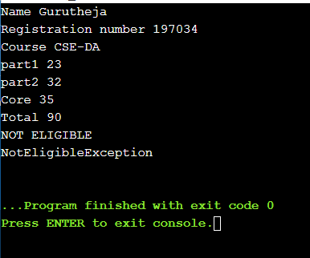

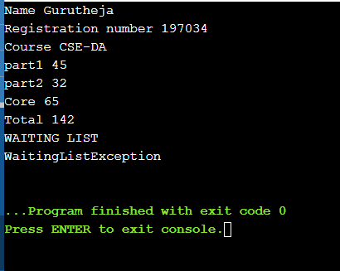

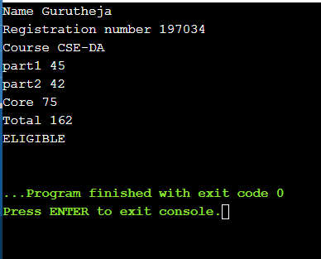

3. .Define a new exception, called ExceptionLineTooLong, that prints out the error message "The strings is too long". Write a program that reads all user entered string message and throws an exception of type ExceptionLineTooLong in the case where a string is longer than 80 characters. Handle also all exceptions that could be thrown by the program.

Ans:

import java.util.Scanner;

class ExceptionLineTooLong extends Exception{

public void ExceptionLineTooLong(){

System.out.println("The String is too long");

}

}

class Main{

public static void main(String[]args){

Scanner sc=new Scanner(System.in);

System.out.println("Enter the String");

String str=sc.nextLine();

try{

if(str.length()>=80){

throw new ExceptionLineTooLong();

}

}

catch(ExceptionLineTooLong e){

System.out.println(e);

}

}

}

Output: