Metamaterial FE Workbench
User manual

Band gaps of locally resonant lattices and plates with the Bloch finite-element method: what each input means, how to draw your own unit cell, how to set different materials for the frame, the resonators and a membrane, and how to read the results.
Applies to the file metamaterial-workbench.html (version of 9 November 2026).
The workbench runs in any modern browser, offline, without installation.

Contents
1. What the workbench does
1.1 What you can compute
1.2 Two kinds of wave
2. Getting started
2.1 Opening the workbench
2.2 Your first analysis in five steps
3. The screen layout
4. Section 1: Geometry
4.1 Choosing the unit cell
4.2 Cell A: wall cross-section
4.3 Cell A: resonator
4.4 Custom beam cell
4.5 Cells B, C and Build your own
4.6 The cell editor
4.7 Shapes: polygons, rectangles, circles
4.8 Moving, resizing, turning and copying parts
4.9 Thickness: centred, upward or downward
5. Section 2: Material
5.1 Giving the resonator a different material
5.2 Adding a membrane with its own material and thickness
5.3 Order of priority
6. Section 3: Solver
6.1 Zone path, symmetry and your own k-path
7. Running and stopping
8. Reading the results
8.1 Dispersion tab (parametric cells)
8.2 Dispersion tab (editable cells)
8.3 Sensitivity tab
8.4 Edge waves tab
8.5 Edge waves in a finite sample (M × N)
8.6 Driven sample: where does the energy go?
8.7 Topology check: Chern number and Zak phase
8.8 Method tab
9. Worked examples
9.1 Hexagonal honeycomb with a cantilever resonator
9.2 Electrospun membrane cell
9.3 An asymmetric cell built from shapes
10. Tips and troubleshooting
10.1 Good practice
11. Units, symbols and glossary

1. What the workbench does
A locally resonant metamaterial is a periodic structure (for example a honeycomb of thin walls) that carries small resonators (for example little cantilevers with a mass at the tip). Near the resonance of the resonators, vibration cannot travel through the structure: a band gap opens. The workbench tells you where these band gaps are, how wide they are, how strongly waves are damped inside them, and how sensitive they are to the design.
It does this with the finite-element method (FE) applied to one repeating piece of the structure, the unit cell, using Bloch–Floquet periodic conditions. Everything you need is in one file that runs in the browser; no data leaves your computer.

1.1 What you can compute
Result | What it tells you | Where
Band structure | Which frequencies can travel through the lattice, for each direction of travel. Empty frequency ranges are band gaps. | Dispersion tab
Complex band | How strongly a wave is damped per cell at each frequency (attenuation), and its phase. | Dispersion tab
Mode shapes | An animation of how the cell moves at a chosen point of the band structure. | Dispersion tab
Band-gap list and assessment | Every complete gap with its edges and width, and a plain-language summary. | Dispersion tab
Sensitivity | How the gap edges move when you change resonator mass, resonator stiffness, host mass, host stiffness or cell size. | Sensitivity tab
Edge waves | Whether waves can travel along a free edge of a finite strip of the lattice. | Edge waves tab

1.2 Two kinds of wave
A flat lattice vibrates in two independent ways, and the workbench treats both:
- Out-of-plane (flexural) waves: the structure moves up and down, perpendicular to its plane. This is usually what matters for sound and vibration isolation of plates and panels.
- In-plane waves: the structure moves within its own plane (stretching and in-plane bending of the walls).
A full band gap is a frequency range where neither kind of wave can travel.

2. Getting started

2.1 Opening the workbench
- Double-click the file metamaterial-workbench.html. It opens in your default browser (Chrome, Edge, Firefox or Safari).
- Nothing needs to be installed and no internet connection is needed.
- On opening, the workbench immediately analyses the default design (a 14 mm regular hexagon with one cantilever resonator) so that you see results straight away.
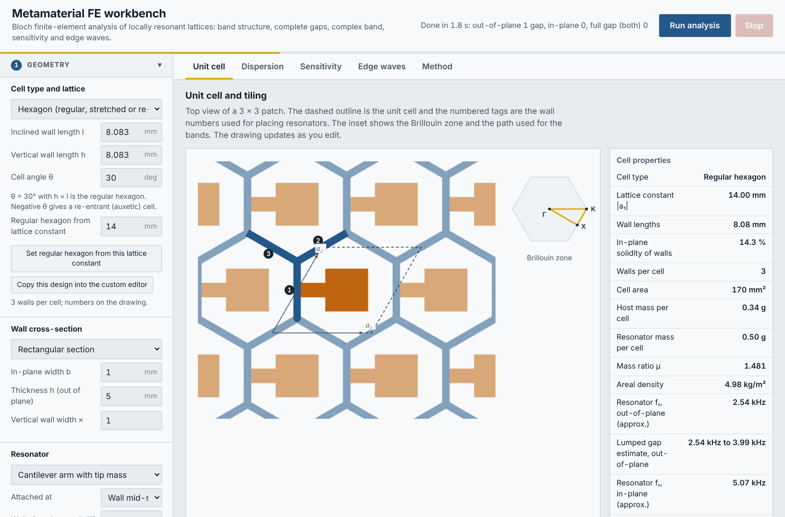
Figure 1. The workbench after opening: the input panel on the left, the result tabs on the right, Run and Stop at the top right.

2.2 Your first analysis in five steps
- In 1 Geometry, choose the unit cell (for example A · Hexagon, cantilever with tip mass) and enter its sizes.
- In 2 Material, choose the material of the host (walls) and, if different, of the resonator.
- Look at the Unit cell tab to check the drawing: it updates as you type.
- Press Run analysis (top right). The progress bar and status text show what is being computed. Press Stop at any time to cancel.
- Open the Dispersion tab: the yellow hatched bands are the band gaps, listed with their frequencies in “Band gaps found”.
Tip
Start with the default settings. Increase “Bands to compute”, “k-points per path segment” or “Complex-band frequencies” only when you need more detail: computing time grows with each of them.

3. The screen layout
Figure 2. Top bar: title, status text, Run analysis and Stop.
Area | Contents
Top bar | Status text (what is running, results summary, error messages), Run analysis, Stop. A thin progress bar under the top bar fills during a run.
Left panel | All inputs, in three numbered sections: 1 Geometry, 2 Material, 3 Solver. Click a section title to fold or unfold it.
Tabs | Unit cell (drawing or editor), Dispersion (main results), Sensitivity, Edge waves, Method (the theory behind the calculations).

All lengths are in millimetres, masses in grams, frequencies in hertz, Young’s modulus in GPa and density in kg/m³.

4. Section 1: Geometry
Everything about the shape and size of the unit cell is set here. A unit cell is a lattice (the load-carrying frame, the “host”) plus a resonator (the parts that vibrate locally). You start from one of three ready-made cells or build your own; every cell can be edited afterwards in the Unit cell tab.
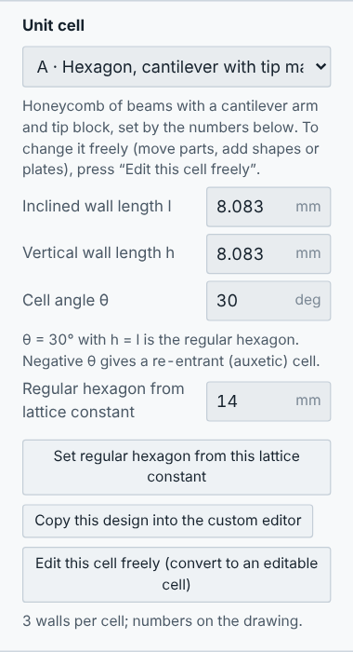
Figure 3. Geometry section: choose the unit cell first.

4.1 Choosing the unit cell
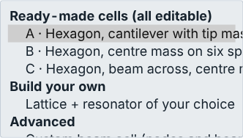
Figure 4. The unit-cell list: three ready-made cells, Build your own, and the custom beam cell.
Choice | What it is | Where its sizes are set
A · Hexagon, cantilever with tip mass | Honeycomb of beams; a cantilever arm with a tip block on chosen walls. Regular, stretched or re-entrant hexagon. | Geometry: hexagon, wall cross-section, resonator (sections 4.2–4.3)
B · Hexagon, centre mass on six spokes, inner ring, six blocks | Hexagonal frame; a central hexagonal mass held by six spokes to the corners, an inner hexagonal ring and six small hexagonal blocks where ring and spokes meet. | Geometry: Lattice and Resonator (section 4.5)
C · Hexagon, beam across, centre mass | Hexagonal frame; one beam across the cell (between two opposite sides, or two opposite corners) carries a centre mass. | Geometry: Lattice and Resonator (section 4.5)
Build your own | Choose a lattice (hexagon, square, triangle, kagome or free) and a resonator (cantilever with tip mass, centre mass on spokes, beam across with centre mass, membrane with centre mass, mass on spring, or none). | Geometry: Lattice and Resonator (section 4.5)
Custom beam cell | Any planar beam cell typed as nodes and beams (JSON text). | In the text editor (section 4.4)

Whatever you choose, every analysis is available: dispersion and complex band with a written summary of the gaps, mode shapes, sensitivity, and edge waves (strip or finite sample).
- Hexagon: θ = 30° with h = l is the regular hexagon. A negative θ gives the re-entrant (auxetic) cell. To get a regular hexagon of a given lattice constant (distance between cell centres), type it in “Regular hexagon from lattice constant” and press Set regular hexagon.
- Edit this cell freely (button under the cell list, and at the top of the Unit cell tab) converts the current parametric cell into an editable cell: every wall, arm, block and mass becomes a part that you can move, resize, delete or add to. Your settings for cell A are kept; choose A again in the list to return to them.
- Copy this design into the custom editor turns the current parametric design into editable nodes and beams (JSON text).

4.2 Cell A: wall cross-section
Input | Meaning
Rectangular / circular | Shape of the wall cross-section.
In-plane width b | Thickness of the wall seen from above (in the plane of the lattice).
Thickness h (out of plane) | Height of the wall, perpendicular to the lattice (for a circular rod: its diameter).
Vertical wall width × | Hexagon only: makes the vertical walls thicker or thinner than the inclined ones.

4.3 Cell A: resonator
Type | What it is | Inputs
None | Bare lattice, for reference. | –
Cantilever arm with tip mass | A beam clamped to a wall or junction, with a block or a point mass at its free end. | Attachment, walls, direction, shape (straight or L), arm length, width, thickness; tip block length, width, height, density, position; or point mass and cube side
Mass on spring | An ideal mass–spring attached at a point. | Mass m, stiffness k (or tune k to a target frequency)
Central mass on ligaments | A cube in the middle of the cell held by thin beams to the corners or wall mid-spans. | Mass, cube side, ligament width and thickness

- Attached at: wall mid-span, any point along the wall (0–1), or the junctions. Walls: the wall numbers shown on the drawing, separated by commas, or “all”.
- Arm direction: into the cell, out of the cell, both sides (a pair), or a fixed angle.
- Arm length from wall face: the free length, measured from the face of the wall (the part inside the wall is modelled as a stiff stub).

4.4 Custom beam cell
For a planar beam cell that the parametric types cannot describe, choose Custom beam cell and edit the text: lattice vectors a1, a2 (mm), sections (name, shape, b, h, and optionally E_GPa and rho), nodes (x, y, optional mass), beams (node i, node j, shift = cell offset of node j, section, role host or res) and optional springs. Errors are explained under the editor.

4.5 Cells B, C and Build your own
These cells are built from the numbers in two boxes, Lattice and Resonator. For B and C the lattice is the hexagon and the resonator is fixed; for Build your own you choose both. The cell appears in the Unit cell tab, where every part can still be moved, resized, deleted or added to.
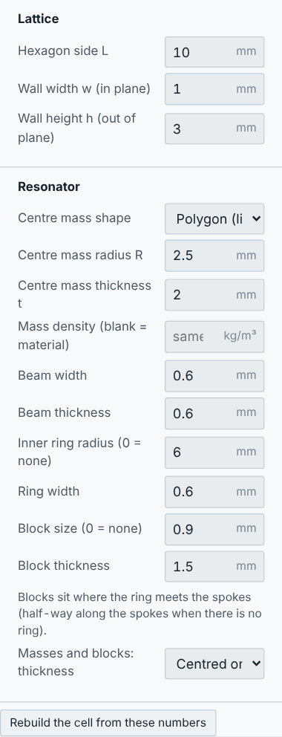
Figure 5. Lattice and Resonator boxes of cell B.
Lattice | Size | Notes
Hexagon (honeycomb) | Side L | Each cell carries three of its six walls; the neighbours supply the rest.
Square | Lattice constant a | Two walls per cell.
Triangle | Triangle side a | Three walls per cell; the resonator sits in the upward-pointing triangle.
Kagome | Triangle side L | The resonator sits in the hexagonal opening (side L).
Free | – | No frame: draw it yourself in the Unit cell tab (Shape → Frame of beams, or Beam). Use resonator “None” here and draw it too.

All frames have the wall width w (in the plane) and wall height h (out of the plane).
Resonator | Inputs
Cantilever with tip mass | Walls (numbers or “all”), position along the wall (0–1), arm length from the wall face, arm width and thickness, tip block length, width and height. The arm points into the cell.
Centre mass on spokes | Centre mass shape (polygon like the cell, or circle), radius R and thickness t; spoke width and thickness; inner ring radius (0 = none) and width; block size (0 = none) and thickness. Blocks sit where ring and spokes meet.
Beam across, centre mass | Centre mass as above; beam width and thickness; between two opposite sides (mid-points) or two opposite corners.
Membrane with centre mass | Centre mass as above; membrane thickness. The membrane fills the cell opening and uses the Membrane material.
Mass on spring | Mass (g), frequency (Hz) and the walls it sits on (at their mid-points).
None | Bare lattice, for comparison.

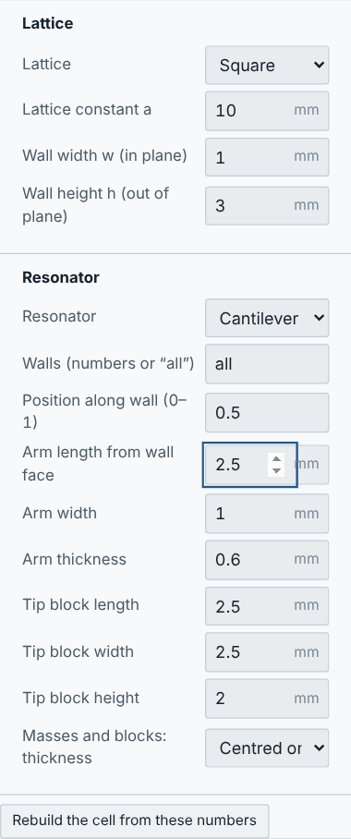
Figure 6. Build your own: a square lattice with a cantilever and tip mass on every wall.
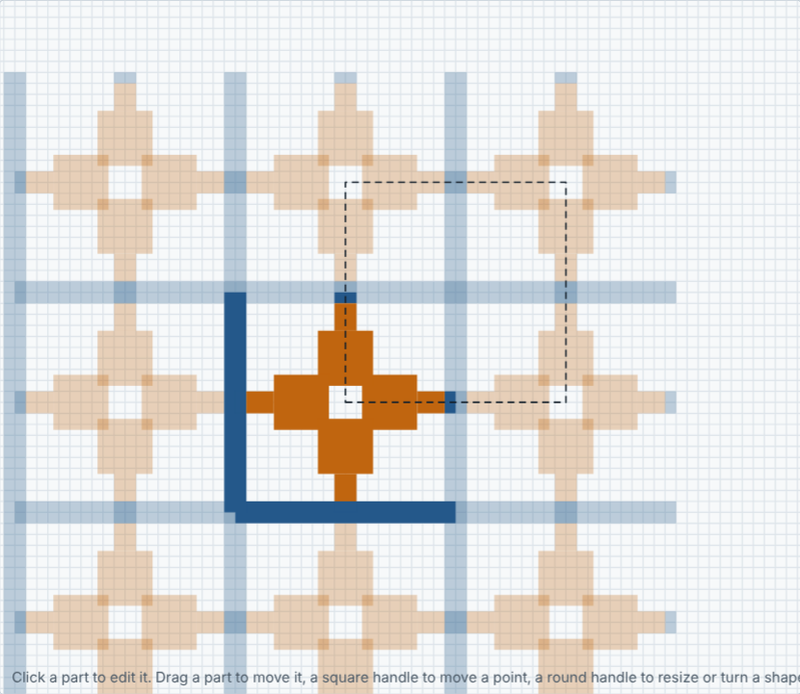
Figure 7. The resulting cell in the Unit cell tab.
Editing a built cell
Changing a number in the Lattice or Resonator box rebuilds the cell straight away, as long as you have not edited it by hand.
Once you have edited it in the Unit cell tab, the numbers no longer change it: a note appears with a button Rebuild the cell from these numbers (your hand edits are replaced; Undo brings them back).

Editable cells in general
Every cell except A and the custom beam cell is an editable cell: cells with plates or membranes, tall walls modelled as shells, holes, resonators of any shape, size or position, and asymmetric designs. Cell A can be turned into one with Edit this cell freely.
Figure 8. Top of the Unit cell tab for a parametric cell: one click turns it into an editable cell.

4.6 The cell editor
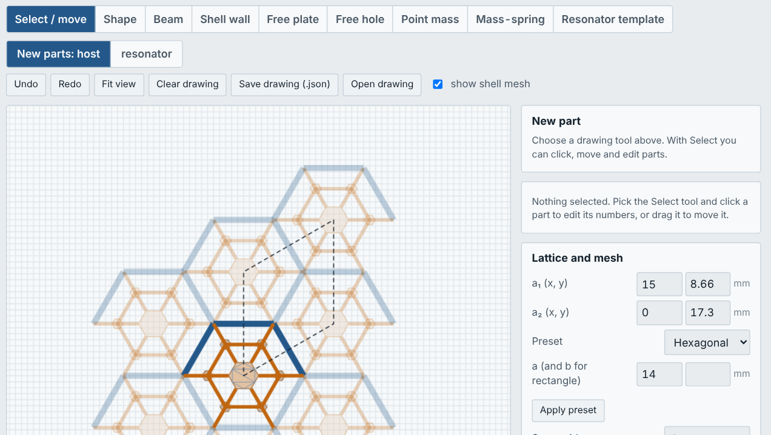
Figure 9. Cell editor with cell B. The dark parts are the reference cell; the faint copies show how it repeats.

Drawing tools
Figure 10. Toolbar of the cell editor.
Tool | How to use it
Select / move | Click a part to select it and edit its numbers on the right. Drag a part to move it (it moves in steps of the snap grid). Drag a square handle to move a point; drag the round handle of a shape to resize or turn it. Drag the background to pan; use the mouse wheel to zoom. Delete removes the selected part.
Shape | Places a regular polygon (any number of sides), a rectangle or a circle, used as a shell plate, a frame of beams, shell walls or a hole (section 4.7). Click where its centre goes, or type the centre and press Add at this centre.
Beam | Click the start point, then the end point. Drawing continues from the last point; press Esc or right-click to stop. Properties: width b, height h, axis height z.
Shell wall | Like a beam, but modelled as a vertical shell strip with thickness t and height H (bottom edge at z₀). Use it for tall, thin walls.
Free plate | A plate of any outline. Click the corners; click the first corner again (or press Enter) to close. Properties: thickness t, height z. Use it for plates and membranes.
Free hole | A hole of any outline: draw a closed outline inside an existing plate. (Round or polygonal holes are easier with the Shape tool.)
Point mass | Click a point on a part. Properties: mass (g), cube side (for rotary inertia), height.
Mass-spring | Click a point on a part. Properties: mass (g) and resonance frequency (Hz).
Resonator template | Click the attachment point: a cantilever with a block, an L-shaped arm, or a mass on a spring is added with the sizes from the “New part” card.
New parts: host / resonator | Sets whether newly drawn parts belong to the lattice (host) or to the resonators.

Snapping and periodicity
- Points snap to existing points (red circle), to the edge of another part (yellow circle, the part is split there so the two join) and to the grid.
- The dashed outline is the unit cell. Parts may cross it: the cell is repeated automatically, and points also snap to the repeated copies, so a wall drawn to the copy of a corner joins the neighbouring cell correctly.
- Two plates that share an edge must share the same end points on that edge so that their meshes join.
- A beam that crosses another beam, or the outline of a plate, at the same height is joined to it at the crossing point automatically.
- A part that touches nothing of the lattice floats freely. The Model table then shows Not connected with the part numbers, and the status line warns after a run. Move the part until it touches a host part.

Lattice and mesh
- a₁, a₂: the lattice vectors (mm). Presets: hexagonal, square, rectangular.
- Snap grid: grid spacing for snapping (0 switches it off).
- Element size: the finite-element size. Smaller is more accurate but slower. As a rule, use at least 4 elements over the height of a shell wall and at least 6–8 elements per wavelength of the highest frequency of interest.

Properties of a part
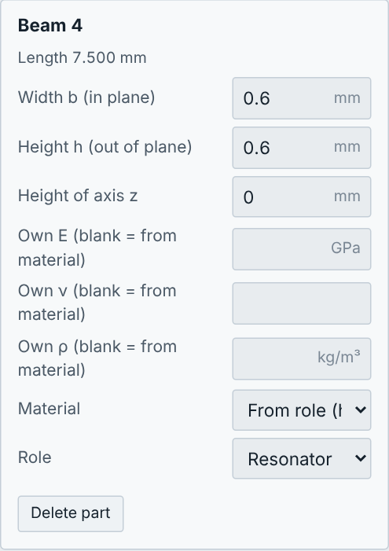
Figure 11. Properties of a selected beam: sizes, its own material values (optional), material choice and role.
Select a part to change its size, height, Material (host, resonator or membrane, see section 5), optional own E, ν, ρ, and its role (host or resonator).

Saving and opening drawings
Save drawing (.json) downloads the drawing as a small text file; Open drawing loads it again. The drawing is also kept automatically in your browser between sessions. Undo and Redo keep the last 80 changes.

4.7 Shapes: polygons, rectangles, circles
The Shape tool is the quickest way to build or change a cell. A shape is kept as its numbers (centre, size, rotation), so it can be changed exactly at any time, made bigger or smaller, or turned.
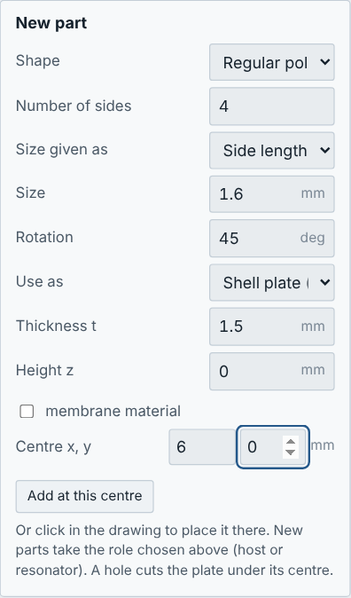
Figure 12. New-part card of the Shape tool: here a square (4 sides, side 1.6 mm, turned 45°) used as a 1.5 mm thick resonator plate.
Input | Meaning
Shape | Regular polygon (3 sides = triangle, 4 = square, 6 = hexagon, any number), rectangle, or circle.
Number of sides | Regular polygon only.
Size given as | Corner radius R (centre to a corner), side length, or inner radius (centre to the middle of a side); for a circle the radius or diameter.
Width, height (rectangle) | Side lengths before rotation.
Rotation | Turns the shape about its centre (degrees, anticlockwise).
Use as | Shell plate: a filled plate of thickness t. Frame of beams: a beam along every edge (width b, height h). Shell walls: a vertical shell wall along every edge (thickness t, height H). Hole in a plate: cuts the plate that contains its centre.
Membrane material | Plate only: gives the plate the Membrane material (section 5.2).
Centre x, y | Where the shape goes; press Add at this centre, or click in the drawing instead.

New shapes take the role chosen with New parts: host / resonator. Use “resonator” for masses, membranes and rings that should vibrate, so that they are coloured orange and counted in the mass ratio.
Examples
A hexagonal central mass: Regular polygon, 6 sides, corner radius 2.5 mm, Shell plate, t = 2 mm, role resonator.
A round hole in a membrane: Circle, diameter 3 mm, Hole in a plate, centred on the membrane.
A square frame inside a hexagon: Regular polygon, 4 sides, side 6 mm, Frame of beams, b = 0.6 mm, h = 1 mm.

4.8 Moving, resizing, turning and copying parts
Every part can be changed with the mouse or by typing numbers; use whichever is easier.
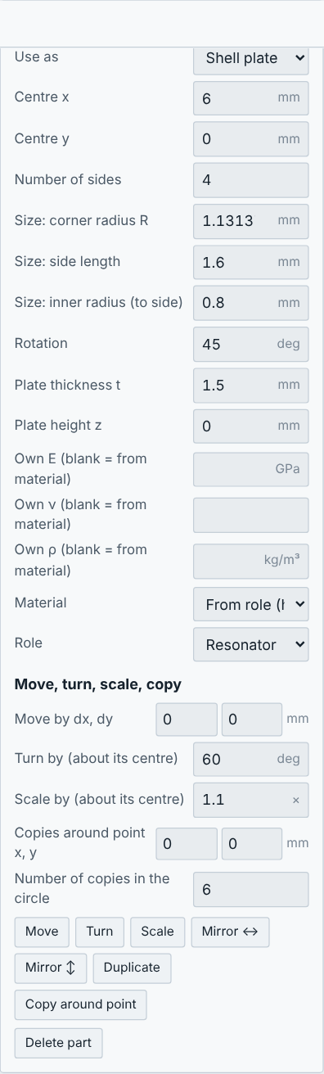
Figure 13. Panel of a selected shape: centre, size (as corner radius, side length or inner radius), rotation, thickness, material, role, and the move, turn, scale and copy tools.
With the mouse | By numbers
Drag the part to move it. | Type the centre (shapes), the end points x₁, y₁, x₂, y₂ (beams, walls), the position (masses) or the corner list (free plates).
Drag the round handle of a shape to make it bigger or smaller and to turn it; drag the corner handle of a rectangle to change its width and height. | Type the size, the rotation or a beam length.
Drag a square handle to move a single point. | Move by dx, dy, Turn by an angle, Scale by a factor (about the part centre), Mirror ↔ / ↕.
– | Duplicate makes a copy next to it; Copy around point makes n copies evenly spaced in a circle (for example six spokes or six blocks).

Nothing has to be symmetric: parts can be placed anywhere, in any size. The workbench finds the symmetry of the cell by itself and chooses the zone path accordingly (section 6.1). Undo (Ctrl+Z) reverts any change.

4.9 Thickness: centred, upward or downward
Every beam and plate has a height z: the level where it joins other parts. Its thickness can be measured three ways (option Thickness measured on the part, or Masses and blocks: thickness in the Resonator box):
Option | Meaning | Typical use
Centred on z | Half of the thickness above z, half below. This is the default. | Frames, spokes, membranes: everything in one mid-plane.
Upward from z | The part sits on z: its bottom face is at z. | A mass or block glued on top of a membrane or plate.
Downward from z | The part hangs from z: its top face is at z. | A mass under a plate.

- Parts still join where they meet at z; the offset is carried by a rigid link inside the element, which is the standard way to model a stiffener or block sitting on a plate.
- An offset part couples out-of-plane and in-plane motion. The summary then reports only the complete gap (all waves), which is the exact one.
- Thickness t (or height h) is the size of the part; z is its position. Changing t never moves the joining level.

5. Section 2: Material
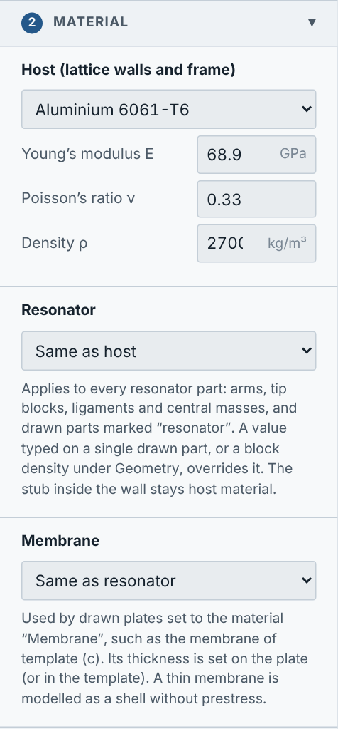
Figure 14. Material section with the three materials.
The workbench uses up to three materials. Each has a preset list (aluminium, titanium, steel, CFRP, PA12, PLA, photopolymer resin, electrospun nanofibre mat) or Custom values of Young’s modulus E (GPa), Poisson’s ratio ν and density ρ (kg/m³).
Material | Used for | Default
Host | Lattice walls and frame (and every drawn part marked host). | Aluminium 6061-T6
Resonator | Cantilever arms, tip blocks, ligaments, central masses, and every drawn part marked resonator. | Same as host
Membrane | Drawn plates whose material is set to “Membrane”, such as the membrane of template (c). | Same as resonator

5.1 Giving the resonator a different material
- Open 2 Material.
- Under Resonator, choose a preset or Custom, and type E, ν and ρ.
- Run the analysis. The isolated resonator frequency shown under Geometry and in the Unit cell tab is updated as well.
- A block density typed under Geometry → Resonator still overrides the density of the tip block only.
- In a drawn cell, values typed on a single part (“Own E, ν, ρ”) override the material of that part only.

5.2 Adding a membrane with its own material and thickness
- Under 1 Geometry, choose Build your own, Lattice Hexagon, Resonator Membrane with centre mass.
- Set the sizes and the Membrane thickness (mm). The cell is built at once in the Unit cell tab.
- Under 2 Material → Membrane, choose Electrospun nanofibre mat (approx.) or Custom and type the E, ν and ρ of your membrane.
- To change the thickness later, select the membrane with Select / move and edit Thickness t.
- Press Run analysis.
To make any other plate a membrane, select it and set Material = Membrane. To draw a membrane by hand, use Free plate or Shape → Shell plate, set its role to resonator (if it carries a mass) and its material to Membrane.
Important for membranes
The membrane is modelled as a thin elastic shell without prestress. A real electrospun mat is usually stretched (pre-tensioned), which makes it stiffer. If you have a measured resonance, adjust the membrane E (or thickness) until the computed resonance matches, then use the model for design changes.
Very soft or very thin membranes need a fine mesh: reduce the element size if the results change when you halve it.

5.3 Order of priority
Priority | Source of the value
1 (highest) | Value typed on the part itself (drawn cells: “Own E, ν, ρ”; parametric: block density)
2 | Material chosen for the part (Host, Resonator or Membrane)
3 | If none is chosen: Resonator material for resonator parts, Host material for host parts

6. Section 3: Solver
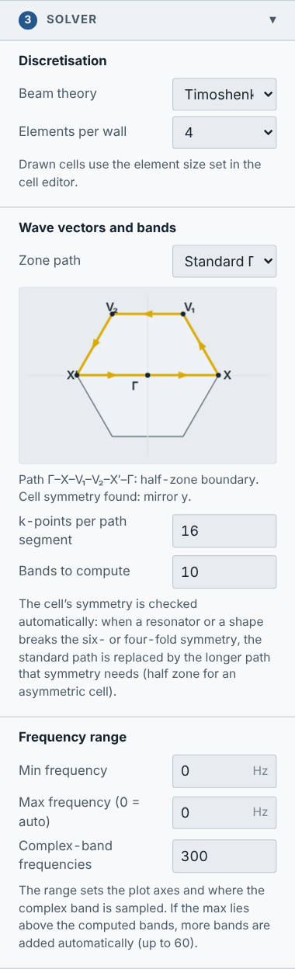
Figure 15. Solver section.
Input | Meaning | Typical value
Beam theory | Timoshenko (includes shear and rotary inertia, recommended) or Euler–Bernoulli (classical slender beams). | Timoshenko
Elements per wall | Number of beam elements per wall (parametric cells). More = more accurate at high frequency. | 4
Zone path | The path of wave directions: standard, forced standard, automatic, quarter zone, half zone, or your own path (section 6.1). | Standard
k-points per path segment | Number of wave vectors computed along each part of the path. | 10–20
Bands to compute | Number of lowest bands. Raised automatically if the frequency range needs more. | 10
Min / Max frequency | Frequency range of the plots and of the complex band; 0 for Max means automatic. | 0 / 0
Complex-band frequencies | Number of frequencies at which the complex band is computed. | 300 (parametric), 40–100 (drawn)

6.1 Zone path, symmetry and your own k-path
The band structure is computed along a path of wave vectors in the Brillouin zone. The small picture in the Solver panel shows the zone (grey outline) and the path (yellow arrows) for the current cell, and the line under it names the path and the symmetry found.
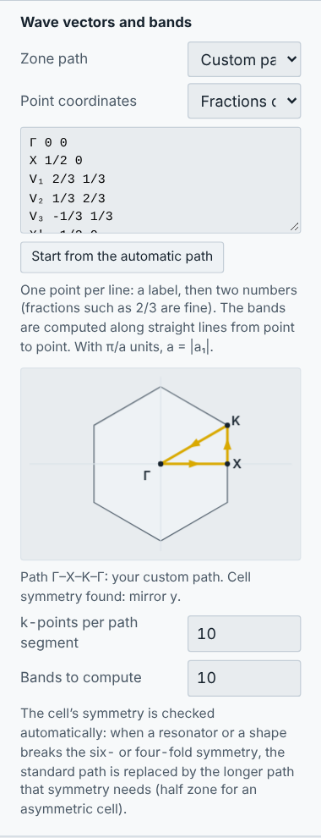
Figure 16. Zone path preview and the custom path editor.
Choice | What it does
Standard (if the cell allows it) | Γ–X–K–Γ for hexagonal and Γ–X–M–Γ for square lattices, but only when the cell really has six-fold (four-fold) symmetry with a mirror. Otherwise the workbench switches to the path the cell needs. This is the default.
Forced standard | Always the standard path, even for a less symmetric cell (as in earlier versions). The gap may then look wider than it is.
Automatic | Chosen from the symmetry found: standard path, quarter-zone boundary (two mirrors) or half-zone boundary (no mirror).
Quarter zone, half zone | The boundary of a quarter or half of the zone. The half zone is correct for any cell, symmetric or not.
Custom path | Your own points, in order. Type one point per line: a label, then two numbers, either as fractions of b₁, b₂ (for example K 2/3 1/3) or as kx, ky in units of π/a (a = |a₁|). Start from the automatic path fills in the current path as a starting point.

Why the path matters
A band gap is only complete if no wave crosses it in any direction. For an asymmetric cell (one-sided arms, shapes off-centre) the standard path can miss the direction where a band reaches into the gap, so the gap looks wider than it is. Example: the default hexagon with one arm gives 2091.8–2961.9 Hz on the forced standard path and 2098.2–2961.9 Hz on the half zone that its symmetry requires.

7. Running and stopping
- Run analysis computes the band structure and the complex band of the current cell and opens the Dispersion tab.
- Stop cancels any running calculation (dispersion, complex band, sensitivity sweep, edge waves, drawn cell). The inputs and previous results are kept; press Run again when ready.
- The status text shows progress and, at the end, a summary or an error message explaining what to change.
Cell | Typical time
Parametric hexagon, default settings | about 2–5 s
Editable cell with beams | about 5–15 s
Editable cell with plates or membranes | about 10–40 s

8. Reading the results

8.1 Dispersion tab (parametric cells)
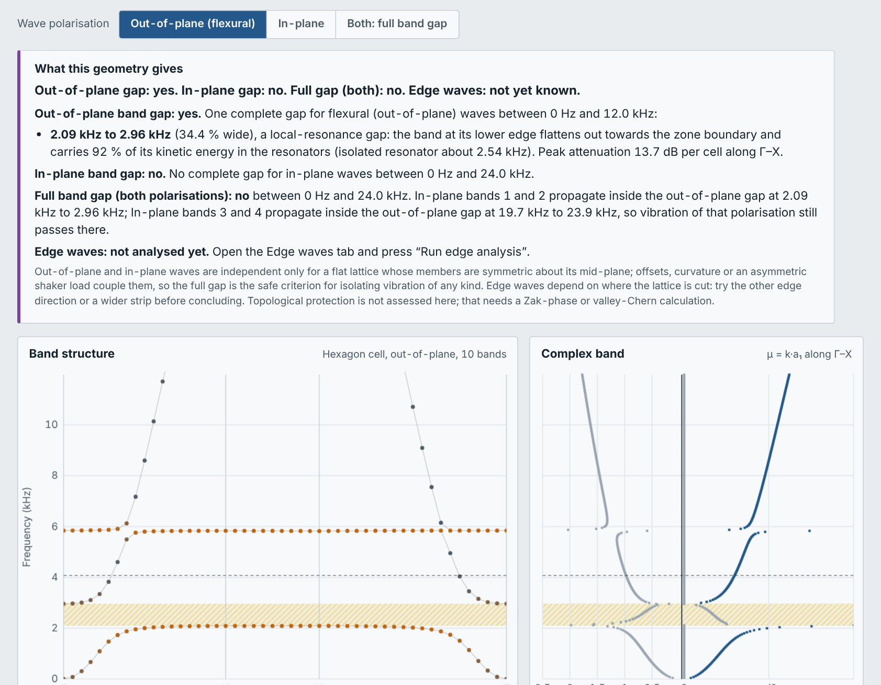
Figure 17. Dispersion tab: assessment box, band structure (left) and complex band (right).
- Wave polarisation buttons: out-of-plane, in-plane, or both (full band gap).
- Assessment box (“What this geometry gives”): a plain-language summary: is there a band gap, what type it is (local resonance or Bragg), how strong the attenuation is, and whether edge waves exist.
- Band structure: frequency against wave direction along the zone path. Each dot is a wave that can travel. Colour shows where the energy is: blue in the lattice, orange in the resonators. A flat orange band is the resonator; the gap usually opens just above it. Yellow hatched ranges are complete band gaps.
- Complex band: for each frequency, the phase change per cell (right half) and the attenuation per cell in nepers (left half; × 8.686 gives dB per cell). Inside a gap all waves are attenuated; a local-resonance gap shows a sharp attenuation peak.
- Mode shape: click any dot of the band structure to animate that wave. Pause and amplitude controls are under the animation.
- Band gaps found: each gap with the bands it lies between, its lower and upper frequency and its relative width (width divided by centre frequency).
- Hover over either plot to read the frequency at the cursor.

8.2 Dispersion tab (editable cells)
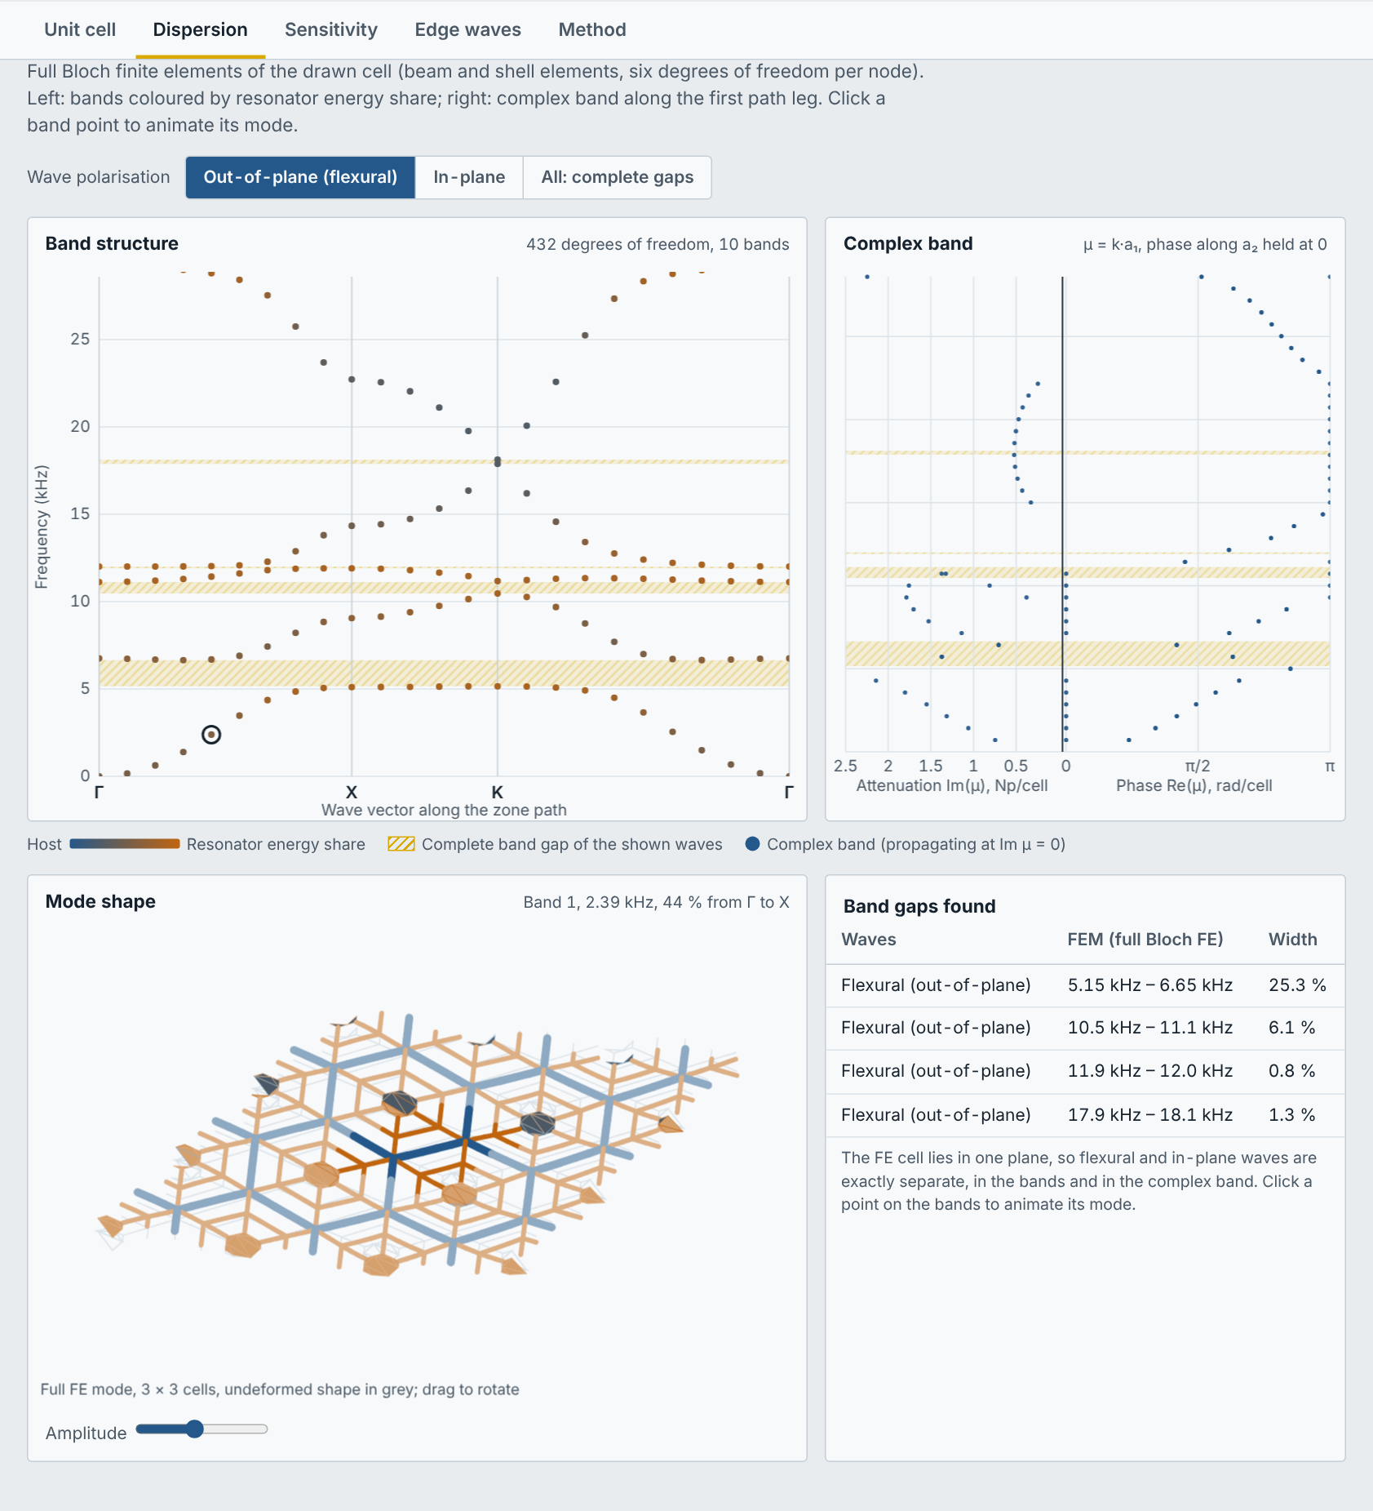
Figure 18. Results of a drawn cell: bands, complex band, an animated 3D mode shape and the list of band gaps.
A box What this geometry gives now opens the tab for every editable cell, in the same style as for cell A: for each kind of wave whether there is a gap, its range and width, whether it is a local-resonance or a Bragg gap (from where the energy of the band below sits), and the peak attenuation in dB per cell. It also reports the edge-wave result once you have run it.
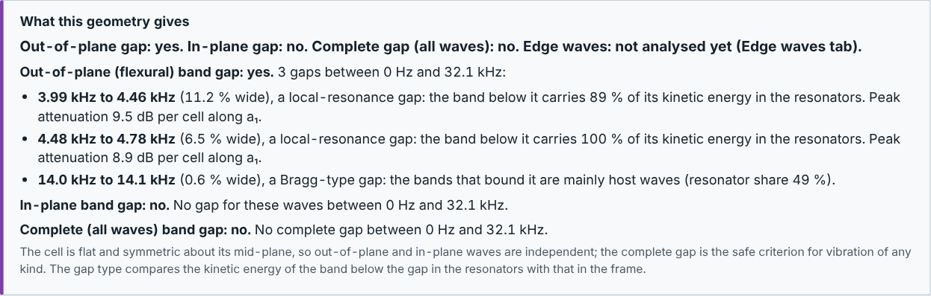
Figure 19. Written summary of cell C after a run.
The plots read as above. The mode shape is the deformed 3D mesh (grey: undeformed shape); drag it to rotate. For a flat cell the out-of-plane and in-plane waves are separated exactly; for a cell that is not flat (for example walls modelled as shells with an offset) the separation is approximate and the “All: complete gaps” view is the safe one.

8.3 Sensitivity tab
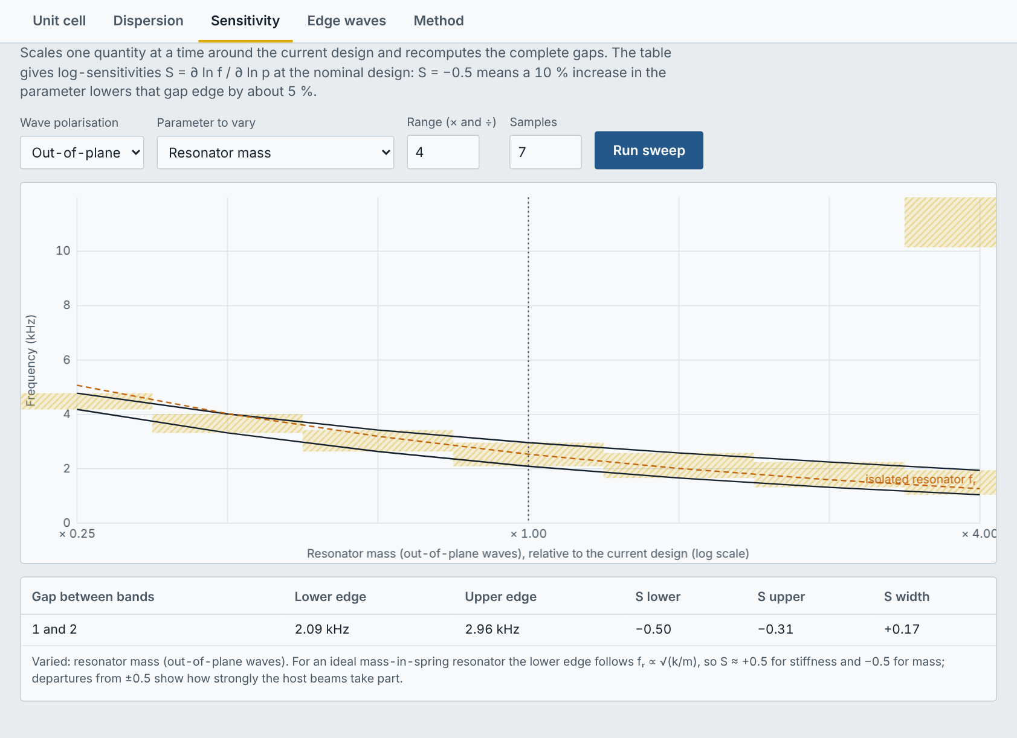
Figure 20. Sensitivity sweep: gap map against a design parameter and the sensitivity table.
Choose a parameter (resonator mass, resonator stiffness, host density, host stiffness or cell size), a range factor and a number of samples, then press Run sweep. The map shows how the gaps move; the table gives the log-sensitivity S = ∂ln f / ∂ln p: S = −0.5 means a 10 % increase of the parameter lowers that gap edge by about 5 %.
For an editable cell two more choices appear: All waves (complete gaps) and One part: a size or thickness, which lists every part with its dimensions (width, height or thickness of beams, walls and plates; the size of a shape; a mass). Each sample rebuilds and re-solves the whole cell at half the k-point density, so a sweep takes roughly as long as one analysis per sample.
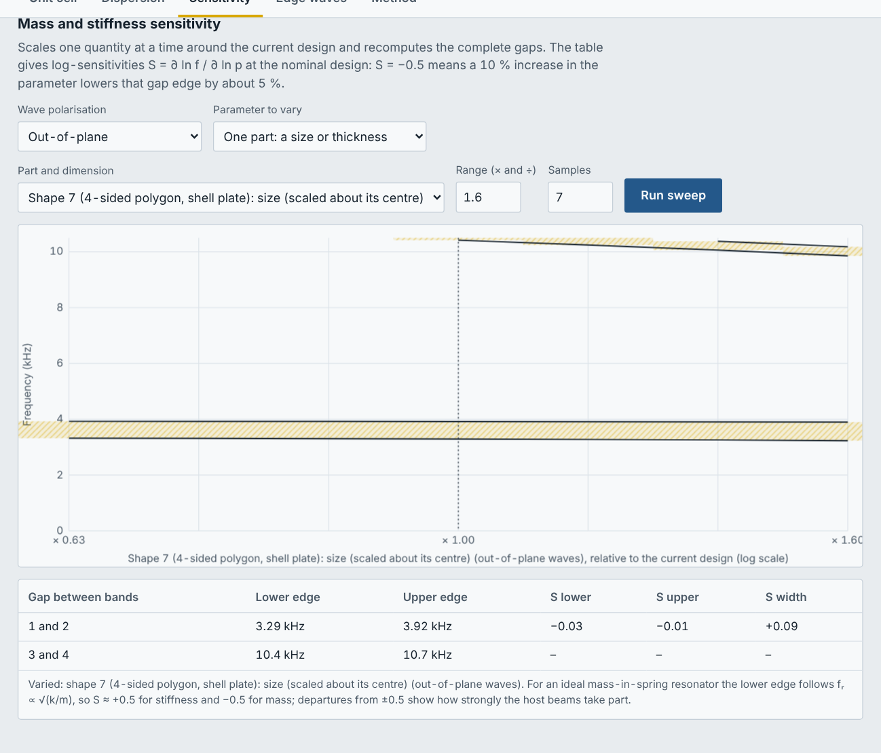
Figure 21. Sensitivity of an editable cell to the size of one resonator shape.

8.4 Edge waves tab
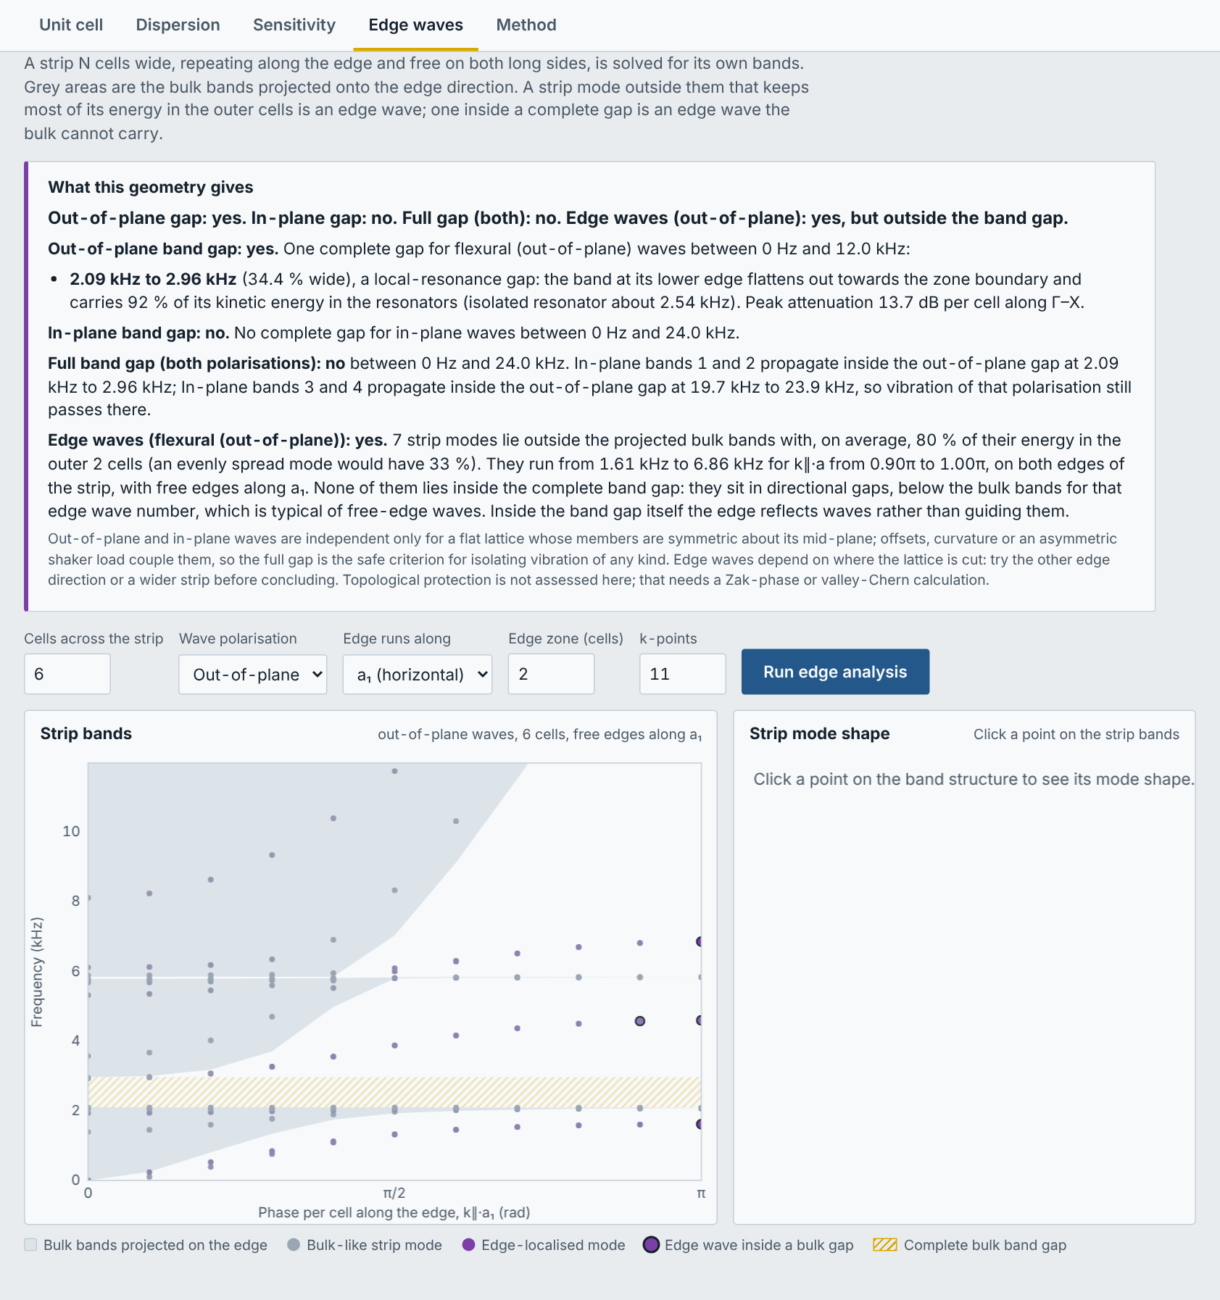
Figure 22. Edge-wave analysis of a strip of cells with free edges.
A strip N cells wide with free long edges is solved. Grey areas are the bands of the infinite lattice; purple dots are waves whose energy stays near the edges. A purple dot inside a band gap is an edge wave that the bulk cannot carry. Choose the strip width, the polarisation, the edge direction and the number of k-points, then press Run edge analysis.
An edge mode is counted on both long edges of the strip together, so a pair of identical edge states (one on each edge) is recognised. For an editable cell, the cell is copied N times across the strip exactly as drawn, so the parts lying on the edge depend on how the cell is drawn; moving parts across the dashed outline gives a different edge. The strip is solved with the same beam and shell elements. Click a point to see the strip mode in 3D (drag to turn). For cells with many shell elements, use 4–6 cells and 7–11 k-points first.
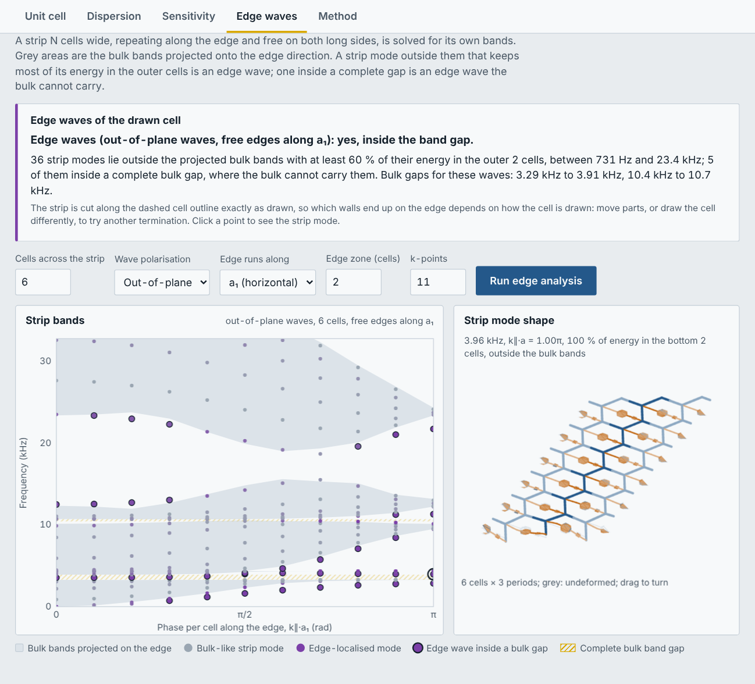
Figure 23. Edge waves of an editable cell: strip bands with the projected bulk bands, and an edge mode localised on the bottom edge.

8.5 Edge waves in a finite sample (M × N)
Choose Model → Finite sample M × N, all edges free. A finite piece of M × N cells, free on every side, is solved for its vibration modes near a centre frequency (0 = the centre of the first bulk gap). Each mode is plotted at its frequency (vertical) and at the share of its energy on the edges and corners of the sample (horizontal). The dashed line marks an evenly spread mode.
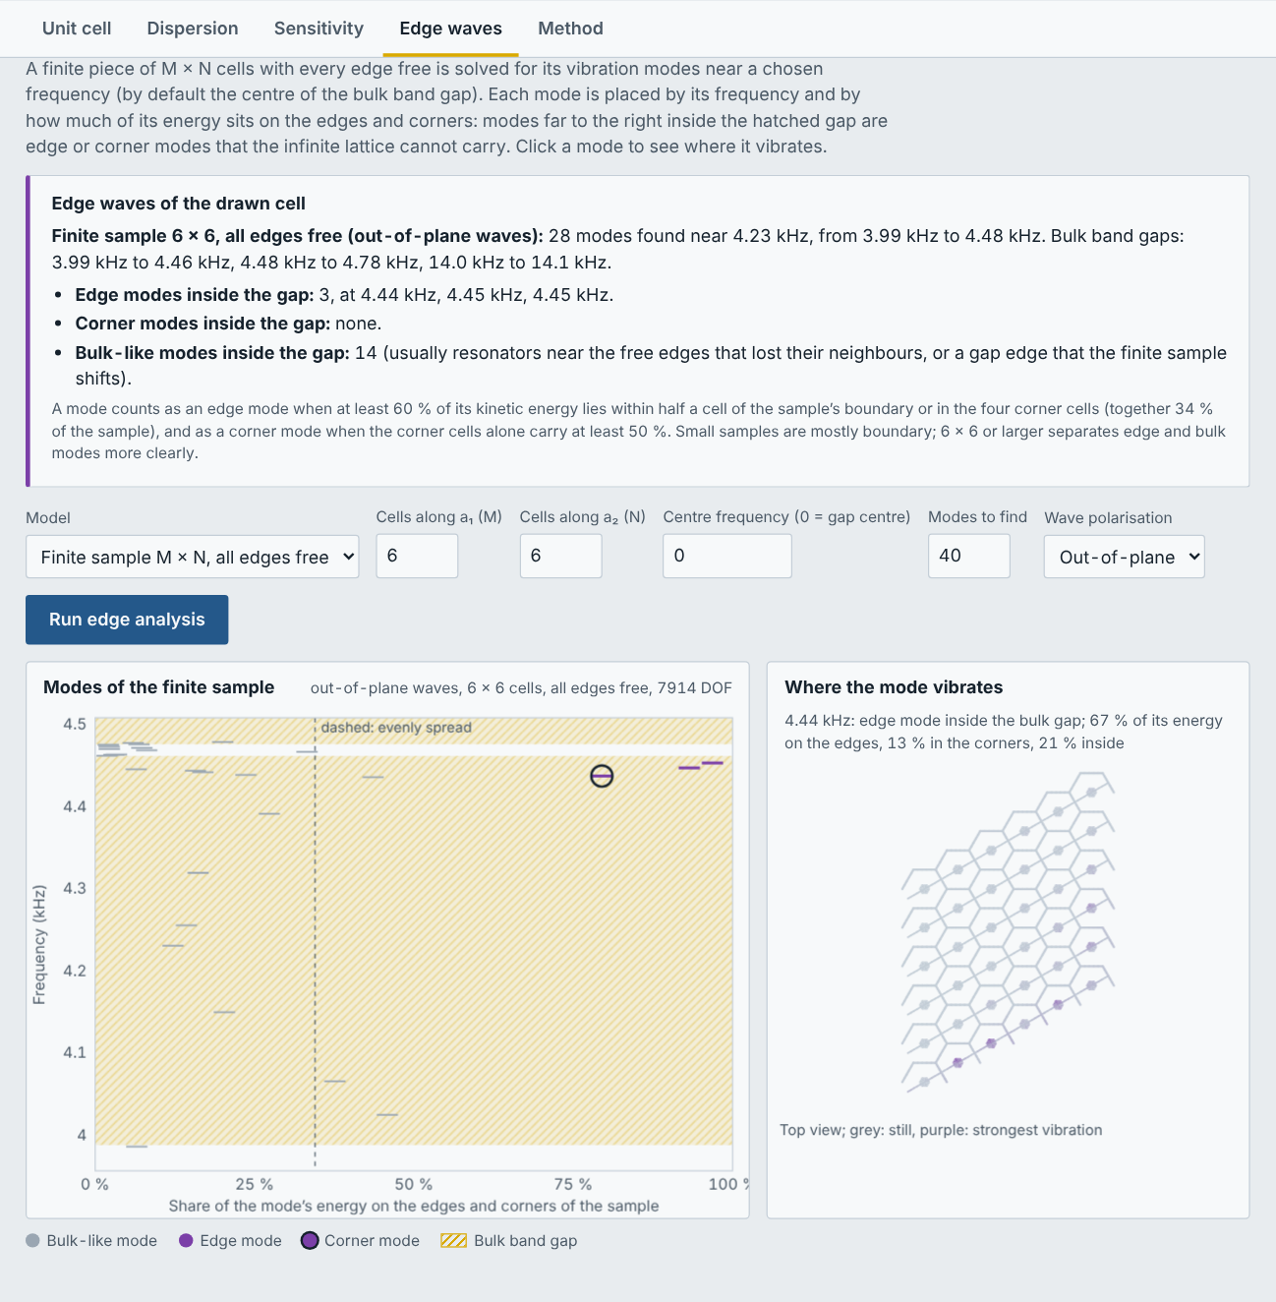
Figure 24. Finite 6 × 6 sample of cell C: modes near the gap, and where the selected edge mode vibrates (purple = strongest).
Result | Meaning
Edge mode | Most of its energy lies within half a cell of the boundary: a wave travelling along the free edge.
Corner mode | Most of its energy lies in the four corner cells.
Bulk-like mode | Energy spread over the sample. Inside a local-resonance gap these are usually resonators vibrating on their own.
Inside the gap | The mode’s frequency lies in a bulk band gap, where the infinite lattice carries no wave: an edge or corner mode there is a true edge or corner state.

The text above the plots lists the frequencies of every edge and corner mode inside the gap. Click a mode to see on the right where it vibrates. The model has about 300–700 unknowns per cell: start with 4 × 4, then 6 × 6 or more if needed (a 6 × 6 sample of cell C takes about 12 s, 4 × 4 of cell B about 18 s). The finite sample also works for cell A.

8.6 Driven sample: where does the energy go?
This reproduces a measurement: the finite sample is shaken on one cell, and the workbench shows where the vibration energy goes at every frequency. Choose Model → Finite sample, then:
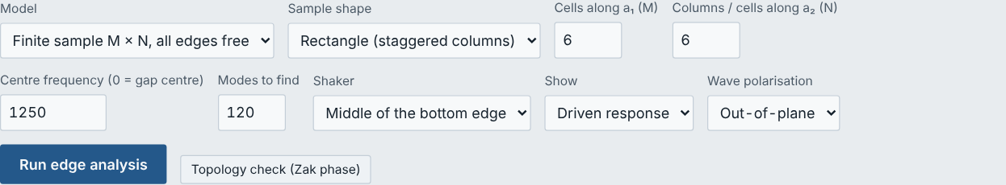
Figure 25. Settings of the finite sample: shape, size, centre frequency, number of modes, shaker and view.
Setting | Meaning
Sample shape | Rectangle (staggered columns): N columns of M cells, every other column shifted by half a cell, like a sample cut from a hexagonal sheet. Parallelogram: M × N cells along a₁ and a₂.
Shaker | The cell that is driven (out of plane; along a₁ for in-plane waves): middle of the bottom edge, middle of the left edge, centre, or corner. “Bottom” is the side the columns (a₁) start from. None shows the modes only.
Modes to find | The response is built from these modes, so it is reliable only in the middle of their range (the summary gives that range). More modes widen it.
Show | Driven response or Modes (section 8.5).

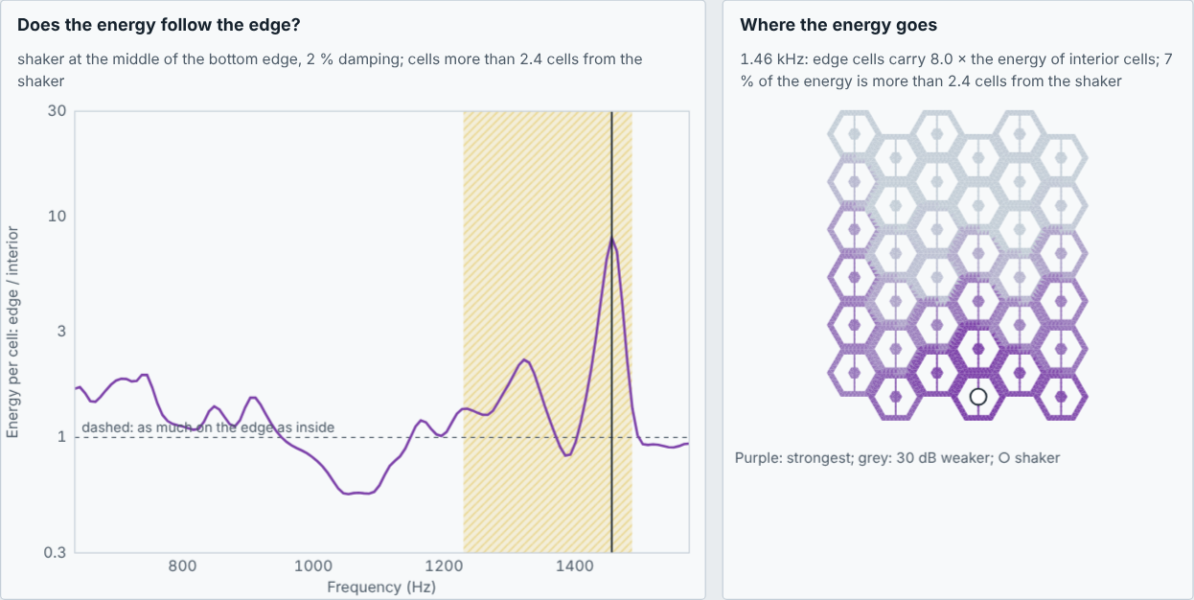
Figure 26. Your “only edge-wave” cell, 6 columns of 6 cells, shaker on the bottom edge: inside the bulk gap the edge cells carry up to 8 times the energy of interior cells; the map shows the energy running along the edges at 1.46 kHz.
The curve is the energy per cell in edge cells divided by interior cells, both counted more than 2.4 cells from the shaker. Above the dashed line (1) the energy follows the edges; the summary lists every range where the ratio is at least 3. Click the curve to see the energy map at that frequency (purple strongest, grey 30 dB weaker). Use at least 6 × 6 cells so that there are interior cells far from the shaker. Damping is 2 %.

8.7 Topology check: Chern number and Zak phase
Press Topology check (Zak phase) in the Edge waves tab. It answers whether an edge wave is required by topology or is an ordinary edge state of the cut.
- Chern number is always 0 here: every structure in the workbench is passive (beams, plates, masses), so time reversal makes the Berry curvature odd in k and its integral vanishes. One-way (chiral) edge waves would need something active, such as spinning gyroscopes or a rotating frame.
- Zak phase is computed for the bands below each gap of the chosen wave type, along three directions (edges parallel to a₂, to a₁ and to a₂ − a₁), with a Wilson loop over 24 wave vectors, measured from the cell centre.
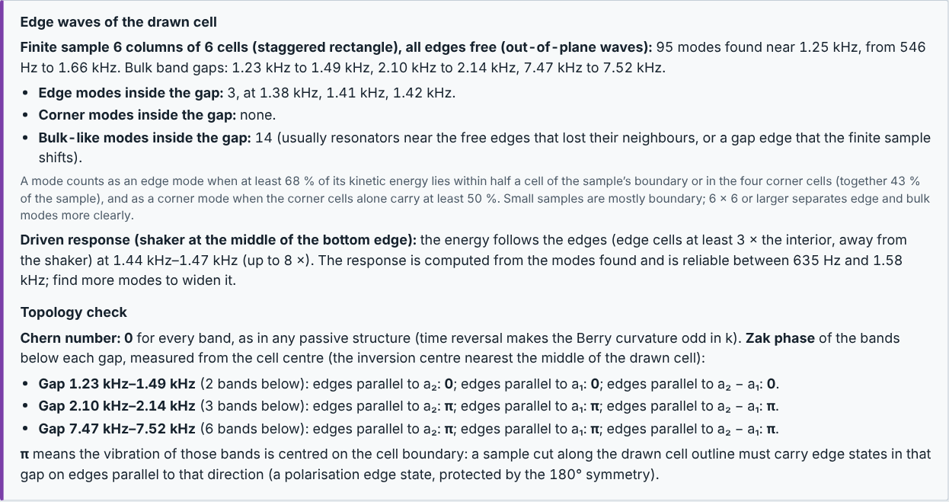
Figure 27. Edge-wave summary with the topology check.
Result | Meaning
0 | The bands below the gap vibrate around the cell centre. No edge state is required; edge waves that the strip or the finite sample show are ordinary edge states of the cut (real, but changed or removed by cutting the edge differently).
π | The bands vibrate around the cell boundary. A sample cut along the drawn cell outline must carry edge states in that gap on edges parallel to that direction: a polarisation edge state, protected by the 180° symmetry.
Not quantised | The cell has no 180° symmetry (for example a one-sided cantilever), so the phase takes any value and protects nothing.
Not defined | The bands below the gap change along the loop (the gap closes in that direction).

The phase depends on where the cell is cut: drawing the cell shifted by half a lattice vector turns 0 into π for a single band. The workbench measures from the inversion centre nearest the middle of the drawn cell, because strips and finite samples are cut along the drawn outline. The same check runs on cell A (through its beam-and-shell model).

8.8 Method tab
Explains the models and equations used (beam and shell elements, Bloch conditions, complex band, sensitivity, edge waves) and how they were validated.

9. Worked examples

9.1 Hexagonal honeycomb with a cantilever resonator
- Geometry → A · Hexagon, cantilever with tip mass. Type 14 in “Regular hexagon from lattice constant” and press Set regular hexagon.
- Wall cross-section: rectangular, b = 1 mm, h = 5 mm.
- Resonator: Cantilever arm with tip mass; attached at wall mid-span, walls “1”, into the cell; arm length 6.5 mm, width 2 mm, thickness 1 mm; rectangular block 6 × 6 × 5 mm, centred on the arm tip.
- Material → Host: Aluminium 6061-T6; Resonator: same as host.
- Run analysis.
Result: an out-of-plane local-resonance gap from about 2.10 to 2.96 kHz (34 % wide). Try Material → Resonator → Stainless steel: the heavier resonator lowers and widens the gap.

9.2 Electrospun membrane cell
- Geometry → Build your own; Lattice Hexagon, L = 10 mm, w = 1 mm, h = 3 mm.
- Resonator Membrane with centre mass; R = 2.5 mm, t = 2 mm, membrane thickness 0.1 mm.
- Material → Membrane → Electrospun nanofibre mat (approx.) or your own values.
- Solver → k-points per segment 8, Complex-band frequencies 40.
- Run analysis.
With an aluminium membrane the gap is near 1.6–1.9 kHz; with a soft electrospun mat (E ≈ 0.05 GPa) it drops to tens of hertz. This shows how strongly the membrane material controls the resonance, and why it is worth calibrating its E against a measurement.

9.3 An asymmetric cell built from shapes
- Geometry → C · Hexagon, beam across, centre mass, beam between two opposite corners.
- Choose Shape, New parts: resonator. Regular polygon, 4 sides, size given as side length 1.6 mm, rotation 45°, Shell plate, t = 1.5 mm; centre x = 6, y = 0 → Add at this centre. A small square block now sits on one of the two beams.
- Look at the Solver panel: the cell now has only one mirror, so the path changes from Γ–X–K–Γ to the half-zone boundary.
- Run analysis. Then in Sensitivity choose One part, the square’s size, range 1.6, 7 samples → Run sweep to see how the block size moves the gaps.
- In Edge waves choose 6 cells, 11 k-points → Run edge analysis, and click the large circled points to see the edge modes.

10. Tips and troubleshooting
Message or symptom | What to do
“… must be a positive number” | An input is empty, zero or negative. Correct it; the status text names the input.
“The tip block is longer than the arm can carry when centred” | Shorten the block or lengthen the arm, or choose “Starts at arm tip”.
“… has a mechanism” / “not positive definite” | Part of the drawing can move without bending anything (for example a part joined at only one point that can rotate freely, or a part not connected at all). Join the parts properly.
“A point mass is not on any drawn part” | Place masses and mass-springs on a beam, wall or plate (use snapping).
Bands near the top look incomplete | Raise “Bands to compute” or lower the max frequency.
Calculation is slow | Use a larger element size (editable cells), fewer k-points or fewer complex-band frequencies; press Stop to cancel.
Results change when the mesh is refined | The mesh is too coarse: reduce the element size until the gap edges stop changing.
Model table shows “Not connected”, or bands start at 0 Hz | A part does not touch the lattice and floats. Move it until it touches a host part, or join it with a beam.
Edge analysis is slow | Use fewer cells across the strip, fewer k-points or a larger element size; press Stop to cancel.
“Custom k-path: cannot read …” | Write one point per line: label, then two numbers, e.g. X 1/2 0.
Save drawing does nothing in the online preview | Downloads work in the HTML file opened from your computer; the drawing is also kept automatically in the browser.

10.1 Good practice
- Check the drawing in the Unit cell tab before running.
- Compare with a bare lattice (resonator = None) to see which gaps come from the resonators.
- Refine the mesh once to confirm the gap edges have converged.
- A gap that opens just above a flat orange band is a local-resonance gap; a gap at the zone boundary of the bare lattice is a Bragg gap.

11. Units, symbols and glossary
Term | Meaning
Unit cell | The smallest piece of the structure that, repeated, builds the whole lattice.
Lattice vectors a₁, a₂ | The two shifts that copy the unit cell onto its neighbours.
Band structure | Frequencies of free waves versus wave direction and wavelength.
Band gap | A frequency range with no free wave: vibration is blocked.
Local-resonance gap | A gap created by the resonators, near their resonance frequency.
Bragg gap | A gap created by the periodicity itself, where the wavelength is about twice the cell size.
Complex band, attenuation | How fast a wave decays per cell, in nepers (1 Np = 8.686 dB).
Γ, X, K, M | Special wave directions on the zone path (Γ = very long wavelength).
Host / resonator | The load-carrying lattice / the parts that resonate.
Timoshenko beam | Beam model that includes shear deformation and rotary inertia (better for short, thick walls).
Shell | Thin plate element used for plates, membranes and tall walls in drawn cells.
Edge wave | A wave that travels along a free edge and decays into the lattice.

Units used everywhere: mm, g, Hz, GPa, kg/m³.

