**AI-Based Diabetes Prediction System**

au211521243058: m.j guru venkatesh  
 Naan Mudhalvan ID: 122104

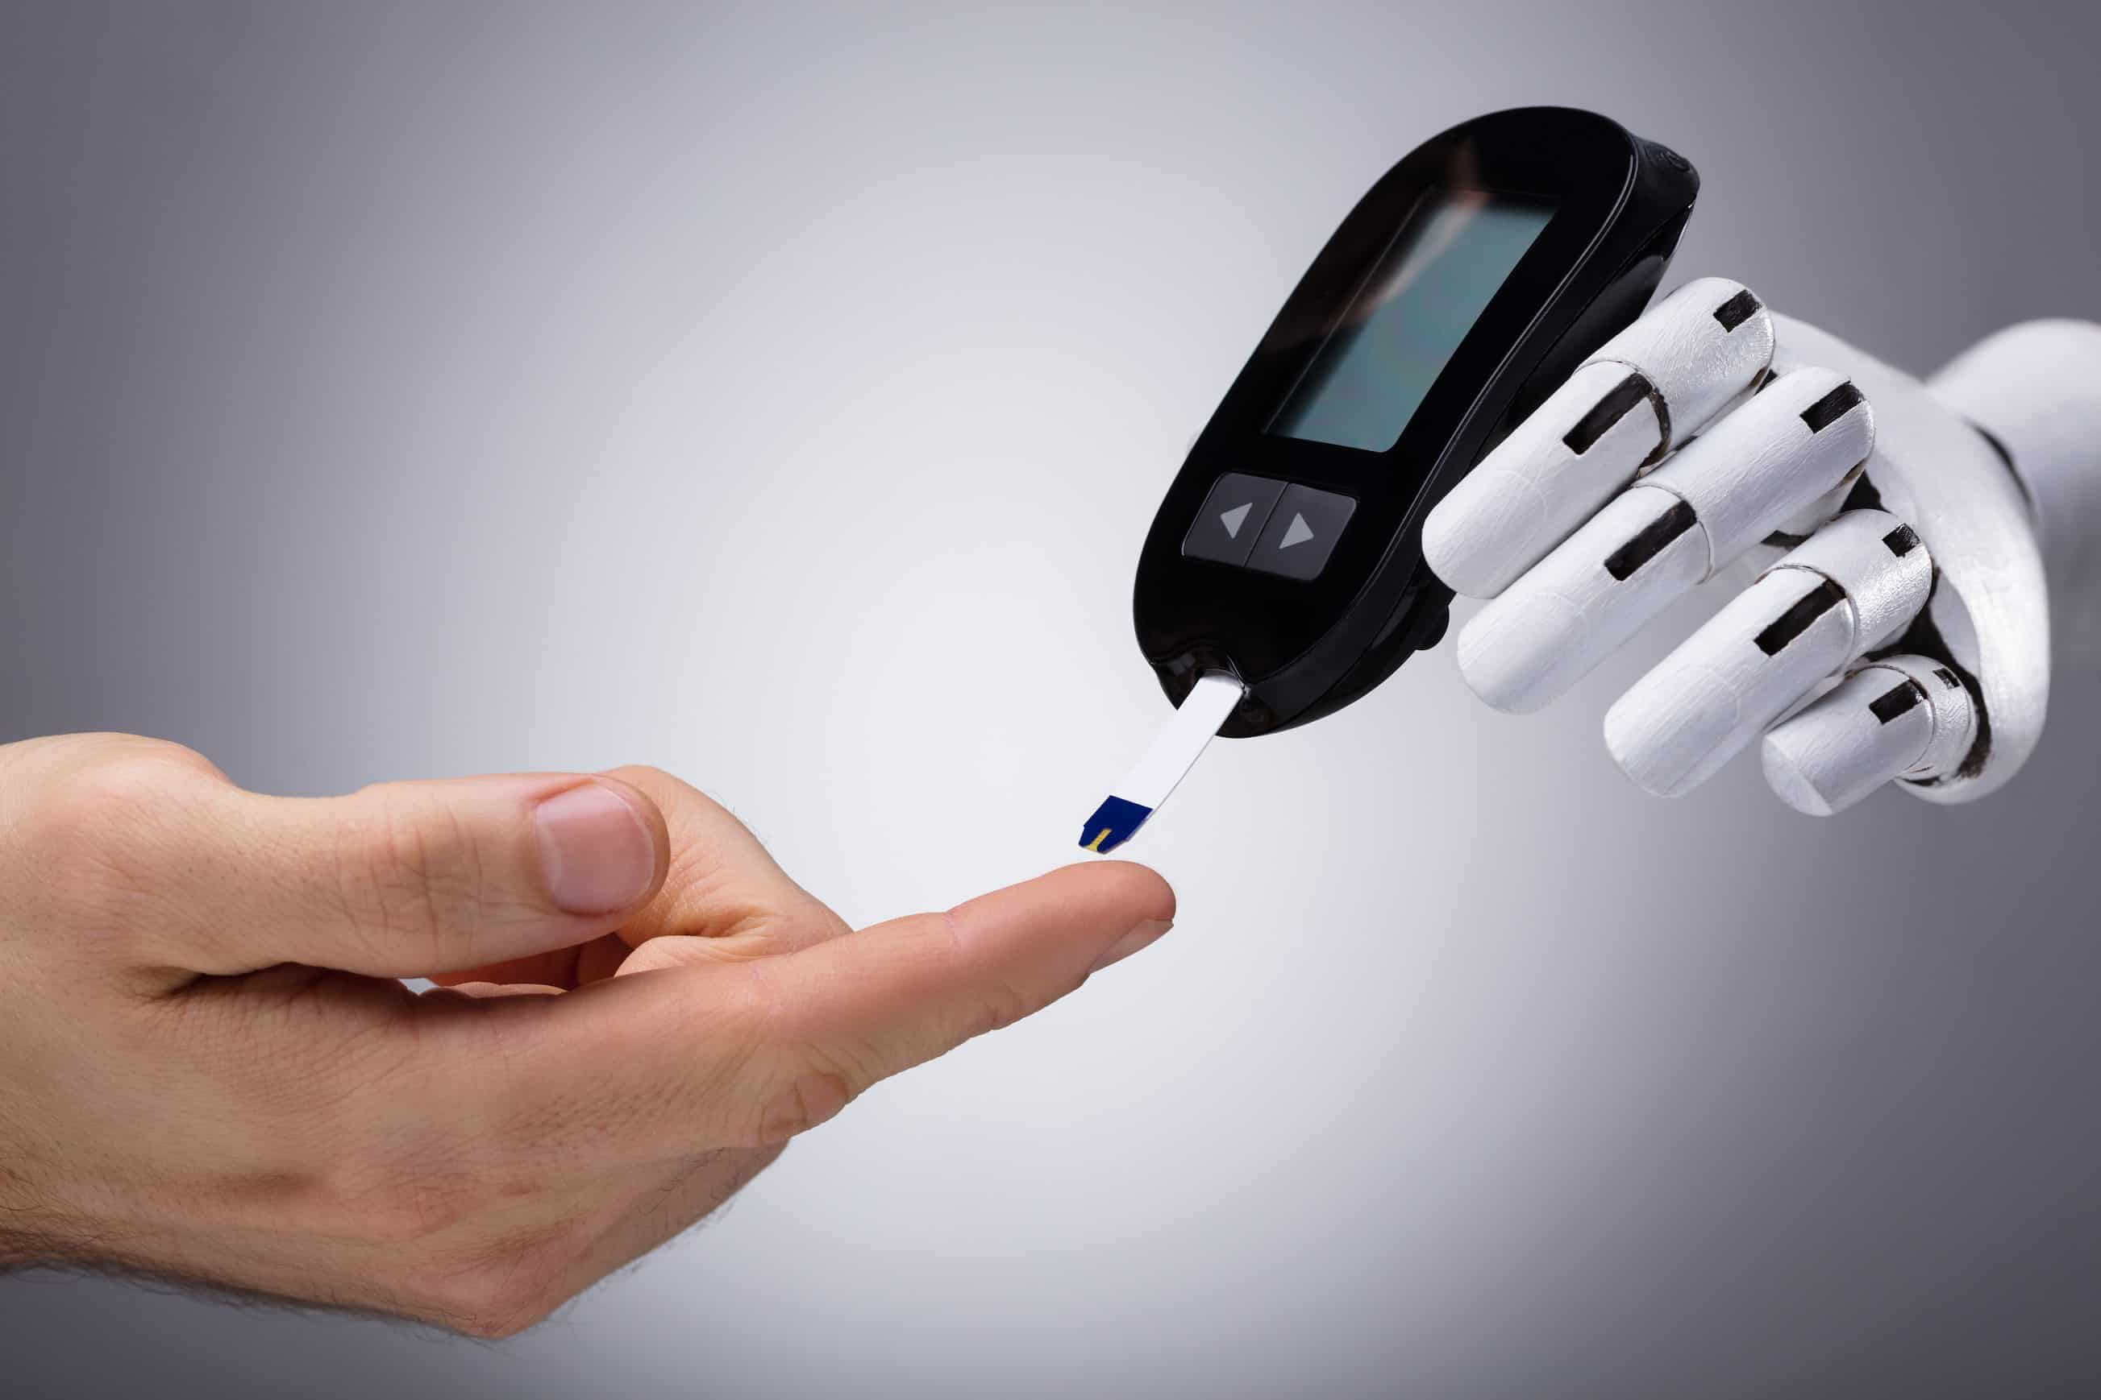

**Phase 4: Development Part 2 - Building a Diabetes Prediction System**

In Phase 4 of developing your diabetes prediction system, Building a diabetes prediction system involves several key steps, including loading and preprocessing the dataset, selecting a machine learning algorithm, preparing the data for model training and evaluating its performance. Here is a step-by-step process on how to begin this project:

**Step 1: Data Collection:**

* Begin by collecting a dataset that contains relevant information for predicting diabetes. Common datasets for diabetes prediction include the Diabetes dataset from scikit-learn or publicly available medical datasets.

Dataset Link:[**https://www.kaggle.com/datasets/mathchi/diabetes-data-set**](https://www.kaggle.com/datasets/mathchi/diabetes-data-set)



**Step 2: Data loading:**

* We load the dataset into our data analysis environment, using Python with the Pandas library, enabling us to access and manipulate the data effectively

**Step 3: Data Exploration:**

* To gain a deep understanding of our dataset, we initiate data exploration. This process includes:  
  1. Checking for missing values to ensure data quality.  
  2. Obtaining summary statistics to grasp the dataset's characteristics.  
  3. Evaluating data types, distribution, and patterns.

**Step 4: Data Preprocessing:**

* To prepare our data for modeling, we perform necessary data preprocessing tasks, including:  
   1. Handling missing values by imputing them (for example, replacing them with the mean).  
  2. Encoding categorical variables if needed.  
  3. Standardizing or normalizing features to ensure that all variables are on a common scale.

**Step 5: Selecting a Machine Learning Algorithm**

* **Understanding the Problem**: Before selecting an algorithm, it's crucial to understand the nature of the problem. In this case, it's binary classification—predicting whether a person has diabetes or not.
* **Algorithm Selection:** Choose a machine learning algorithm suitable for binary classification. Common choices include Logistic Regression, Decision Trees, Random Forest, Support Vector Machines, and Neural Networks.
* **Consider Data Characteristics:** The characteristics of your dataset, such as the size, complexity, and feature types, can influence the algorithm choice.

**Step 6: Training the Model**

* **Data Split**: Split your dataset into training and testing sets to train and evaluate the model. The training set is used to teach the model, while the testing set is reserved for evaluation.
* **Model Initialization:** Initialize the selected machine learning algorithm, creating a blank slate for the model.
* **Model Training:** Train the model by feeding it the training data. The algorithm learns patterns and relationships within the data to make predictions.

**Step 7: Evaluating Model Performance**

* **Prediction Generation**: Use the trained model to make predictions on the testing data.
* **Performance Metrics:** Evaluate the model's performance using appropriate metrics. Common metrics for binary classification include:  
  **Accuracy:** Measures the proportion of correctly predicted instances.  
  **Precision:** Quantifies the ratio of true positive predictions to all positive predictions, emphasizing the model's ability to avoid falsepositives.  
  **Recall:** Measures the ratio of true positives to all actual positives, highlighting the model's ability to avoid false negatives.  
  **F1 Score:** Harmonic mean of precision and recall, balancing the trade-off between precision and recall.
* **Additional Evaluation**: A classification report provides a summary of precision, recall, and F1 score for both classes (positive and negative). A confusion matrix visually represents true positives, true negatives, false positives, and false negatives.
* **Model Refinement:** If the model's performance is unsatisfactory, you may need to iterate on the process, including data preprocessing, feature engineering, and hyperparameter tuning to improve the model

**Python code for building a diabetes prediction system using “Logistic Regression”:**

#Import necessary libraries

import pandas as pd

from sklearn.model_selection import train_test_split

from sklearn.preprocessing import StandardScaler

from sklearn.linear_model import LogisticRegression

from sklearn.metrics import accuracy_score, classification_report, confusion_matrix

import joblib  
  
data = pd.read_csv('diabetes.csv')  
  
# Data preprocessing

X = data.drop('Outcome', axis=1)  # Features

y = data['Outcome']  # Target variable

# Split the data into training and testing sets

X_train, X_test, y_train, y_test = train_test_split(X, y, test_size=0.2, random_state=42)

# Feature scaling (optional, but often useful)

scaler = StandardScaler()

X_train = scaler.fit_transform(X_train)

X_test = scaler.transform(X_test)

# Select and train a machine learning model (Logistic Regression)

model = LogisticRegression(random_state=42)

model.fit(X_train, y_train)

# Evaluate the model

y_pred = model.predict(X_test)

accuracy = accuracy_score(y_test, y_pred)

print(f'Accuracy: {accuracy:.2f}')

# Additional evaluation metrics

print(classification_report(y_test, y_pred))

print(confusion_matrix(y_test, y_pred))

# Save the trained model for future use

joblib.dump(model, 'diabetes_model_logistic_regression.pkl')

OUTPUT:

Accuracy: 0.75

precision recall f1-score support

0 0.81 0.80 0.81 99

1 0.65 0.67 0.66 55

accuracy 0.75 154

macro avg 0.73 0.74 0.73 154

weighted avg 0.76 0.75 0.75 154

[[79 20]

[18 37]]

['diabetes_model_logistic_regression.pkl']

**Step 8: Model Validation**

* It's crucial to validate your model's performance on a separate test dataset that it hasn't seen during training. This step ensures that your model generalizes well to new, unseen data.

**Step 9: Model Interpretability**

* Depending on the chosen algorithm, you may want to interpret the model's predictions. Techniques like feature importance analysis, SHAP values, and LIME can help understand which features are driving the model's predictions

**Step 10: Iteration**

* If your model's performance is not satisfactory, consider iterating through the process by trying different algorithms, feature engineering strategies, or data preprocessing techniques.

**Step 11: Deployment**

* Once you're satisfied with your model's performance, you can deploy it to make predictions on new data.

**Conclusion:**By the end of Phase 4 , we have successfully loaded and preprocessed our dataset, chosen relevant features, and defined our target variable. We are now well-prepared to move on to the subsequent phases, which involve data splitting, model selection, training, and evaluation. Our ultimate goal is to develop an accurate diabetes prediction system to benefit individuals' health and well-being.