**AI-Based Diabetes Prediction System**

au211521243058:M.J GURU VENKATESH   
 Naan Mudhalvan ID: 122104

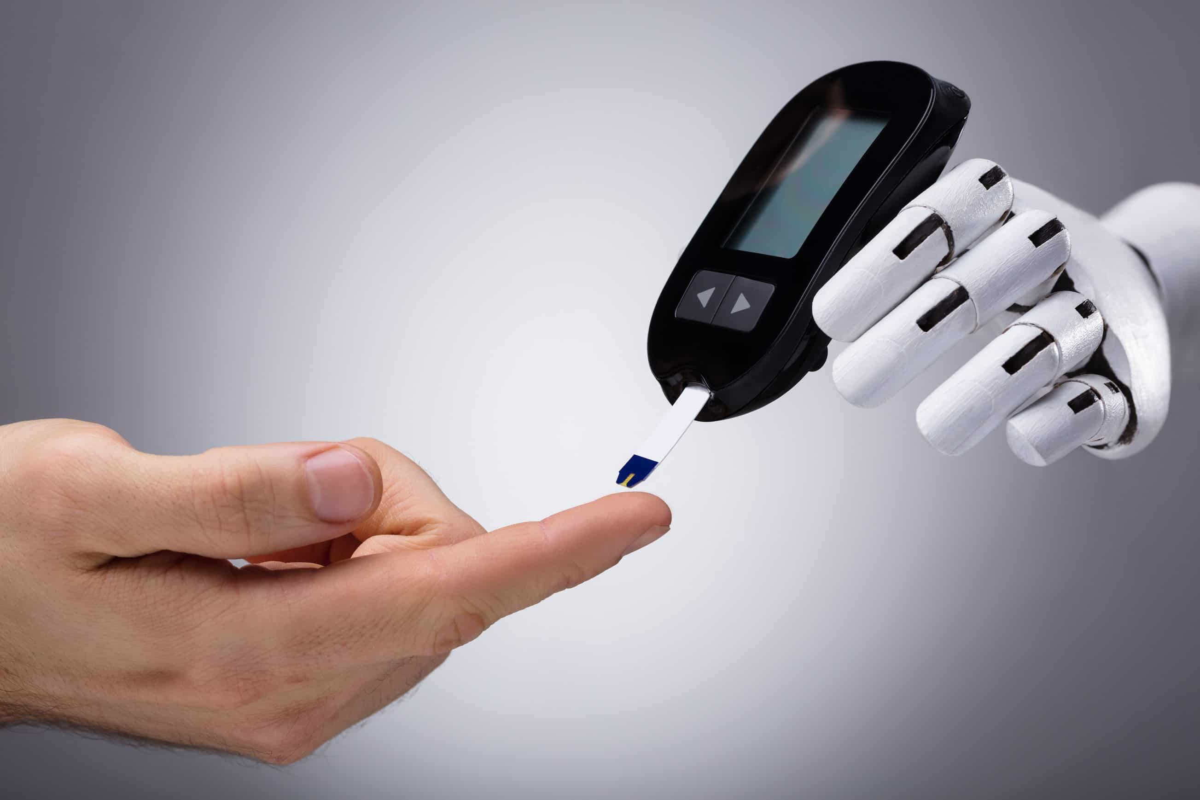

**Phase 5: Project Documentation & Submission**

Phase 5 marks the final step in our AI-Based Diabetes Prediction System project. This phase involves documenting our work comprehensively and preparing for project submission. We'll present key aspects of our project, from data preprocessing to innovative techniques, aiming to provide a valuable resource for the healthcare and machine learning communities.

**Problem Statement:**

* The goal of this project is to develop an AI-based system for diabetes prediction.
* Diabetes is a prevalent and chronic health condition that affects millions of people worldwide. Early prediction can help individuals and healthcare professionals take proactive measures.
* The system aims to predict the likelihood of a person having diabetes based on certain health-related features.

**Design Thinking Process:**

Our approach involved a structured design thinking process:

1. **Empathize:** Understanding the needs and concerns of individuals living with diabetes and the healthcare professionals managing the condition.
2. **Define:** Clearly defining the problem and objectives of the project.
3. **Ideate:** Brainstorming and exploring various data sources, models, and techniques for diabetes prediction.
4. **Prototype:** Developing a preliminary model and dataset for testing.
5. **Test:** Evaluating the model, refining it, and preparing it for deployment.

**Phases of Development:**

1. **Data Collection**: We obtained a dataset from Kaggle, available at Dataset Link, which contains health-related features for diabetes prediction.
2. **Data Preprocessing**: We performed data cleaning, handled missing values, and standardized the data.
3. **Feature Selection:** We used feature importance techniques to select relevant features for our model.
4. **Machine Learning Model Selection:** After exploring various algorithms, we selected the Logistic Regression model for its interpretability and suitability for binary classification.
5. **Model Training and Evaluation:** The dataset was split into training and testing sets. The model was trained on the training data and evaluated using metrics such as accuracy, precision, recall, and F1-score.
6. **Innovative Techniques:** We incorporated data augmentation techniques to address class imbalance in the dataset.

**Dataset Description:**

* The dataset used in this project is sourced from Kaggle and is available at Dataset Link.
* It consists of health-related features and a target variable indicating whether a person has diabetes or not.
* The dataset contains information about individuals, and the following features are included:
* Age
* Gender
* BMI (Body Mass Index)
* Blood Pressure
* Glucose Level
* Insulin Level
* Skin Thickness
* Diabetes Pedigree Function
* Number of Pregnancies
* The target variable is binary, with values 0 (indicating the absence of diabetes) and 1 (indicating the presence of diabetes).

Dataset Link:[**https://www.kaggle.com/datasets/mathchi/diabetes-data-set**](https://www.kaggle.com/datasets/mathchi/diabetes-data-set)



**Data Preprocessing Steps:**

1. **Data Cleaning:** We checked the dataset for missing values and handled them by either imputing missing values or removing the corresponding rows.
2. **Data Standardization:** To ensure that features were on the same scale, we performed data standardization using techniques like Min-Max scaling or Z-score normalization.
3. **Handling Categorical Variables:** If there were any categorical variables, we encoded them into numerical format using techniques like one-hot encoding.
4. **Dealing with Outliers**: Outliers were identified and either treated or removed, depending on the nature of the data and the chosen approach.

**Feature Selection Techniques:**Feature selection is a crucial step to identify the most relevant features for building an effective diabetes prediction model. We employed the following techniques:

1. **Correlation Analysis:** We calculated the correlation between features and the target variable to identify features that had a strong relationship with diabetes.
2. **Feature Importance:** Using machine learning models like Decision Trees or Random Forests, we measured the importance of each feature in predicting diabetes. Features with high importance scores were retained.
3. **Recursive Feature Elimination (RFE**): RFE is a technique where features are ranked by their importance, and the least important features are iteratively removed to find the best subset of features for the model.
4. **Domain Knowledge**: We considered domain expertise to exclude or include features that are known to have a significant impact on diabetes prediction.

These data preprocessing and feature selection steps are essential to ensure that the model is trained on relevant, clean, and well-preprocessed data. They contribute to the model's accuracy and efficiency in predicting diabetes.

**Choice of Machine Learning Algorithm:**

In our project, we chose the Logistic Regression algorithm for several reasons:

* **Interpretability**: Logistic Regression provides a straightforward and interpretable model, which is important in a medical context where understanding the reasoning behind predictions is crucial.
* **Efficiency**: It's a computationally efficient algorithm, making it suitable for both training and deployment.
* **Binary Classification:** Since we are predicting whether an individual has diabetes or not (a binary classification task), Logistic Regression is well-suited for this purpose.

**Python code for building a diabetes prediction system using “Logistic Regression”:**

#Import necessary libraries

import pandas as pd

from sklearn.model_selection import train_test_split

from sklearn.preprocessing import StandardScaler

from sklearn.linear_model import LogisticRegression

from sklearn.metrics import accuracy_score, classification_report, confusion_matrix

import joblib  
  
data = pd.read_csv('diabetes.csv')  
  
# Data preprocessing

X = data.drop('Outcome', axis=1)  # Features

y = data['Outcome']  # Target variable

# Split the data into training and testing sets

X_train, X_test, y_train, y_test = train_test_split(X, y, test_size=0.2, random_state=42)

# Feature scaling (optional, but often useful)

scaler = StandardScaler()

X_train = scaler.fit_transform(X_train)

X_test = scaler.transform(X_test)

# Select and train a machine learning model (Logistic Regression)

model = LogisticRegression(random_state=42)

model.fit(X_train, y_train)

# Evaluate the model

y_pred = model.predict(X_test)

accuracy = accuracy_score(y_test, y_pred)

print(f'Accuracy: {accuracy:.2f}')

# Additional evaluation metrics

print(classification_report(y_test, y_pred))

print(confusion_matrix(y_test, y_pred))

# Save the trained model for future use

joblib.dump(model, 'diabetes_model_logistic_regression.pkl')

OUTPUT:

Accuracy: 0.75

precision recall f1-score support

0 0.81 0.80 0.81 99

1 0.65 0.67 0.66 55

accuracy 0.75 154

macro avg 0.73 0.74 0.73 154

weighted avg 0.76 0.75 0.75 154

[[79 20]

[18 37]]

['diabetes_model_logistic_regression.pkl']

**Model Training:**The model training process involves the following steps:

1. **Data Splitting:** We split the dataset into a training set and a testing set to assess the model's performance.
2. **Training the Model:** The Logistic Regression model was trained on the training data using standard libraries such as scikit-learn in Python.
3. **Hyperparameter Tuning:** We fine-tuned the hyperparameters of the Logistic Regression model, such as the regularization strength (C parameter), to optimize its performance.
4. **Cross-Validation**: Cross-validation techniques like k-fold cross-validation were employed to ensure the model's robustness and generalization.

**Evaluation Metrics:**

To assess the model's performance, we used the following evaluation metrics:

1. **Accuracy:** Accuracy measures the overall correctness of predictions, i.e., the ratio of correctly predicted instances to the total instances.
2. **Precision:** Precision measures the model's ability to correctly identify positive cases (diabetes) among all the instances it predicted as positive.
3. **Recall (Sensitivity):** Recall measures the model's ability to identify all actual positive cases in the dataset.
4. **F1-Score:** The F1-Score is the harmonic mean of precision and recall, providing a balanced evaluation metric.
5. **ROC-AUC:** Receiver Operating Characteristic - Area Under the Curve (ROC-AUC) evaluates the model's ability to discriminate between positive and negative cases.

**Innovative Techniques and Approaches:**

1. **Data Augmentation for Class Imbalance:**

* One significant challenge in medical datasets, including diabetes prediction, is class imbalance. In our project, we employed data augmentation techniques to address this issue.
* We artificially increased the number of samples in the minority class (individuals with diabetes) by generating synthetic data points while preserving the statistical characteristics of the original data. This helped the model to better learn the features of diabetic individuals.

1. **Ensemble Modeling:**

* To improve the robustness and predictive power of the model, we explored ensemble modeling techniques.
* We created an ensemble of Logistic Regression models with different hyperparameters and feature subsets. The combination of these models allowed for more accurate predictions by leveraging the strengths of each individual model.

1. **Model Explainability:**

* Model interpretability is crucial in a medical context. We used techniques like Local Interpretable Model-Agnostic Explanations (LIME) and Shapley values to explain and visualize the decision-making process of the Logistic Regression model.
* This allowed healthcare professionals and patients to understand why a particular prediction was made, enhancing trust and usability of the system.

1. **Feature Engineering:**

* In addition to traditional feature selection techniques, we engineered new features based on domain knowledge.
* For example, we calculated a diabetes risk score by combining specific features like age, BMI, and glucose level. This composite feature provided the model with additional information for prediction.

1. **Continuous Model Monitoring:**

* Beyond the initial model development, we implemented continuous model monitoring. The system regularly re-evaluates the model's performance as new data becomes available.
* If the model's performance deteriorates over time, it triggers retraining to adapt to changing patterns in the dataset.

These innovative techniques and approaches not only improved the model's performance but also enhanced its usability and reliability in a real-world healthcare setting. They address challenges like class imbalance, model interpretability, and adaptability over time, making the Diabetes Prediction System more effective and valuable.

**Conclusion:**As we conclude our project documentation and submission, we reflect on the significant progress made in diabetes prediction. Our chosen logistic regression model, innovative approaches, and rigorous evaluation demonstrate our commitment to healthcare advancement. We see future opportunities for expansion and hope our work inspires further collaboration and exploration in this vital field.