Petri Net and Finite State Machine Design for a PLC Controlled Pneumatic Milling Training Model
Preliminary paper 1 | Petri net control model, structured text refinement and verification specification
Author: [Student name] | Department: [Department] | Institution: [University]

Abstract
This paper specifies the sequence controller of a conceptual pneumatic milling training model governed by a programmable logic controller (PLC). A pneumatic cylinder clamps an abstract workpiece, a second cylinder provides a short guided feed movement, and an independently powered motor drives a spindle. The controller is first modeled as a place/transition Petri net in which the eight operating states, the positions of the two cylinders, the spindle state, the guard and the supply pressure are places, and in which commands, confirmations, faults and recovery are transitions connected by read arcs. The net has 20 places and 45 transitions; its reachability graph of 124 markings was generated by a short Python script and checked mechanically. The net is 1-safe, covered by six place invariants that enforce mutual exclusion of states and of opposite end positions, reversible from every fault, and free of deadlocks and dead transitions. Six safety properties hold in every reachable marking, among them that the feed never leaves home unless the clamp is closed and that the clamp is never released while the spindle runs. The nominal cycle is a transition invariant of 17 firings. The finite state machine with states Idle, Clamp, SpinUp, Advance, Retract, SpinDown, Release and Complete is then derived as the controller component of the net and refined into IEC 61131-3 structured text with timeouts, latched faults and an explicit priority rule. Logical tags, invariants and test cases make the design inspectable before a physical apparatus exists. The work is a controller specification and verification plan, not an implemented machine or a proof of machinery safety. Physical validation would require selected parts, a machine specific risk assessment, dry runs and measured reaction times.
Keywords: programmable logic controller; Petri net; reachability analysis; place invariant; finite state machine; pneumatic actuator; milling model; interlock; fault handling.

1 Introduction
An instructional milling model can demonstrate how sensors, logic and actuators form an automatic sequence. Milling combines workpiece location, spindle rotation and feed motion. These functions must occur in an ordered way: feeding before secure clamping or before the spindle reaches its intended condition is an invalid state. A controller that simply energizes outputs for preset intervals cannot tell whether a mechanical step has completed. Using observed conditions for state transitions makes the intended behavior easier to test.
The model considered here is deliberately limited. A pneumatic cylinder is suitable for illustrating clamping and a binary guided feed, while a separate motor provides spindle rotation. The proposed system is an educational control cell. Its binary end position sensing cannot demonstrate tool path accuracy or dimensional tolerance, and no material removal has been tested. A real cutting machine would require a structural design, known forces, tool selection, workholding calculations and protective measures beyond the control sequence.
The research question is how to describe a normal cycle and its abnormal transitions precisely enough that a PLC program, a formal analysis and a test suite can be derived from the same specification. Petri nets are chosen as the primary model because a milling cycle is not purely sequential: the spindle keeps running while the feed advances and retracts, the two cylinders and the spindle each have their own state, and the guard and the supply pressure change independently of the controller. A finite state machine can only name the controller states; a Petri net also represents the plant and the permissive conditions as marked places, so that properties such as "the feed never moves while the clamp is open" can be checked over all reachable markings rather than argued informally [5], [6]. The relation to PLC practice is direct: the sequential function chart of IEC 61131-3 and GRAFCET of IEC 60848 are restricted Petri nets, and token passing implementations of Petri nets in ladder logic and structured text are established [1], [7], [8]. This paper describes behavior in language independent terms, then gives representative structured text style control rules. The vendor, terminal addresses and physical component selection remain open.

2 System architecture and assumptions
The proposed plant has a clamp actuator with open and closed end indications, a guided feed actuator with home and forward indications, a spindle drive with running and stopped feedback, a pressure permissive, and an enclosure guard indication. The operator supplies Start, Stop and Reset requests. The PLC commands clamp extension and release, feed extension and return, and spindle enable. An annunciator indicates a latched fault. Each signal is a logical name rather than a confirmed physical terminal.
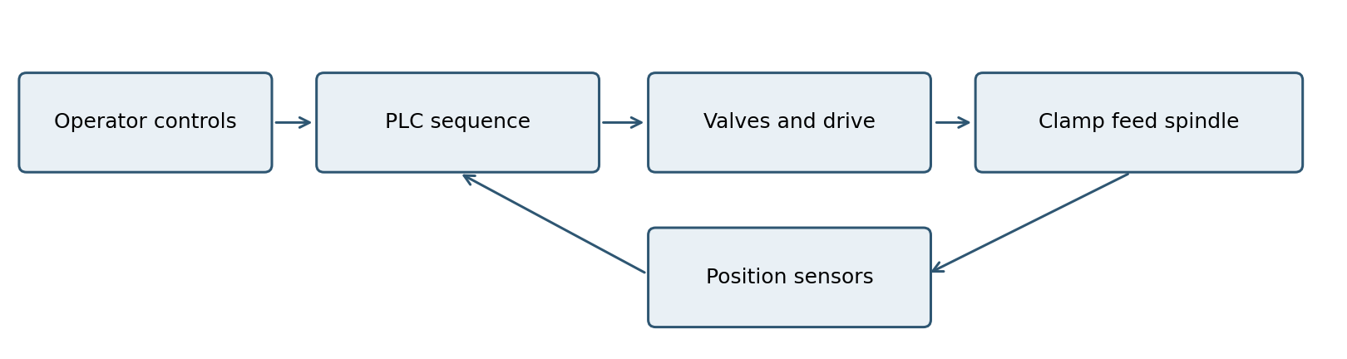
Figure 1. Functional boundary of the proposed training cell.
The PLC receives sensor states, selects one operating state and computes outputs for that state. Input validity matters: a ClampClosed switch confirms the chosen sensing location, but does not establish that the workpiece resists an unknown cutting load. Similarly, a drive run bit may not independently establish shaft speed. The resulting design must preserve the difference between a logical confirmation and a measured mechanical condition.
For an illustrative force check, a 32 mm bore at 0.50 MPa gauge pressure produces a theoretical extension force pπD²/4 of about 402 N. A 50% conceptual allowance leaves about 201 N for preliminary reasoning. The value is not a verified clamping force at the tool. Losses, fixture geometry and cutting loads must be determined for any physical apparatus. Festo documentation distinguishes theoretical cylinder force from practical sizing allowance [2].

3 Petri net model and finite state controller

3.1 Petri net of the controller and plant
Figure 2 shows the controller component of the net and Figure 3 the plant and permissive components; Table 1 lists the places and Table 2 the transitions. A place holds a token when the condition it names is true. The controller places are the eight operating states, of which exactly one is marked. The plant places describe the clamp cylinder (open, moving, closed), the feed carriage (home, moving, forward), the spindle (stopped, running), the guard (closed, open) and the supply pressure (adequate, low). The initial marking M0 places tokens in Idle, C_open, F_home, S_stopped, G_closed and P_ok.
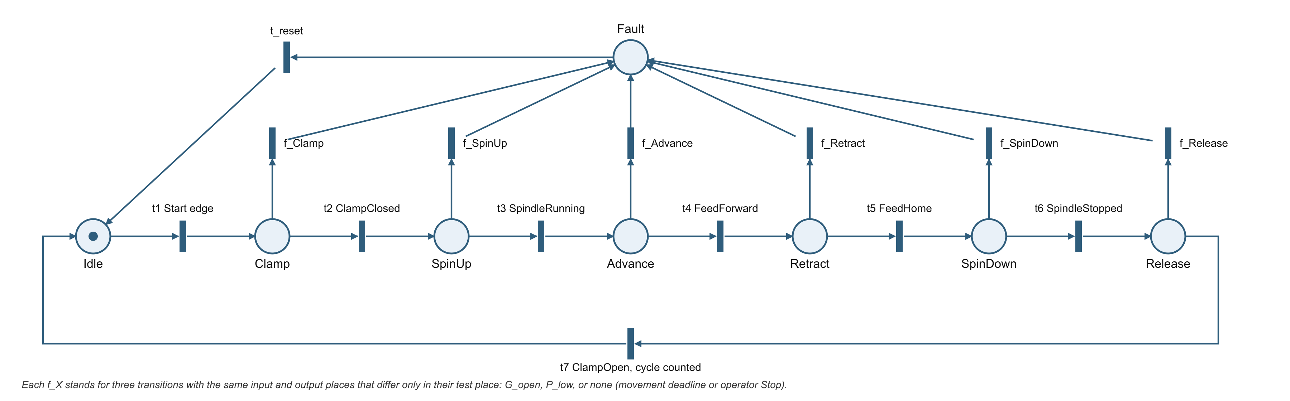
Figure 2. Controller component of the Petri net: the single token marks the active state; f_X are the fault transitions and t_reset the recovery transition.
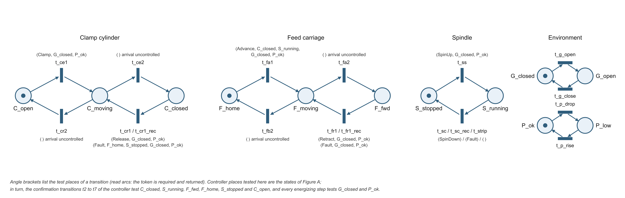
Figure 3. Plant and permissive components of the Petri net with the test places of each transition in angle brackets.
Component | Place | Meaning; a token means the condition holds
Controller | Idle | Waiting for a new Start edge; no motion output energized (initially marked)
Controller | Clamp | ClampExtend commanded; waiting for ClampClosed
Controller | SpinUp | SpindleEnable commanded; waiting for SpindleRunning
Controller | Advance | SpindleEnable and FeedExtend commanded; waiting for FeedForward
Controller | Retract | SpindleEnable and FeedRetract commanded; waiting for FeedHome
Controller | SpinDown | Spindle command removed; waiting for SpindleStopped
Controller | Release | ClampRetract commanded; waiting for ClampOpen
Controller | Fault | Latched fault or operator stop; FaultLamp energized; Reset required
Clamp cylinder | C_open, C_moving, C_closed | Rod at open end (initially marked), between end sensors, at closed end
Feed carriage | F_home, F_moving, F_fwd | Carriage at home (initially marked), between end sensors, at forward end
Spindle | S_stopped, S_running | Shaft stopped (initially marked) or run confirmation present
Guard | G_closed, G_open | Enclosure closed (initially marked) or open
Supply pressure | P_ok, P_low | Pressure above (initially marked) or below the permissive threshold

Table 1. Places of the Petri net and the initial marking M0.
Transition | Input → output place | Test places (read arcs) | Meaning
t1 t_start | Idle → Clamp | G_closed, P_ok, C_open, F_home, S_stopped | New Start edge accepted with every permissive true
t2 t_clamp_ok | Clamp → SpinUp | G_closed, P_ok, C_closed | Clamp closed confirmed
t3 t_spin_ok | SpinUp → Advance | G_closed, P_ok, S_running | Spindle run confirmed
t4 t_fwd_ok | Advance → Retract | G_closed, P_ok, F_fwd | Feed forward confirmed
t5 t_home_ok | Retract → SpinDown | G_closed, P_ok, F_home | Feed home confirmed
t6 t_stop_ok | SpinDown → Release | G_closed, P_ok, S_stopped | Spindle stop confirmed
t7 t_complete | Release → Idle | G_closed, P_ok, C_open | Clamp open confirmed; complete counter incremented
f_X_guard (6) | X → Fault | G_open | Guard opened while active state X is marked
f_X_press (6) | X → Fault | P_low | Pressure lost while active state X is marked
f_X_abort (6) | X → Fault | none | Movement deadline expired or operator Stop in state X
f_Advance_spin | Advance → Fault | S_stopped | Spindle run confirmation lost during feed
t_reset | Fault → Idle | G_closed, P_ok, C_open, F_home, S_stopped | Reset edge accepted with the plant at its reference position
t_ce1, t_ce2, t_cr2, t_cr1, t_cr1_rec | C_open → C_moving → C_closed and back | t_ce1: Clamp; t_cr1: Release; t_cr1_rec: Fault, F_home, S_stopped; each with G_closed, P_ok; arrivals untested | Extend, arrive closed, fall back open, retract on command, supervised recovery retract
t_fa1, t_fa2, t_fb2, t_fr1, t_fr1_rec | F_home → F_moving → F_fwd and back | t_fa1: Advance, C_closed, S_running; t_fr1: Retract; t_fr1_rec: Fault; each with G_closed, P_ok; arrivals untested | Advance, arrive forward, fall back home, retract on command, supervised recovery retract
t_ss, t_sc, t_sc_rec, t_strip | S_stopped ↔ S_running | t_ss: SpinUp, G_closed, P_ok; t_sc: SpinDown; t_sc_rec: Fault; t_strip: none | Start, coast to stop on command, coast to stop in Fault, drive trip
t_g_open, t_g_close, t_p_drop, t_p_rise | G_closed ↔ G_open, P_ok ↔ P_low | none | Environment changes that may occur at any time

Table 2. Transitions of the Petri net; X ranges over the six active states Clamp to Release.
Transitions are of four kinds. Controller transitions move the single controller token: t1 to t7 along the normal cycle, the fault family f_X from each active state to Fault, and t_reset from Fault to Idle. Commanded plant transitions start a movement and test the commanding controller place: t_ce1 starts clamp extension only while Clamp is marked, t_fa1 starts feed advance only while Advance is marked, and so on. Uncontrolled plant transitions complete a movement toward either end position, trip the spindle, or change the guard and the pressure; they have no controller precondition because the controller cannot forbid them. Supervised recovery transitions retract the feed and the clamp and let the spindle coast while Fault is marked.
Read arcs, drawn in Figure 3 as test places in angle brackets, connect the layers without consuming tokens [9]. Every energizing step tests G_closed and P_ok, so the priority of a fault over normal progression is structural: when a permissive is lost, the normal transition is disabled in the same marking in which the fault transition becomes enabled. Confirmation transitions test the plant place they wait for, and movement transitions test the controller place that commands them together with the plant conditions that must hold; t_fa1, for example, tests Advance, C_closed and S_running. The net is therefore a closed loop model of command, response and confirmation rather than a diagram of the program alone.
Three simplifications are declared. The Complete state is represented by the firing of t7, since it lasts one evaluation and only increments a counter. Timeouts and the operator Stop are represented by the untested abort transitions, which may fire at any time while a state is active; this is conservative because it admits every interleaving that a real timer could produce. Sensor faults are not modeled: places denote true mechanical conditions, and the stuck or contradictory sensor cases remain in the test matrix of Section 4.

3.2 Structural properties
The incidence matrix C has one row per place and one column per transition, with −1 for an input place, +1 for an output place and 0 for a test place. A place invariant is a weight vector x with x·C = 0; the weighted token count x·M is then constant in every reachable marking [5]. Six invariants were verified: the token sums over the eight controller places, over the three clamp places, the three feed places, the two spindle places, the two guard places and the two pressure places equal one each. Together they cover every place, so the net is structurally bounded, in fact 1-safe, and they state the mutual exclusions the program must preserve: exactly one state active and never two end positions of one actuator at once. A transition invariant is a firing count vector y with C·y = 0. The 17 firings of the nominal cycle (t1, t_ce1, t_ce2, t2, t_ss, t3, t_fa1, t_fa2, t4, t_fr1, t_fb2, t5, t_sc, t6, t_cr1, t_cr2, t7) form one, and firing them from M0 returns the net to M0. The cycle therefore exists as a repeatable behavior of the model, not merely as an intended sequence.

3.3 Reachability analysis
The reachability graph was generated by breadth first search with a Python script of about one hundred lines that uses only the standard library; the listing and its output are reproduced in the appendix of the companion thesis manuscript. Table 3 summarizes the results. The 124 reachable markings are far fewer than the 8 × 3 × 3 × 2 × 2 × 2 = 576 combinations that the invariants alone permit, because the controller excludes most of them: the feed is never away from home with the clamp open, and the spindle never runs with the clamp open. The six safety properties S1 to S6 were evaluated as predicates over all markings or all arcs and hold without exception. Property S4 is structural, since t_fa1 carries the corresponding read arcs; the others are behavioral consequences of the whole net and could not have been read off the state diagram.
Property | Method | Result
Reachability | Breadth first search from the initial marking M0 | 124 reachable markings, 587 arcs
Boundedness | Maximum token count over the reachable set | One token per place at most (1-safe)
Place invariants | x·C = 0 verified for six weight vectors; token sums over all markings | Controller, clamp, feed, spindle, guard and pressure place groups each hold exactly one token
Transition invariant | C·y = 0 for the firing vector of the nominal cycle | 17 firings return the net to M0; the cycle is executable from M0
Deadlock | Markings with no enabled transition | None
Dead transitions | Transitions that never occur in the graph | None of the 45
Reversibility, liveness | Reverse search from M0 over the graph | M0 is reachable from all 124 markings, so every fault is recoverable and the net is live
S1 | Feed away from home ⇒ clamp closed | Holds in every marking
S2 | Spindle running ⇒ clamp closed | Holds in every marking
S3 | Release marked ⇒ spindle stopped | Holds in every marking
S4 | Feed advance fires only with guard closed, pressure adequate, clamp closed and spindle running | Holds on every arc
S5 | SpinUp, Advance, Retract or SpinDown marked ⇒ clamp closed | Holds in every marking
S6 | Feed away from home ⇒ Advance, Retract or Fault marked | Holds in every marking
One step fault response | 66 markings with the guard open or pressure low while an active state is marked | A fault transition is enabled in all 66; no energizing step is enabled in any

Table 3. Results of the structural and reachability analysis of the net in Figures 2 and 3.
Two results concern fault handling. First, in each of the 66 markings in which the guard is open or the pressure is low while an active state is marked, a fault transition is enabled and no energizing transition is enabled; the controller can do nothing but fault, which is the intended one step response. Second, M0 is reachable from every reachable marking, so the net is reversible and therefore live: every fault, including one entered while a cylinder is between its end sensors, can be recovered by the supervised recovery transitions followed by t_reset. No dead markings and no dead transitions exist. The 32 reachable Fault markings enumerate the plant configurations that a recovery procedure must handle, which is a concrete input to the SafeRecoveryConfirmed predicate left open in the structured text.

3.4 State path and transition rules
The controller component of the net is a state machine: every controller transition has exactly one input and one output place, so a single token identifies the active state and the component can be executed by one CASE statement over an enumerated variable. Figure 4 and Table 4 present that component in the form a PLC programmer expects; the read arcs of Figure 3 reappear as the conditions in the third column.
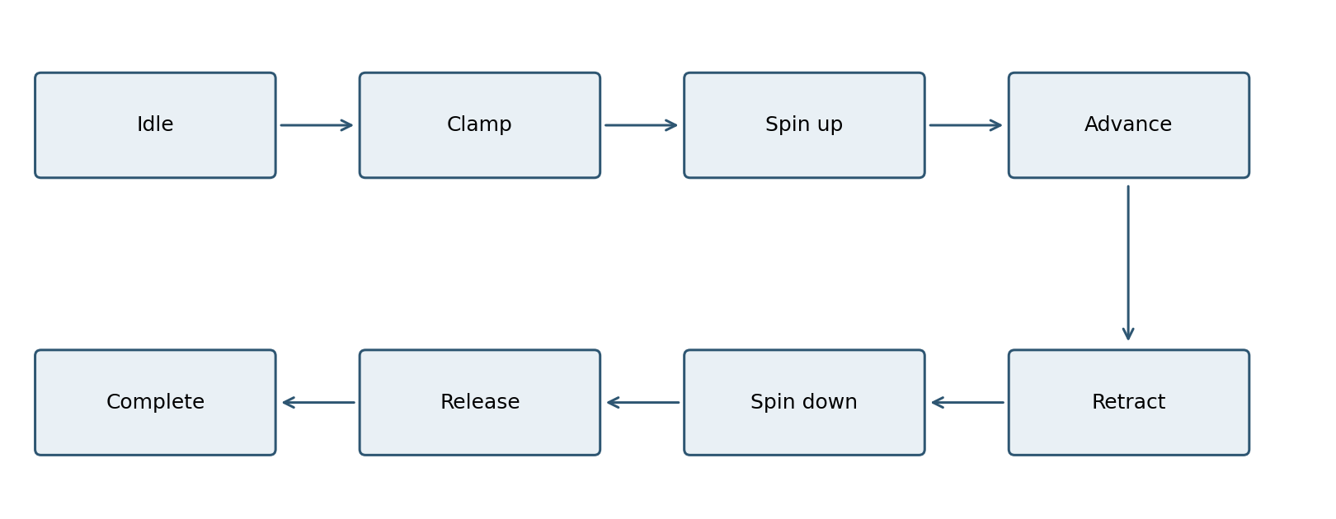
Figure 4. Nominal state order of the controller component. An active state can also enter Fault.
State | Command | Condition to advance
Idle | All motion outputs off | Fresh Start and all permissives true
Clamp | ClampExtend | ClampClosed accepted
SpinUp | SpindleEnable | SpindleRunning accepted
Advance | SpindleEnable and FeedExtend | FeedForward accepted
Retract | SpindleEnable and FeedRetract | FeedHome accepted
SpinDown | Spindle output off | SpindleStopped accepted
Release | ClampRetract | ClampOpen accepted
Complete | Increment complete counter once | Return to Idle

Table 4. Controller state contract for the proposed normal cycle.
Table 4 is the normal path contract. A state owns its command outputs; on every controller evaluation, outputs should be assigned from the selected state rather than allowed to retain stale values. A timeout or invalid global condition interrupts progress and selects Fault. The transition from Advance to Retract requires particular care: a feed end input and a pressure failure observed together should resolve to the fault path according to a stated priority rule.

3.5 Preconditions and invariants
A start is accepted only when the guard is closed, supply pressure is adequate, the feed is home, the clamp is open, the spindle is stopped and no fault is latched. Start is edge triggered, so a button held through completion cannot begin another cycle. The central software invariant is: FeedExtend implies GuardClosed, PressureOK, ClampClosed and SpindleRunning; it is the program level form of the read arcs on t_fa1 and of properties S1, S4 and S5 of Table 3. Another invariant is that the clamp cannot be released until a trustworthy spindle stopped condition has been observed. These are intended program properties, not claims that the actual mechanism has met a safety performance level.
Opposite end indications on the same actuator must also be interpreted consistently. Simultaneous ClampOpen and ClampClosed is treated as a sensor contradiction unless the final mechanism makes overlap physically possible. During movement, neither end indication may be true. A timeout then bounds the interval in which the controller waits for confirmation. Timer values cannot be selected from this paper alone: they require measured actuator and motor response times on the selected hardware.

3.6 Fault handling and recovery
Fault causes include pressure loss, guard opening, contradictory indications, loss of a required confirmation, and movement deadlines. A fault is latched even after the input that caused it returns to normal. Reset requires a new operator action and a verified recoverable plant condition. Restoring pressure or closing a guard should not resume feed motion automatically. A power restart should also avoid silently continuing an interrupted cycle.
Turning a PLC output off does not necessarily remove mechanical energy. A detented valve may retain a port state, stored air may move a cylinder, and a spindle may coast. OSHA identifies milling among hazardous cutting actions [3]. ISO 13849-1:2023 concerns the design of safety related control system parts [4]. A built machine would need a separate, machine specific safety analysis and validation of the complete protective function. The ordinary PLC sequence described in this paper is only one element of that eventual design.

4 Verification method
Verification begins with a traceable requirements list. Each input, output and transition is assigned a test identifier. A test harness sets an initial state, presents timed input events, records the chosen state and output snapshot, then compares the trace against expected behavior. Successful completion tests check the normal order and one count increment. Negative tests assert a missing confirmation, an open guard, a low pressure condition or contradictory sensors, then check that feed and spindle commands are inhibited as intended.
The reachability graph gives the verification a complete denominator. Its 124 markings and 587 arcs enumerate every combination of state, plant condition and permissive that the model admits, so transition coverage can be defined as the fraction of controller arcs exercised by executed tests rather than as an informal checklist. The six place invariants translate directly into trace assertions (exactly one state active, never both end indications of one actuator), and the six safety properties translate into negative tests whose expected outcome is already known from the model. A test that passes on the PLC therefore confirms that the implementation agrees with an analyzed model, while a failing test localizes either an implementation defect or a modeling assumption that the hardware does not satisfy.
Examples of boundary tests include sensor arrival immediately before and after a deadline, Stop pressed in the same scan as FeedForward, and Start held through a controller restart. This matters because an apparently correct nominal cycle can leave priority and reset defects undiscovered. Transition coverage should include every normal edge and each specified state to Fault edge. A formal record should distinguish a case that has been designed from a case actually executed and passed on a PLC simulator or physical controller.
When hardware exists, commissioning should first verify wiring and input polarity with motive power isolated. Dry cycles should be logged without a cutting operation. The record needs program version, parameter settings, event timestamps and observed output responses. The installed guard, electrical isolation, spindle stopping and pneumatic energy release must be evaluated under a documented safety procedure. No such physical commissioning result is reported in this paper.

5 Discussion and limitations
A finite state machine improves the clarity of sequencing because each command has a local context and each exceptional condition can have a defined reaction. It does not resolve mechanical uncertainties. An end switch may activate with no workpiece present, and a short pneumatic feed may vary in speed as supply pressure or load changes. The proposed design has no measured spindle stopping time, tool force, part quality or certified safety architecture. These gaps constrain what a software simulation could prove.
The Petri net analysis has limits of its own. It is untimed, so it establishes which markings are possible but not how long a hazardous intermediate marking persists; the one evaluation step between a lost permissive and the fault transition must be bounded by measured scan, output and valve delays. Read arcs on the permissive places encode the intended priority of faults over normal progression, and the structured text must implement that priority explicitly or the guarantee is lost. Places represent true mechanical states, so sensor faults such as a stuck or contradictory switch are covered by the test matrix rather than by the net. Finally, the interleaving semantics assumes that at most one transition fires at a time, which is a conservative abstraction of a scanning controller that evaluates its whole program between two input samples.
The next development stage should select a PLC and actuator components, define the physical layout and risk assessment, and implement the state rules in an actual vendor project. A scan level test harness can then verify logical invariants, followed by safely executed dry tests. Only after the physical system is characterized should a cutting study estimate dimensional accuracy or productive capacity.

6 Conclusion
The paper provides a reviewable control specification for a PLC governed pneumatic milling training cell. Its main outputs are an architecture, a Petri net of the controller and plant whose 124 reachable markings were analyzed mechanically, six verified place invariants and six verified safety properties, the state contract derived from the net, software invariants and a fault oriented test plan. They support implementation and verification but do not constitute a tested physical milling machine. The timed interpretation of the same net, its simulation and the cost study are presented separately in the second preliminary paper.

References
[1] International Electrotechnical Commission, IEC 61131-3:2025, Programmable controllers, Part 3: Programming languages. https://webstore.iec.ch/en/publication/68533
[2] Festo, Standards based cylinders DNC, ISO 15552, technical documentation. https://www.festo.com/media/catalog/202856_documentation.pdf
[3] Occupational Safety and Health Administration, Machine Guarding eTool. https://www.osha.gov/etools/machine-guarding
[4] International Organization for Standardization, ISO 13849-1:2023, Safety of machinery, Safety related parts of control systems, Part 1. https://www.iso.org/standard/73481.html
[5] T. Murata, "Petri nets: Properties, analysis and applications," Proceedings of the IEEE, vol. 77, no. 4, pp. 541–580, 1989. https://doi.org/10.1109/5.24143
[6] R. Zurawski and M. Zhou, "Petri nets and industrial applications: A tutorial," IEEE Transactions on Industrial Electronics, vol. 41, no. 6, pp. 567–583, 1994.
[7] International Electrotechnical Commission, IEC 60848:2013, GRAFCET specification language for sequential function charts.
[8] M. Uzam and A. H. Jones, "Discrete event control system design using automation Petri nets and their ladder diagram implementation," International Journal of Advanced Manufacturing Technology, vol. 14, no. 10, pp. 716–728, 1998. https://doi.org/10.1007/BF01438224
[9] R. David and H. Alla, Discrete, Continuous, and Hybrid Petri Nets, 2nd ed. Berlin: Springer, 2010. https://doi.org/10.1007/978-3-642-10669-9

