Timed Petri Net Simulation and Economic Sensitivity Analysis of a PLC Controlled Pneumatic Milling Model
Preliminary paper 2 | Stochastic timed Petri net experiment, analytic check and cost scenario
Author: [Student name] | Department: [Department] | Institution: [University]

Abstract
This paper examines a proposed PLC controlled pneumatic milling training model using a reproducible Monte Carlo execution of a stochastic timed Petri net and an illustrative economic calculation. The net is the timed interpretation of the controller model given in the companion paper: one attempt is a token passing through seven timed transitions (clamp, spindle confirmation, approach, feed advance, feed return, spindle stop and clamp release) with normally distributed firing delays, three of which are scaled by the pressure drawn for the attempt, and through immediate transitions that classify rejected attempts. A fixed random seed generates 300 attempts in each of three scenarios: nominal pressure, wider pressure variation and scheduled fault injection. Nominal trials all completed, with a mean simulated cycle of 10.271 s and a sample standard deviation of 0.509 s; the analytic expectation derived from the same net is 10.267 s with a standard deviation of 0.507 s, which confirms the implementation. The pressure variation scenario completed 279 attempts against an expectation of 283.6, and the injected fault scenario completed 275. These statistics are generated outcomes of declared assumptions and are not measurements from hardware. At hypothetical utilization and cost inputs, a narrow simple payback is 1.85 years, but the conclusion depends strongly on an unverified labor saving. The study demonstrates a transparent analysis method while identifying the measurements needed before physical or investment claims are possible.
Keywords: stochastic timed Petri net; discrete event simulation; pneumatic system; PLC; cycle time; sensitivity analysis; economic efficiency.

1 Introduction
A numerical experiment can help organize what needs to be measured when a proposed machine has not yet been built. The milling model specified in the companion control design paper consists of pneumatic clamping and guided feed, plus an independently powered spindle. The PLC controls their order using sensor confirmation. Its conceptual normal path is clamp, spindle startup, approach, feed, return, spindle stop and release. This paper asks how a simple model of pressure and segment timing changes completed cycle time and rejected attempts.
The controller is treated as the Petri net specified in the companion control design paper, whose eventual program could use the languages specified by IEC 61131-3 [3]. That paper analyzes the untimed net: which markings are reachable and which safety properties hold in all of them. The present paper gives the nominal cycle of that net a timed interpretation. Each transition of the cycle receives a random firing delay, so the model becomes a stochastic timed Petri net in the tradition of Molloy and of the generalized stochastic Petri nets of Ajmone Marsan and colleagues, except that the delays are normal rather than exponential and are therefore evaluated by Monte Carlo execution instead of by a Markov chain [4], [5], [6]. The numerical experiment represents the plant timing and attempt classification; it is not a scan by scan execution of a compiled PLC program. This boundary matters when interpreting fault results.
The second question is economic. A faster sequence may reduce operator handling, but a nominal cycle time alone does not show that labor can be redeployed or that capital is justified. Accordingly, the economic section expresses annual net benefit as a function of assumed cycle rate, annual hours, seconds of genuine labor time saved, labor value and incremental electricity. All cost inputs are hypothetical. The method makes an investment threshold visible without presenting a procurement recommendation.

2 Numerical model and data generation

2.1 Timed Petri net of one attempt
Figure 1 shows the timed Petri net executed by the simulator. One attempt is one token that leaves the place Ready, passes through the seven timed transitions T1 to T7 and returns to Ready through the immediate transition i_count, which records a completed cycle. The firing delays are independent normal draws with the means and standard deviations of Table 1: 1.10, 1.35, 1.75, 2.90, 1.45, 0.90 and 0.80 s for clamp travel, spindle confirmation, approach, feed advance, feed return, spindle stop and clamp release. Their nominal means sum to 10.25 s. T3 and T4 together occupy the controller state Advance of the companion paper, so the seven timed transitions refine the six active controller states rather than replacing them. Each delay has a lower bound of 0.15 s. These timings are chosen to illustrate a model and have not been obtained from a real machine.
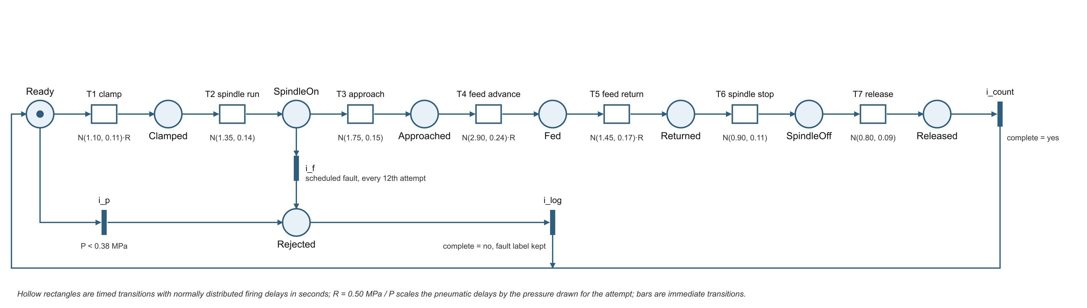
Figure 1. Stochastic timed Petri net of one simulated attempt; the immediate transitions i_p and i_f classify rejected attempts.
Transition | Segment | Controller state (companion paper) | Mean s | SD s | Scaled by R
T1 | Clamp travel | Clamp | 1.10 | 0.11 | yes
T2 | Spindle run confirmation | SpinUp | 1.35 | 0.14 | no
T3 | Approach | Advance | 1.75 | 0.15 | no
T4 | Feed advance | Advance | 2.90 | 0.24 | yes
T5 | Feed return | Retract | 1.45 | 0.17 | yes
T6 | Spindle stop confirmation | SpinDown | 0.90 | 0.11 | no
T7 | Clamp release | Release | 0.80 | 0.09 | no

Table 1. Timed transitions of the attempt net; delays are normal draws in seconds, truncated below at 0.15 s.
Gauge pressure is sampled around 0.50 MPa. Nominal pressure standard deviation is 0.028 MPa; in the variation case it increases to 0.075 MPa. A lower bound of 0.28 MPa prevents negative or implausibly small simulation inputs. The delays of T1, T4 and T5 (clamp travel, feed advance and feed return) are multiplied by R, the ratio of the nominal 0.50 MPa to the drawn pressure. This inverse relationship is a simplifying assumption, not a validated pneumatic equation. Real movement depends on valve flow, tubing, load, cushion settings and dynamic pressure.

2.2 Scenario and rejection rules
Scenario | Pressure spread MPa | Attempts | Scheduled injection
Nominal | 0.028 | 300 | None
Pressure variation | 0.075 | 300 | None
Injected faults | 0.028 | 300 | Every twelfth attempt

Table 2. Inputs to the three simulation scenarios.
Rejections are the immediate transitions of Figure 1. The transition i_p fires when the sampled pressure is below the illustrative 0.38 MPa threshold and classifies the attempt as a pressure fault. In the third scenario i_f fires on every twelfth attempt after spindle confirmation and assigns one of four rotating labels: guard open, clamp switch stuck, feed timeout or low pressure. A rejected attempt receives an arbitrary early elapsed value, the sum of the first two delays plus 0.35 s, and is excluded from completed cycle statistics. The model does not resolve time dependent fault reaction, spindle coast or cylinder stopping distance. There are 900 attempts in total, generated with the fixed seed 20260916.
A complete record contains scenario, trial number, pressure in bar, elapsed seconds, completion status, fault label, clamp duration and feed duration. The summary mean is calculated from complete cycles only, while completion and fault counts include all attempts. Excluding interrupted attempts from productive cycle time prevents a short failure from appearing as a fast completed part. It also creates selection: a scenario with more rejected low pressure draws can have an apparently similar successful cycle mean. Both outcomes must therefore be read together.

2.3 Analytic expectation from the timed net
Because the attempt net is a chain, the completed cycle time is the sum of seven independent delays, three of which share the common factor R. The expected cycle is therefore E[R](1.10 + 2.90 + 1.45) + (1.35 + 1.75 + 0.90 + 0.80) seconds, and the variance follows from E[R] and E[R²] together with the segment variances. Both moments were obtained by numerical integration of the pressure distribution restricted to the completed region P ≥ 0.38 MPa, since only completed attempts enter the statistics. For the nominal spread E[R] = 1.0032, giving an expected completed cycle of 10.267 s with a standard deviation of 0.507 s. For the wider spread the conditioning removes the slow low pressure attempts, E[R] = 0.9997, the expected completed mean is 10.248 s with a standard deviation of 0.819 s, and the expected number of rejections is 300 × Φ((0.38 − 0.50)/0.075) = 16.4. These values are properties of the declared net, not of a machine; they serve in Section 3 as an independent check of the simulation code.

3 Simulation results
Scenario | Complete / 300 | Mean s | SD s | 95th pct s
Nominal | 300 | 10.271 | 0.509 | 11.158
Pressure variation | 279 | 10.248 | 0.806 | 11.678
Injected faults | 275 | 10.271 | 0.545 | 11.189

Table 3. Statistics for completed simulated cycles; faults remain in attempt counts.
Table 3 reports values from the seeded model, rounded for display. The nominal 95% Student t interval for its simulated mean is 10.213–10.329 s. The corresponding intervals are 10.153–10.343 s for the pressure variation case and 10.206–10.336 s for the injected fault case. These intervals describe sampling variability under the chosen generator; they do not include uncertainty about whether its timing distributions reflect a physical machine.
Table 4 compares the simulated statistics with the analytic expectations of Section 2.3. The nominal simulated mean differs from its expectation by 0.004 s, less than one standard error of 0.029 s, and the standard deviations agree to within 0.002 s. For the pressure variation scenario the simulated completed mean equals the conditional expectation to three decimals, while 21 rejections were observed against an expectation of 16.4 with a binomial standard deviation of 3.9. The injected fault scenario shares the nominal pressure spread, so its completed cycles have the nominal expectation; its larger sample standard deviation of 0.545 s reflects the 275 completed draws. The agreement verifies that the simulation executes the declared timed net correctly; it says nothing about whether the net resembles a physical machine.
Scenario | Expected mean s | Simulated mean s | Expected SD s | Simulated SD s | Expected rejections | Observed rejections
Nominal | 10.267 | 10.271 | 0.507 | 0.509 | 0.0 | 0
Pressure variation | 10.248 | 10.248 | 0.819 | 0.806 | 16.4 | 21
Injected faults | 10.267 | 10.271 | 0.507 | 0.545 | 25 scheduled | 25

Table 4. Analytic expectation of the timed net against the seeded simulation.
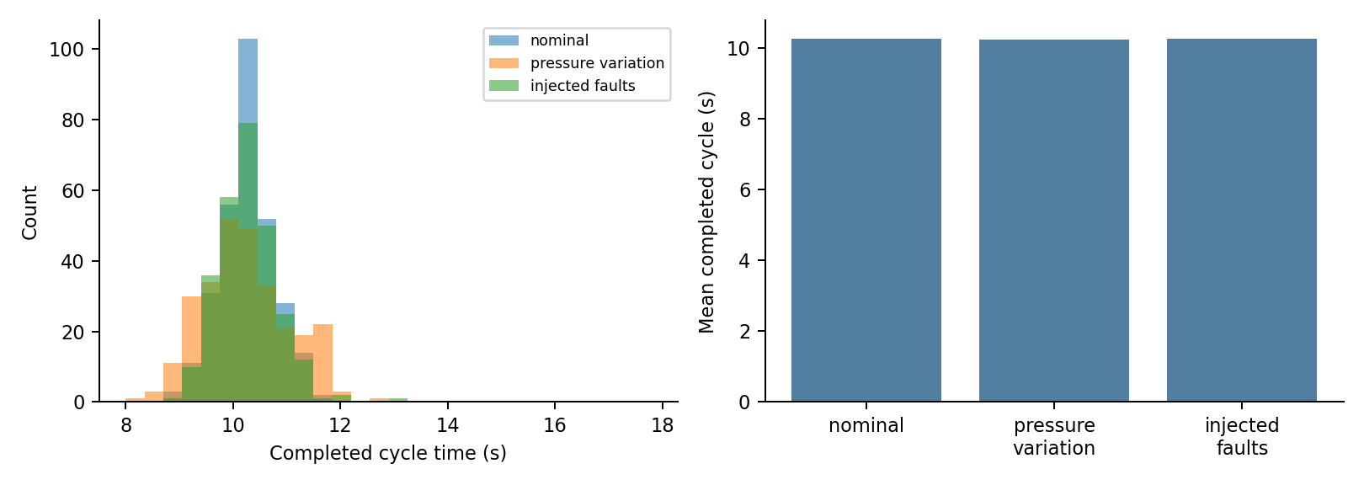
Figure 2. Completed cycle time distributions and means generated by the model.
The wider pressure case has a completed cycle standard deviation about 1.58 times the nominal value and 21 rejected attempts. Its successful mean remains close to nominal because a low pressure attempt below threshold is removed from the completed set. The injected fault case records 25 rejections and 275 completions. The injected failures are scheduled test stimuli, not an estimate of naturally occurring failure frequency. No statistical comparison here establishes a real world performance difference.
The model cannot report the number of acceptable machined parts because it contains no cutter geometry, material response, part dimensions or quality measurement. Its reciprocal mean of about 350 nominal model cycles per hour omits loading, unloading, fault recovery, inspection and pauses. This is an idealized sequence rate, the maximum firing frequency of the cycle of the net when the token never waits for an operator, not demonstrated shop throughput. The primary result is the traceable relationship between assumptions, trial outcomes and displayed statistics.

4 Economic sensitivity analysis

4.1 Base case formula
Let N be annual productive cycles, t be genuine labor seconds saved per cycle, w be labor value per hour, e be incremental electricity in kWh per cycle, c be price per kWh and K be initial investment. Narrow annual net benefit is B = N(tw/3600 − ec). Simple payback is K/B only when B is positive. The calculation excludes maintenance, taxes, financing, quality effects, safety engineering and discounted cash flow. It also assumes that saved seconds translate into economic value.
Assumption | Illustrative value | Status
Investment K | USD 2,950 | Concept budget, not a quotation
Annual use | 150 cycles/h × 800 h | Not observed
Labor time saved t | 2.0 s per cycle | No manual baseline trial
Labor value w | USD 24/h | Assumed
Incremental energy e | 0.0002 kWh/cycle | Not compressor measured
Electricity c | USD 0.18/kWh | Assumed

Table 5. Illustrative economic inputs; none is a measured project value.
At 120,000 illustrative productive cycles annually, the assumed saved time equals 66.7 labor hours, valued at USD 1,600. Incremental energy is 24 kWh annually, valued at USD 4.32. The narrow net amount is USD 1,595.68, giving a simple payback of about 1.85 years. These arithmetic outputs should not be interpreted as evidence that a real installation would recover its cost. Neither the operator time saving nor the marginal compressor electricity has been measured.

4.2 Sensitivity and break even
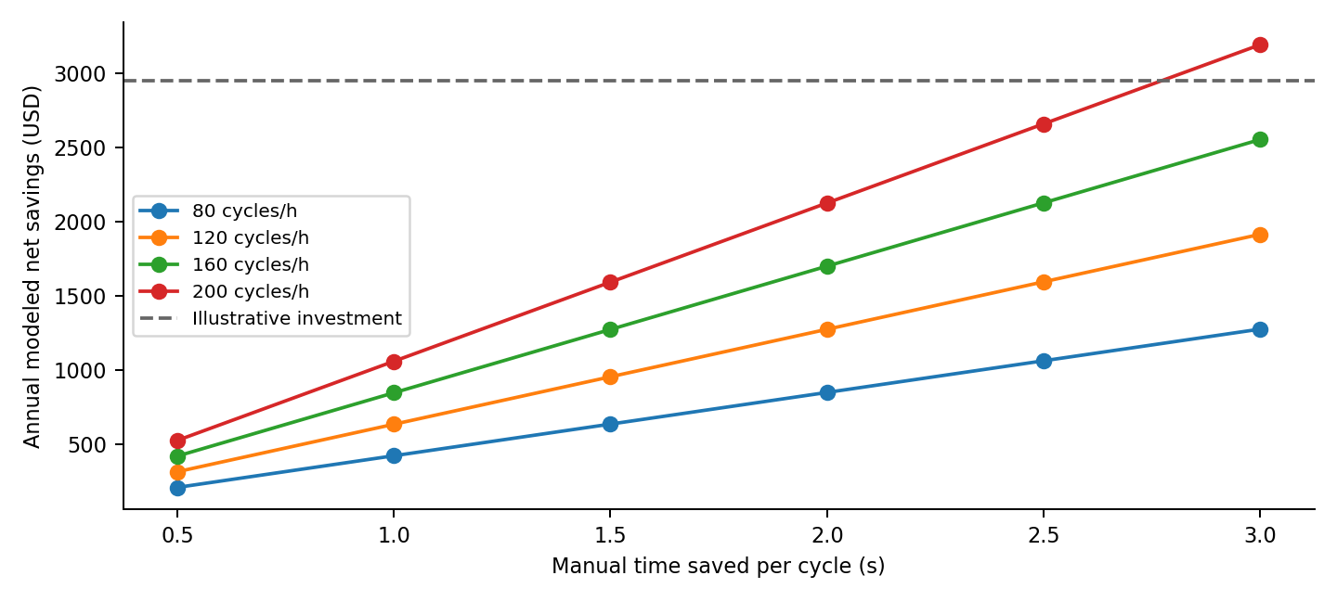
Figure 3. Modeled annual net benefit at varying time saved and cycle rates.
Figure 3 holds annual operating time at 800 h and other assumptions fixed while varying cycle rate and seconds saved. The net benefit is nearly linear in each of those variables under this simple equation. The line at USD 2,950 identifies the investment amount, not an annual cost. Crossing it corresponds to a simple payback below one year under the narrow assumptions. Some combinations in the graph may be impractical because operator loading, guard closure or quality inspection could cap actual production.
For a two year simple payback target, the required time saving is t = (3600/w)[K/(2N) + ec]. At the base case inputs it is approximately 1.85 seconds per cycle. The hypothetical two seconds is only slightly above that threshold, even before maintenance and other excluded costs are included. An actual time study is therefore more important to the investment conclusion than numerical precision in the simulated cycle mean. A complete business case would also measure availability and cost per good part.

5 Limitations and required physical study
Pressure is treated as one value for an attempt; pressure transients in the cylinder chambers are not modeled. Movement times are drawn independently, despite possible correlations from shared supply and temperature. The attempt model classifies faults, but it does not execute actual PLC scan logic or verify the behavior of electrical outputs. It cannot certify guards or demonstrate workholding force. Vendor cylinder guidance can support component calculations, but the selected geometry and operating conditions still need validation [1,2].
The timed net is a chain: it executes the nominal transition invariant of the controller net and represents faults as immediate exits rather than as the concurrent guard, pressure and spindle transitions analyzed in the companion paper. It therefore cannot estimate how long a hazardous intermediate marking persists or how long recovery from a fault takes. A generalized stochastic Petri net of the complete controller and plant model, with timed plant transitions and immediate controller transitions, would allow those quantities to be computed [5], but its delay distributions would first have to be measured on the selected hardware. Sampling pressure once per attempt also makes the three scaled delays perfectly correlated within an attempt and independent between attempts, which is a modeling choice rather than an observed property.
A future physical protocol should record pressure near actuators, PLC command edges, sensor arrival edges, spindle stop behavior, operator handling time and compressor power. It should compare observed cycles with a defined manual or existing automated baseline and retain all rejected attempts. If material removal is introduced, the study also needs tool, material, feed, depth of cut, dimensional inspection, reject rate and protective design. No such measurements are represented by the simulated charts in this paper.

6 Conclusion
The stochastic timed Petri net produces a repeatable illustration of timing variation and fault accounting for the proposed training model, and its analytic expectation confirms that the simulation executes the declared net. Its pressure variation case broadens completed cycle times and increases rejections under declared assumptions. The illustrative economics make the payback highly dependent on genuine labor time saved. The model and calculations are suitable for planning measurements and discussing control design, while physical and financial claims remain open until actual apparatus and operating data are supplied.

References
[1] Festo, Air consumption of cylinders, calculation guidance. https://www.festo.com/ie/en/s/air-consumption
[2] Festo, Standards based cylinders DNC, ISO 15552, technical documentation. https://www.festo.com/media/catalog/202856_documentation.pdf
[3] International Electrotechnical Commission, IEC 61131-3:2025, Programmable controllers, Part 3. https://webstore.iec.ch/en/publication/68533
[4] M. K. Molloy, "Performance analysis using stochastic Petri nets," IEEE Transactions on Computers, vol. C-31, no. 9, pp. 913–917, 1982. https://doi.org/10.1109/TC.1982.1676110
[5] M. Ajmone Marsan, G. Balbo, G. Conte, S. Donatelli and G. Franceschinis, Modelling with Generalized Stochastic Petri Nets. Chichester: Wiley, 1995.
[6] R. David and H. Alla, Discrete, Continuous, and Hybrid Petri Nets, 2nd ed. Berlin: Springer, 2010. https://doi.org/10.1007/978-3-642-10669-9
[7] T. Murata, "Petri nets: Properties, analysis and applications," Proceedings of the IEEE, vol. 77, no. 4, pp. 541–580, 1989. https://doi.org/10.1109/5.24143

