**Web Service Automation Solution User Guide**

The automation solution is placed inside the “APIAutomator” folder for AIG project:

AIG - \\AIG\APIAutomator\

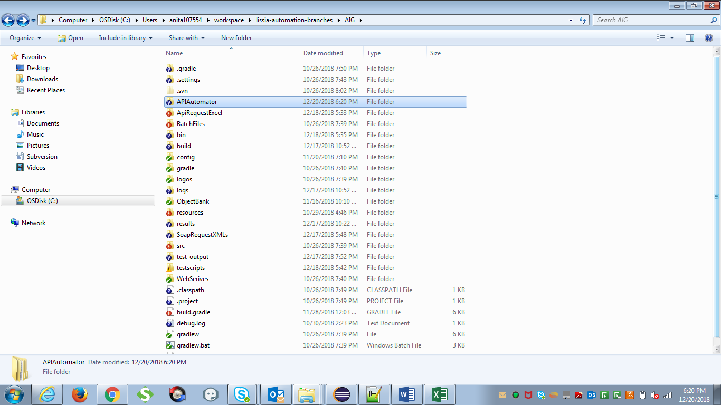

**Prerequisite**:

**End User should have Soap UI installed in the system.**

Follow the below steps to execute the required web service automation solution:

1. Firstly, user needs to set the Soap UI location until the bin folder -

C:\Program Files (x86)\SmartBear\SoapUI-X.X.X\bin

Or

C:\Program Files\SmartBear\SoapUI-X.X.X\bin

This is a onetime activity which is required to set the path for the tool. In order to set the path the user needs to navigate inside the web service folder which is to be executed and click on “userVariablePathSet.exe”. Enter the path and click OK button.

For e.g.: If the user has to execute the “GoLive” Service, then he needs to navigate to location “\\AIG\APIAuotmator\GoLive\”

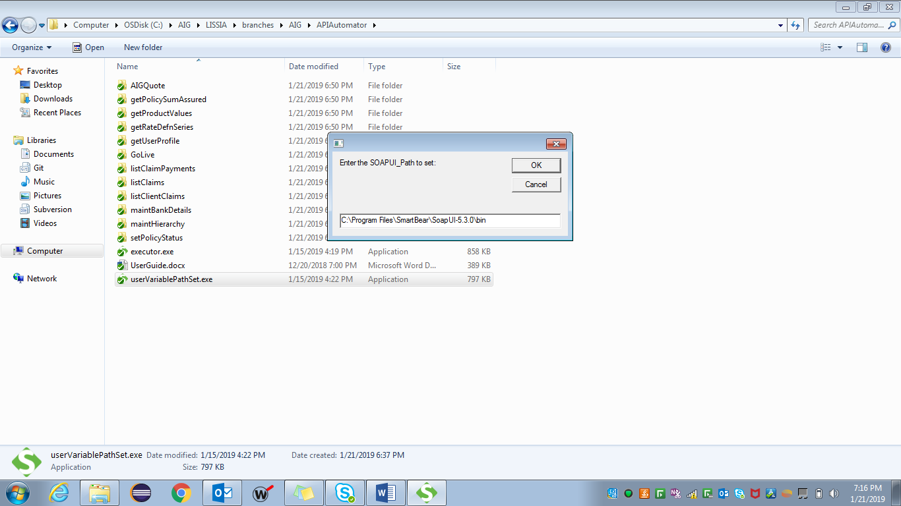

Clear the contents of Request and Response folders inside the web service solution.

1. After this the user needs to open the Web Service’s excel file inside the solution and input data on “Runner” sheet which has list of all the unique test cases. User needs to feed in “n” as input under the “Execute” column for the test cases which are to be skipped from execution. Then add data on all the import sheets starting with “Req”.

For e.g.: If the user has to execute the GoLive Service, then he needs to navigate to the location “\\AIG\APIAuotmator\GoLive\” and open “GoLive_v1.0.xlsx” file to add the input data.

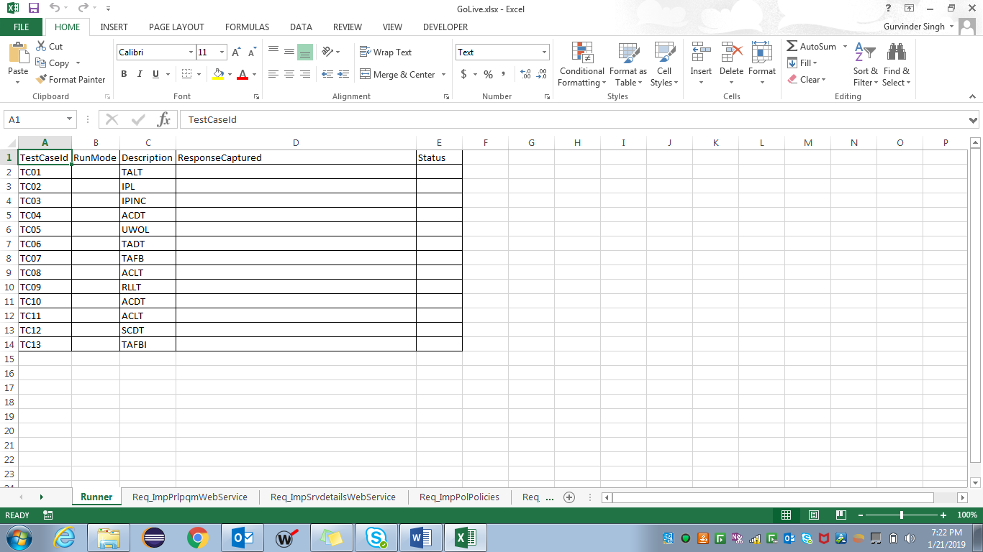

1. After adding all the input details into the test data template, the user needs to save and close the template file.

Next, executor file need to be run in order to start the execution.

Executor file is placed under \\APIAutomator folder.

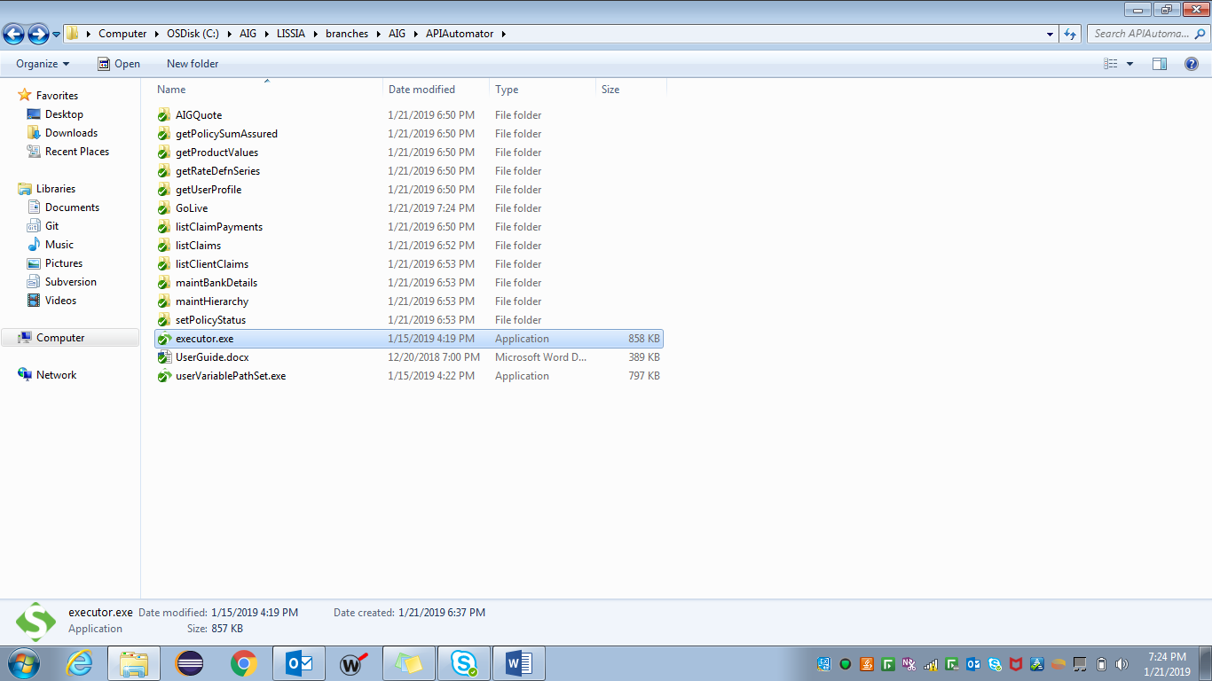

This will bring a pop up asking for input from the user to select the web service which needs to be executed.

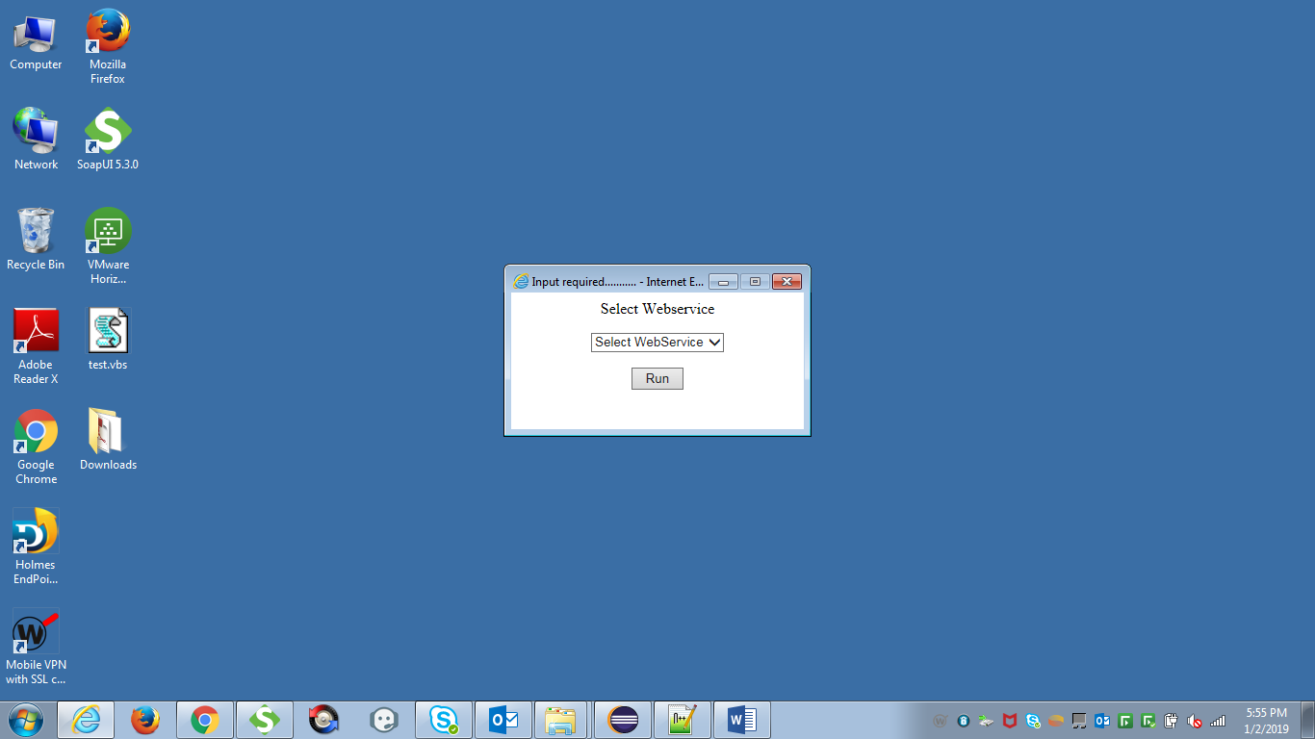 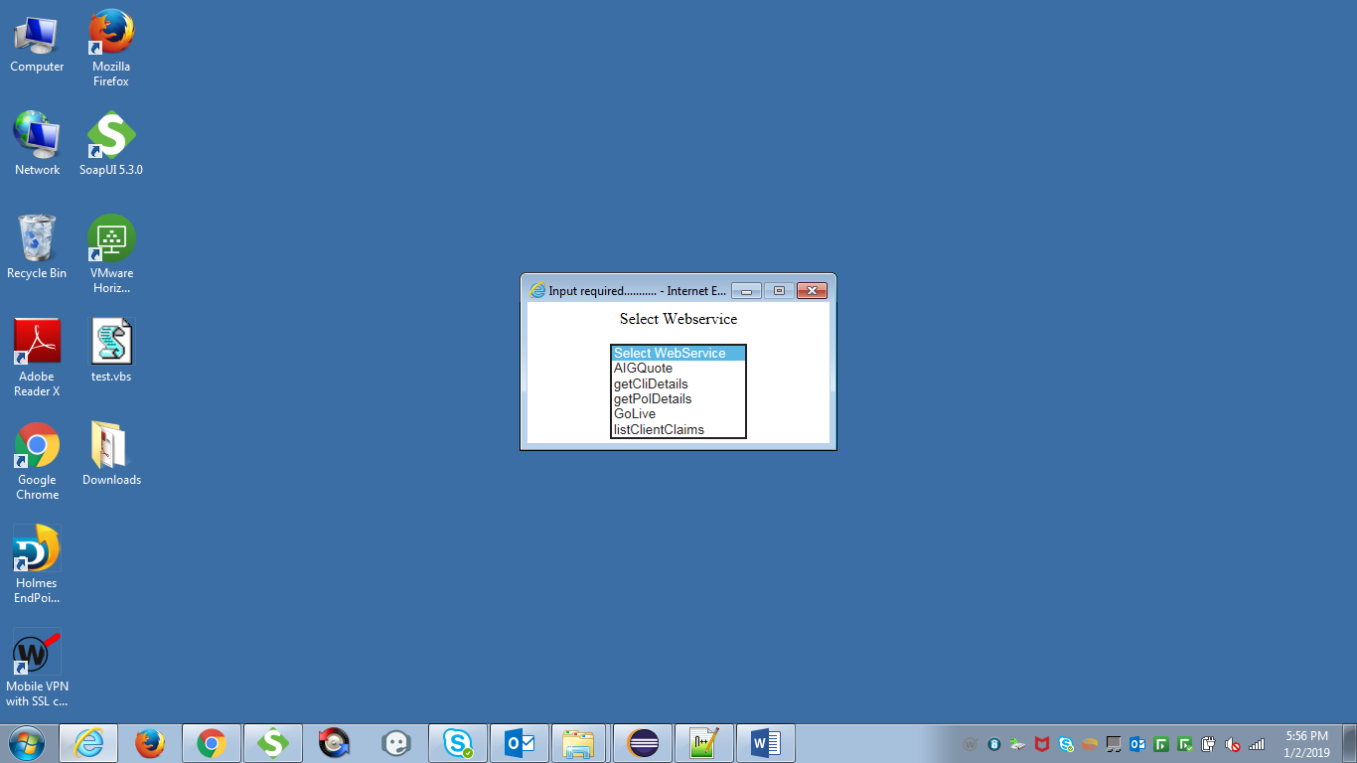

User needs to select the web service from the drop down list and click on Run button.

A progress bar is displayed showing the stage of the execution.

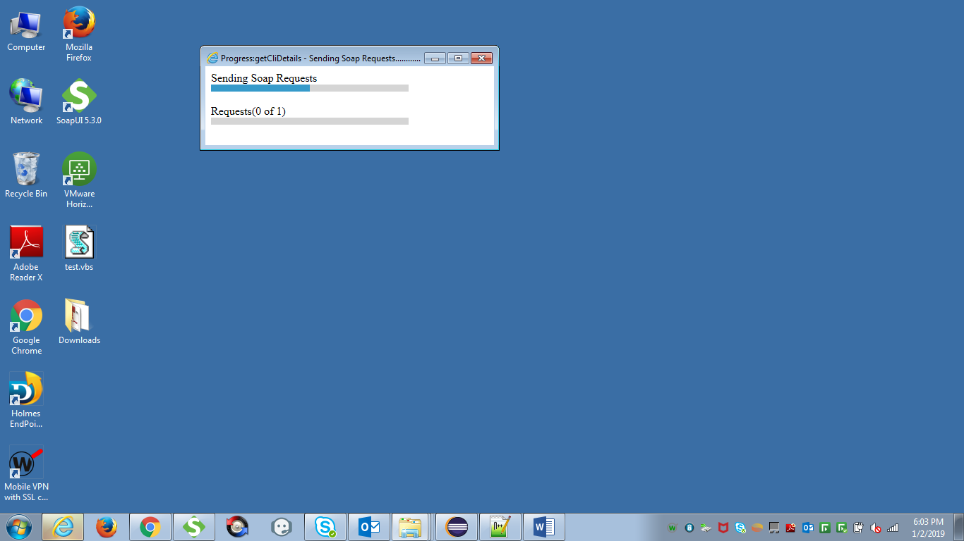

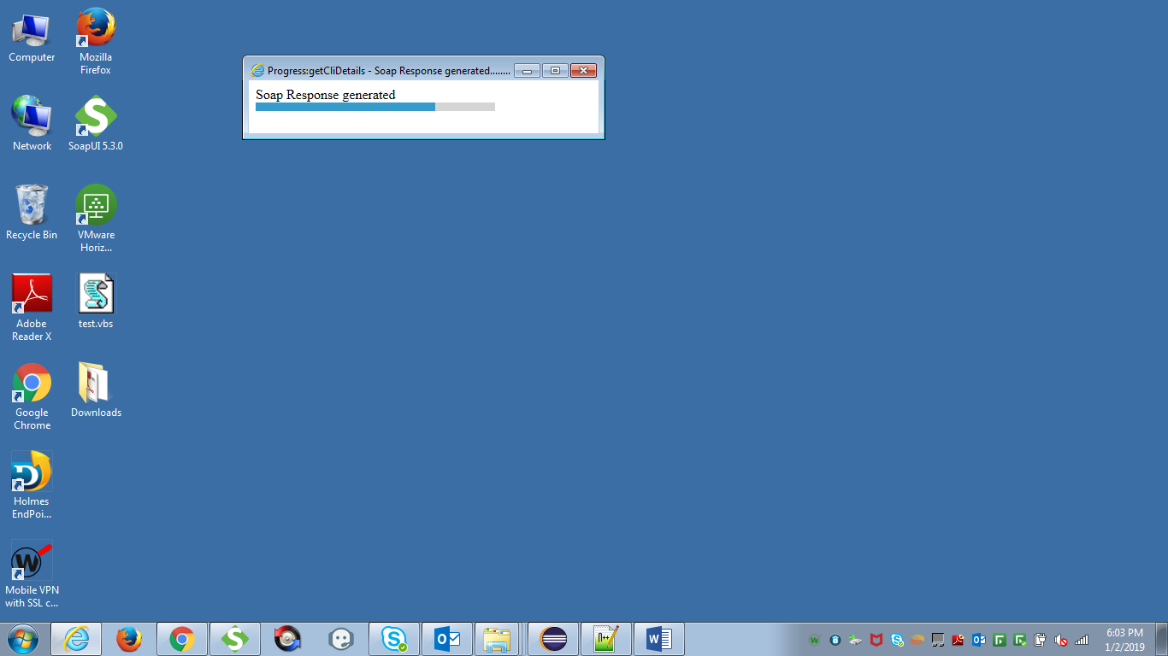

When the response has been generated and captured successfully, then the progress bar is stopped displaying.

This will generate the request XMLs under “Request” folder, response XMLs under the “Response” folder and capture the response to the same input test data template in the Export sheets.