1. Console "Hello Word" in document.ready function
Ans.

<!DOCTYPE html>
<html>
<head>
<link rel="stylesheet" href="style.css">
<script src="https://code.jquery.com/jquery-3.3.1.min.js"></script>
</head>
<body>
<script>
$(document).ready(function(){
console.log("Hello World");
});
</script>
</body>
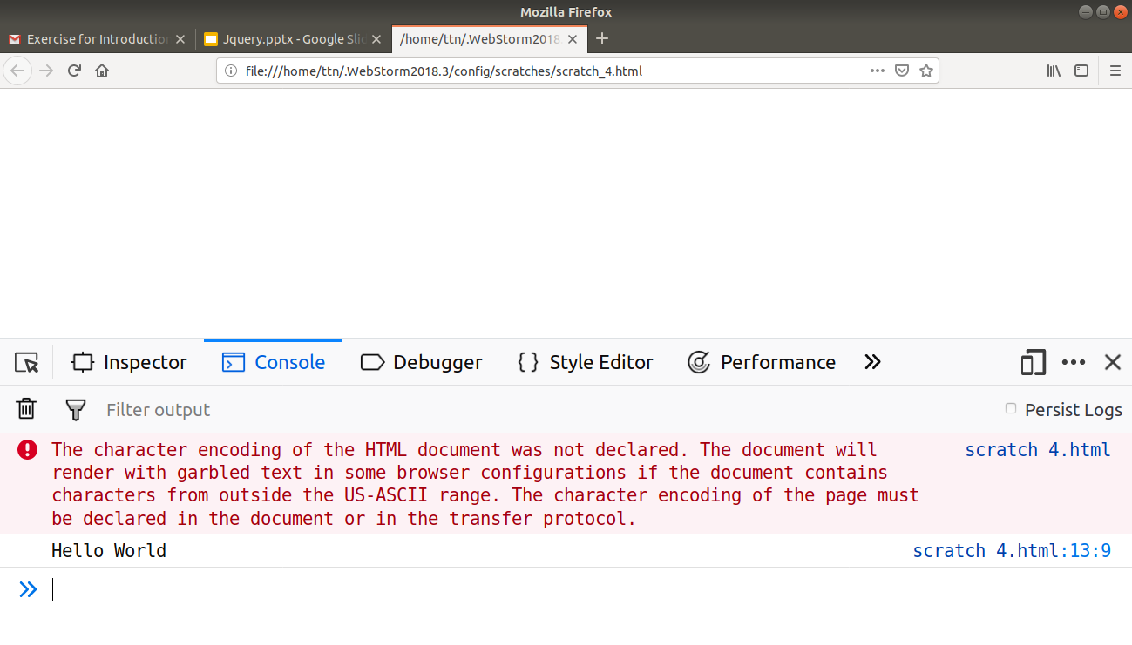
</html>

2. Select a ID name "#test" and add class "load" when DOM is loaded
Ans.
<!DOCTYPE html>
<html>
<head>
<link rel="stylesheet" href="style.css">
<script src="https://code.jquery.com/jquery-3.3.1.min.js"></script>
</head>
<body>
<script>
$(document).ready(function(){
var ele = $("<p>Load class</p>", {class:"load"});
$("#test").append(ele);
});
</script>
<p id="test">
This is test id
</p>
</body>
</html>
Output:

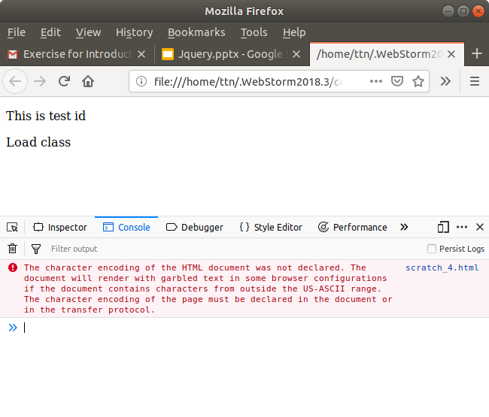

3. Change the color of element which class name end with "-new"
Ans.

<!DOCTYPE html>
<html>
<head>
<link rel="stylesheet" href="style.css">
<script src="https://code.jquery.com/jquery-3.3.1.min.js"></script>
</head>
<body>
<script>
$(document).ready(function(){
$("[id$='-new']").css("color", "red");
});
</script>
<div id="abc-new">
This is test id
</div>
</body>
</html>
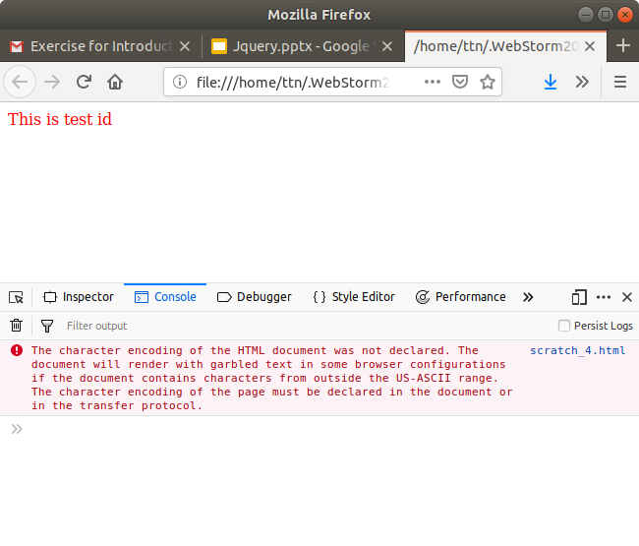

4. Disable submit button using jquery attr method
Ans.
<!DOCTYPE html>
<html>
<head>
<script src="https://code.jquery.com/jquery-3.3.1.min.js"></script>
</head>
<body>
<script>
$(document).ready(function(){
$("#b1").attr("disabled", "true");
});
</script>
<div id="main">
<input type="button" id="b1" value="Submit">
</div>
</body>
</html>

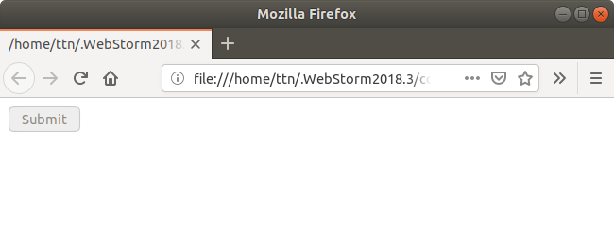

5. Change the font size of ".target" which has parent element with id name "#main"
Ans.
<!DOCTYPE html>
<html>
<head>
<script src="https://code.jquery.com/jquery-3.3.1.min.js"></script>
</head>
<body>
<script>

$(document).ready(function(){
$("#main").children(".target").css("font-size", "30px")
});
</script>
<div id="main">
This is parent element
<div class="target">
This is target element
</div>
</div>
</body>
</html>
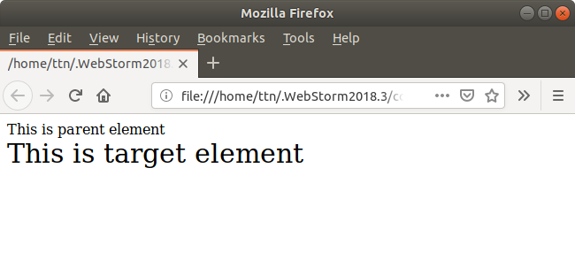
6. After page load change the HTML of div element with "p" element
Ans.
<!DOCTYPE html>
<html>
<head>
<link rel="stylesheet" href="style.css">
<script src="https://code.jquery.com/jquery-3.3.1.min.js"></script>
</head>
<body>
<script>
$(document).ready(function(){
var ele = $("<p>this is p element</p>");
$("#test").replaceWith(ele);
});
</script>
<div id="test">
This is test id
</div>
</body>
</html>

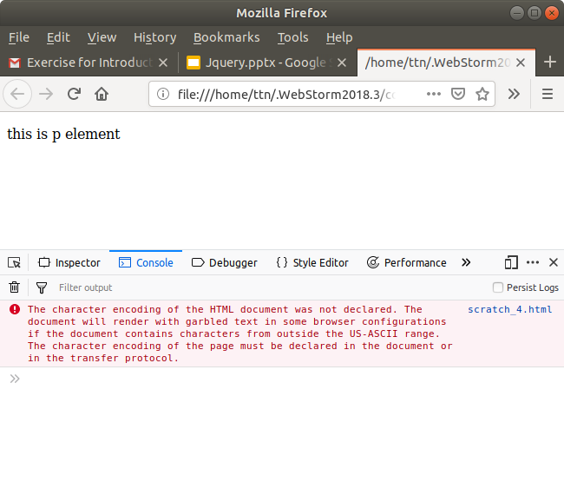

7. Bind a click function to an "click" element and append next "click" next to it.
Ans.
<!DOCTYPE html>
<html>
<head>
<script src="https://code.jquery.com/jquery-3.3.1.min.js"></script>
<script>
$(document).ready(function(){
$("#next").on("click", function (e) {
$("#next").append($("<p>Next clicked</p>", {id:"next"}))
})
});
</script>
</head>
<body id="next">
This is body
</body>
</html>
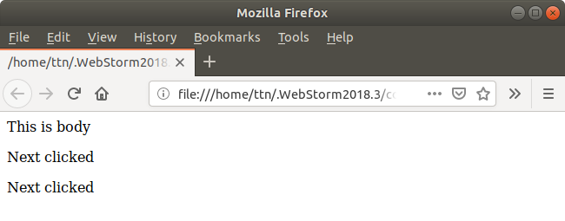

8. Click event not working on element which added dynamicly or via script, make it work using .on method
Ans.
<!DOCTYPE html>
<html>
<head>
<script src="https://code.jquery.com/jquery-3.3.1.min.js"></script>
<script>
$(document).ready(function(){
$("#next").append($("<button>Click here</button>", {id:"#b1"}));
$("body#next").on("click", function (e) {
alert("button clicked");
})
});
</script>
</head>
<body id="next">
This is body
</body>
</html>
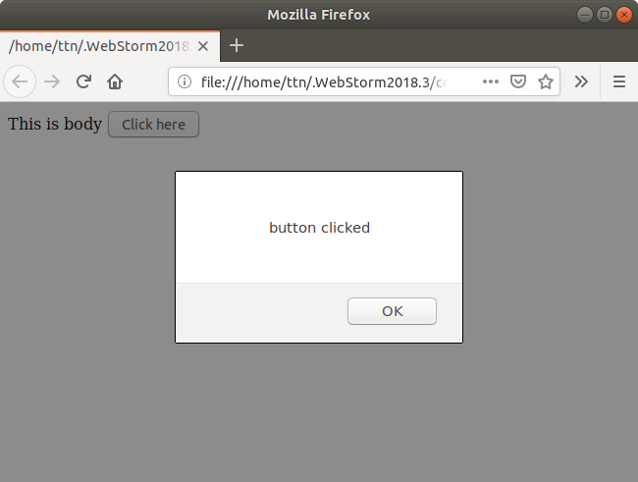

9. Get dropdown selected value on onchanage event and append in div container
Ans.
<!DOCTYPE html>
<html>
<head>
<script src="https://code.jquery.com/jquery-3.3.1.min.js"></script>
<script>
$(document).ready(function(){
$("#selection").on("change", function (e) {
$(".mainDiv").append($(this).val() + "<br>");
})
})
</script>
</head>
<body id="next">
<div class="mainDiv">
Select here :
<select id="selection">
<option> Select your choice</option>
<option> First choice</option>
<option> Second choice</option>
<option> Third choice</option>
<option> Fourth choice</option>
</select>
</div>
</body>
</html>
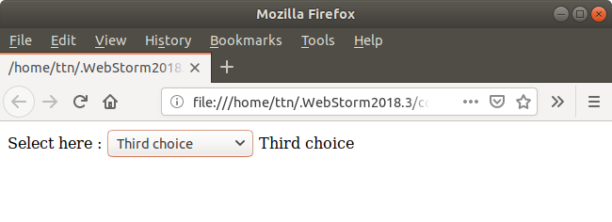

10. Create a dropdown menu using hover method in jquery
Ans.
<!DOCTYPE html>
<html>
<head>
<script src="https://code.jquery.com/jquery-3.3.1.min.js"></script>
<script>
$(document).ready(function(){
$(".mainDiv").hover(function () {
$(this).append("<ul class='dropdown'><li>Hovered 1</li><li>Hovered 2</li></ul>");
}, function () {
$(".dropdown").remove();
})
})
</script>
</head>
<body id="next">
<div class="mainDiv">
Select here :
</div>
</body>
</html>

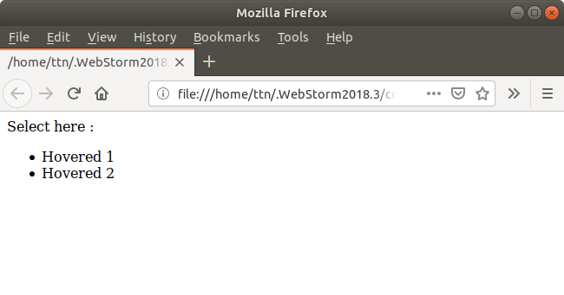

11. On clicking on "google" tag. It is taking us to google home page. Stop it from happening.
Ans.
<!DOCTYPE html>
<html>
<head>
<script src="https://code.jquery.com/jquery-3.3.1.min.js"></script>
<script>
$(document).ready(function(){
$('#anchor').on("click", function (e) {
e.preventDefault();
});
})
</script>
</head>
<body id="next">
<div class="mainDiv">
<a href="http://www.google.com" id="anchor">google</a>
</div>
</body>
</html>

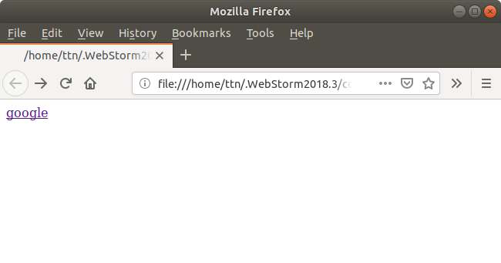

12. We have bind a click funtion to parent div but we want stop it from performing when user clicks on its child li
Ans.
<!DOCTYPE html>
<html>
<head>
<script src="https://code.jquery.com/jquery-3.3.1.min.js"></script>
<script>
$(document).ready(function(){
$('.parent').on("click", function (e) {
alert("parent clicked");
});
$('.child').on("click", function (e) {
alert("child clicked");
});
$('.child').on("click", function (e) {
e.stopPropagation();
})
})
</script>
</head>
<body id="next">
<div class="parent">
This is parent div
<div class="child">This is child div</div>
</div>
</body>
</html>

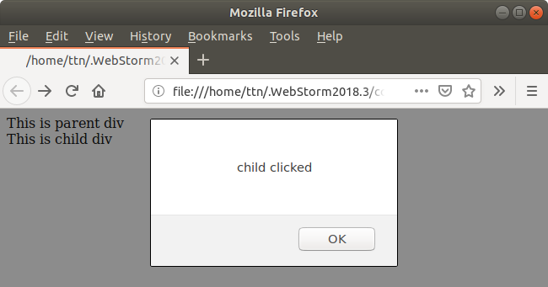

13. Get the max height of elements using jquery each method
Ans.
<!DOCTYPE html>
<html>
<head>
<script src="https://code.jquery.com/jquery-3.3.1.min.js"></script>
<script>
$(document).ready(function(){
$('#cal-height').click(function () {
$('#find-height').children().each(function (i, el) {
$('#shw-height').append('<p>Max Height of <span>' + $(this).prop('tagName') + '</span> is: ' + $(this).height() + '<br>');
})
});
})
</script>
</head>
<body id="next">
<div id="find-height">
<p>This is paragraph.</p>
<h2>This is h2 heading.</h2>
<h4>This is h4 heading.</h4>
<div>This is div.</div>
</div>
<div><button id="cal-height">Calculate Height</button></div>
<div id="shw-height"></div>
</body>
</html>

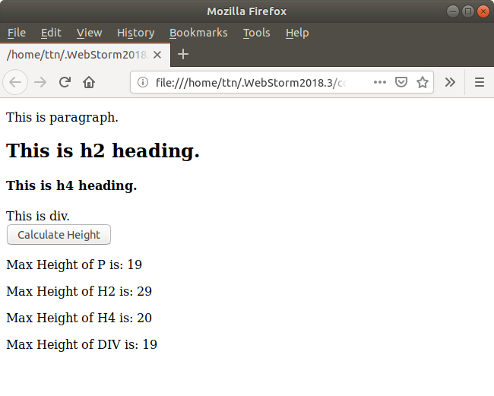

14. Chagne color of every cell which has numberl larger than 10.
Ans.
<!DOCTYPE html>
<html>
<head>
<script src="https://code.jquery.com/jquery-3.3.1.min.js"></script>
<script>
$(document).ready(function(){
$('td').each(function () {
if($(this).text() > 10){
$(this).css('background', 'yellow');
}
})
})
</script>
</head>
<body id="next">
<div>
<table id="tbl" border="1px">
<thead style="border: 3px blue solid; border-collapse: collapse;">
<th>col 1</th>
<th>col 2</th>
<th>col 3</th>
<th>col 4</th>
</thead>
<tr>
<td>12</td>
<td>4</td>
<td>8</td>
<td>25</td>
</tr>
<tr>
<td>0</td>
<td>87</td>
<td>16</td>
<td>7</td>
</tr>
<tr>
<td>34</td>
<td>8</td>
<td>4</td>
<td>1</td>
</tr>
</table>
</div>
</body>
</html>
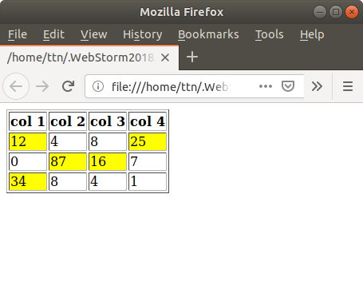

15. Retrive the data from server using ajax get call
Ans.

<!DOCTYPE html>
<html>
<head>
<script src="https://code.jquery.com/jquery-3.3.1.min.js"></script>
<script>
$('.get-data').on('click', function () {
$.ajax({
type: "GET",
dataType: 'jsonp',
url: "https://jsonplaceholder.typicode.com/users",
async: false,
contentType: "application/json; charset=utf-8",
success: function (msg) {
console.log(JSON.stringify(msg));
for(var i = 0; i < msg.length; i++){
$('.shw-table-1').append('<tr><td>' + msg[i].name + '</td><td>' + msg[i].email + '</td><td>' + msg[i].phone + '</td><td>' + msg[i].website +'</td></tr>')
}
},
error: function (err) {
console.log(err);
}
});
});
</script>
</head>
<body>
<div>
<button class="get-data"> Get Data by Ajax</button>
<table style="width: 100%;">

<tr style="border: 2px blue solid; border-collapse: collapse; text-align: left">
<th>Name</th>
<th>Email</th>
<th>Phone</th>
<th>Website</th>
</tr>
<tbody class="shw-table-1">
</tbody>
</table>
</div>
</body>
</html>

16. Add cross button on row and bind click function which make a delete request to server, after success event remove the row from dom
Ans.
<!DOCTYPE html>
<html>
<head>
<script src="https://code.jquery.com/jquery-3.3.1.min.js"></script>
<script>
$('.get-data').on('click', function () {
$.ajax({
type: "GET",
dataType: 'jsonp',
url: "https://jsonplaceholder.typicode.com/users",
async: false,
contentType: "application/json; charset=utf-8",
success: function (msg) {
for(var i = 0; i < msg.length; i++){
$('.shw-table-2').append('<tr><td class=' + msg[i].id + '>' + msg[i].id + '</td><td>' + msg[i].name + '</td><td>' + msg[i].email + '</td><td><a class="close-btn" href="javascript:void(0);">X</a></td></tr>');
}
},
error: function (err) {
console.log(err);
}
});
$(document).on('click', 'a.close-btn' ,function (e) {
e.preventDefault();
var el = $(this).parent().parent();
var post_id = el.find('td:first').text();
$.ajax({
type: "PUT",
url: "https://jsonplaceholder.typicode.com/posts/" + post_id,
success: function (res) {
if(post_id == res.id) {
el.remove();
}
}
});
});
});
</script>
</head>
<body>
<div>
<table style="width: 100%;">
<thead>
<tr style="border: 2px blue solid; border-collapse: collapse; text-align: left">
<th>UserId</th>
<th>Title</th>
<th>Completed</th>
<th>Action</th>
</tr>
</thead>
<tbody class="shw-table-2"></tbody>
</table>
</div>
</body>
</html>

17. Create a image array and in div create a slide show to animate images of delay of 500ms
Ans.
<!DOCTYPE html>
<html>
<head>
<script src="https://code.jquery.com/jquery-3.3.1.min.js"></script>
<script>
var images = ['images/1.jpg','images/2.jpg','images/3.jpg','images/4.jpg','images/5.jpg','images/6.jpg'];
var count = images.length;
$('#start-ss').click(function () {
setInterval(start_slider, 500);
})
function start_slider() {
$('#shw-images').attr('src', images[(++(images.length))%count]).animate({
transition: 0.8
});
}
</script>
</head>
<body>
<div>
<button id="start-ss">Start Slideshow!</button>
<div>
<img id="shw-images" src="images/1.jpg" alt="images" style="width: 250px; height: 250px;">
</div>
</div>
</body>
</html>

