Q1. Write a program to replace a substring inside a string with other string ?
Ans.

class Scratch {
static void ques1()
{
//program to replace a substring inside a string with other string
String str="Hello this is main string";
System.out.println("Main string is : " + str);
String result = str.replaceAll("is", "isis");
System.out.println("After replacing : " + result);
}
public static void main(String[] args) {
ques1();
}
}
Output:
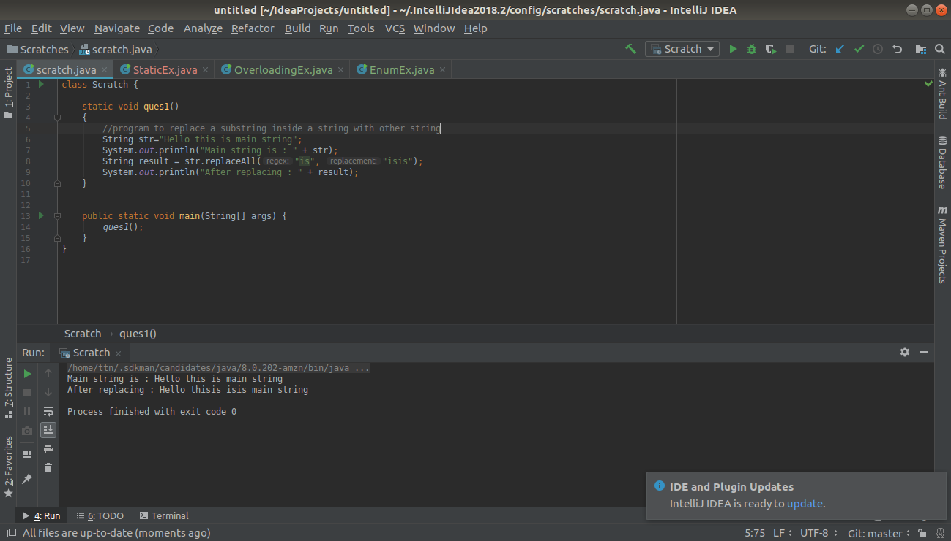
Q2. Write a program to find the number of occurrences of the duplicate words in a string and print them ?
Ans.
class Scratch {
static void ques2()
{
//program to find the number of occurrences of the duplicate words in a string and print them
String str = "this is string that contains duplicate words this is string";
String split[] = str.split(" ");
for(int i = 0 ; i < split.length ; i++)
{
int count = 1;
for (int j = i+1; j < split.length; j++)
{
if(split[j].equals(split[i]))
{
count = count + 1;
split[j] = "0";
}
}
if(!(split[i].equals("0")) && count > 1)
{
System.out.println(" " + split[i] + " : " + count);
}
}
}
public static void main(String[] args) {
ques2();
}
}

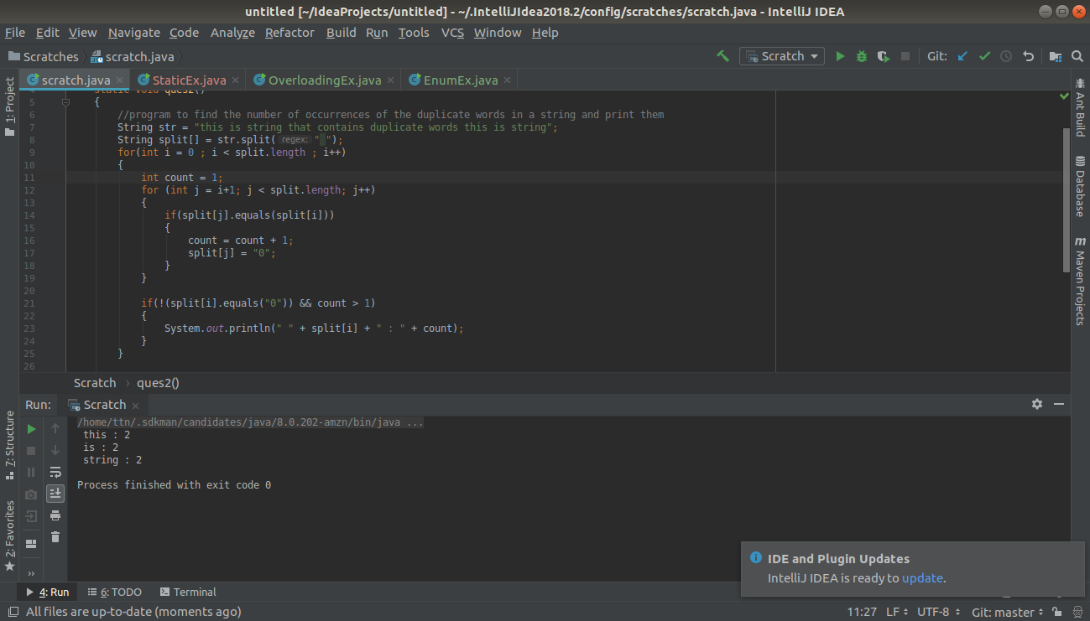

Q3. Write a program to find the number of occurrences of a character in a string without using loop?
Ans.
class Scratch {
static void ques3(String str, String ch)
{
//program to find the number of occurrences of a character in a string without using loop
System.out.println("Original string is : " + str);
int result = str.length() - str.replaceAll(ch, "").length();
System.out.println("Number of occurences of '" + ch + "' is : " + result);
}
public static void main(String[] args) {
ques3("This is string", "i");
}
}

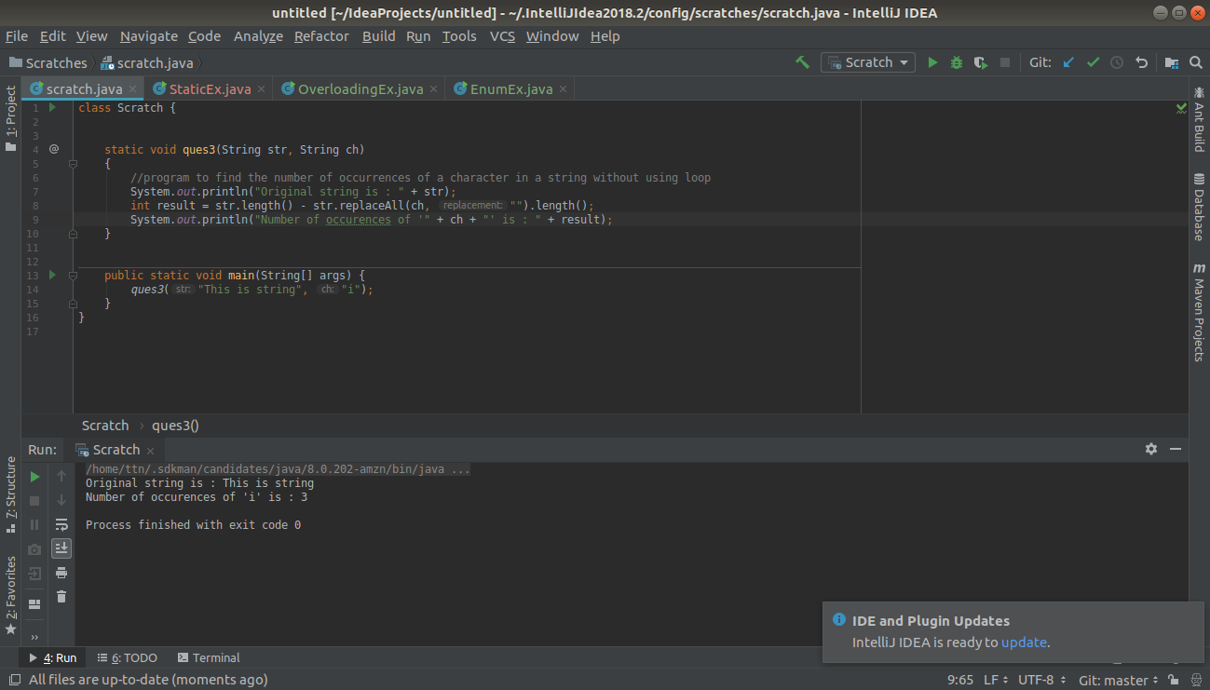
Q4. Calculate the number & Percentage Of Lowercase Letters,Uppercase Letters, Digits And Other Special Characters In A String
Ans.
class Scratch {
static void ques4(String str)
{
//Calculate the number & Percentage Of Lowercase Letters,Uppercase Letters, Digits And Other Special Characters In A String
int lower, upper, digits, special;
lower = upper = digits = special = 0;
char strArr[] = str.toCharArray();
for(int i = 0 ; i < strArr.length ; i++)
{
if(Character.isLowerCase(strArr[i]))
lower++;
else if(Character.isUpperCase(strArr[i]))
upper++;
else if(Character.isDigit(strArr[i]))
digits++;
else
special++;
}
System.out.println("\nString is : " + str);
System.out.println("\nUppercase : " + upper + " and percentage is : " + ((float)upper/str.length())*100 + "%");
System.out.println("\nLowercase : " + lower + " and percentage is : " + ((float)lower/str.length())*100 + "%");
System.out.println("\nDigits : " + digits + " and percentage is : " + ((float)digits/str.length())*100 + "%");
System.out.println("\nSpecial : " + special + " and percentage is : " + ((float)special/str.length())*100 + "%");
}
public static void main(String[] args) {
ques4("This is string");
}
}
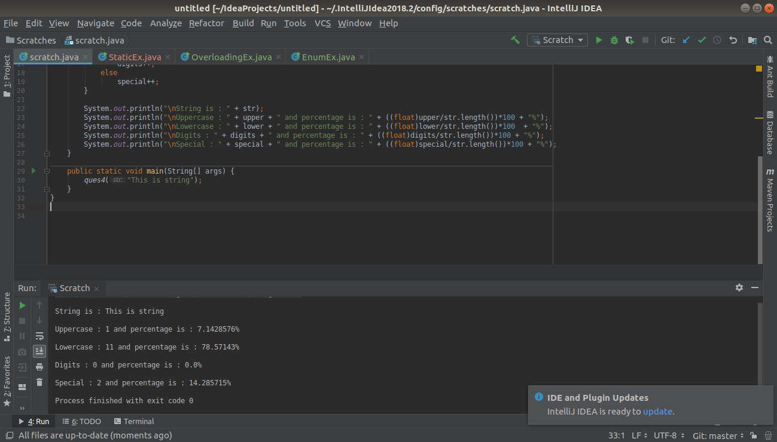

Q5. Find common elements between two arrays.
Ans.
class Scratch {
static void ques5()
{
//Q5. Find common elements between two arrays.
int a[] = new int[]{1, 2, 3, 4, 5, 6};
int b[] = new int[]{5, 6, 3, 2, 7};
for(int i = 0 ; i < a.length ; i++)
{
for(int j = 0 ; j < b.length ; j++)
{
if(a[i] == b[j])
System.out.print(" " + a[i]);
}
}
}
public static void main(String[] args) {
ques5();
}
}
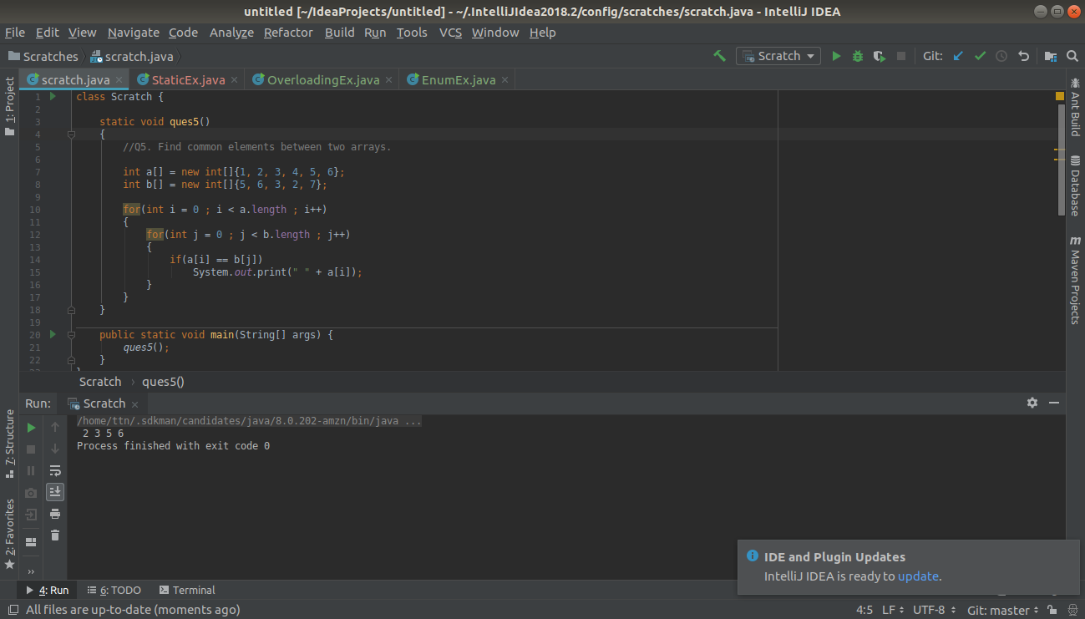

Q6. There is an array with every element repeated twice except one. Find that element
Ans.
class Scratch {
static void ques6()
{
//Q6. There is an array with every element repeated twice except one. Find that element
int a[] = new int[]{1, 1, 2, 3, 4, 5, 2, 3, 4, 6, 6, 7, 7};
int i, j, flag;
for(i = 0 ; i < a.length ; i++)
{
flag = 0;
for(j = 0 ; j < a.length ; j++)
{
if(a[i] == a[j])
{
flag++;
}
}
if(flag == 1)
{
System.out.println("Resultant element is : " + a[i]);
break;
}
}
}
public static void main(String[] args) {
ques6();
}
}
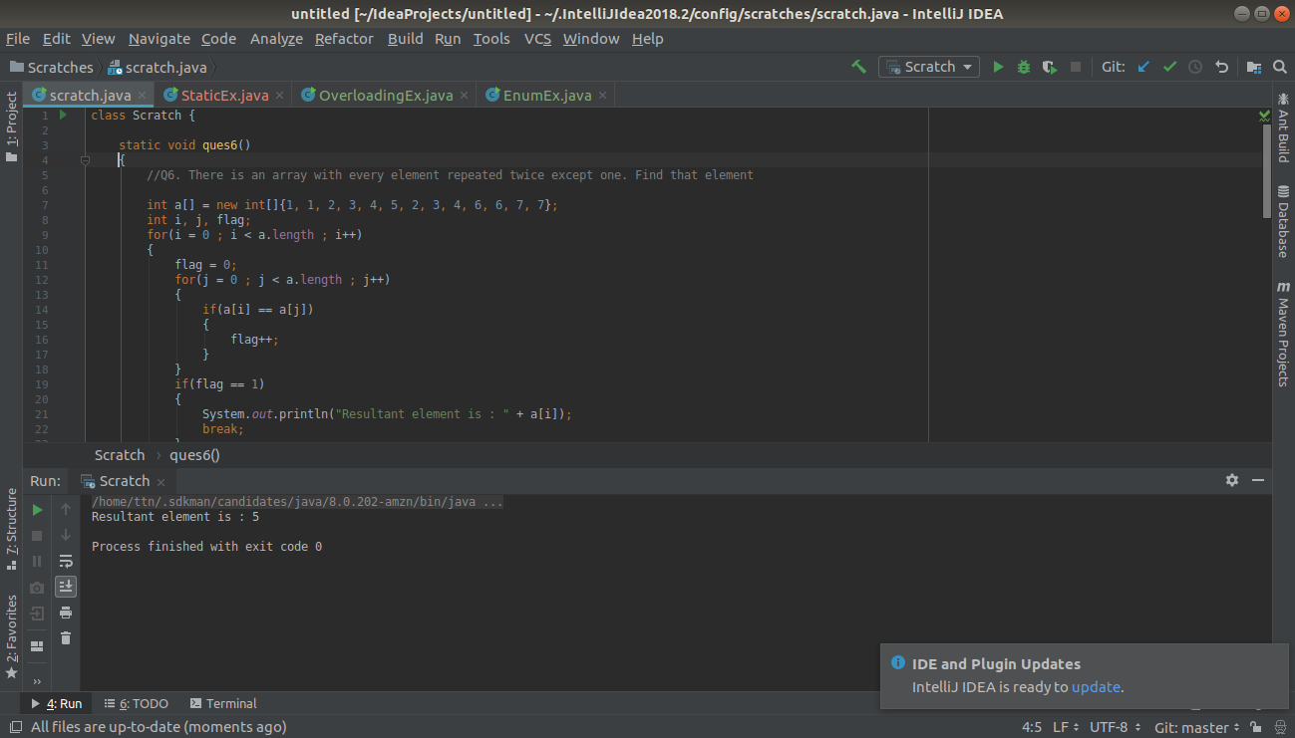
Q7. Write a program to print your Firstname,LastName & age using static block,static method & static variable respectively
Ans.
public class StaticEx {
//Q7. Write a program to print your Firstname,LastName & age using static block,static method & static variable respectively
static int age = 23;
static
{
System.out.print(" Gurvinder ");
}
static void method()
{
System.out.print(" Singh ");
}
public static void main(String args[])
{
method();
System.out.println("\n Age is : " + StaticEx.age);
}
}
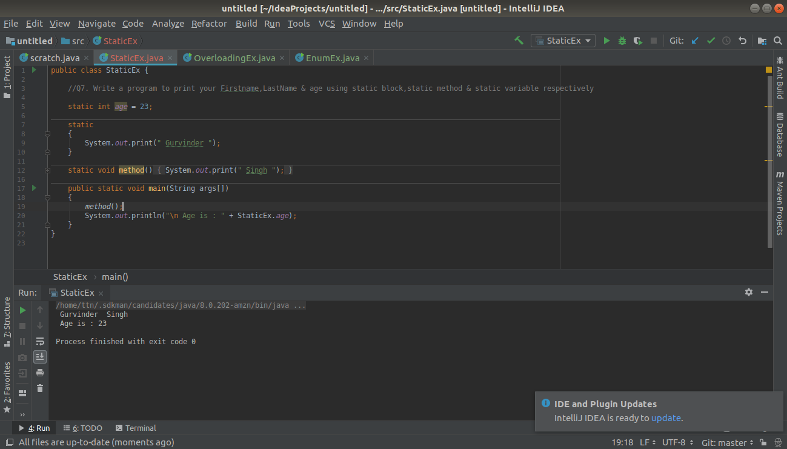
Q8. Write a program to reverse a string and remove character from index 4 to index 9 from the reversed string using String Buffer
Ans.
class Scratch {
static void ques8()
{
//Q8. Write a program to reverse a string and remove character from index 4 to index 9 from the reversed string using String Buffer
StringBuffer sb = new StringBuffer("mainstringbuffer");
System.out.println("Original string is : " + sb);
StringBuffer reverse = sb.reverse();
System.out.println("Reverse of string is : " + reverse);
//removing char from index 4 to 9
System.out.println("After removing characters from index 4 to 9, string is : " + reverse.replace(4, 9, ""));
}
public static void main(String[] args) {
ques8();
}
}
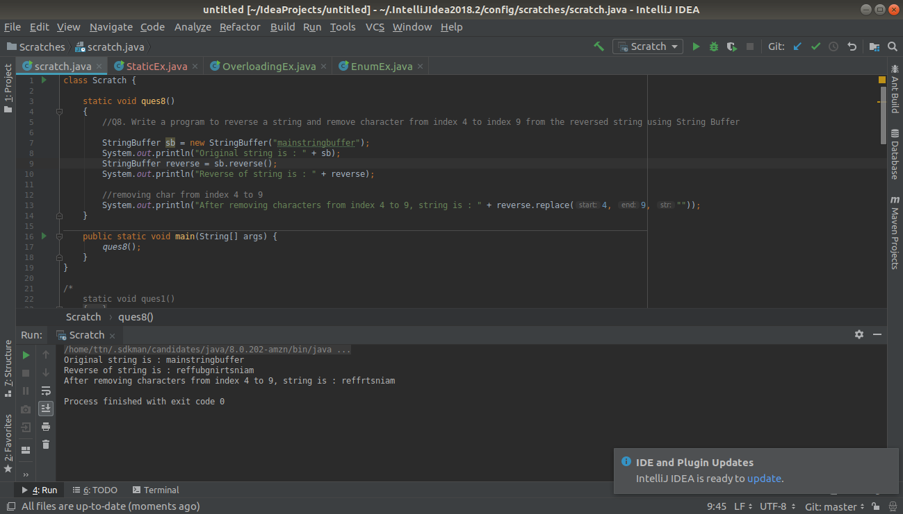
Q9.Write a program to display values of enums using a constructor & getPrice() method (Example display house & their prices)
Ans.
enum House
{
HOUSE1(1001), HOUSE2(1002), HOUSE3(1003);
private int price;
House(int price)
{
this.price = price;
}
public int getPrice()
{
return price;
}
}
public class EnumEx {
public static void main(String s[])
{
House h1 = House.HOUSE1;
House h2 = House.HOUSE2;
House h3 = House.HOUSE3;
System.out.println(" House 1 : " + h1.getPrice());
System.out.println(" House 2 : " + h2.getPrice());
System.out.println(" House 3 : " + h3.getPrice());
}
}

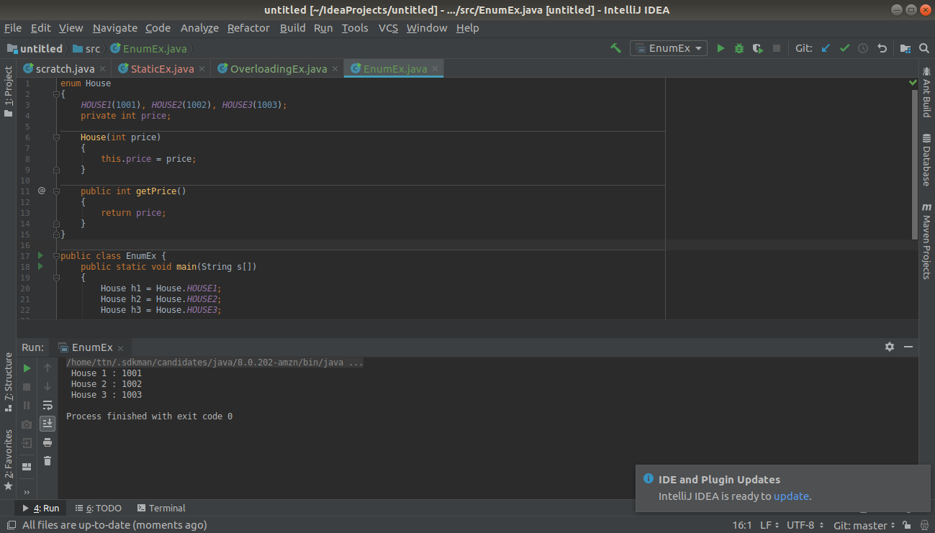
Q10.Write a single program for following operation using overloading
A) Adding 2 integer number
B) Adding 2 double
C) multiplying 2 float
D) multiplying 2 int
E) concate 2 string
F) Concate 3 String
Ans.
public class OverloadingEx {
// Write a single program for following operation using overloading
// A) Adding 2 integer number
// B) Adding 2 double
// C) multiplying 2 float
// D) multiplying 2 int
// E) concate 2 string
// F) Concate 3 String
private void add(int a, int b)
{
System.out.println("Sum of two integers : " + a + " and " + b + " is " + (a+b));
}
private void add(double a, double b)
{
System.out.println("Sum of two doubles : " + a + " and " + b + " is " + (a+b));
}
private void multiply(int a, int b)
{
System.out.println("Multiply of two integers : " + a + " and " + b + " is " + (a*b));
}
private void multiply(float a, float b)
{
System.out.println("Multiply of two floats : " + a + " and " + b + " is " + (a*b));
}
private void concatenate(String s1, String s2)
{
String result = s1 + s2;
System.out.println("Concatenate two strings : " + result);
}
private void concatenate(String s1, String s2, String s3)
{
String result = s1 + s2 + s3;
System.out.println("Concatenate three strings : " + result);
}
public static void main(String s[])
{
OverloadingEx obj = new OverloadingEx();
obj.add(10, 20);
obj.add(1.1, 2.2);
obj.multiply(10, 20);
obj.multiply(1.1f, 2.2f);
obj.concatenate(" Hello ", " Java");
obj.concatenate(" Hello ", " Programming ", " World ");
}
}
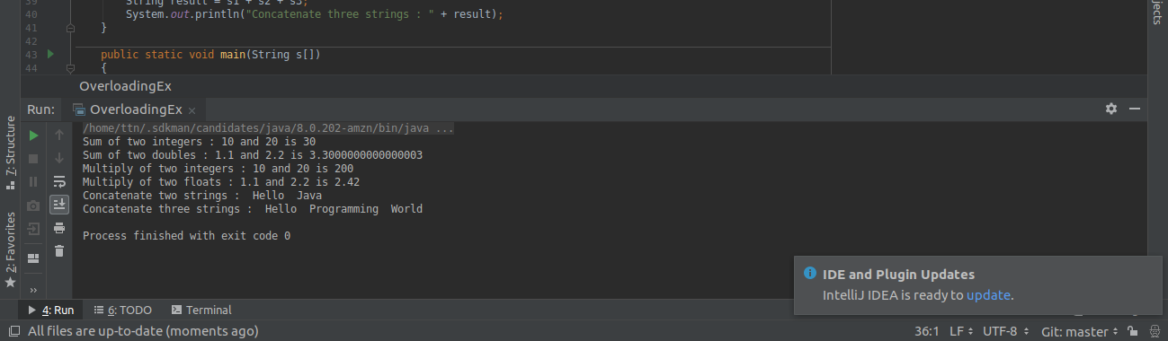
Q11.Create 3 sub class of bank SBI,BOI,ICICI all 4 should have method called getDetails which provide there specific details like rateofinterest etc,print details of every banks
Ans.
class Q11 {
// Q11. Create 3 sub class of bank SBI,BOI,ICICI all 4 should have method called getDetails which provide
// there specific details like rate_of_interest etc,print details of every banks
public static void main(String[] args) {
Bank obj=new Bank();
System.out.println("Main Bank Class details-");
obj.getDetails();
Bank obj1=new SBI();
System.out.println("\n\nSBI details-");
obj1.getDetails();
Bank obj2=new BOI();
System.out.println("\n\nBOI details-");
obj2.getDetails();
ICICI obj3=new ICICI();
System.out.println("\n\nICICI details-");
obj3.getDetails();
}
}
class Bank{
public void getDetails()
{
System.out.println("Hi This is a bank!! Interest varies from 4-7%");
System.out.println("Minimum balance to start a new account varies from 5000-10,000 ");
}
}
class SBI extends Bank{
@Override
public void getDetails(){
System.out.println("SBI has interest 4%");
System.out.println("Minimum balance is 5000/ ");
System.out.println("Govt Bank");
}
}
class BOI extends Bank{
@Override
public void getDetails(){
System.out.println("BOI has interest 5%");
System.out.println("Minimum balance is 10000/ ");
System.out.println("Govt Bank");
}
}
class ICICI extends Bank{
@Override
public void getDetails(){
System.out.println("ICICI has interest 7%");
System.out.println("Minimum balance is 15000/ ");
System.out.println("Private Bank");
}
}

