Problem Statement: There can be multiple customers, who can place multiple orders on the site. Now a sales person can handle these orders will distribute into multiple sales persons (One order will be assign to one salesperson only). So a sales person can have multiple orders of multiple customers

1. Create Database
Ans.

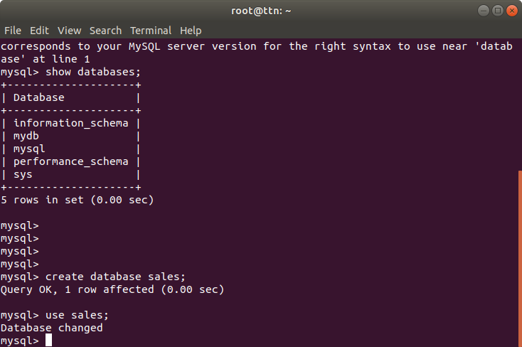

2. Design Schema.
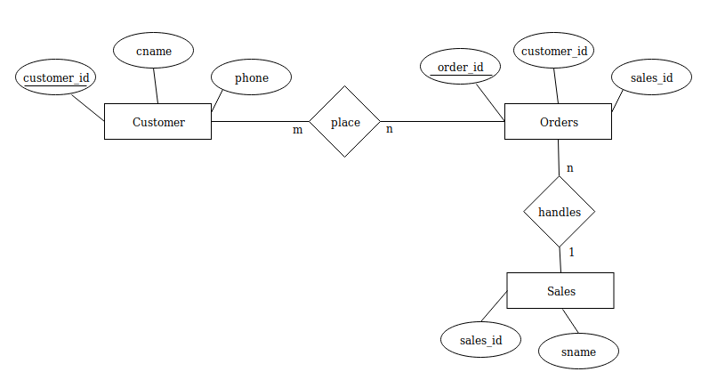
Ans.

3. Create tables.
Ans.

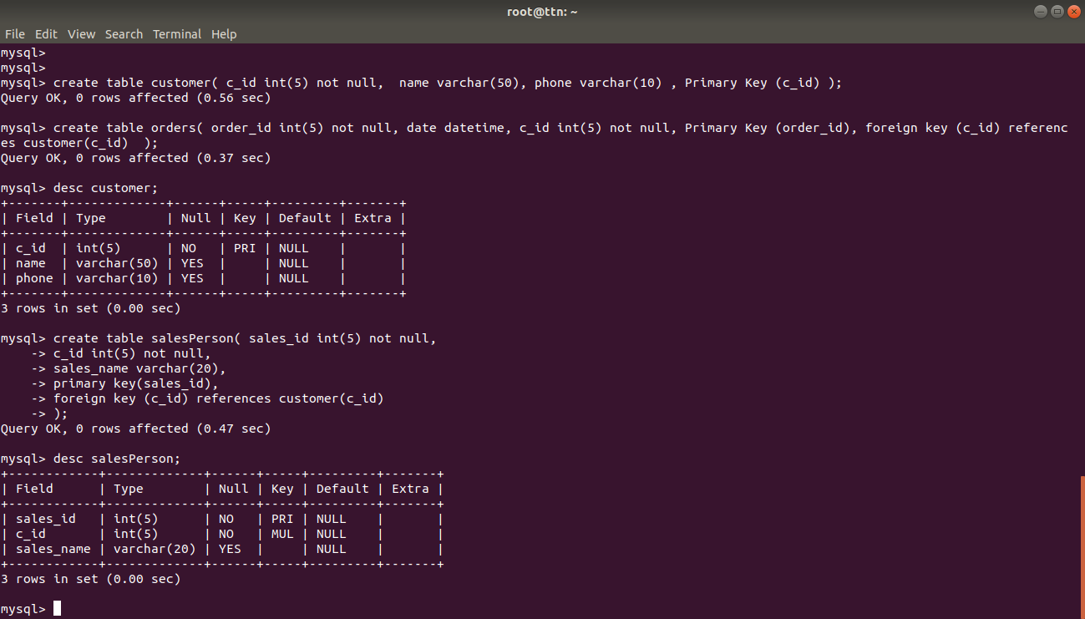
4. Insert sample data.
Ans.

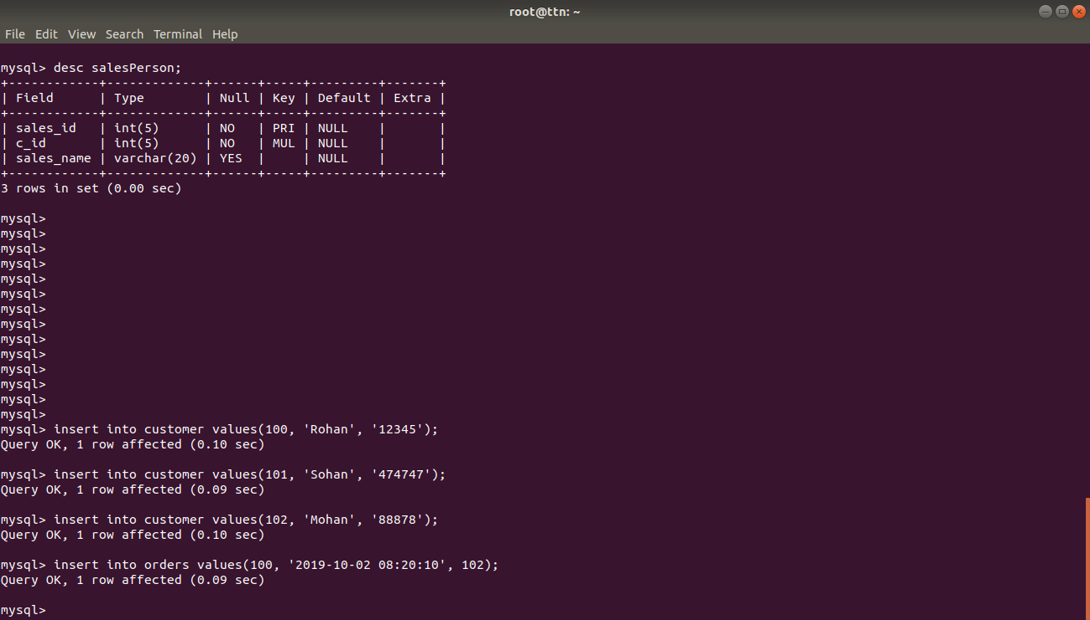
5. Find the sales person have multiple orders.
Ans.

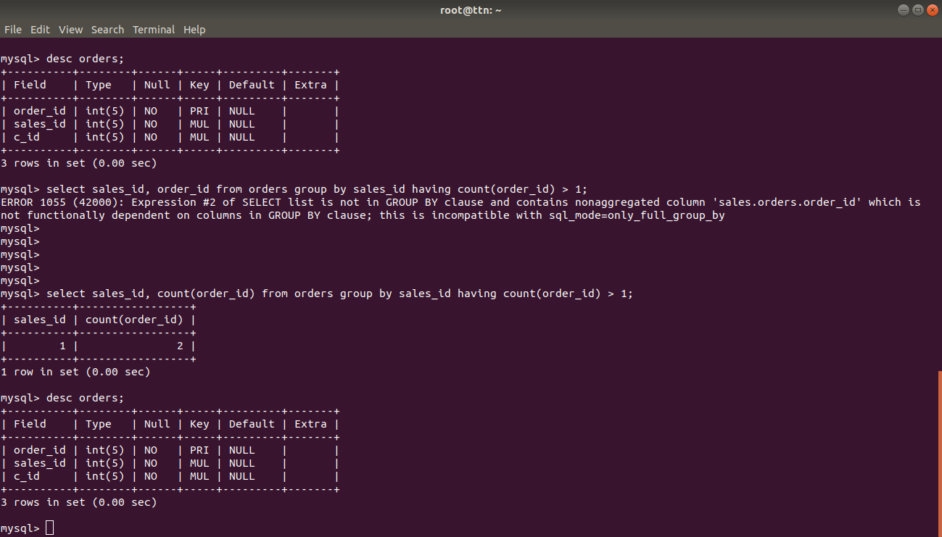

6. Find the all sales person details along with order details
Ans.
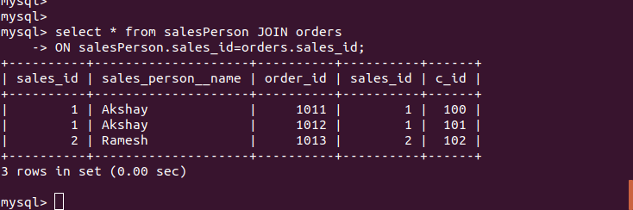

7. Create index
Ans.
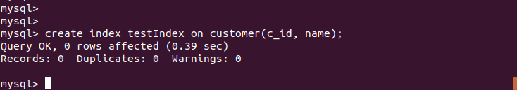

8. How to show index on a table
Ans.
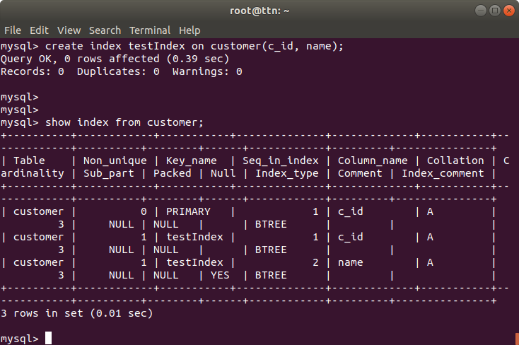

9.Find the order number, sale person name, along with the customer to whom that order belongs to
Ans.

