1. Git Setup https://confluence.atlassian.

2. Initialize a Git Repository
Ans.
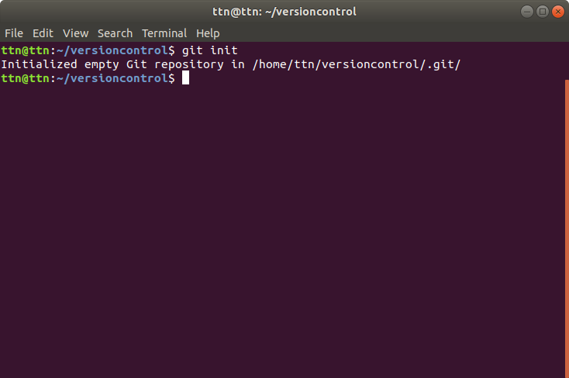

3. Add files to the repository
Ans.
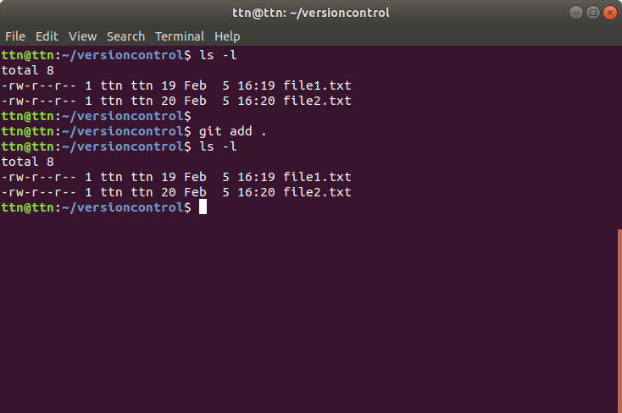

4. Unstage 1 file
Ans.
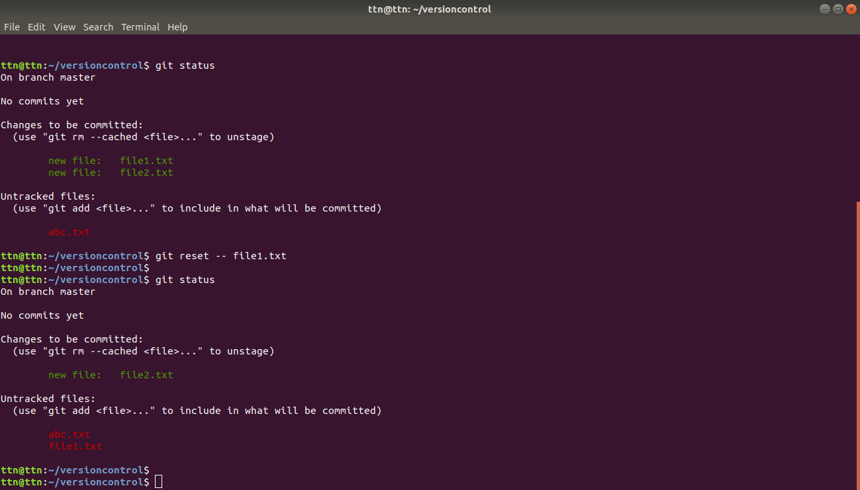

5. Commit the file
Ans.
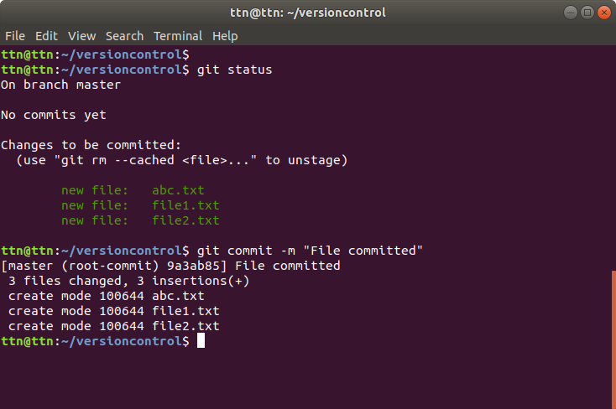

6. Add a remote
Ans.
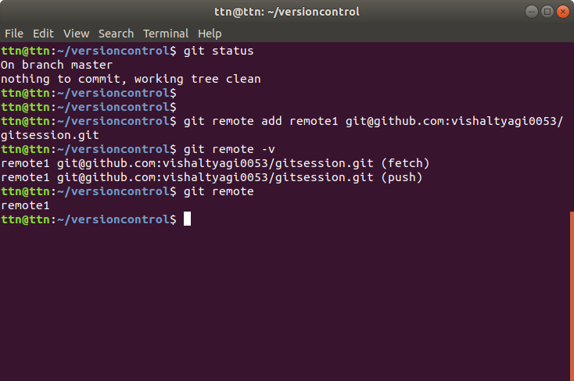

7. Undo changes to a particular file
Ans.
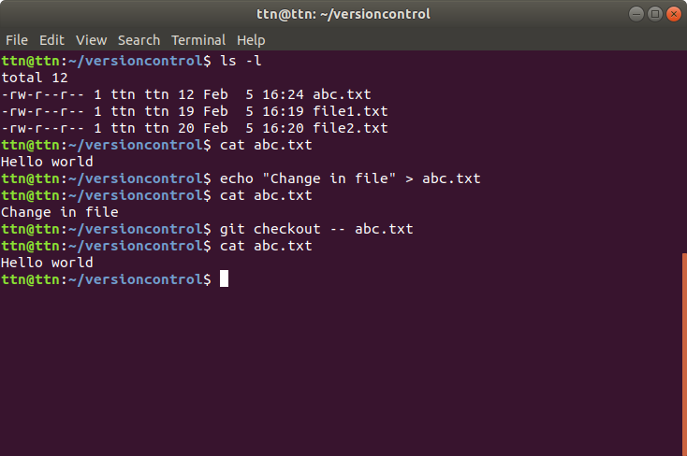

8. Push changes to Github
Ans.

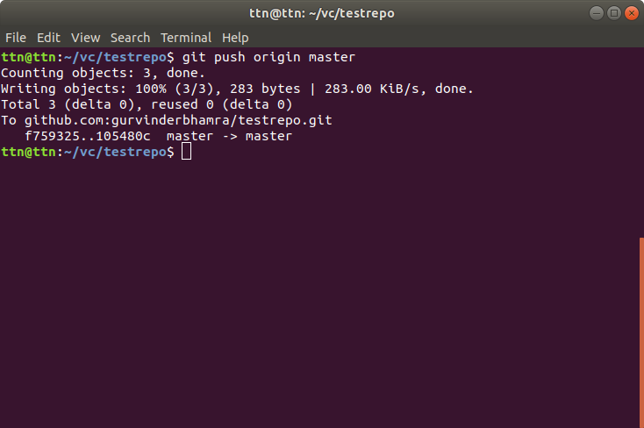

9. Clone the repository
Ans.
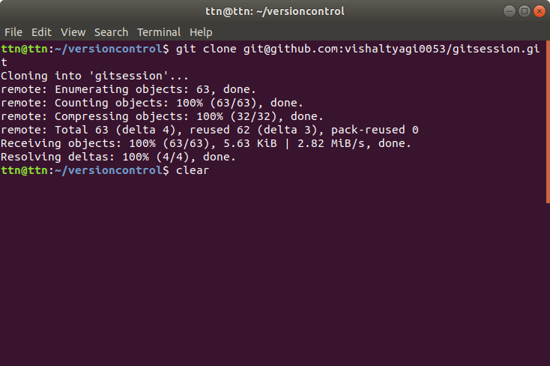

10. Add changes to one of the copies and pull the changes in the other.
Ans.

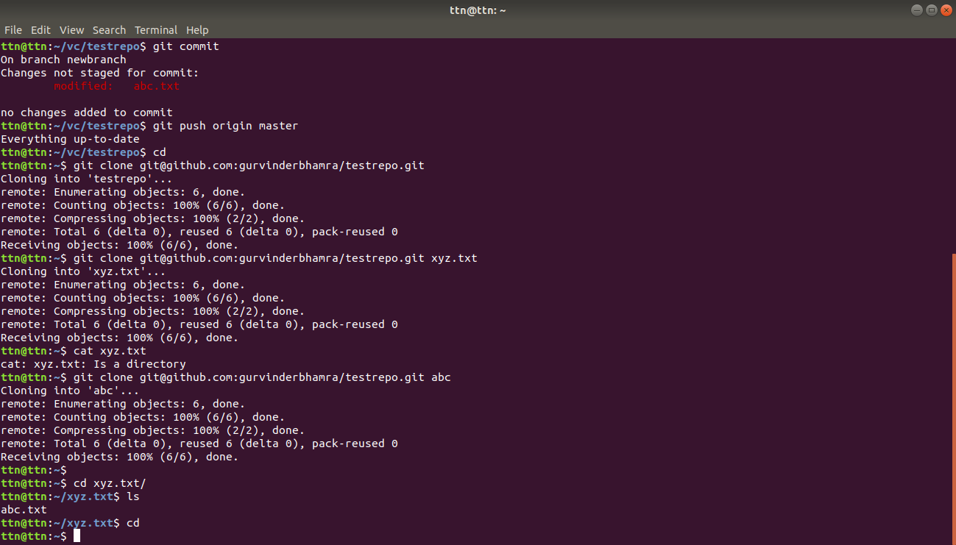

11. Check differences between a file and its staged version
Ans.

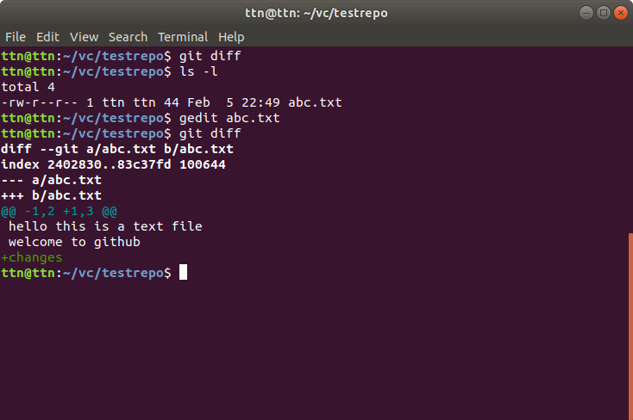

12. Ignore a few files to be checked in
Ans.

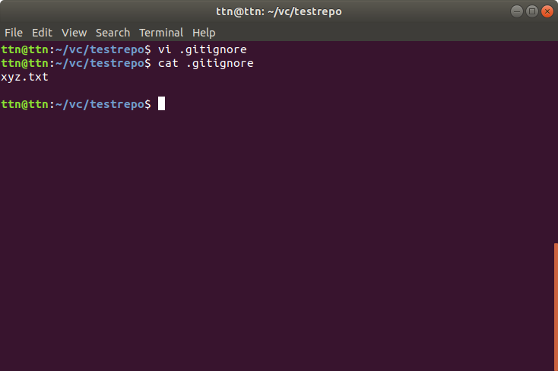
13. Create a new branch.
Ans.
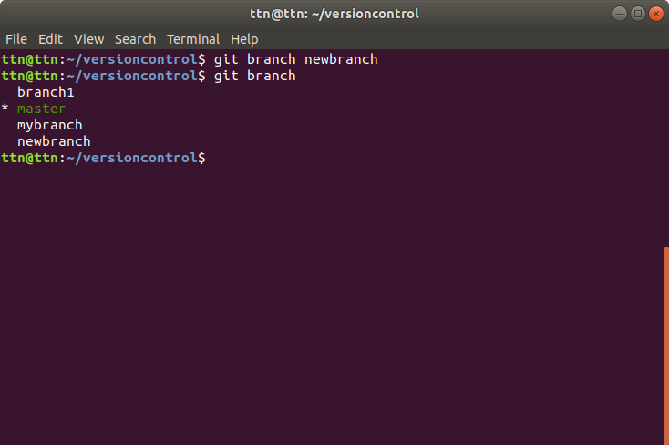

14. Diverge them with commits
Ans.
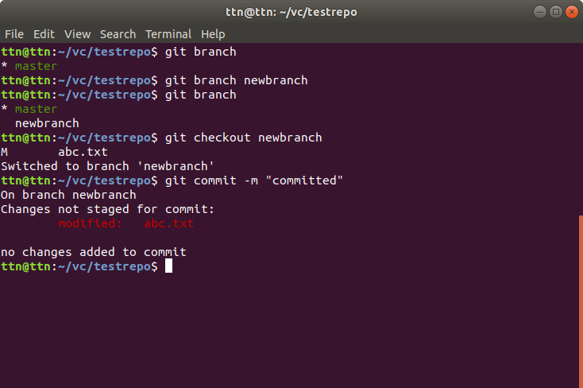

15. Edit the same file at the same line on both branches and commit
Ans.
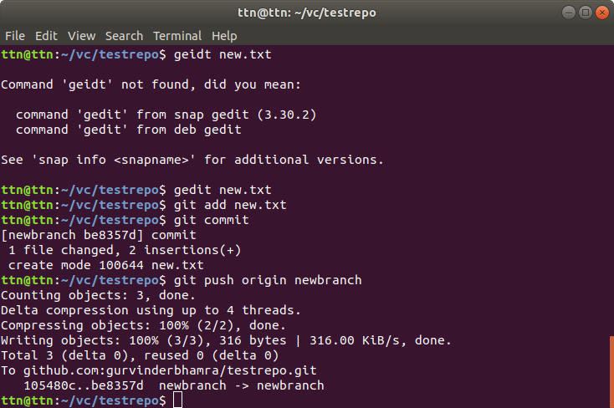

16. Try merging and resolve merge conflicts
Ans.
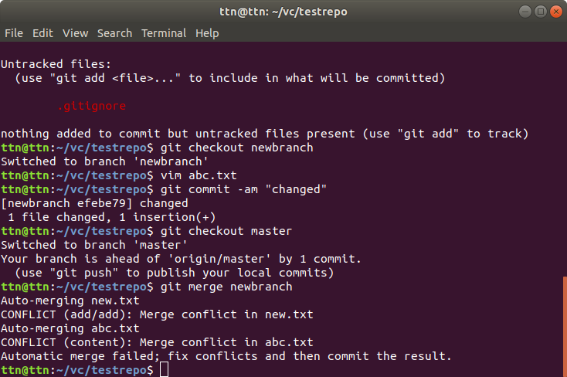
17. Stash the changes and pop them
Ans.
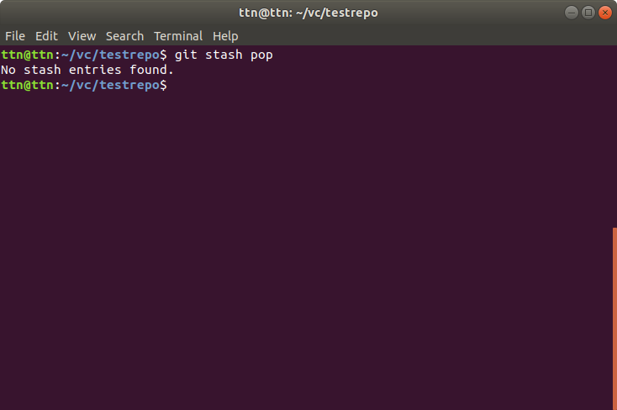

18. Add the following code to your .bashrc file :
color_prompt="yes"
parse_git_branch() {
git branch 2> //dev/null | sed -e '/^[^*]/d' -e 's/* \(.*\)/(\1)/'
}
if [ "$color_prompt" = yes ]; then
PS1='\u@\h\[\033[00m\]:\[\033[
else
PS1='\u@\h:\W $(parse_git_branch)\$ '
fi
unset color_prompt force_color_prompt
Ans.

