Starting Zookeeper:

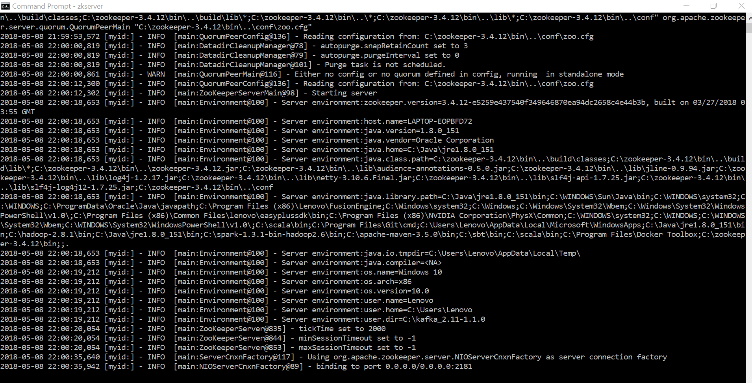

Starting kafka-server:

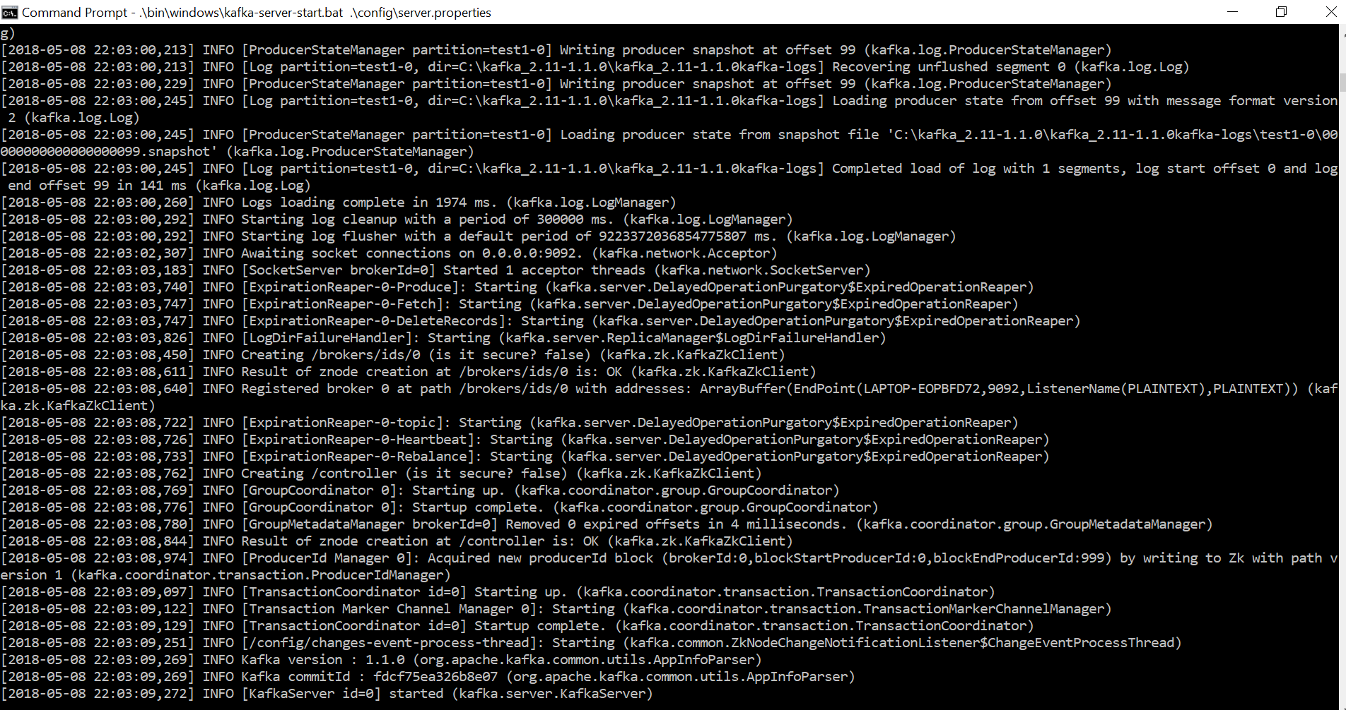

Kafka-consumer:

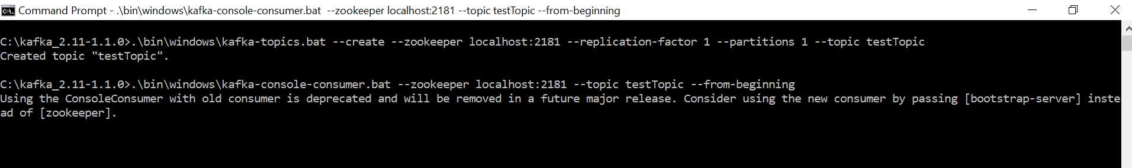

Launching Spark-Streaming API:

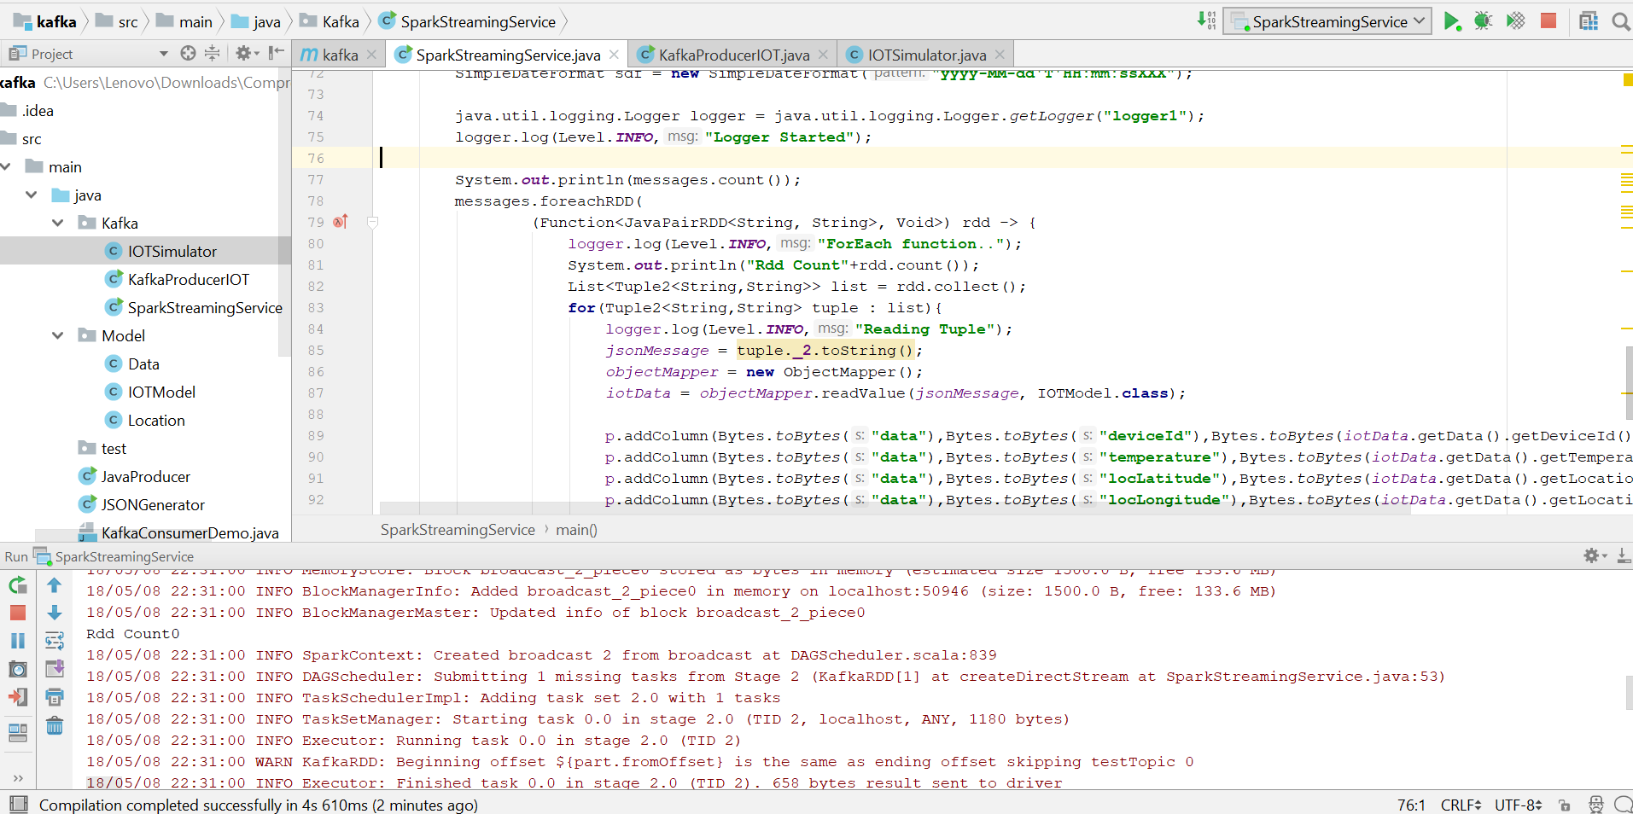

Simulating and Producing IOT devices data through Kafka Producer:

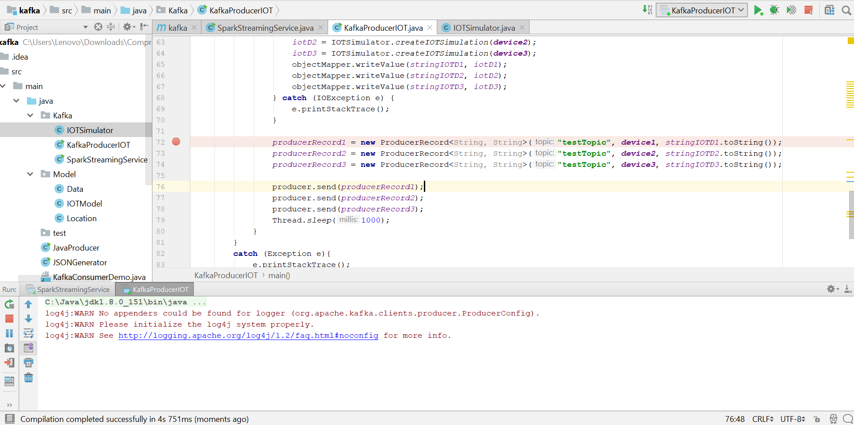

Console data in Kafka Consumer: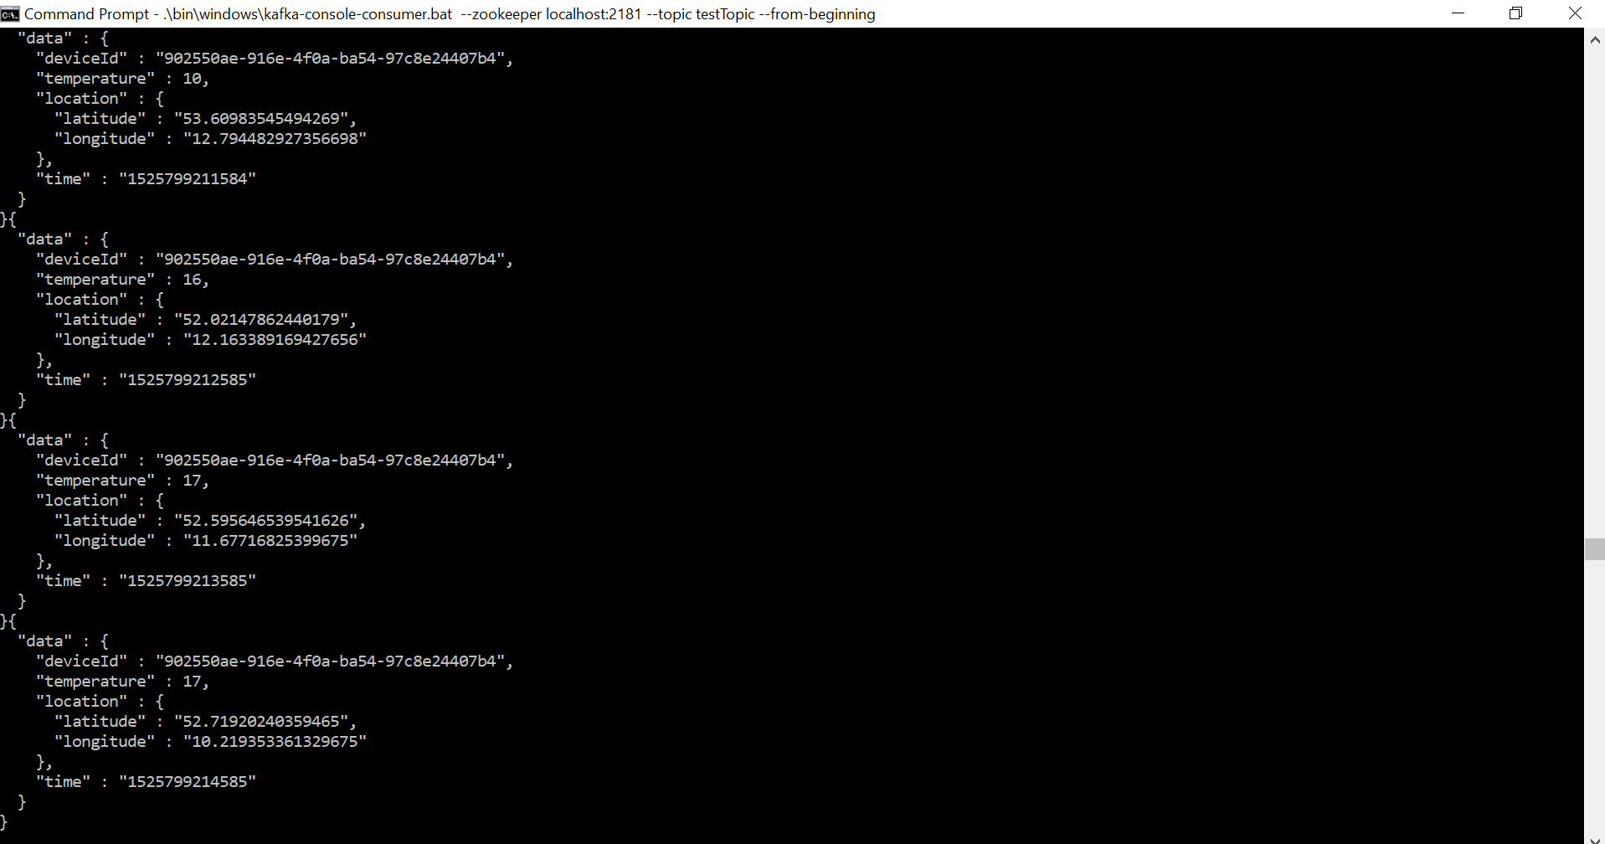

Stream keeps running (Rdd Count90 represents number of lines of json data streamed in a shot by 3 devices):

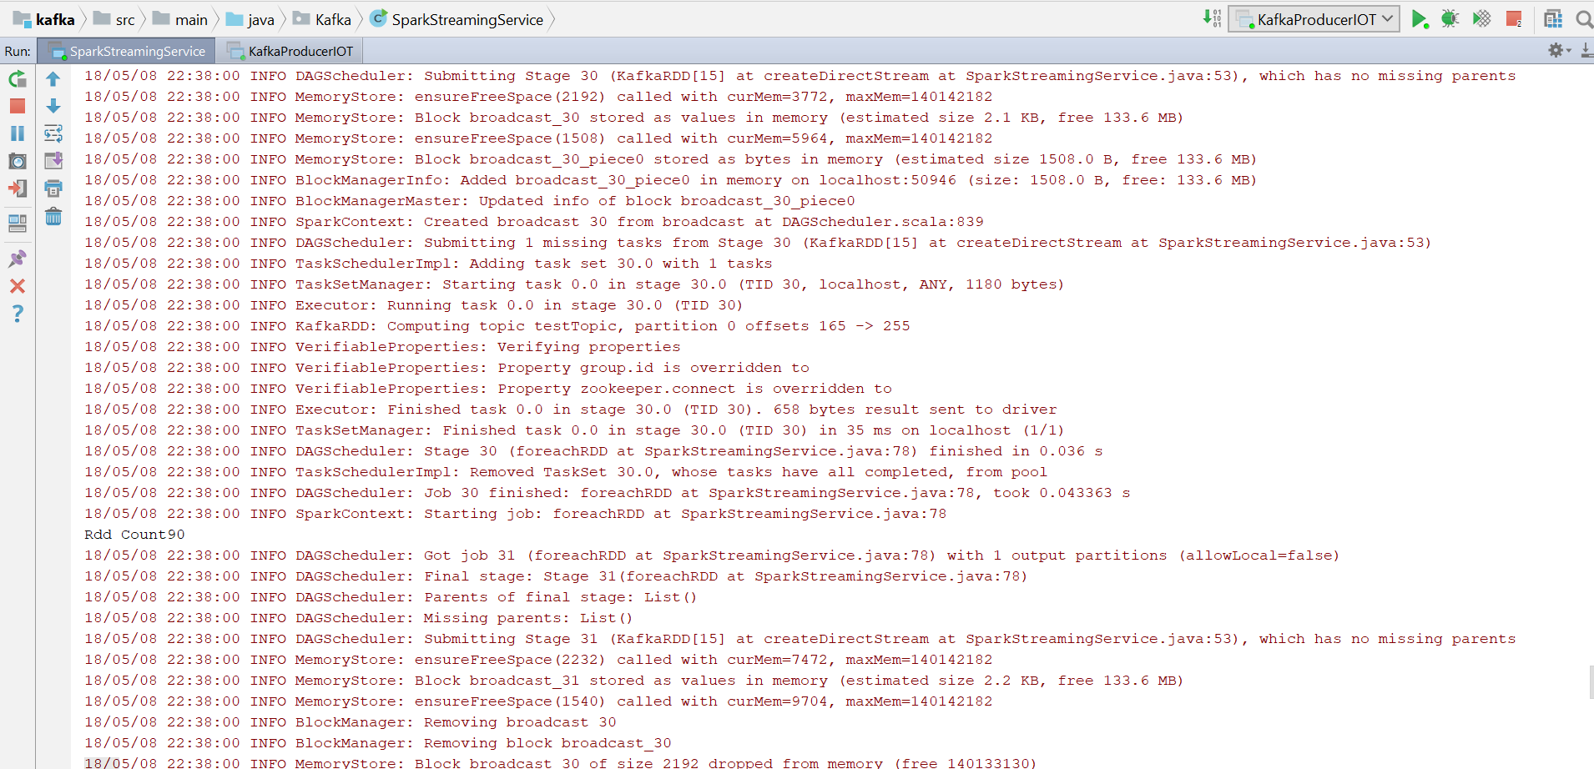

Impala/Hive table is created on top of Hbase where data was consumed: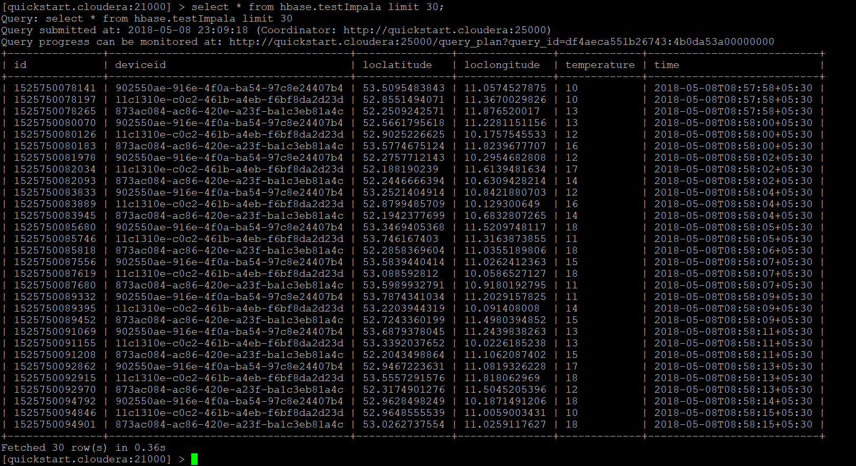

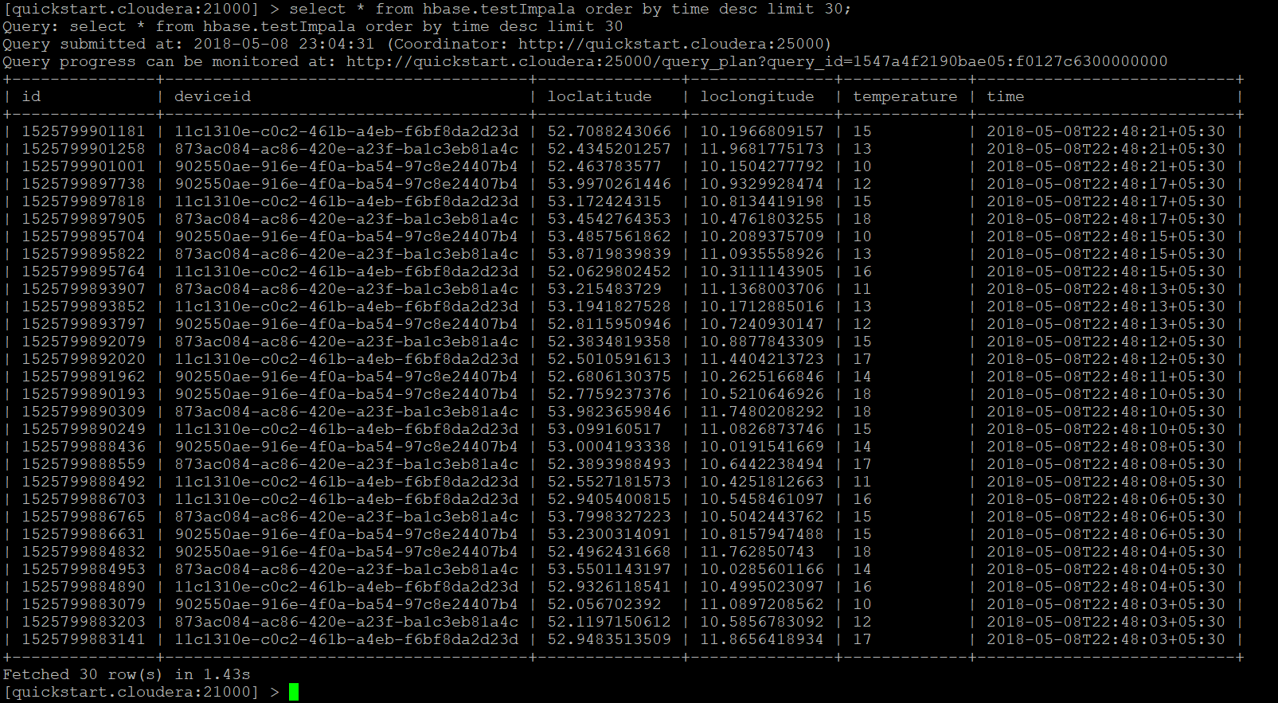

Analysis queries and it’s results are as following:

1. The maximum temperatures measured for every device.

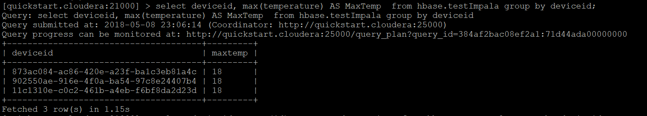

1. The amount of data points aggregated for every device.

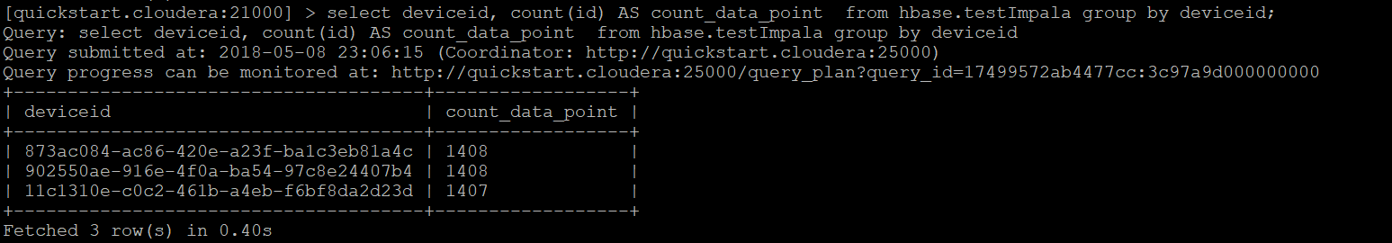

1. The highest temperature measured on a given day for every device.

