Manual – ANINHADO 3.0 (BANGU)

Table of contents

- What is ANINHADO? 2
    - Measures of nestedness 2
    - Citing 2
- How to run ANINHADO? 3
- Formatting the matrix 3
- Step-by-step description 4
  - If you type the wrong command… 4
  - Output files 5
- NODF 5
- T 5
  - About idiosyncratic temperatures 6
  - CAUTION: Opening output files 6
  - Warranty 6
  - Acknowledgments 6
  - The Authors 7

- What is ANINHADO?
ANINHADO (“nested” in Portuguese) is a program developed for fast and autonomous calculation of two distinct measures of nestedness. Nestedness is a feature of binary matrices (also called presence/absence matrices). The notion of nestedness is particularly relevant for studies focusing the patterns of species occurrence among a set of locations (e.g., islands) and the patterns of interacting species within ecological networks. ANINHADO is a program for researchers already familiarized with the nestedness concept and null model analysis.
ANINHADO is a C++ program (Platform DOS under Windows) with the following characteristics:
- 1239 NCL and 692CL
- Handles up to 10000 large matrices (3000 x 3000)
- The current version of ANINHADO is Aninhado_Bangu.exe.

- Measures of nestedness
The degree of nestedness of a given binary matrix can be computed using distinct metrics. ANINHADO computes two of them: the recently-proposed NODF (Almeida-Neto et al. 2008) and the popular matrix’s Temperature (T, Atmar & Paterson 1993). Click the references above to have access to detailed description of both metrics. If you do not have access to Oikos please contact us: aninhamento@gmail.com and we will send you the pdf. We strongly recommended the use of NODF to characterize the degree of nestedness due its theoretical consistence and its statistical behavior (Almeida-Neto et al. 2008). However, users may use T for compare his/her studied systems with published data.

2. Citing
- If you use ANINHADO in your analyses (no matter if you use T or NODF), please cite: Guimaraes, P. R., P. Guimaraes. 2006. Improving the analyses of nestedness for large sets of matrices. Environmental Modelling and Software. 21: 1512-1513.

- If you use NODF, please also cite: Almeida-Neto M., Guimaraes P., Guimaraes P.R., Loyola R.D. & Ulrich W. 2008. A consistent metric for nestedness analysis in ecological systems: reconciling concept and measurement. Oikos (in press: doi: 10.1111/j.0030-1299.2008.16644.x)

- If you use T, please also cite: Atmar, W. & Paterson, B. D. 1993. The measure of order and disorder in the distribution of species in fragmented habitats. Oecologia 96: 373-382.
- How to run ANINHADO?
- Formatting the matrix
The first step to run ANINHADO is to format your data matrix in a readable format. ANINHADO reads a variety of file formats containing matrices, including any text format exported by Microsoft EXCEL and NTC format. If you want to analyze your real data or computer-generated matrices using ANINHADO, please pay attention with the following rules:

- Rows containing text characters (e.g., letters) will be ignored by the program.
- Special characters such as spaces and tabulations will be ignored.
- Rows are separated by a paragraph mark (Row Feed).
- Matrix’s elements must be 0s or 1s. Other numbers will lead to wrong results.
- CAUTION: file name size must be lower than eight words.

- Step-by-step description
A detailed description of how to analyze sets of multiple matrices is available below. We illustrate the analysis with our test data.
  - Be sure that the matrix that you want to analyze is in the same folder that ANINHADO.exe.
  - Double-click in ANINHADO.exe. The prompt DOS should appear with the following text:
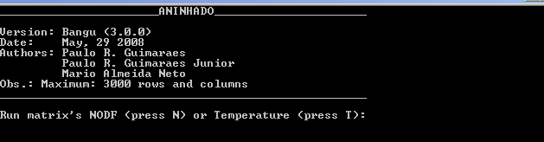
  - Type “N” if you want to calculate NODF and “T” if you want to calculate matrix’s Temperature.
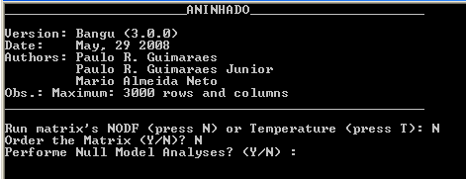
  - ANINHADO has four pre-determined null models that users not familiarized with programming can use to compare real matrices with theoretical predictions: (1) ER: presences are randomly assigned to any cell within the matrix, (2) CE: the probability of a cell aij show a presence is 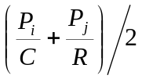, in which Pi is the number of presences in the row i, Pj is the number of presences in the column j, C is the number of columns and R is the number of rows, (3) COL: presences are randomly assigned within the columns and (4) LI: presences are randomly assigned within the rows. If you want that a file containing values generated by each ANINHADO’s null models, type “Y”. Otherwise type “N”. CAUTION: perform null model analysis may increase the processing time.
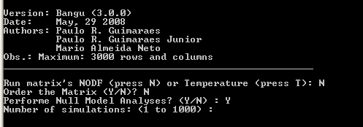
  - Type the number of null model replicates that you want to generate.
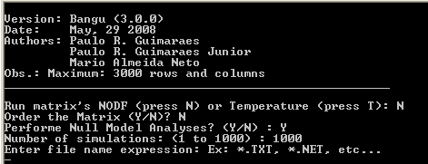
  - There are two options of analysis using ANINHADO.exe:
      - The analysis of a single matrix: write the name of the file containing the matrix (e.g., Bangu.txt) and press “enter” key.
      - The analysis of all matrices in a given folder: write the file extension (e.g., “*.txt”) and press “enter” key.

- If you type a wrong command…
Mistyping occur when the user type a wrong command. For example, the user wants to analyze a single matrix and mistype the name of the matrix. In these situations ANINHADO automatically restarts the step of the analysis avoiding crashing. Although ANINHADO show routines to reduce crashing, mistyping may eventually requires restart it before perform analyses.

- Output files
- NODF
ANINHADO generates 4 files when calculating NODF:
  - Systemp: a file containing the name of each file analyzed and the degree of nestedness for rows, columns and the entire matrix.
  - [ matrix file name]_Ordered.txt: a file containing the packed matrix.
  - [matrix file name]_row_pairwise.txt : a file containing a matrix describing the pairwise values of nestedness for rows
  - [matrix file name]_column_pairwise.txt: a file containing a matrix describing the pairwise values of nestedness for columns
If the user runs null model analysis other 12 files are generated
  - [matrix file name]_RowNestedness_[null model name] (4 files). Each file contains an ensemble of degrees of nestedness for rows generated by a given null model. Each value in the file is the degree of nestedness observed for rows in a given null model replicate.
  - [matrix file name]_ColumnNestedness_[null model name] (4 files). Each file contains an ensemble of degrees of nestedness for columns generated by a given null model. Each value in the file is the degree of nestedness observed for columns in a given null model replicate.
  - [matrix file name]_TotalNestedness_[null model name] (4 files). Each file contains an ensemble of total degrees of nestedness generated by a given null model. Each value in the file is the total degree of nestedness observed in a given null model replicate.

- T
ANINHADO generates five types of files when calculating T:
  - Systemp: a file containing the names and temperatures of each analyzed matrix.
  - [matrix file name].pck: a file containing the names and temperatures of each analyzed matrix. The file contains the original matrix size, final matrix size, original and packed percentage of presences, computed as the number of observed presences divided by the maximum number of possible occurrences (the product of the number of rows by the number of columns in the original matrix). If the user opted to print the packed matrix, the matrix will be printed in this file.
  - [matrix file name].null: a file containing the temperatures generated by each one of the four null models for the analyzed matrix.
  - [matrix file name].col: a file containing the idiosyncratic temperatures of the columns for the analyzed matrix.
  - [matrix file name].lin: a file containing the idiosyncratic temperature of the rows for the analyzed matrix. Both .col and .lin files have the same structure, in which rows (or columns) are organized at the final, packed organization:
- Note about T’s idiosyncratic temperatures

All but one “all-black” row (a row with all cells with 1s) is removed during analysis. As a consequence, the removed, all-black rows are absent in idiosyncratic files. Note that the original position described in the file is the position BEFORE these rows be removed and therefore some indexes will be absent. The same is true for columns. In addition, note that some idiosyncratic temperatures may be much higher than 100. In contrast, T is often lower than 100 (except some very symmetric matrices, in which T may be a little higher than 100 due approximation).

- CAUTION: Opening the output files

Computers will not recognize some file extensions (e.g., .null, .col) of the output files of ANINHADO or will associate these files to wrong programs (e.g., lin). Therefore, open the output files using the Notepad or Excel.

- Warranty

ANINHADO has to be considered as software available ‘‘as is’’ without warranty of any kind.

- Acknowledgments

We are in debt to Wirt Atmar for providing the NTC code. This program is a result of discussions with the following researchers: Andrea E. Rizzoli, Jordi Bascompte, Jeff Ollerton, Mariano Paracuellos, Marco A. Mello, Miguel A. Fortuna, Pedro Jordano, Sarah Elmendorf, Sérgio F. dos Reis, Stephen Hyslop and the input of many users from different countries. However, any problem is exclusively our fault and we will appreciate if you communicate it to us.

- The authors

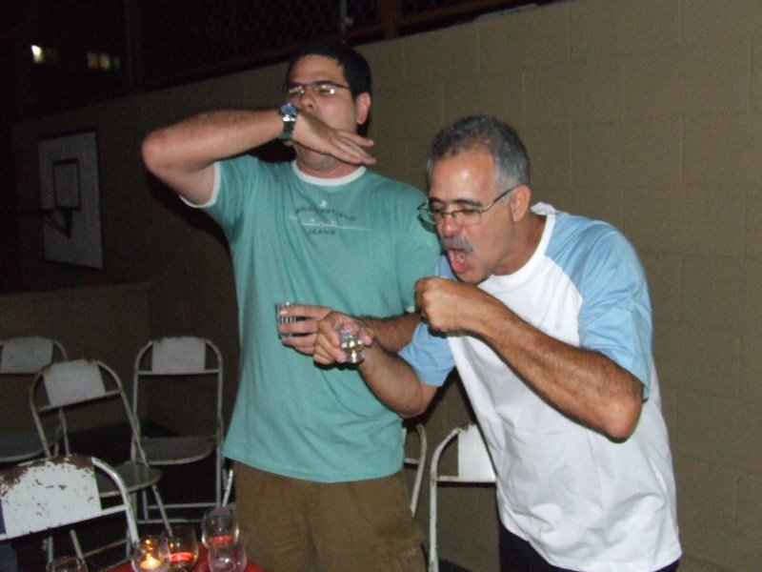
After arguing due the implementation of Mário’s NODF, the two Guimarães reconcile through a Mexican ritual popular in Brazil.


Meanwhile, Mário is waiting a pão de queijo to celebrate that new version of ANINHADO is finally finished.

Paulo Roberto Guimarães (Guimarães, P., right): Born in Rio de Janeiro, Brazil in 1952. Electrical engineer graduated by PUC-RJ and specialist in Telecommunication software. He lives in Campinas, São Paulo, Brazil.

Paulo Roberto Guimarães Jr (Guimarães, P. R., left): Born in Rio de Janeiro, Brazil in 1978. Biologist, MSc and PhD in Ecology by UNICAMP. He is a former postdoc associate at Physics Insitute, UNICAMP and now Assistant Project Scientist at the Department of Ecology and Evolutionary, UCSC. He also lives in Santa Cruz, California, U.S.

Mário Almeida-Neto (Almeida-Neto, M.). Born in Belo Horizonte, Brazil in 1975. Biologist (UNESP - S.J. Rio Preto), MSc and PhD in Ecology (UNICAMP). Presently, he is a post-doc researcher in the Laboratório de Interações Insetos-Plantas at UNICAMP. Current projects involve the analysis of tritrophic interaction networks (plants-herbivores-parasitoids) along anthropogenic disturbance gradients. Mário developed the NODF algorithm.

