Installation ManualInstallation Manual

UNI92K-4DMUNI92K-4DMW

|  |
| --- |
| ***UNI92K - UFS*** |
| ***Software Architecture*** |
| SRS Rev. 0.01 |



Copyright ©UNITEST Corporation

**Table of Contents**

1. Introduction 3

1.1. Purpose 3

1.2. Scope 3

1.3. Definitions, Acronyms, and Abbreviations 3

1.4. Reference 3

1.5. Overview 3

2. Overall Description 4

2.1. Product Perspective 4

2.1.1. System Interfaces 4

2.1.2. User Interfaces 5

2.1.3. Software Interfaces 5

2.1.4. Memory Constraints 5

2.1.5. Operations 5

2.2. User Characteristics 5

2.3. Constraints 5

3. Specific Requirements 6

3.1. Functional Requirements 6

3.1.1. Power Up/Down 6

3.1.2. DRAM 7

3.1.3. Item 구성 7

3.1.4. Multi Queue 8

3.1.5. FAIL MEMORY 8

3.2. Performance Requirements 8

3.2.1. Write / Read Performance 8

4. Software Reuse 9

5. Supporting Information 10

5.1. Software Specific Requirement 10

5.2. Revision History 10

# UFS Overview

본 문서는 UNI92K-UFS의 기능들을 설명하는 SRS(Software Requirements Specification)이다.

## General architecture of UFS Host Controller Interface

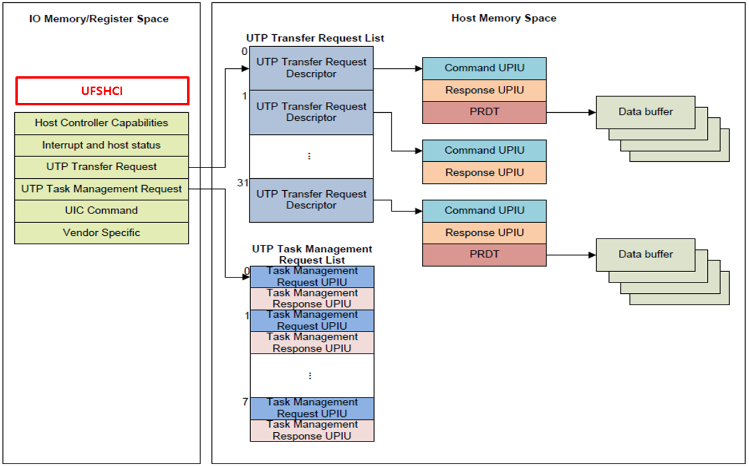

## UFS Transfer Request List

### UTP transfer request descriptor

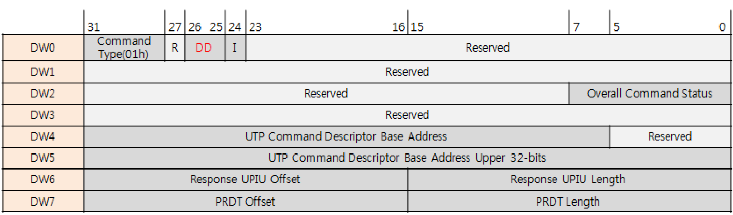

* DD ( Data Direction )

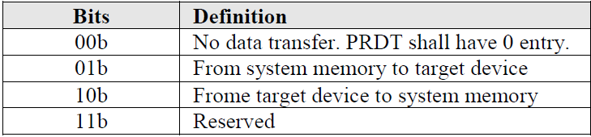

* I ( Interupt )

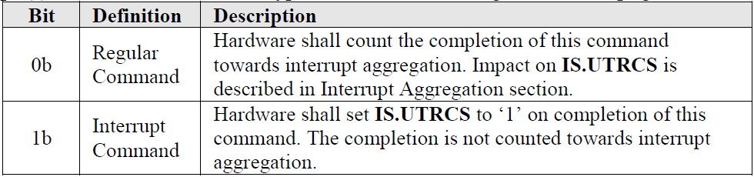

* Overall Command Status

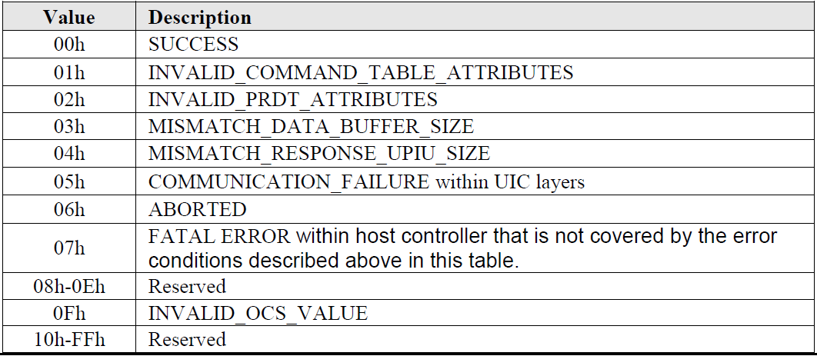

* Contains a pointer for a UTP Command Descriptor (UCD)

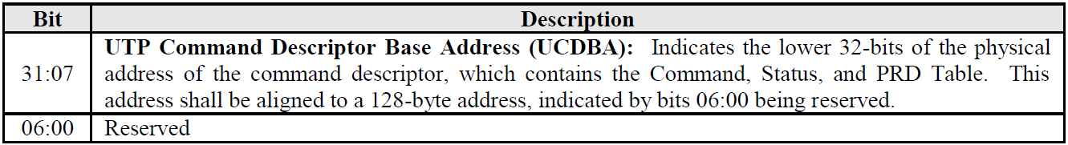

### UTP command descriptor

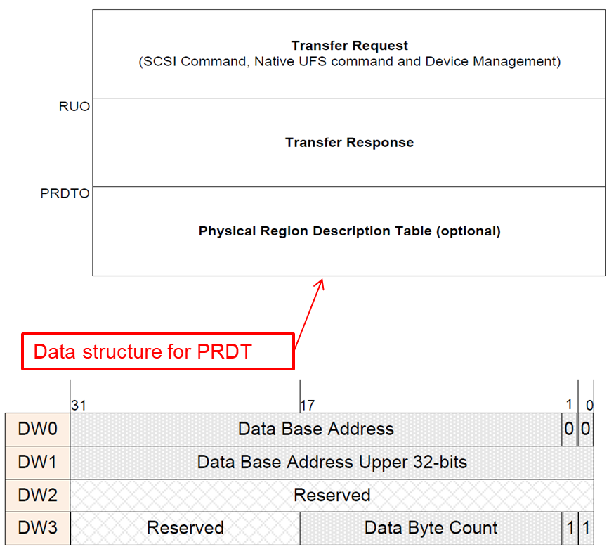

## UTP Task Management Request List

### UTP task management request descriptor

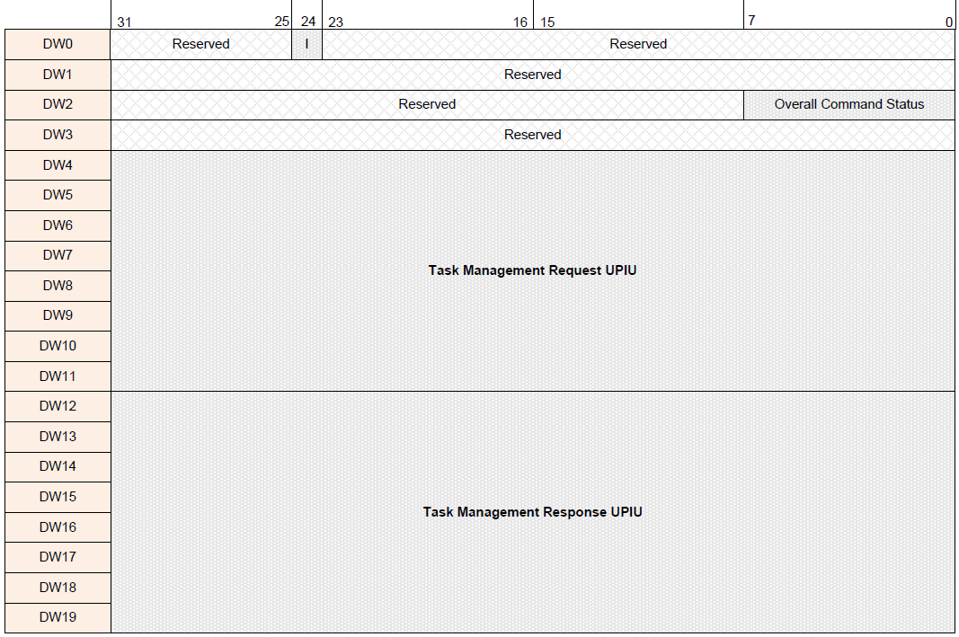

* I ( Interupt )

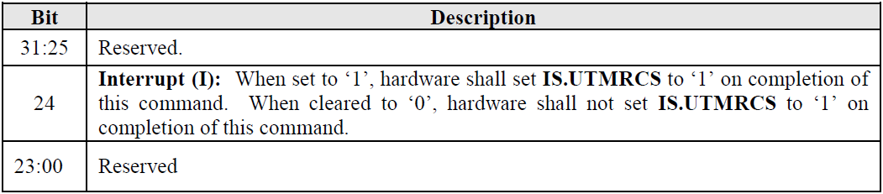

* Overall Command Status

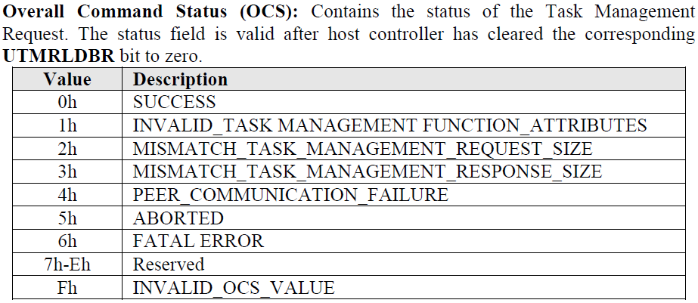

## UPIU (UFS Protocol Information Unit) format

### UPIU total size

* Integer Multiple of 32-bits
* Smallest sized UPIU is 32 bytes

### UPIU types

* COMMAND UPIU
* RESPONSE UPIU
* DATA OUT UPIU
* DATA IN UPIU
* READY TO TRANSFER UPIU
* TASK MANAGEMENT REQUEST UPIU
* TASK MANAGEMENT RESPONSE UPIU
* QUERY REQUEST UPIU
* QUERY RESPONSE UPIU
* REJECT UPIU
* NOP OUT UPIU
* NOP IN UPIU

### Basic Header Format

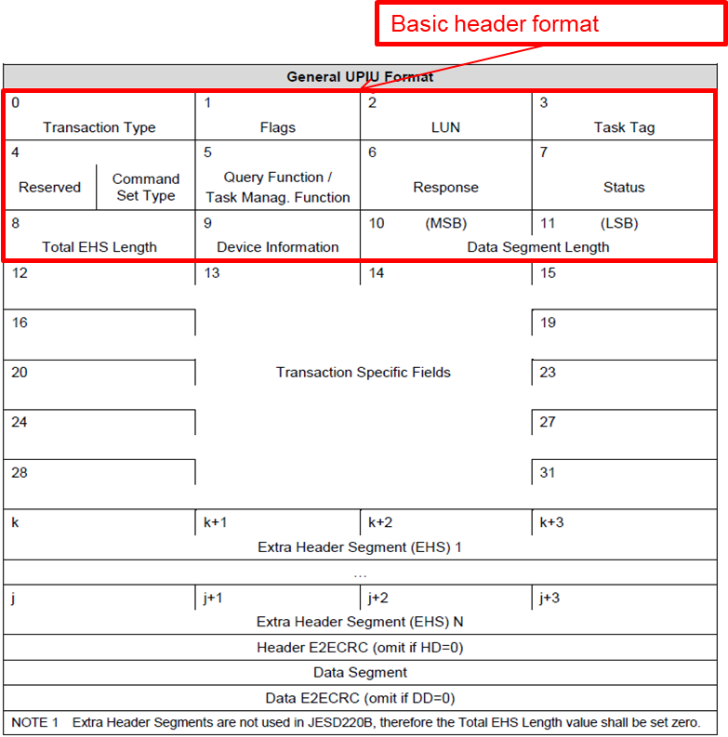

* 0 - Transaction Type

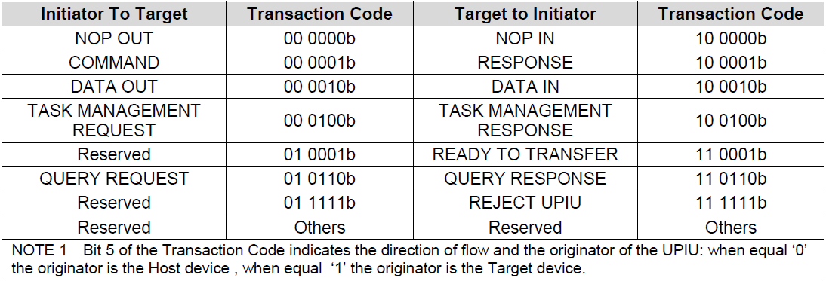

* 1 - Flag: Vary with transaction type

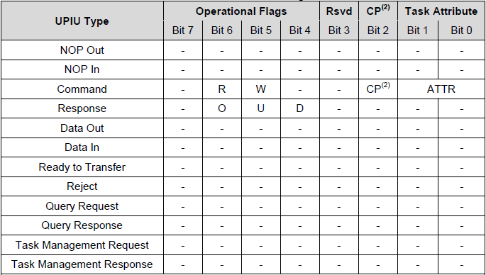

* 2 - Logical Unit Number of target device
* 3 - Task Tag ( Queue )

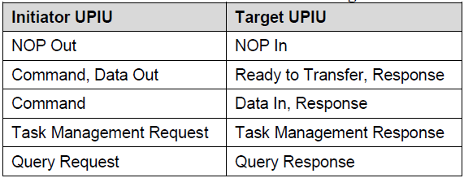

* 4 - Command Set Type

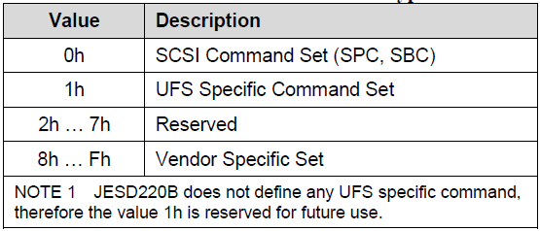

* 5 - Be used in QUERY, TASK MAG. Function

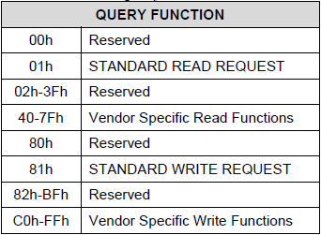

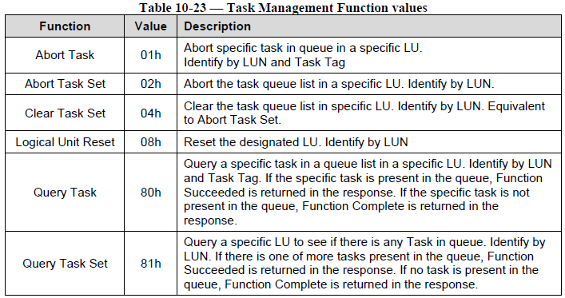

* 6 – Response

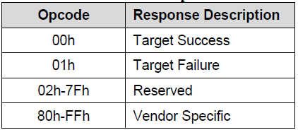

* 7 - SCSI status (RESPONSE UPIU with CMD set type = 0x00)

### COMMAND UPIU

* Transaction Specific Fields를 CDB로 구성
* CDB 설정에 따라 SCSI Command 구성

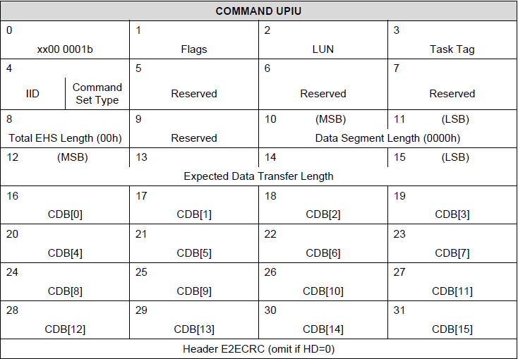

### QUERY REQUEST UPIU

* Transaction Specific Fields를 OPCODE와 OSF 로 구성
* OPCODE와 OSF에 따라 Query Descriptor 구성

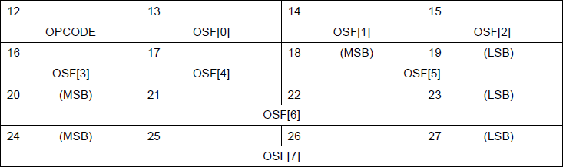

### TASK MANAGEMENT REQUEST UPIU

* Transaction Specific Fields를 Input Parameter 로 구성

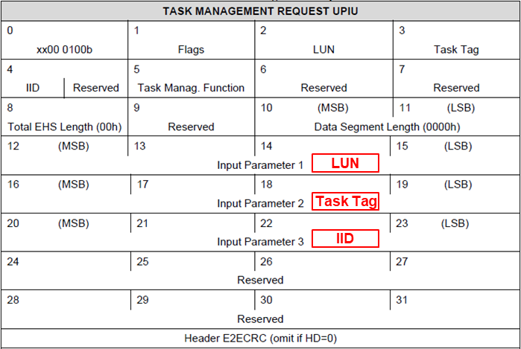

## RATE Series and GEARs

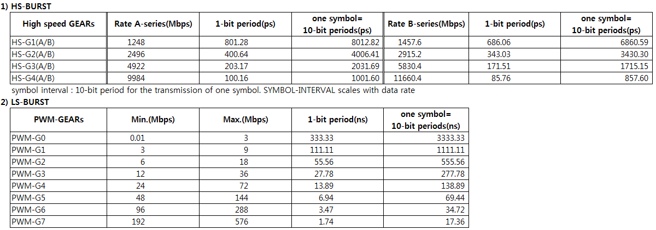

# UFS Initialize Host

## Initialize Host

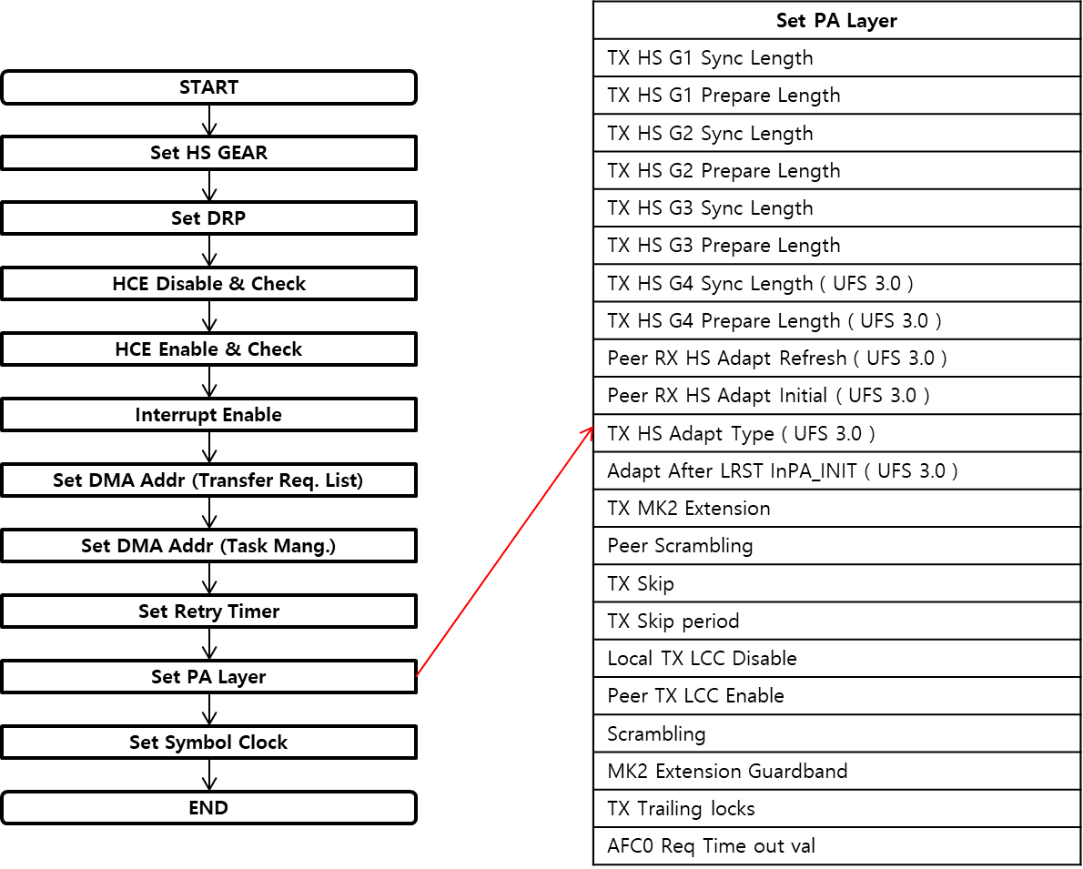

# UFS Link Startup

## Initialize Link Startup

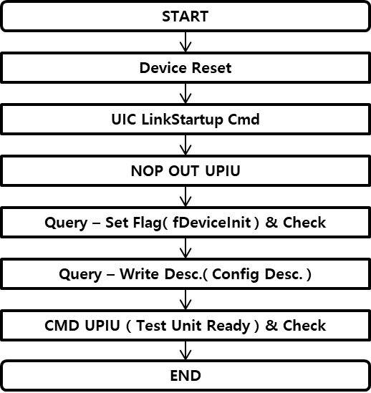

# UFS Set Power Mode

## Set Power mode

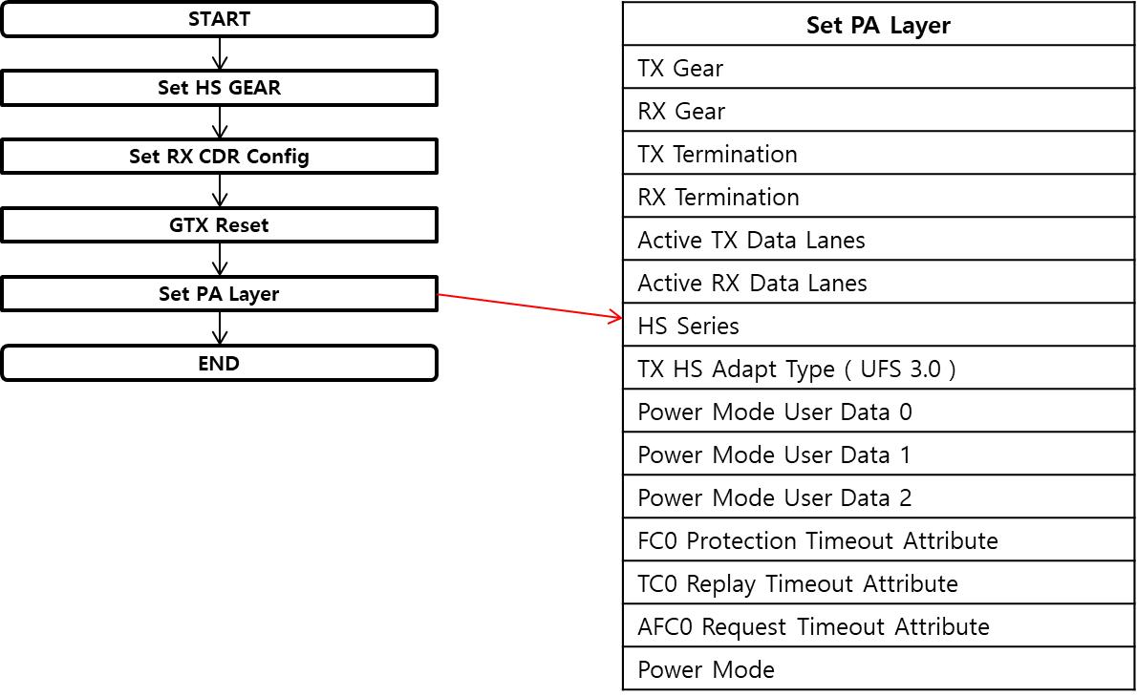

# UFS Command UPIU Operation

## Command UPIU Operation

* Flow

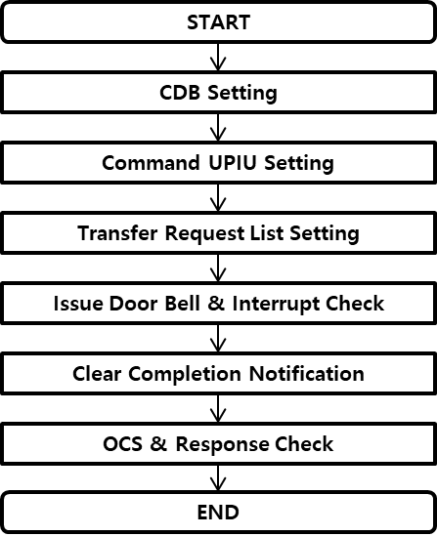

* Example
  + Read Capacity16

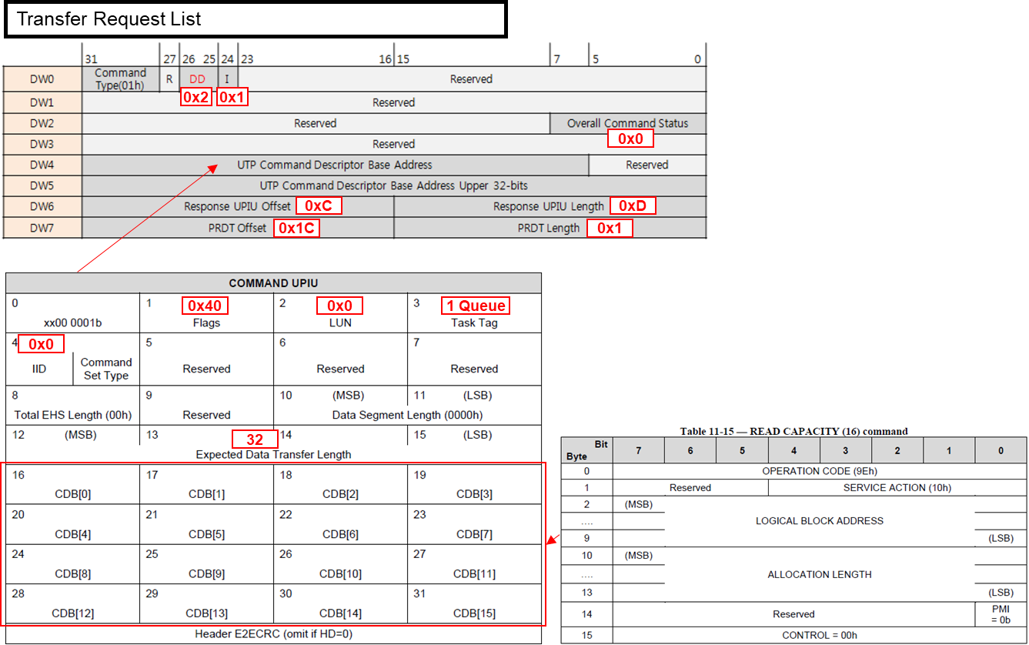

# UFS Query UPIU Operation

## Query UPIU Operation

* Flow

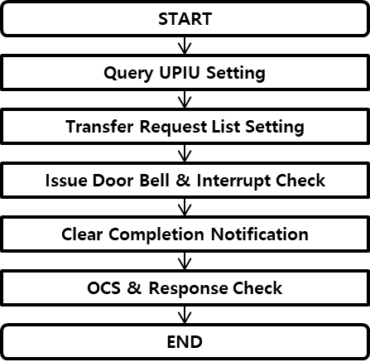

* Example ( Write Descriptor ( Configuration Descriptor ) )

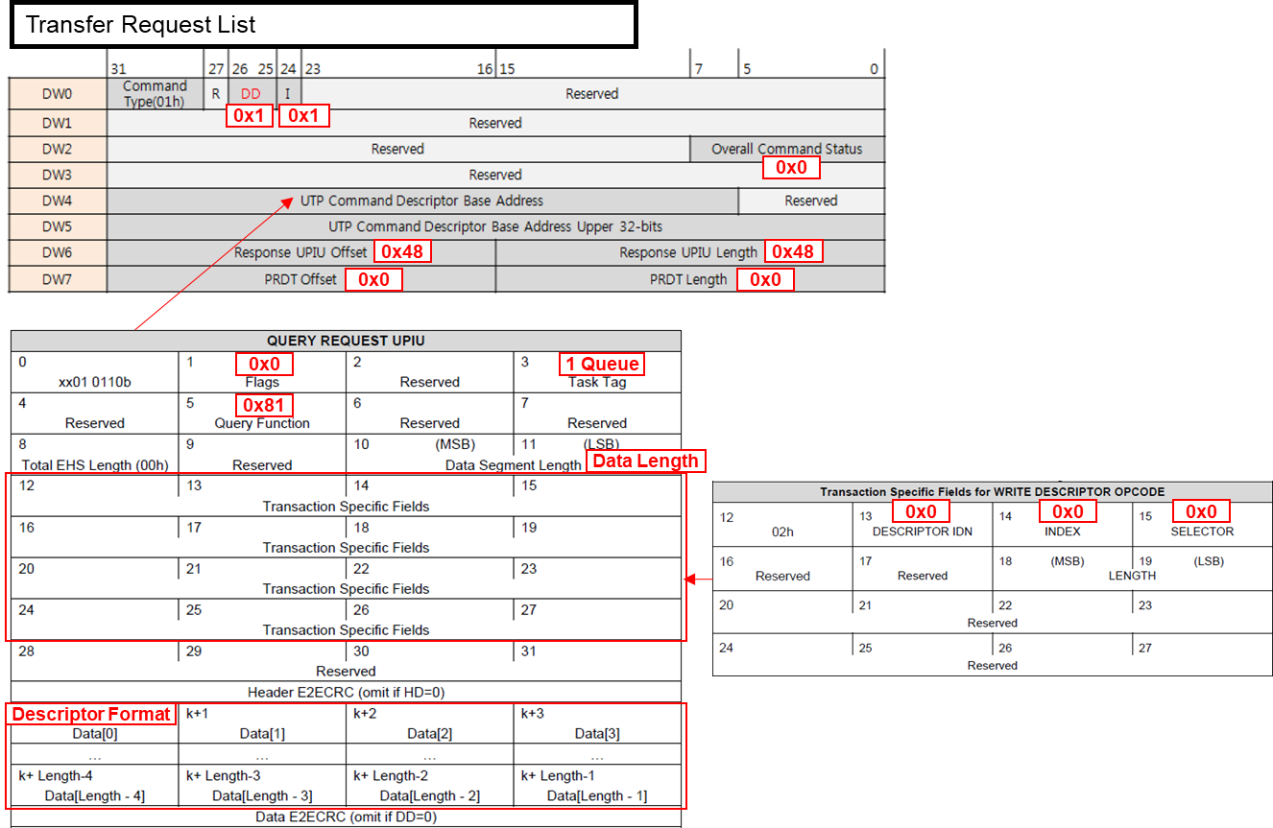

# UFS Task Management UPIU Operation

## Task Management UPIU Operation

* Flow

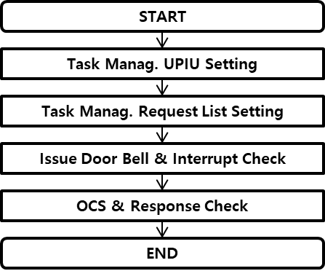

* Example ( Abort Task Function )

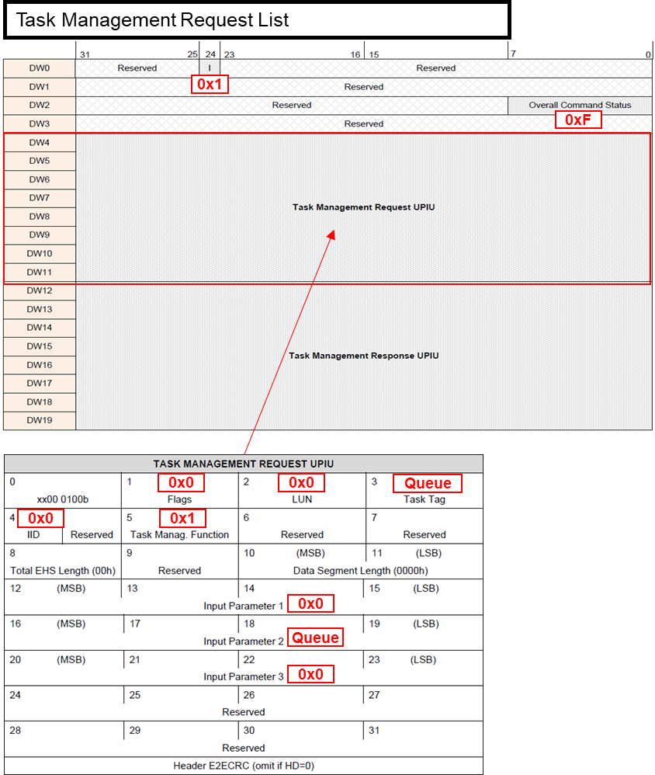

# Supporting Information

## Revision History

|  |  |  |  |
| --- | --- | --- | --- |
| 날짜 | 버전 | 설명 | 작성자 |
|  |  |  |  |
|  |  |  |  |
|  |  |  |  |
|  |  |  |  |
|  |  |  |  |
|  |  |  |  |
|  |  |  |  |

|  |
| --- |
| **UniTest Inc.**  27, Gigok-ro, Giheung-gu, Yongin-si, Gyeonggi-do, Korea  Zip Code: 446-930  Tel : 82-31-547-0300  Fax : 82-31-547-0468 |