Исходный код

Файл Create-User-Interface-Programmatically/app/src/main/AndroidManifest.xml

<manifest xmlns:android="http://schemas.android.com/apk/res/android"
package="com.example.create_user_interface_programmatically">

<application
android:allowBackup="true"
android:icon="@mipmap/ic_launcher"
android:label="@string/app_name"
android:roundIcon="@mipmap/ic_launcher_round"
android:supportsRtl="true"
android:theme="@style/AppTheme">

<activity android:name=".MainActivity">
<intent-filter>
<action android:name="android.intent.action.MAIN" />
<category android:name="android.intent.category.LAUNCHER" />
</intent-filter>
</activity>

</application>
</manifest>

Файл Create-User-Interface-Programmatically/app/src/main/java/com/example/create_user_interface_programmatically/MainActivity.java

package com.example.create_user_interface_programmatically;

import android.support.v7.app.AppCompatActivity;
import android.os.Bundle;
import android.view.Gravity;
import android.widget.Button;
import android.widget.LinearLayout;
import android.widget.LinearLayout.LayoutParams;
import android.widget.TextView;

public class MainActivity extends AppCompatActivity {
@Override
protected void onCreate(Bundle savedInstanceState) {
super.onCreate(savedInstanceState);

LinearLayout linLayout = new LinearLayout(this);
linLayout.setOrientation(LinearLayout.VERTICAL);

LayoutParams linLayoutParams = new LayoutParams(LayoutParams.MATCH_PARENT, LayoutParams.MATCH_PARENT);

setContentView(linLayout, linLayoutParams);

TextView tv = new TextView(this);
tv.setText("TextView");
linLayout.addView(tv);

Button btn = new Button(this);
btn.setText("Button");
linLayout.addView(btn);

LayoutParams lpView = new LayoutParams(LayoutParams.WRAP_CONTENT, LayoutParams.WRAP_CONTENT);
tv.setLayoutParams(lpView);
btn.setLayoutParams(lpView);

LinearLayout linLayoutForBtn = new LinearLayout(this);
linLayoutForBtn.setOrientation(LinearLayout.HORIZONTAL);
lpView = new LayoutParams(LayoutParams.WRAP_CONTENT, LayoutParams.WRAP_CONTENT);
lpView.leftMargin = 100;
linLayoutForBtn.setLayoutParams(lpView);
linLayout.addView(linLayoutForBtn);

lpView = new LayoutParams(LayoutParams.WRAP_CONTENT, LayoutParams.WRAP_CONTENT);
lpView.leftMargin = 50;

btn = new Button(this);
btn.setLayoutParams(lpView);
btn.setText("Button1");
linLayoutForBtn.addView(btn);

btn = new Button(this);
btn.setLayoutParams(lpView);
btn.setText("Button1");
linLayoutForBtn.addView(btn);

btn = new Button(this);
btn.setLayoutParams(lpView);
btn.setText("Button1");
linLayoutForBtn.addView(btn);

tv = new TextView(this);
lpView = new LayoutParams(LayoutParams.WRAP_CONTENT, LayoutParams.WRAP_CONTENT);
lpView.gravity = Gravity.CENTER_HORIZONTAL;
tv.setLayoutParams(lpView);
tv.setText("TextView");
linLayout.addView(tv);

tv = new TextView(this);
lpView = new LayoutParams(LayoutParams.WRAP_CONTENT, LayoutParams.WRAP_CONTENT);
lpView.gravity = Gravity.RIGHT;
lpView.rightMargin = 50;
tv.setLayoutParams(lpView);
tv.setText("TextView");
linLayout.addView(tv);
}
}

Скриншоты

Создание проекта

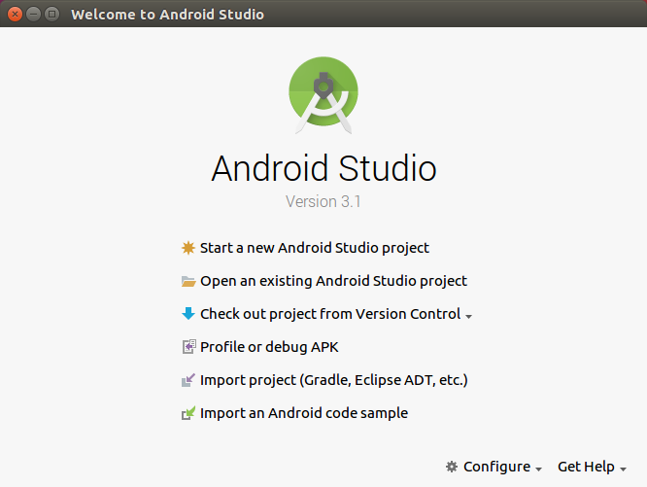

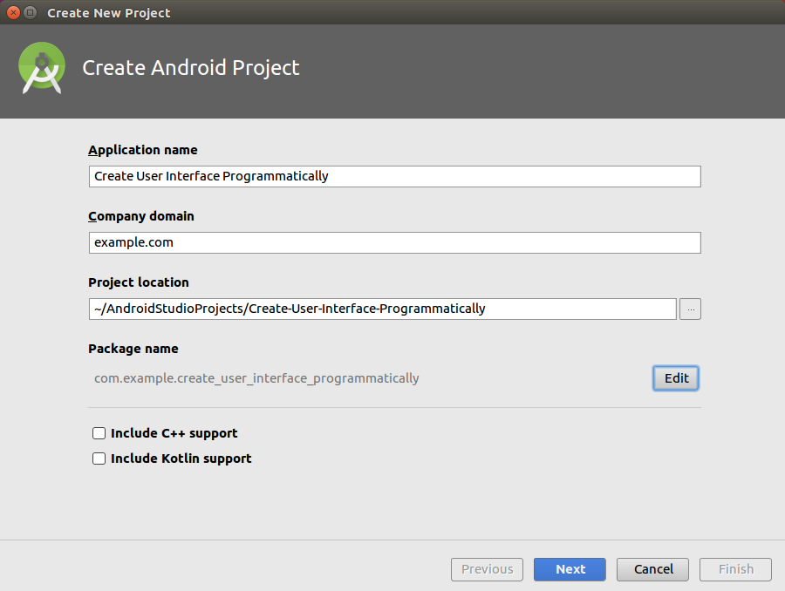
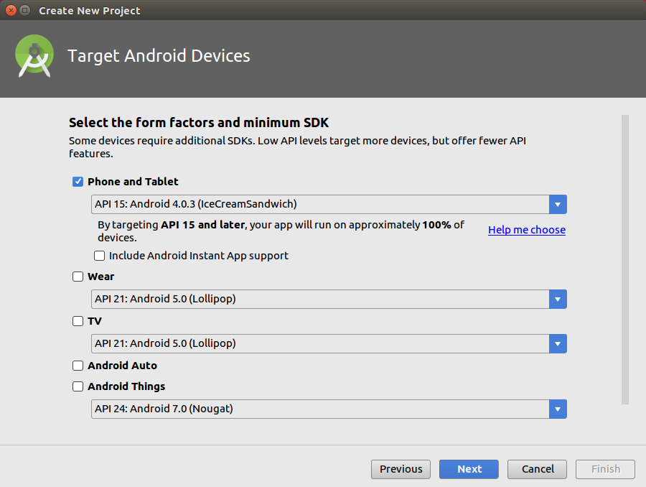

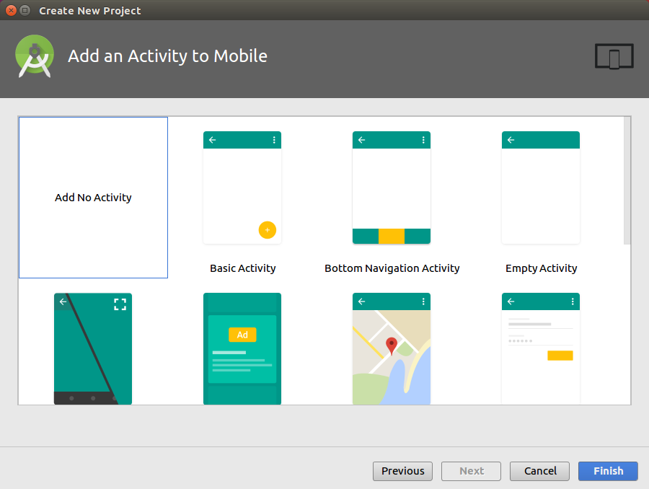

Запуск мобильного приложения на эмуляторе

