Часть № 1 - Явный Intent

Исходный код

Файл Explicit-Intent-With-Activity/app/src/main/AndroidManifest.xml
<manifest xmlns:android="http://schemas.android.com/apk/res/android"
package="com.example.explicit_intent_with_activity">

<application
android:allowBackup="true"
android:icon="@mipmap/ic_launcher"
android:label="@string/app_name"
android:roundIcon="@mipmap/ic_launcher_round"
android:supportsRtl="true"
android:theme="@style/AppTheme">

<activity
android:name=".CreateMessageActivity"
android:label="@string/app_name">
<intent-filter>
<action android:name="android.intent.action.MAIN" />
<category android:name="android.intent.category.LAUNCHER" />
</intent-filter>
</activity>

<activity
android:name=".ReceiveMessageActivity"
android:label="@string/title_activity_receive_message">
</activity>

</application>
</manifest>

Файл Explicit-Intent-With-Activity/app/src/main/res/layout/activity_create_message.xml
<?xml version="1.0" encoding="utf-8"?>
<LinearLayout xmlns:android="http://schemas.android.com/apk/res/android"
xmlns:tools="http://schemas.android.com/tools"
android:layout_width="match_parent"
android:layout_height="match_parent"
android:orientation="vertical"
android:layout_margin="20dp"
tools:context=".CreateMessageActivity">

<Button
android:id="@+id/buttonSendMessage"
android:layout_width="wrap_content"
android:layout_height="wrap_content"
android:text="SEND MESSAGE" />

<EditText
android:id="@+id/message"
android:layout_width="match_parent"
android:layout_height="wrap_content"
android:inputType="textPersonName"
android:text="A little message" />

</LinearLayout>

Файл Explicit-Intent-With-Activity/app/src/main/java/com/example/explicit_intent_with_activity/CreateMessageActivity.java
package com.example.explicit_intent_with_activity;

import android.content.Intent;
import android.support.v7.app.AppCompatActivity;
import android.os.Bundle;
import android.view.View;
import android.view.View.OnClickListener;
import android.widget.EditText;

public class CreateMessageActivity extends AppCompatActivity {
@Override
protected void onCreate(Bundle savedInstanceState) {
super.onCreate(savedInstanceState);
setContentView(R.layout.activity_create_message);

findViewById(R.id.buttonSendMessage).setOnClickListener(new OnClickListener() {
@Override
public void onClick(View v) {
onSendMessage(v);
}
});
}

public void onSendMessage(View view) {
EditText messageView = (EditText)findViewById(R.id.message);
String messageText = messageView.getText().toString();
Intent intent = new Intent(this, ReceiveMessageActivity.class);
intent.putExtra("message", messageText);
startActivity(intent);
}

}

Файл Explicit-Intent-With-Activity/app/src/main/res/layout/activity_receive_message.xml
<?xml version="1.0" encoding="utf-8"?>
<LinearLayout xmlns:android="http://schemas.android.com/apk/res/android"
xmlns:tools="http://schemas.android.com/tools"
android:layout_width="match_parent"
android:layout_height="match_parent"
android:orientation="vertical"
android:layout_margin="20dp"
tools:context=".ReceiveMessageActivity">

<TextView
android:id="@+id/message"
android:layout_width="wrap_content"
android:layout_height="wrap_content"
android:textSize="32sp"
android:text="Hello World!" />

</LinearLayout>

Файл Explicit-Intent-With-Activity/app/src/main/java/com/example/explicit_intent_with_activity/ReceiveMessageActivity.java
package com.example.explicit_intent_with_activity;

import android.content.Intent;
import android.support.v7.app.AppCompatActivity;
import android.os.Bundle;
import android.widget.TextView;

public class ReceiveMessageActivity extends AppCompatActivity {
public static final String EXTRA_MESSAGE = "message";

@Override
protected void onCreate(Bundle savedInstanceState) {
super.onCreate(savedInstanceState);
setContentView(R.layout.activity_receive_message);

Intent intent = getIntent();
String messageText = intent.getStringExtra(EXTRA_MESSAGE);
TextView messageView = (TextView)findViewById(R.id.message);
messageView.setText(messageText);
}

}

Скриншоты

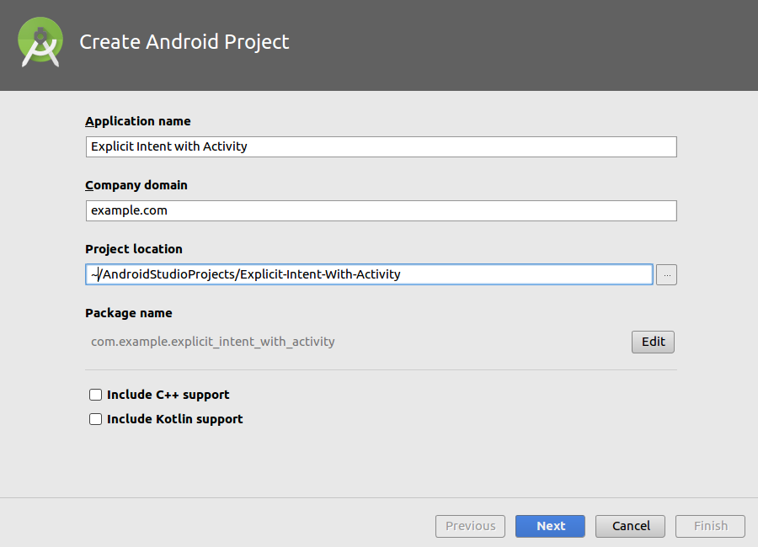

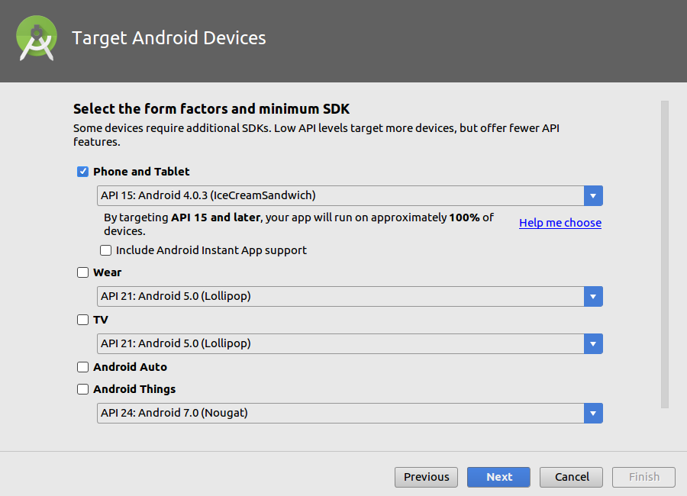

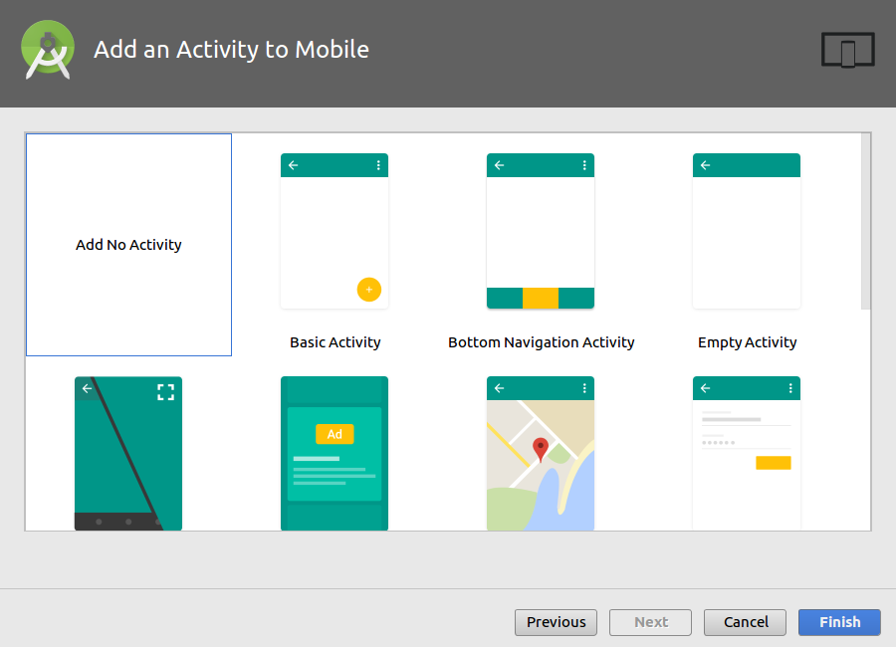

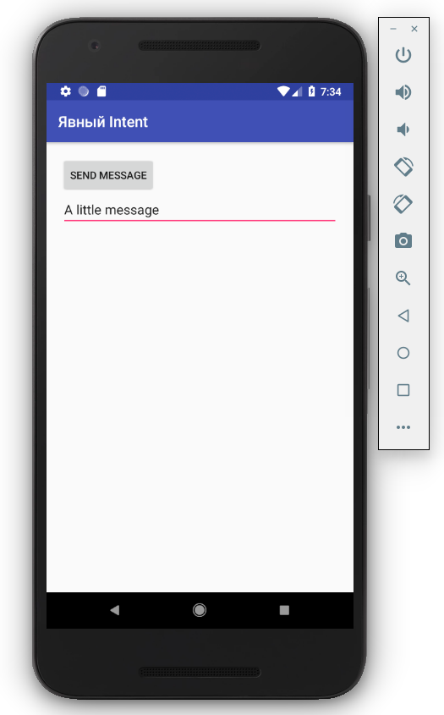

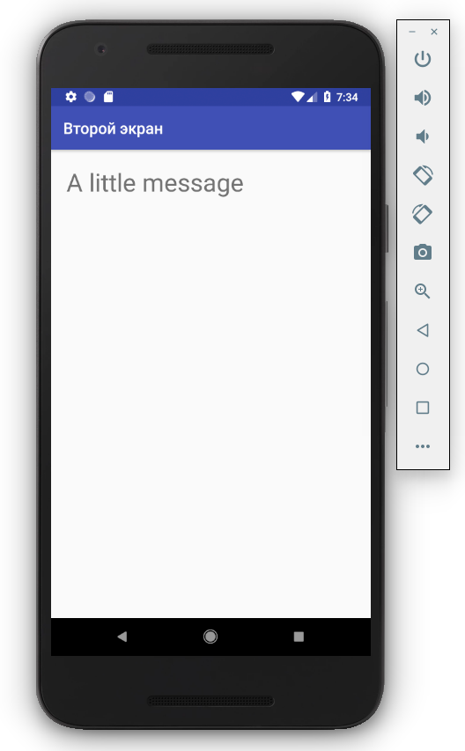

Часть № 2 – Неявный Intent

Исходный код

Файл Implicit-Intent-With-Action/app/src/main/AndroidManifest.xml
<manifest xmlns:android="http://schemas.android.com/apk/res/android"
package="com.example.implicit_intent_with_action">

<application
android:allowBackup="true"
android:icon="@mipmap/ic_launcher"
android:label="@string/app_name"
android:roundIcon="@mipmap/ic_launcher_round"
android:supportsRtl="true"
android:theme="@style/AppTheme">

<activity
android:name=".CreateMessageActivity"
android:label="@string/app_name">
<intent-filter>
<action android:name="android.intent.action.MAIN" />
<category android:name="android.intent.category.LAUNCHER" />
</intent-filter>
</activity>

<activity
android:name=".ShareActivity"
android:label="@string/title_activity_receive_message">
<intent-filter>
<action android:name="android.intent.action.SEND"/>
<category android:name="android.intent.category.DEFAULT"/>
<data android:mimeType="text/plain"/>
<data android:mimeType="image/*"/>
</intent-filter>
</activity>

</application>
</manifest>

Файл Implicit-Intent-With-Action/app/src/main/res/layout/activity_create_message.xml
<?xml version="1.0" encoding="utf-8"?>
<LinearLayout xmlns:android="http://schemas.android.com/apk/res/android"
xmlns:tools="http://schemas.android.com/tools"
android:layout_width="match_parent"
android:layout_height="match_parent"
android:orientation="vertical"
android:layout_margin="20dp"
tools:context=".CreateMessageActivity">

<Button
android:id="@+id/buttonSendMessage"
android:layout_width="wrap_content"
android:layout_height="wrap_content"
android:text="SEND MESSAGE" />

<EditText
android:id="@+id/message"
android:layout_width="match_parent"
android:layout_height="wrap_content"
android:inputType="textPersonName"
android:text="A little message" />

</LinearLayout>

Файл Implicit-Intent-With-Action/app/src/main/java/com/example/implicit_intent_with_action/CreateMessageActivity.java
package com.example.implicit_intent_with_action;

import android.content.Intent;
import android.support.v7.app.AppCompatActivity;
import android.os.Bundle;
import android.view.View;
import android.view.View.OnClickListener;
import android.widget.EditText;

public class CreateMessageActivity extends AppCompatActivity {
@Override
protected void onCreate(Bundle savedInstanceState) {
super.onCreate(savedInstanceState);
setContentView(R.layout.activity_create_message);

findViewById(R.id.buttonSendMessage).setOnClickListener(new OnClickListener() {
@Override
public void onClick(View v) {
onSendMessage(v);
}
});
}

public void onSendMessage(View view) {
EditText messageView = (EditText)findViewById(R.id.message);
String messageText = messageView.getText().toString();
Intent intent = new Intent(Intent.ACTION_SEND);
intent.setType("text/plain");
intent.putExtra(Intent.EXTRA_TEXT, messageText);
startActivity(intent);
}

}

Файл Implicit-Intent-With-Action/app/src/main/res/layout/activity_share.xml
<?xml version="1.0" encoding="utf-8"?>
<LinearLayout xmlns:android="http://schemas.android.com/apk/res/android"
xmlns:tools="http://schemas.android.com/tools"
android:layout_width="match_parent"
android:layout_height="match_parent"
android:orientation="vertical"
android:layout_margin="20dp"
tools:context=".ShareActivity">

<TextView
android:id="@+id/message"
android:layout_width="wrap_content"
android:layout_height="wrap_content"
android:textSize="32sp"
android:text="Hello World!" />

</LinearLayout>

Файл Implicit-Intent-With-Action/app/src/main/java/com/example/implicit_intent_with_action/ShareActivity.java
package com.example.implicit_intent_with_action;

import android.content.Intent;
import android.support.v7.app.AppCompatActivity;
import android.os.Bundle;
import android.widget.TextView;

public class ShareActivity extends AppCompatActivity {
@Override
protected void onCreate(Bundle savedInstanceState) {
super.onCreate(savedInstanceState);
setContentView(R.layout.activity_share);

Intent intent = getIntent();
String messageText = intent.getStringExtra(Intent.EXTRA_TEXT);
TextView messageView = (TextView)findViewById(R.id.message);
messageView.setText(messageText);
}

}

Скриншоты

