Часть № 1

Исходный код

Файл Layout-Inflater-App/app/src/main/AndroidManifest.xml
<manifest xmlns:android="http://schemas.android.com/apk/res/android"
package="com.example.layout_inflater_app">

<application
android:allowBackup="true"
android:icon="@mipmap/ic_launcher"
android:label="@string/app_name"
android:roundIcon="@mipmap/ic_launcher_round"
android:supportsRtl="true"
android:theme="@style/AppTheme">
<activity android:name=".MainActivity">
<intent-filter>
<action android:name="android.intent.action.MAIN" />

<category android:name="android.intent.category.LAUNCHER" />
</intent-filter>
</activity>
</application>
</manifest>

Файл Layout-Inflater-App/app/src/main/java/com/example/layout_inflater_app/MainActivity.java
package com.example.layout_inflater_app;

import android.support.v7.app.AppCompatActivity;
import android.os.Bundle;
import android.view.LayoutInflater;
import android.view.View;
import android.widget.Button;
import android.widget.LinearLayout;
import android.widget.TextView;

import java.util.Locale;

public class MainActivity extends AppCompatActivity {

private LayoutInflater ltInflater;
private LinearLayout linLayout;

@Override
protected void onCreate(Bundle savedInstanceState) {
super.onCreate(savedInstanceState);
setContentView(R.layout.activity_main);

linLayout = (LinearLayout)findViewById(R.id.linLayout);

ltInflater = getLayoutInflater();
View view = ltInflater.inflate(R.layout.text, null, false);
linLayout.addView(view);

ltInflater.inflate(R.layout.btn, linLayout, true);

addRow("Марья", "Бухгалтер", 10000, 0xFF2F4F4F);
addRow("Петр", "Программер", 13000, 0xFF800080);
addRow("Антон", "Программер", 13000, 0xFF2F4F4F);
addRow("Даша", "Бухгалтер", 10000, 0xFF800080);
}

private void addRow(String firstName, String occupation, Integer salary, Integer bgcolor) {
View row = ltInflater.inflate(R.layout.group, null, false);

row.setBackgroundColor(bgcolor);
((TextView)row.findViewById(R.id.firstName)).setText(firstName);
((TextView)row.findViewById(R.id.occupation)).setText(occupation);
((TextView)row.findViewById(R.id.salary)).setText(String.format(Locale.getDefault(), "%d", salary));

linLayout.addView(row);
}
}

Файл Layout-Inflater-App/app/src/main/res/layout/activity_main.xml
<?xml version="1.0" encoding="utf-8"?>
<android.support.constraint.ConstraintLayout xmlns:android="http://schemas.android.com/apk/res/android"
xmlns:app="http://schemas.android.com/apk/res-auto"
xmlns:tools="http://schemas.android.com/tools"
android:layout_width="match_parent"
android:layout_height="match_parent"
tools:context=".MainActivity">

<LinearLayout xmlns:android="http://schemas.android.com/apk/res/android"
android:layout_width="match_parent"
android:layout_height="match_parent"
android:orientation="vertical"
android:id="@+id/linLayout">

</LinearLayout>

</android.support.constraint.ConstraintLayout>

Файл Layout-Inflater-App/app/src/main/res/layout/text.xml
<?xml version="1.0" encoding="utf-8"?>
<TextView xmlns:android="http://schemas.android.com/apk/res/android"
android:id="@+id/tvLayout"
android:layout_width="match_parent"
android:layout_height="match_parent"
android:text="Layout with TextView"
style="@style/MyTextStyle">
</TextView>

Файл Layout-Inflater-App/app/src/main/res/layout/btn.xml
<?xml version="1.0" encoding="utf-8"?>
<Button xmlns:android="http://schemas.android.com/apk/res/android"
android:layout_width="wrap_content"
android:layout_height="wrap_content"
android:text="Кнопка">

</Button>

Файл Layout-Inflater-App/app/src/main/res/layout/group.xml
<?xml version="1.0" encoding="utf-8"?>
<LinearLayout xmlns:android="http://schemas.android.com/apk/res/android"
android:layout_width="match_parent"
android:layout_height="wrap_content"
android:orientation="vertical"
android:background="#2F4F4F">

<TextView android:id="@+id/firstName"
android:layout_width="match_parent"
android:layout_height="wrap_content"
android:textAlignment="center"
android:text="Антон"
android:textSize="30sp"
android:textColor="#DCDCDC"/>

<LinearLayout
android:layout_width="match_parent"
android:layout_height="wrap_content"
android:orientation="horizontal">

<LinearLayout
android:layout_width="wrap_content"
android:layout_height="wrap_content"
android:orientation="horizontal">
<TextView
android:layout_width="wrap_content"
android:layout_height="wrap_content"
android:textAlignment="center"
android:text="Должность: "
android:textSize="18sp"
android:textColor="#DCDCDC"/>
<TextView android:id="@+id/occupation"
android:layout_width="wrap_content"
android:layout_height="wrap_content"
android:textAlignment="center"
android:text="Программер"
android:textSize="18sp"
android:textColor="#DCDCDC"/>
</LinearLayout>

<LinearLayout
android:layout_width="fill_parent"
android:layout_height="wrap_content"
android:orientation="horizontal"
android:gravity="right">
<TextView
android:layout_width="wrap_content"
android:layout_height="wrap_content"
android:textAlignment="center"
android:text="Оклад: "
android:textSize="18sp"
android:textColor="#DCDCDC"/>
<TextView android:id="@+id/salary"
android:layout_width="wrap_content"
android:layout_height="wrap_content"
android:textAlignment="center"
android:text="13000"
android:textSize="18sp"
android:textColor="#DCDCDC"/>
</LinearLayout>

</LinearLayout>

</LinearLayout>

Файл Layout-Inflater-App/app/src/main/res/values/styles.xml
<resources>

<!-- Base application theme. -->
<style name="AppTheme" parent="Theme.AppCompat.Light.DarkActionBar">
<!-- Customize your theme here. -->
<item name="colorPrimary">@color/colorPrimary</item>
<item name="colorPrimaryDark">@color/colorPrimaryDark</item>
<item name="colorAccent">@color/colorAccent</item>
</style>

<style name="MyTextStyle">
<item name="android:textColor">#FF00FF</item>
<item name="android:textSize">30sp</item>
<item name="android:typeface">monospace</item>
</style>

</resources>

Файл Layout-Inflater-App/app/build.gradle
apply plugin: 'com.android.application'

android {
compileSdkVersion 27
defaultConfig {
applicationId "com.example.layout_inflater_app"
minSdkVersion 15
targetSdkVersion 27
versionCode 1
versionName "1.0"
testInstrumentationRunner "android.support.test.runner.AndroidJUnitRunner"
}
buildTypes {
release {
minifyEnabled false
proguardFiles getDefaultProguardFile('proguard-android.txt'), 'proguard-rules.pro'
}
}
}

dependencies {
implementation fileTree(dir: 'libs', include: ['*.jar'])
implementation 'com.android.support:appcompat-v7:27.1.1'
testImplementation 'junit:junit:4.12'
androidTestImplementation 'com.android.support.test:runner:1.0.1'
androidTestImplementation 'com.android.support.test.espresso:espresso-core:3.0.1'
implementation 'com.android.support.constraint:constraint-layout:1.0.2'
}

Скриншоты

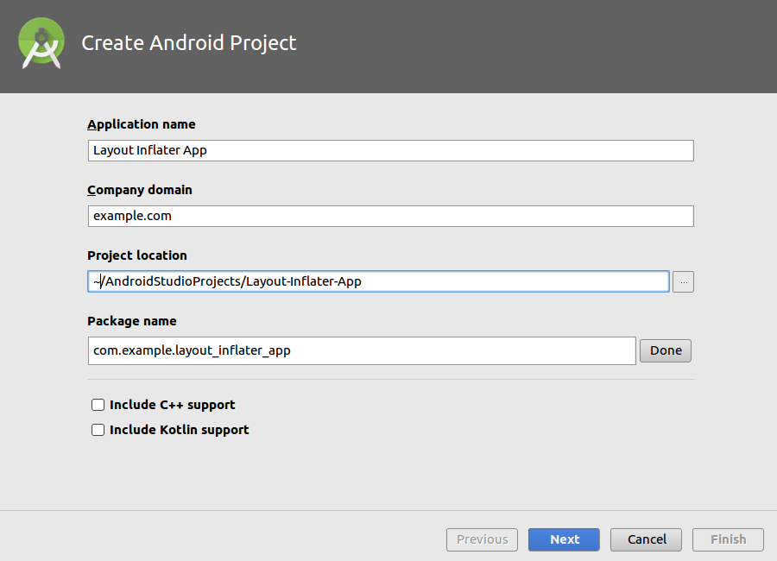

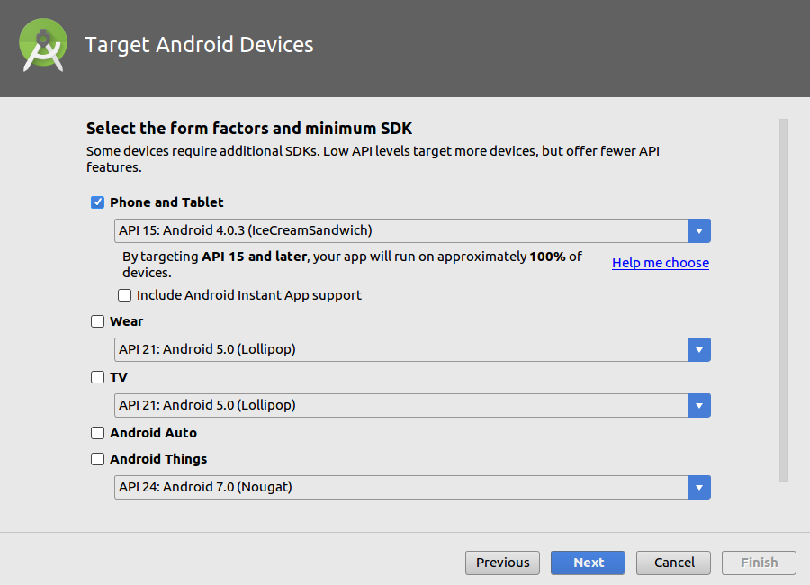

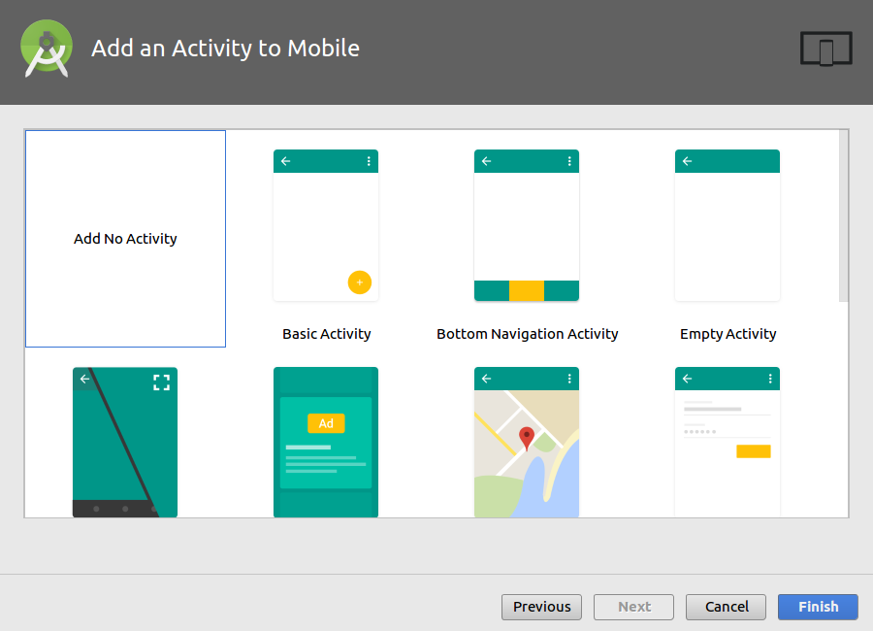

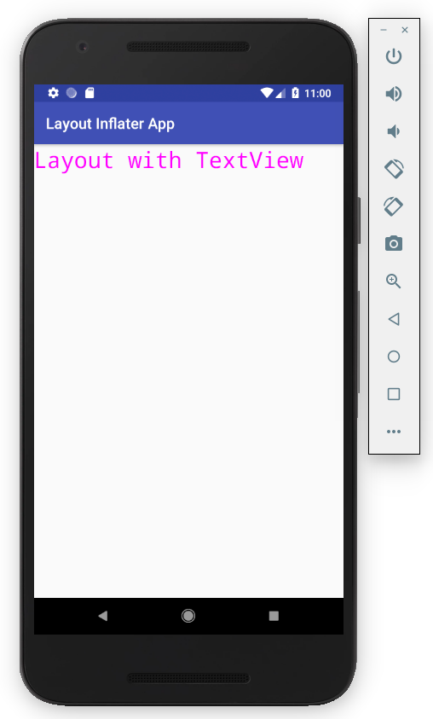
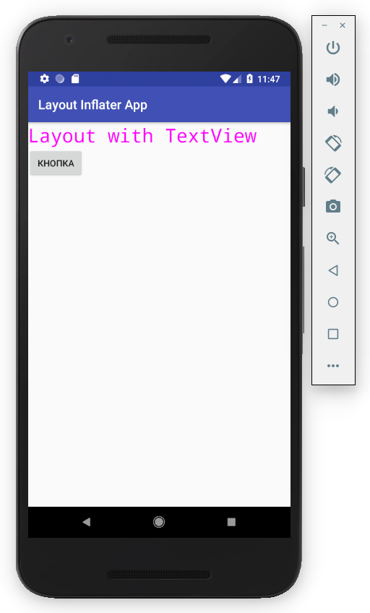

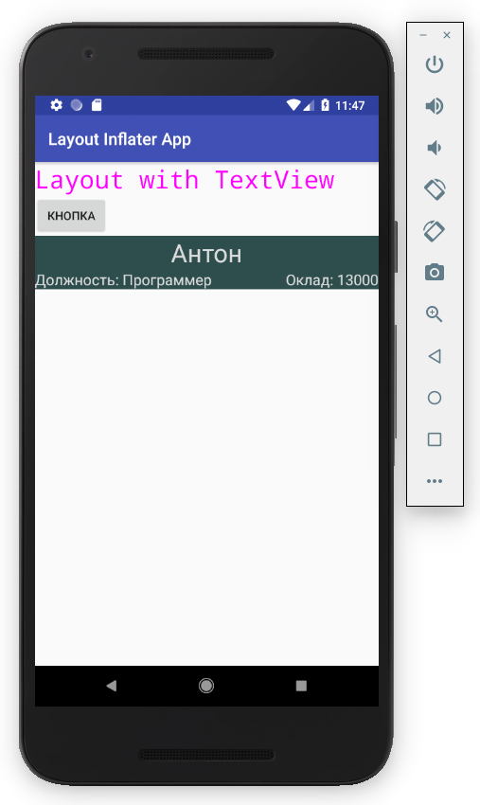
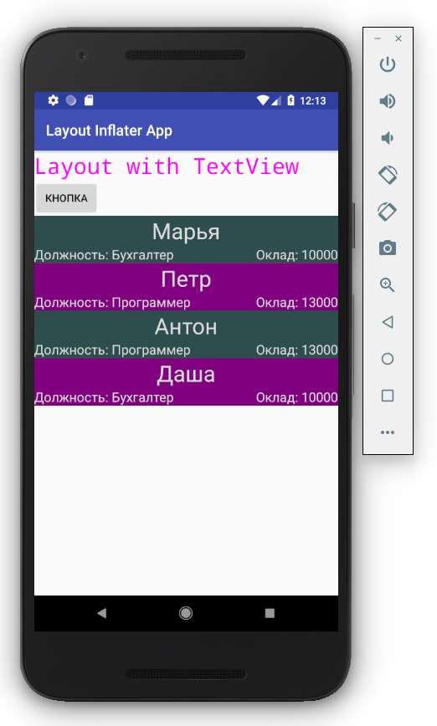

Часть № 2

Исходный код

Файл Layout-Inflater-Chat-App/app/src/main/AndroidManifest.xml
<?xml version="1.0" encoding="utf-8"?>
<manifest xmlns:android="http://schemas.android.com/apk/res/android"
package="com.example.layout_inflater_chat_app">

<application
android:allowBackup="true"
android:icon="@mipmap/ic_launcher"
android:label="@string/app_name"
android:roundIcon="@mipmap/ic_launcher_round"
android:supportsRtl="true"
android:theme="@style/AppTheme">
<activity android:name=".MainActivity">
<intent-filter>
<action android:name="android.intent.action.MAIN" />

<category android:name="android.intent.category.LAUNCHER" />
</intent-filter>
</activity>
</application>

</manifest>

Файл Layout-Inflater-Chat-App/app/src/main/java/com/example/layout_inflater_chat_app/MainActivity.java
package com.example.layout_inflater_chat_app;

import android.support.v7.app.AppCompatActivity;
import android.os.Bundle;
import android.view.LayoutInflater;
import android.view.View;
import android.view.View.OnClickListener;
import android.widget.EditText;
import android.widget.LinearLayout;
import android.widget.TextView;
import android.support.v4.content.res.ResourcesCompat;

import java.text.SimpleDateFormat;
import java.util.Calendar;

public class MainActivity extends AppCompatActivity {

private final SimpleDateFormat df = new SimpleDateFormat("HH:mm");
private Integer msgCnt = 0;

@Override
protected void onCreate(Bundle savedInstanceState) {
super.onCreate(savedInstanceState);
setContentView(R.layout.activity_main);

final LinearLayout msgLinLayout = (LinearLayout)findViewById(R.id.msgLinLayout);
final LayoutInflater ltInflater = getLayoutInflater();

findViewById(R.id.btnOK).setOnClickListener(new OnClickListener() {
@Override
public void onClick(View v) {
View view = ltInflater.inflate(R.layout.msg, null, false);

msgCnt++;
((TextView)view.findViewById(R.id.msgText)).setText(msgCnt.toString() + ". " +
((EditText)findViewById(R.id.msgEditText)).getText().toString()
);

if (msgCnt % 2 != 0) {
view.setBackgroundDrawable(ResourcesCompat.getDrawable(getResources(),
R.drawable.rounded_border_odd, null));
} else {
view.setBackgroundDrawable(ResourcesCompat.getDrawable(getResources(),
R.drawable.rounded_border_even, null));
}

Calendar c = Calendar.getInstance();
String formattedDate = df.format(c.getTime());
((TextView)view.findViewById(R.id.msgTime)).setText(formattedDate);

msgLinLayout.addView(view);

((EditText)findViewById(R.id.msgEditText)).setText("");
}
});

findViewById(R.id.btnCancel).setOnClickListener(new OnClickListener() {
@Override
public void onClick(View v) {
((EditText)findViewById(R.id.msgEditText)).setText("");
}
});
}

}

Файл Layout-Inflater-Chat-App/app/src/main/res/layout/activity_main.xml
<?xml version="1.0" encoding="utf-8"?>
<android.support.constraint.ConstraintLayout xmlns:android="http://schemas.android.com/apk/res/android"
xmlns:app="http://schemas.android.com/apk/res-auto"
xmlns:tools="http://schemas.android.com/tools"
android:layout_width="match_parent"
android:layout_height="match_parent"
tools:context=".MainActivity">

<LinearLayout android:id="@+id/linLayout"
android:layout_width="match_parent"
android:layout_height="match_parent"
android:orientation="vertical"
android:layout_margin="5dp">

<TextView
android:layout_width="wrap_content"
android:layout_height="wrap_content"
android:text="Введите текст:"
app:layout_constraintBottom_toBottomOf="parent"
app:layout_constraintLeft_toLeftOf="parent"
app:layout_constraintRight_toRightOf="parent"
app:layout_constraintTop_toTopOf="parent" />

<EditText
android:id="@+id/msgEditText"
android:layout_width="match_parent"
android:layout_height="wrap_content"
android:inputType="textPersonName"
android:hint="Поле ввода" />

<LinearLayout
android:layout_width="match_parent"
android:layout_height="wrap_content"
android:gravity="right">
<Button android:id="@+id/btnCancel"
android:layout_width="wrap_content"
android:layout_height="wrap_content"
android:text="Отмена"/>
<Button android:id="@+id/btnOK"
android:layout_width="wrap_content"
android:layout_height="wrap_content"
android:text="ОК"/>
</LinearLayout>

<ScrollView
android:layout_width="fill_parent"
android:layout_height="fill_parent">
<LinearLayout android:id="@+id/msgLinLayout"
android:layout_width="match_parent"
android:layout_height="wrap_content"
android:orientation="vertical"
android:showDividers="middle"
android:divider="@drawable/empty_tall_divider">
</LinearLayout>
</ScrollView>

</LinearLayout>

</android.support.constraint.ConstraintLayout>

Файл Layout-Inflater-Chat-App/app/src/main/res/layout/msg.xml
<?xml version="1.0" encoding="utf-8"?>
<RelativeLayout xmlns:android="http://schemas.android.com/apk/res/android"
android:layout_width="match_parent"
android:layout_height="wrap_content"
android:background="@drawable/rounded_border_odd">
<TextView android:id="@+id/msgText"
android:layout_width="wrap_content"
android:layout_height="wrap_content"
android:layout_alignParentLeft="true"
android:layout_toLeftOf="@id/msgTime"
android:textSize="30sp"
android:text="1. Привет" />
<TextView android:id="@+id/msgTime"
android:layout_width="wrap_content"
android:layout_height="wrap_content"
android:layout_alignParentRight="true"
android:textSize="30sp"
android:text="20:15" />
</RelativeLayout>

Файл Layout-Inflater-Chat-App/app/src/main/res/drawable/rounded_border_even.xml
<?xml version="1.0" encoding="utf-8"?>
<shape xmlns:android="http://schemas.android.com/apk/res/android"
android:shape="rectangle">

<stroke
android:width="4dp"
android:color="#FF6B8E23" />

<solid android:color="#FF6B8E23" />

<corners android:radius="10dp" />

<padding
android:left="20dp"
android:top="10dp"
android:right="20dp"
android:bottom="10dp" >
</padding>

</shape>

Файл Layout-Inflater-Chat-App/app/src/main/res/drawable/rounded_border_odd.xml
<?xml version="1.0" encoding="utf-8"?>
<shape xmlns:android="http://schemas.android.com/apk/res/android"
android:shape="rectangle">

<stroke
android:width="4dp"
android:color="#FFADFF2F" />

<solid android:color="#FFADFF2F" />

<corners android:radius="10dp" />

<padding
android:left="20dp"
android:top="10dp"
android:right="20dp"
android:bottom="10dp" >
</padding>

</shape>

Файл Layout-Inflater-Chat-App/app/src/main/res/drawable/empty_tall_divider.xml
<?xml version="1.0" encoding="utf-8"?>
<shape xmlns:android="http://schemas.android.com/apk/res/android">
<size
android:height="5dp"
android:width="0dp"/>
</shape>

Файл Layout-Inflater-Chat-App/app/build.gradle
apply plugin: 'com.android.application'

android {
compileSdkVersion 27
defaultConfig {
applicationId "com.example.layout_inflater_chat_app"
minSdkVersion 15
targetSdkVersion 27
versionCode 1
versionName "1.0"
testInstrumentationRunner "android.support.test.runner.AndroidJUnitRunner"
}
buildTypes {
release {
minifyEnabled false
proguardFiles getDefaultProguardFile('proguard-android.txt'), 'proguard-rules.pro'
}
}
}

dependencies {
implementation fileTree(dir: 'libs', include: ['*.jar'])
implementation 'com.android.support:appcompat-v7:27.1.1'
implementation 'com.android.support.constraint:constraint-layout:1.0.2'
testImplementation 'junit:junit:4.12'
androidTestImplementation 'com.android.support.test:runner:1.0.1'
androidTestImplementation 'com.android.support.test.espresso:espresso-core:3.0.1'
implementation 'com.android.support.constraint:constraint-layout:1.0.2'
}

Скриншоты

