Задание

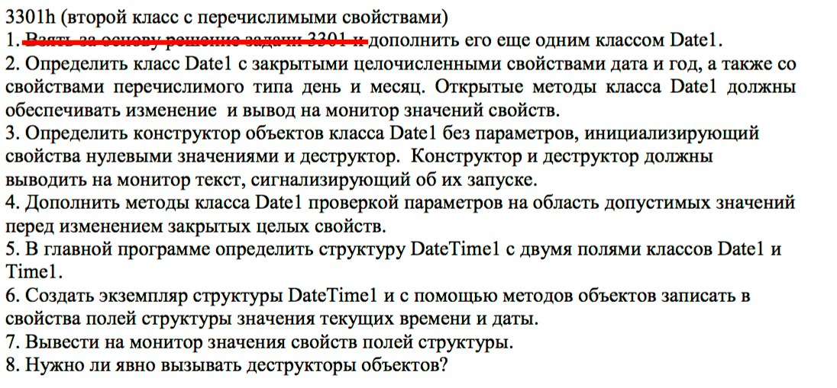

Исходный код

#include <iostream>

using namespace std;

enum _Day { UndefinedDay = 0, Monday = 1, Tuesday = 2, Wednesday = 3, Thursday = 4, Friday = 5, Saturday = 6, Sunday = 7 };
typedef enum _Day Day;

enum _Month { UndefinedMonth = 0, January = 1, February = 2, March = 3, April = 4, May = 5, June = 6, July = 7, August = 8, September = 9, October = 10, November = 11, December = 12 };
typedef enum _Month Month;

class Date1
{
public:
// Конструктор без параметров, инициализирующий свойства нулевыми значениями и деструктор:
Date1()
{
cout << "Date1()" << endl; // тест сигнализирующий о запуске конструктора.

this->date = 0;
this->year = 0;
this->day = UndefinedDay;
this->month = UndefinedMonth;
}

// Деструктор:
~Date1()
{
cout << "~Date1()" << endl; // тест сигнализирующий о запуске деструктора.
}

// Открытые методы обеспечивающие изменение и вывод на монитор значений свойств:

short int getDate() { return this->date; }

void printDate()
{
cout << "date = " << this->date << endl;
}

void setDate(short int date)
{
// Проверка на область допустимых значений перед изменением закрытого целого свойства:
switch (this->getMonth())
{
case January: if (date <= 0 || date > 31) { cout << "ERROR!" << endl; return; }
case February: if (date <= 0 || date > 29) { cout << "ERROR!" << endl; return; }
case March: if (date <= 0 || date > 31) { cout << "ERROR!" << endl; return; }
case April: if (date <= 0 || date > 30) { cout << "ERROR!" << endl; return; }
case May: if (date <= 0 || date > 31) { cout << "ERROR!" << endl; return; }
case June: if (date <= 0 || date > 30) { cout << "ERROR!" << endl; return; }
case July: if (date <= 0 || date > 31) { cout << "ERROR!" << endl; return; }
case August: if (date <= 0 || date > 31) { cout << "ERROR!" << endl; return; }
case September: if (date <= 0 || date > 30) { cout << "ERROR!" << endl; return; }
case October: if (date <= 0 || date > 31) { cout << "ERROR!" << endl; return; }
case November: if (date <= 0 || date > 30) { cout << "ERROR!" << endl; return; }
case December: if (date <= 0 || date > 31) { cout << "ERROR!" << endl; return; }
case UndefinedMonth:
default: if (date <= 0 || date > 31) { cout << "ERROR!" << endl; return; }
}

this->date = date;
}

short int getYear() { return this->year; }
void printYear() { cout << "year = " << this->year << endl; }

void setYear(short int year)
{
// Проверка на область допустимых значений перед изменением закрытого целого свойства:
if (year <= 0) { cout << "ERROR!" << endl; return; }

this->year = year;
}

Day getDay() { return this->day; }

void printDay()
{
cout << "day = ";
switch (this->getDay())
{
case Monday: cout << "Monday"; break;
case Tuesday: cout << "Tuesday"; break;
case Wednesday: cout << "Wednesday"; break;
case Thursday: cout << "Thursday"; break;
case Friday: cout << "Friday"; break;
case Saturday: cout << "Saturday"; break;
case Sunday: cout << "Sunday"; break;
case UndefinedDay:
default: cout << "Undefined"; break;
}
cout << endl;
}

void setDay(Day day) { this->day = day; }

Month getMonth() { return this->month; }

void printMonth()
{
cout << "month = ";
switch (this->getMonth())
{
case January: cout << "January"; break;
case February: cout << "February"; break;
case March: cout << "March"; break;
case April: cout << "April"; break;
case May: cout << "May"; break;
case June: cout << "June"; break;
case July: cout << "July"; break;
case August: cout << "August"; break;
case September: cout << "September"; break;
case October: cout << "October"; break;
case November: cout << "November"; break;
case December: cout << "December"; break;
case UndefinedMonth:
default: cout << "Undefined"; break;
}
cout << endl;
}

void setMonth(Month month) { this->month = month; }

private:
// Закрытые целочисленные свойства:
short int date; // дата.
short int year; // год.

// Свойства перечислимого типа:
Day day; // день.
Month month; // месяц.
};

class Time1
{
public:
Time1()
{
cout << "Time1()" << endl;

this->hours = 0;
this->minutes = 0;
this->seconds = 0;
}

~Time1()
{
cout << "~Time1()" << endl;
}

void init(int hours, int minutes, int seconds)
{
this->hours = hours;
this->minutes = minutes;
this->seconds = seconds;
}

void print()
{
cout << "time = " << this->hours << ":" << this->minutes << ":" << this->seconds << endl;
}

private:
short int hours;
short int minutes;
short int seconds;
};

int main()
{
struct _DateTime1
{
Date1 date;
Time1 time;
};
typedef struct _DateTime1 DateTime1;

DateTime1 now;

now.date.setYear(2018);
now.date.setMonth(May);
now.date.setDate(28);
now.date.setDay(Monday);

now.date.printYear();
now.date.printMonth();
now.date.printDate();
now.date.printDay();

now.time.init(22, 6, 30);
now.time.print();

return 0;
}

Тестирование

