Задание

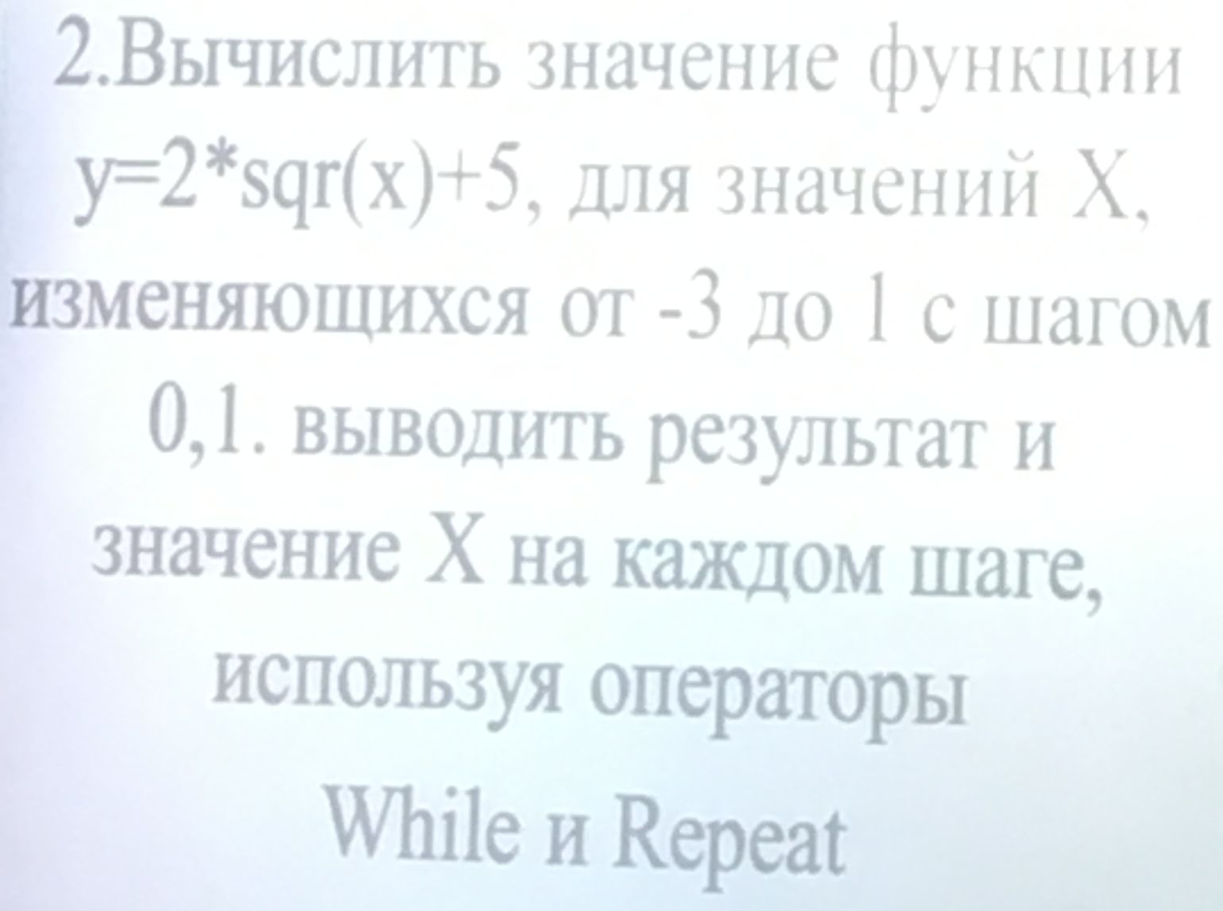

Исходный код

program Foo2SqrXPlus5;

var
x: Real;
begin

WriteLn('Используя while:');
x := -3;
while x <= 1 do begin
WriteLn('x=', x, ' y=', 2 * Sqr(x) + 5);
x := x + 0.1;
end;

WriteLn;

WriteLn('Используя repeat:');
x := -3;
repeat
WriteLn('x=', x, ' y=', 2 * Sqr(x) + 5);
x := x + 0.1;
until x >= 1;

end.

Тестирование

Используя while:
x=-3 y=23
x=-2.9 y=21.82
x=-2.8 y=20.68
x=-2.7 y=19.58
x=-2.6 y=18.52
x=-2.5 y=17.5
x=-2.4 y=16.52
x=-2.3 y=15.58
x=-2.2 y=14.68
x=-2.1 y=13.82
x=-2 y=13
x=-1.9 y=12.22
x=-1.8 y=11.48
x=-1.7 y=10.78
x=-1.6 y=10.12
x=-1.5 y=9.49999999999999
x=-1.4 y=8.91999999999999
x=-1.3 y=8.37999999999999
x=-1.2 y=7.87999999999999
x=-1.1 y=7.41999999999999
x=-0.999999999999998 y=6.99999999999999
x=-0.899999999999998 y=6.61999999999999
x=-0.799999999999998 y=6.27999999999999
x=-0.699999999999998 y=5.98
x=-0.599999999999998 y=5.72
x=-0.499999999999998 y=5.5
x=-0.399999999999998 y=5.32
x=-0.299999999999998 y=5.18
x=-0.199999999999998 y=5.08
x=-0.0999999999999985 y=5.02
x=1.52655665885959E-15 y=5
x=0.100000000000002 y=5.02
x=0.200000000000002 y=5.08
x=0.300000000000002 y=5.18
x=0.400000000000002 y=5.32
x=0.500000000000002 y=5.5
x=0.600000000000002 y=5.72
x=0.700000000000002 y=5.98
x=0.800000000000001 y=6.28
x=0.900000000000001 y=6.62000000000001

Используя repeat:
x=-3 y=23
x=-2.9 y=21.82
x=-2.8 y=20.68
x=-2.7 y=19.58
x=-2.6 y=18.52
x=-2.5 y=17.5
x=-2.4 y=16.52
x=-2.3 y=15.58
x=-2.2 y=14.68
x=-2.1 y=13.82
x=-2 y=13
x=-1.9 y=12.22
x=-1.8 y=11.48
x=-1.7 y=10.78
x=-1.6 y=10.12
x=-1.5 y=9.49999999999999
x=-1.4 y=8.91999999999999
x=-1.3 y=8.37999999999999
x=-1.2 y=7.87999999999999
x=-1.1 y=7.41999999999999
x=-0.999999999999998 y=6.99999999999999
x=-0.899999999999998 y=6.61999999999999
x=-0.799999999999998 y=6.27999999999999
x=-0.699999999999998 y=5.98
x=-0.599999999999998 y=5.72
x=-0.499999999999998 y=5.5
x=-0.399999999999998 y=5.32
x=-0.299999999999998 y=5.18
x=-0.199999999999998 y=5.08
x=-0.0999999999999985 y=5.02
x=1.52655665885959E-15 y=5
x=0.100000000000002 y=5.02
x=0.200000000000002 y=5.08
x=0.300000000000002 y=5.18
x=0.400000000000002 y=5.32
x=0.500000000000002 y=5.5
x=0.600000000000002 y=5.72
x=0.700000000000002 y=5.98
x=0.800000000000001 y=6.28
x=0.900000000000001 y=6.62000000000001

