Задание

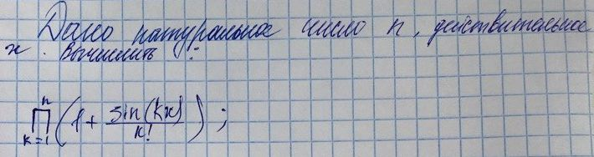

Исходный код

program ProductOnePlusSinDivFactorial;

procedure Input(var n: Integer; var x: Real);
begin
Write('n -> ');
ReadLn(n);

Write('x -> ');
ReadLn(x);
end;

function Product(n: Integer; x: Real): Real;
var
k, f: Integer;
begin
result := 1;
f := 1;
for k := 1 to n do begin
f := f * k;
result := result * (1 + sin(k * x) / f);
end;
end;

var
n: Integer;
x: Real;

begin
Input(n, x);
WriteLn('P = ', Product(n, x));
end.

Тестирование

n -> 8
x -> 42
P = 0.115882935619249

Проверка:
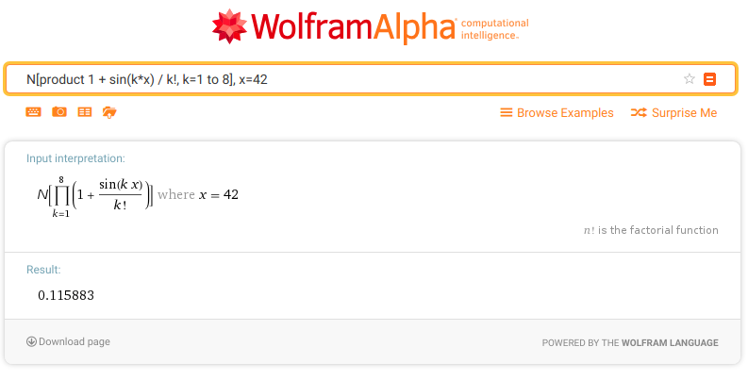
https://www.wolframalpha.com/input/?i=N%5Bproduct+1+%2B+sin(k*x)+%2F+k!,+k%3D1+to+8%5D,+x%3D42

