Загрузим образ виртуальной машины с Xenomai real-time Linux.

Откроем Oracle VM VirtualBox Менеджер и перейдём в меню Файл > Менеджер сетей хоста… (Ctrl + W). Нажмем на кнопку Создать, появится новый виртуальный адаптер хоста vboxnet0, через него будет происходить взаимодействие с виртуальной машиной.

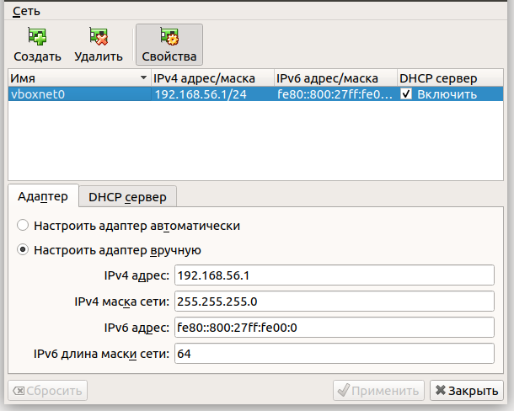

Вернемся в Oracle VM VirtualBox Менеджер и перейдём в меню Машина > Добавить… (Ctrl + A). Выберем ранее загруженный файл debian4.0_xenomai2.4.3.vbox. Запустим виртуальную машину. Узнаем IP-адрес виртуальной машины, чтобы далее подключаться к ней по SSH. Для этого наберем команду /sbin/ifconfig.

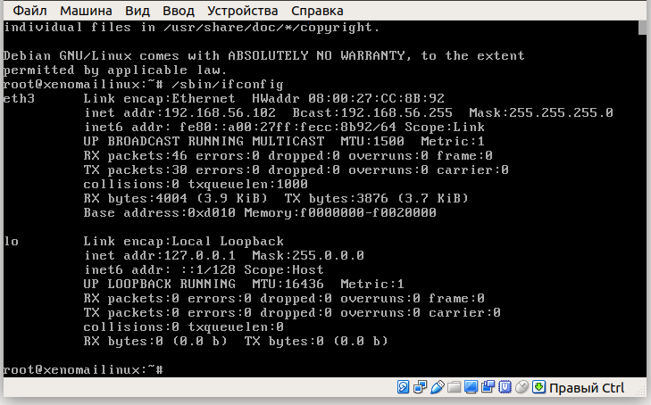
IP-адрес равен 192.168.56.102.

Подключимся к виртуальной машине по SSH, создадим и перейдём в рабочий каталог.

$ ssh root@192.168.56.102
root@xenomailinux:~# mkdir Gussenov
root@xenomailinux:~# cd Gussenov/

Создадим файл lab15.c содержащий код программы запуска трех задач в режиме диспетчеризации FIFO.

#include <stdio.h>
#include <signal.h>
#include <unistd.h>
#include <sys/mman.h>

#include <native/task.h>
#include <native/timer.h>
#include <native/sem.h>

#include <rtdk.h>
#include <sys/io.h>

#define NTASKS 3

RT_TASK demo_task[NTASKS];
RT_SEM mysync;

// set new baseperiod for the clock :
// - clock only increments counter when a base period is passed
// - the unit of the clock counter is called a jiffie, which in fact
// represents that a baseperiod is passed
// e.g. If 10 baseperiods are passed, the clock gives an increase
// in 10 jiffies

#define BASEPERIOD 1e6 // baseperiod in ns.

// when base period is set, all times in the api are expressed in jiffies
#define EXECTIME 200 // execution time in jiffies
#define SPINTIME 10 // spin time in jiffies

void demo(void *arg)
{
RTIME starttime, runtime;

int num=*(int *)arg;

RT_TASK *curtask;
RT_TASK_INFO curtaskinfo;

rt_printf("Task : %d\n",num);
rt_sem_p(&mysync,TM_INFINITE);

// let the task run RUNTIME(=200) jiffies in steps of SPINTIME(=20) jiffies
runtime = 0;

while(runtime < EXECTIME) {
rt_timer_spin(SPINTIME*BASEPERIOD); // spin cpu doing nothing

// note: rt_timer_spin function does not accept jiffies only nanoseconds
// deviates from timing conventions throughout the Xenomai API

runtime = runtime + SPINTIME;

rt_printf("Running Task : %d at time : %d\n",num,runtime);
}
rt_printf("End Task : %d\n",num);
}

//startup code
void startup()
{
int i;
char str[10] ;

// semaphore to sync task startup on
rt_sem_create(&mysync,"MySemaphore",0,S_FIFO);

// change to period mode because round robin does not work
// in one shot mode
rt_timer_set_mode(BASEPERIOD);// set tick period

for(i=0; i < NTASKS; i++) {
rt_printf("start task : %d\n",i);
sprintf(str,"task%d",i);

rt_task_create(&demo_task[i], str, 0, 50, 0);
rt_task_start(&demo_task[i], &demo, &i);
}

rt_printf("wake up all tasks\n");
rt_sem_broadcast(&mysync);
}

void init_xenomai() {
/* Avoids memory swapping for this program */
mlockall(MCL_CURRENT|MCL_FUTURE);

/* Perform auto-init of rt_print buffers if the task doesn't do so */
rt_print_auto_init(1);
}

int main(int argc, char* argv[])
{
printf("\nType CTRL-C to end this program\n\n" );

// code to set things to run xenomai
init_xenomai();

//startup code
startup();

// wait for CTRL-c is typed to end the program
pause();
}

Загрузим файл lab15.c в свой рабочий каталог на виртуальной машине с Xenomai real-time Linux.

$ scp lab15.c root@192.168.56.102:/root/Gussenov/lab15.c

Для компилирования программы выполним предварительные команды для определения и установки flags:

root@xenomailinux:~/Gussenov# export CFLAGS=`xeno-config --xeno-cflags`
root@xenomailinux:~/Gussenov# export LDFLAGS=`xeno-config --xeno-ldflags`

Далее выполним команду компилирования:

root@xenomailinux:~/Gussenov# gcc $CFLAGS $LDFLAGS -lnative -lrtdk lab15.c -o lab15

Для запуска программы может потребоваться регистрация дополнительных библиотек командой:

root@xenomailinux:~/Gussenov# export LD_LIBRARY_PATH=/usr/xenomai/lib

Команда запуска программы:

root@xenomailinux:~/Gussenov# ./lab15

Type CTRL-C to end this program

start task : 0
Task : 0
start task : 1
Task : 1
start task : 2
Task : 2
wake up all tasks
Running Task : 0 at time : 10
Running Task : 0 at time : 20
Running Task : 0 at time : 30
Running Task : 0 at time : 40
Running Task : 0 at time : 50
Running Task : 0 at time : 60
Running Task : 0 at time : 70
Running Task : 0 at time : 80
Running Task : 0 at time : 90
Running Task : 0 at time : 100
Running Task : 0 at time : 110
Running Task : 0 at time : 120
Running Task : 0 at time : 130
Running Task : 0 at time : 140
Running Task : 0 at time : 150
Running Task : 0 at time : 160
Running Task : 0 at time : 170
Running Task : 0 at time : 180
Running Task : 0 at time : 190
Running Task : 0 at time : 200
End Task : 0
Running Task : 1 at time : 10
Running Task : 1 at time : 20
Running Task : 1 at time : 30
Running Task : 1 at time : 40
Running Task : 1 at time : 50
Running Task : 1 at time : 60
Running Task : 1 at time : 70
Running Task : 1 at time : 80
Running Task : 1 at time : 90
Running Task : 1 at time : 100
Running Task : 1 at time : 110
Running Task : 1 at time : 120
Running Task : 1 at time : 130
Running Task : 1 at time : 140
Running Task : 1 at time : 150
Running Task : 1 at time : 160
Running Task : 1 at time : 170
Running Task : 1 at time : 180
Running Task : 1 at time : 190
Running Task : 1 at time : 200
End Task : 1
Running Task : 2 at time : 10
Running Task : 2 at time : 20
Running Task : 2 at time : 30
Running Task : 2 at time : 40
Running Task : 2 at time : 50
Running Task : 2 at time : 60
Running Task : 2 at time : 70
Running Task : 2 at time : 80
Running Task : 2 at time : 90
Running Task : 2 at time : 100
Running Task : 2 at time : 110
Running Task : 2 at time : 120
Running Task : 2 at time : 130
Running Task : 2 at time : 140
Running Task : 2 at time : 150
Running Task : 2 at time : 160
Running Task : 2 at time : 170
Running Task : 2 at time : 180
Running Task : 2 at time : 190
Running Task : 2 at time : 200
End Task : 2

Изменим режим диспетчеризации задач на Round-robin. Изменение режима диспетчеризации для задачи осуществляется с помощью вызова функции rt_task_set_mode(0,T_RRB ,NULL).

Также установим период выполнения задачи (timeslice) с помощью функции rt_task_slice(task_descr, quantum); где task_descr — идентификатор задачи, quantum — период выполнения.

Изменим код таким образом, чтобы задачи выполнялись «по кругу» (0 1 2 0 1 2 и т. д.). Изменения относительно первой программы показаны увеличенным шрифтом.

#include <stdio.h>
#include <signal.h>
#include <unistd.h>
#include <sys/mman.h>

#include <native/task.h>
#include <native/timer.h>
#include <native/sem.h>

#include <rtdk.h>
#include <sys/io.h>

#define NTASKS 3

RT_TASK demo_task[NTASKS];
RT_SEM mysync;

// set new baseperiod for the clock :
// - clock only increments counter when a base period is passed
// - the unit of the clock counter is called a jiffie, which in fact
// represents that a baseperiod is passed
// e.g. If 10 baseperiods are passed, the clock gives an increase
// in 10 jiffies

#define BASEPERIOD 1e6 // baseperiod in ns.

// when base period is set, all times in the api are expressed in jiffies
#define EXECTIME 200 // execution time in jiffies
#define SPINTIME 10 // spin time in jiffies

void demo(void *arg)
{
RTIME starttime, runtime;

int num=*(int *)arg;

RT_TASK *curtask;
RT_TASK_INFO curtaskinfo;

rt_printf("Task : %d\n",num);
rt_sem_p(&mysync,TM_INFINITE);

rt_task_set_mode(0,T_RRB ,NULL);

// let the task run RUNTIME(=200) jiffies in steps of SPINTIME(=20) jiffies
runtime = 0;

while(runtime < EXECTIME) {
rt_timer_spin(SPINTIME*BASEPERIOD); // spin cpu doing nothing

// note: rt_timer_spin function does not accept jiffies only nanoseconds
// deviates from timing conventions throughout the Xenomai API

runtime = runtime + SPINTIME;

rt_printf("Running Task : %d at time : %d\n",num,runtime);
}
rt_printf("End Task : %d\n",num);
}

//startup code
void startup()
{
int i;
char str[10] ;

// semaphore to sync task startup on
rt_sem_create(&mysync,"MySemaphore",0,S_FIFO);

// change to period mode because round robin does not work
// in one shot mode
rt_timer_set_mode(BASEPERIOD);// set tick period

for(i=0; i < NTASKS; i++) {
rt_printf("start task : %d\n",i);
sprintf(str,"task%d",i);

rt_task_create(&demo_task[i], str, 0, 50, 0);
rt_task_slice(&demo_task[i], 5);
rt_task_start(&demo_task[i], &demo, &i);
}

rt_printf("wake up all tasks\n");
rt_sem_broadcast(&mysync);
}

void init_xenomai() {
/* Avoids memory swapping for this program */
mlockall(MCL_CURRENT|MCL_FUTURE);

/* Perform auto-init of rt_print buffers if the task doesn't do so */
rt_print_auto_init(1);
}

int main(int argc, char* argv[])
{
printf("\nType CTRL-C to end this program\n\n" );

// code to set things to run xenomai
init_xenomai();

//startup code
startup();

// wait for CTRL-c is typed to end the program
pause();
}

Аналогично загрузим в рабочий каталог обновлённый файл.

$ scp lab15.c root@192.168.56.102:/root/Gussenov/lab15.c

Скомпилируем и запустим новую программу.

root@xenomailinux:~/Gussenov# gcc $CFLAGS $LDFLAGS -lnative -lrtdk lab15.c -o lab15
root@xenomailinux:~/Gussenov# ./lab15

Type CTRL-C to end this program

start task : 0
Task : 0
start task : 1
Task : 1
start task : 2
Task : 2
wake up all tasks
Running Task : 0 at time : 10
Running Task : 1 at time : 10
Running Task : 2 at time : 10
Running Task : 0 at time : 20
Running Task : 0 at time : 30
Running Task : 0 at time : 40
Running Task : 1 at time : 20
Running Task : 2 at time : 20
Running Task : 0 at time : 50
Running Task : 1 at time : 30
Running Task : 1 at time : 40
Running Task : 2 at time : 30
Running Task : 2 at time : 40
Running Task : 0 at time : 60
Running Task : 0 at time : 70
Running Task : 1 at time : 50
Running Task : 2 at time : 50
Running Task : 2 at time : 60
Running Task : 0 at time : 80
Running Task : 0 at time : 90
Running Task : 1 at time : 60
Running Task : 2 at time : 70
Running Task : 0 at time : 100
Running Task : 0 at time : 110
Running Task : 1 at time : 70
Running Task : 2 at time : 80
Running Task : 2 at time : 90
Running Task : 0 at time : 120
Running Task : 0 at time : 130
Running Task : 1 at time : 80
Running Task : 1 at time : 90
Running Task : 2 at time : 100
Running Task : 0 at time : 140
Running Task : 0 at time : 150
Running Task : 1 at time : 100
Running Task : 1 at time : 110
Running Task : 1 at time : 120
Running Task : 2 at time : 110
Running Task : 2 at time : 120
Running Task : 0 at time : 160
Running Task : 1 at time : 130
Running Task : 1 at time : 140
Running Task : 2 at time : 130
Running Task : 0 at time : 170
Running Task : 0 at time : 180
Running Task : 1 at time : 150
Running Task : 1 at time : 160
Running Task : 2 at time : 140
Running Task : 2 at time : 150
Running Task : 0 at time : 190
Running Task : 0 at time : 200
End Task : 0
Running Task : 1 at time : 170
Running Task : 1 at time : 180
Running Task : 2 at time : 160
Running Task : 2 at time : 170
Running Task : 1 at time : 190
Running Task : 2 at time : 180
Running Task : 1 at time : 200
End Task : 1
Running Task : 2 at time : 190
Running Task : 2 at time : 200
End Task : 2

