CS655 Drone Technologies: Assignment Report
Q8: Medical Package Delivery Drone with Obstacle Avoidance and Temporary Route Blockage Handling
M.Tech (CSE), I Year · July 2026 · Assignment (20 marks)

1. Team details
Roll No. | Name
206126035 | TODO: name
206126033 | TODO: name
206126034 | Sriram

2. Question number and problem statement
Question 8. Simulate a drone delivering a medical package to a remote location while avoiding obstacles and handling a temporary route blockage.

3. Design

3.1 Scenario
A delivery quadcopter is based at a City Hospital, which is its home at (0 m N, 0 m E). It must carry a medical package to a Remote Village Clinic at (130 m N, 100 m E) and come back. Between the two sites are six buildings and towers, 25–40 m tall. The drone cruises at 15 m, so it has to fly around them.
During the outbound flight, a temporary blockage appears on the planned route: a 12 m × 12 m × 30 m structure standing for a crane, a fallen tree or a temporary no-fly zone. The drone has to detect it and deal with it.
Safety boundaries:
- a 160 m × 170 m planning area
- an ArduPilot geofence: a 220 m circle and a 50 m maximum altitude
- RTL altitude above all buildings
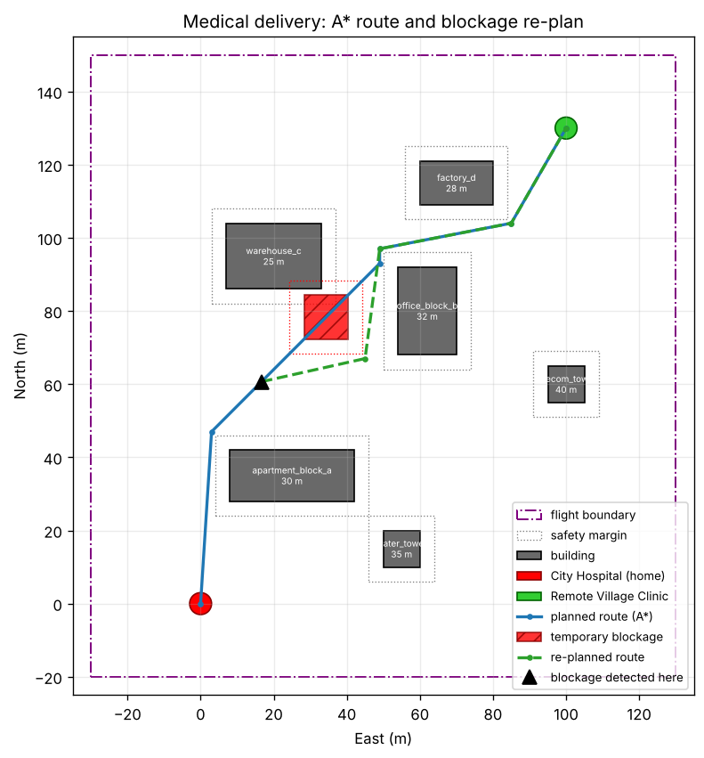
Planned A* route (blue), temporary blockage (red) and the re-planned detour (green)

3.2 System architecture
config/mission.json (map, obstacles, blockage, speed, fence)
| |
v v
generate_world.py planner.py (grid + A* + simplify)
| |
v v
Gazebo world <-- gz --> mission.py (state machine)
^ | MAVLink (pymavlink)
| JSON/UDP v
+---- ardupilot_gazebo -- ArduPilot SITL (ArduCopter)
| MAVLink (UDP 14550)
v
QGroundControl
mission.py --> logs/state.json --> live_map.py
How the parts connect:
- Gazebo simulates the physics and the iris quadcopter.
- ArduPilot SITL runs the real ArduCopter flight-controller firmware. It exchanges sensor data and motor outputs with Gazebo through the ardupilot_gazebo plugin, using JSON over UDP.
- The mission computer (mission.py) commands the flight controller over MAVLink, the same way a companion computer or ground station would on a real drone.

3.3 Global path planning (pre-flight)
- Occupancy grid: 1 m resolution over the flight boundary.
- Obstacle inflation: every building footprint is grown by a 4 m safety margin. This is the configuration-space idea: treat the drone as a point and grow the obstacles instead, which also covers position error and braking overshoot.
- A* search: an 8-connected grid with step costs 1 and √2. It uses the octile-distance heuristic, which is admissible, so the result is optimal. Diagonal moves may not cut obstacle corners.
- Path simplification: greedy line-of-sight shortcutting turns the ~180 grid cells into about 5 straight legs.
- Execution: each waypoint is sent to ArduPilot in GUIDED mode with SET_POSITION_TARGET_LOCAL_NED, at 6 m/s (WPNAV_SPEED).

3.4 Handling the temporary blockage (dynamic local re-planning)
This follows the Unit 3 principle: a pre-flight optimal reference trajectory, plus dynamic local trajectory optimisation when unknown or dynamic threats appear in flight.
- Detection: a simulated forward-looking range sensor with a 25 m range. At every control tick (10 Hz), the remaining route is sampled up to 25 m ahead of the drone. If it enters the blockage (plus margin), the blockage is detected.
- Reaction: the drone immediately holds position.
- Decision: because the obstruction is temporary, the drone waits up to 20 s:
  - If it clears in time, the drone resumes the original, shortest route.
  - If not, the drone re-plans with A* from its current position, with the blockage added as an obstacle, and flies the detour.
  - If no detour exists, the drone aborts and returns home.
- This trades a bounded wait against a longer detour, which costs distance and energy.
- Return leg: planned with what the drone has learned. The blockage is avoided if it is still there.
Two test scenarios show both branches:
- short: the blockage clears 8 s after detection, so the drone resumes.
- long: it is still there after 60 s, so the drone re-plans.

3.5 Mission state machine
PREFLIGHT -> TAKEOFF -> FOLLOW_PATH
FOLLOW_PATH --blockage within 25 m--> HOLD
HOLD --cleared before 20 s--> FOLLOW_PATH (resume)
HOLD --still blocked at 20 s--> REPLAN -> FOLLOW_PATH
FOLLOW_PATH (at village) -> LAND -> DELIVERED
DELIVERED -> TAKEOFF -> FOLLOW_PATH (return)
FOLLOW_PATH (at hospital) -> LAND -> COMPLETE
any error / Ctrl+C -> RTL at 45 m

3.6 Safety and flight boundaries
Mechanism | Setting | Purpose
Planner boundary | 160 m × 170 m area | Routes never leave the predefined area
Safety margin | 4 m around every obstacle | Clearance for drone size and tracking error
Geofence | FENCE_TYPE=3, FENCE_RADIUS=220, FENCE_ALT_MAX=50, FENCE_ACTION=1 | Hard limit enforced by the flight controller; a breach triggers RTL
RTL altitude | RTL_ALT=4500 (45 m) | A failsafe return flies above the tallest building (40 m)
Error handling | Exception or Ctrl+C triggers RTL | The vehicle is never left without a command

4. Tools used
Tool | Version | Purpose
ArduPilot SITL (ArduCopter) | master (Nov 2026) | Flight-controller firmware in simulation
Gazebo Harmonic + ardupilot_gazebo | gz-sim 8 | 3D physics world and quadcopter model
QGroundControl | 5.0.8 | Ground-control station: map, telemetry
MAVProxy | from ArduPilot | MAVLink router and SITL console
Python 3 + pymavlink | 3.10 | Mission control over MAVLink
matplotlib | 3.5+ | Live mission map and result plots
ROS2 Humble + ros_gz bridge | Humble | Installed per the course guide; available for sensor extensions such as a Gazebo lidar

5. Environment / platform
Item | Details
Host | Windows 11 laptop: Intel i7-9750H, 24 GB RAM, NVIDIA GTX 1660 Ti
Guest | Ubuntu 22.04.5 LTS in VMware Workstation Pro (13 GB RAM, 8 vCPU, 3D acceleration on, OpenGL 4.3 via SVGA3D)
Gazebo rendering | --render-engine ogre, which is stable in the VM
Simulated location | ArduPilot default home (CMAC, Canberra); the mission works in local NED metres from the hospital

6. Procedure for execution
The full step-by-step procedure, including installation and troubleshooting, is in README.md and docs/SETUP_GUIDE.md. In short:
cd ~/Drone && ./scripts/run_all.sh long # or: short / none
This opens four terminals:
- Gazebo: worlds/medical_delivery.sdf
- ArduPilot SITL, connected to Gazebo
- Live map: scripts/live_map.py
- Mission: scripts/mission.py --scenario long
Results are written to logs/: flight_map.png, flight_log.csv and events.txt.

7. Results

7.1 Re-plan scenario (long)
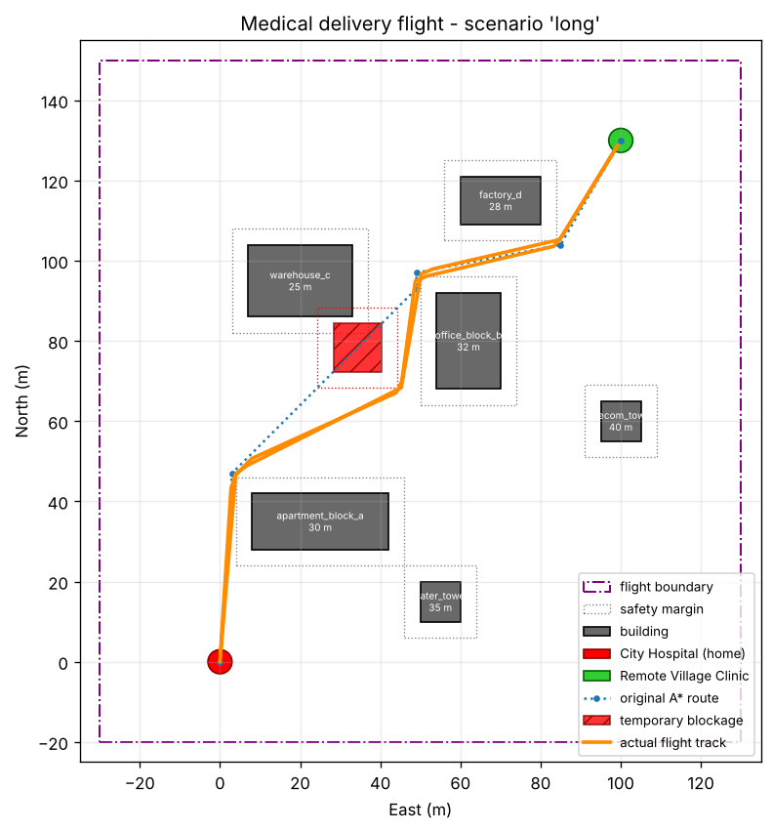
Scenario long: the drone holds 25 m before the blockage, waits 20 s, then flies the A* detour
Event timeline (offline logic test, kinematic drone model):
Time | Event
8.8 s | Blockage detected 24.7 m ahead at (78 N, 34 E); holding position
28.9 s | Still blocked after 20 s; re-planning with A*
28.9 s | New route: 4 legs, 138 m
61.3 s | Package delivered to Remote Village Clinic
107.2 s | Mission complete: 371 m flown, 20 s waiting, 1 re-plan

7.2 Summary of all scenarios
Scenario | Distance flown | Waiting at blockage | Re-plans | Outcome
none | 356 m | 0 s | 0 | Delivered and returned
short | 357 m | 8 s | 0 | Waited, blockage cleared, resumed original route
long | 371 m | 20 s | 1 | Waited, still blocked, re-planned detour
The numbers come from tests/test_mission.py, which runs the full mission logic against a simulated drone. In the SITL + Gazebo runs, the drone follows the same routes. Add logs/flight_map.png and a Gazebo screenshot from your own run here.

8. Conclusion
The simulation shows an autonomous medical delivery that:
- plans a collision-free route around known obstacles with A*,
- detects an unexpected blockage on that route in flight,
- chooses between waiting and re-routing according to how long the blockage lasts,
- delivers the package and returns safely,
- stays within a geofence with failsafe RTL.
Possible extensions:
- a real Gazebo lidar via ROS2 in place of the simulated range sensor
- moving obstacles
- battery-aware route choice
- a payload gripper (MAV_CMD_DO_GRIPPER)

9. Contribution of each member
Roll No. | Name | Contribution
206126035 | TODO | TODO: describe what this member actually did
206126033 | TODO | TODO: describe what this member actually did
206126034 | Sriram | TODO: describe what you actually did

