Impact of subphenotype misclassification on detecting heterogeneous treatment effects in Staphylococcus aureus bacteraemia: A simulation study.

Fergus Hamilton^{1,2}, Sean Ong, Maaike Swets, Jon Underwood, Clark Russell
- Infection Science, North Bristol NHS Trust
- MRC Integrative Epidemiology Unit, University of Bristol.

Fergus.hamilton@bristol.ac.uk
NIHR Clinical Lecturer in Aetiological Epidemiology,
Infection Science,
North Bristol NHS Trust
Bristol BS10 5NB
Background
Staphylococcus aureus bacteraemia (SAB) is clinically heterogeneous. Recently identified, reproducible subphenotypes suggest potential for heterogeneous treatment effects (HTE), but the impact of patient misclassification on detecting these effects is unclear, and strategies to improve detection of HTE are not yet identified.
Methods
We performed a simulation study using recent data from randomised trials and observational studies in SAB. We assessed the impact classification accuracy (70%-100%) on i) power, ii) type 1 error, and iii) bias in post-hoc analyses of HTE. We modelled two strategies to try and maximise power and reduce bias; first by performing enrichment trials (e.g. only randomising those who are predicted to be in a subphenotype), and secondly, by using ordinal outcomes rather than binary outcomes.
Results
Even with perfect classification, based on effect sizes on 84-day mortality seen for adjunctive rifampicin, post-hoc analyses required very large trials (often >20,000 participants) to achieve adequate power for most subphenotypes. Decreasing classification accuracy markedly reduced power, increased type 1 error, and introduced bias. Enrichment strategies were unsuccessful due to extreme screening requirements. Ordinal outcomes increased statistical power, however this increased type 1 error due to the increased precision. Importantly, all results were highly conditional on subphenotype prevalence and mortality, which varied greatly between studies.
Conclusions
Detecting HTE in SAB is challenging, demanding extremely large trials and highly accurate subphenotype classification. To advance stratified medicine in SAB, research should prioritize developing robust classifiers (sensitivity and specificity >95%) and use statistically efficient outcomes and trial designs. Given that trialists cannot be confident of prior subphenotype prevalences, designs that allow for adjusting sample sizes while trials are running (e.g. Bayesian approaches) are preferred.

Introduction
Staphylococcus aureus bacteraemia (SAB) is a common and serious infection associated with significant morbidity and mortality.^{1,2} A defining feature of SAB is its clinical heterogeneity, encompassing variations in patient characteristics (e.g., age, comorbidities), pathogen factors (e.g., methicillin-resistance), portal of entry of bacteraemia, and disease manifestations such as metastatic foci.³ Despite this heterogeneity, clinical trials in SAB often treat it as a single entity, introducing the risk of failing to detect treatments which differentially benefit or harm sub-groups of patients.^{4,5} In particular, trials investigating adjunctive or alternative therapies have frequently failed to show overall benefit compared to standard care, although recent data suggests antimicrobial choice affects outcomes.^{5–7}
Recent efforts have focused on identifying clinically relevant subphenotypes within SAB to enable better patient stratification for research and potentially personalized treatment. Using latent class analysis on routinely available data from observational and trial cohorts from the UK, Spain, the Netherlands, and USA five distinct and reproducible clinical subphenotypes (A-E) have been identified (and replicated).^{8–10}
Importantly, these analyses suggested potential heterogeneous treatment effects¹¹ (HTE) of adjunctive rifampicin across these subphenotypes. Notably, rifampicin appeared potentially harmful in subphenotype B (Nosocomial IV catheter-associated SAB; OR 18.8 for 84 day mortality), although the effect size is likely inflated.^{8,12}
The possibility of such HTE raises critical questions for future clinical trial design and the implementation of stratified medicine approaches. In principle, participants in an RCT (or in clinical practice) should be subphenotyped, then assigned a treatment likely to specifically benefit them. This approach may be more beneficial than applying therapies across unselected patients with SAB, especially when for many subphenotypes the biological plausibility of some therapies may be much less. For example, in nosocomial catheter associated bacteraemia, where the primary treatment is catheter removal, the benefit of adjunctive clindamycin may be much less than in patients with a much higher burden of infection such as patients in with higher infection severity or bioburden such as in endocarditis and native vertebral osteomyelitis.
If treatment effects truly differ between subphenotypes, accurately identifying these subphenotypes becomes paramount. However, any diagnostic test or classification algorithm used to assign patients to subphenotypes will inevitably have imperfect accuracy. Misclassifying patients can lead to biased estimates of subphenotype-specific effects, type 1 error (e.g. false positives), and reduced statistical power to detect true HTE, with potentially misleading conclusions about which patients benefit or are harmed by a treatment. Understanding the quantitative impact of misclassification is essential for interpreting subphenotype analyses and designing efficient trials, including potential enrichment strategies and the use of ordinal outcomes.

Methods
To investigate the interplay between diagnostic accuracy, sample size, and statistical power in trials with substantial treatment-effect heterogeneity, we conducted a comprehensive simulation study using the Aims, data generation, estimands, methods, and performance measures (ADEMP) framework.13 The study was designed to be directly relevant to clinical trials in SAB, with parameters for treatment effects, subphenotype frequencies, and baseline risk taken from recent published literature on SAB subphenotypes. The simulation framework was implemented in R (version 4.5.1) using tidyverse-based scripted analyses.
Full details of the simulation study are in the Supplementary Methods. We provide a brief overview here.

Main analysis:
In our main analysis we simulated a simple, two arm randomized trial with subgroup-specific treatment effects derived from an analysis of the ARREST trial to get base estimates of the sample size required to identify sub-phenotypes in SAB. We then imposed imperfect subphenotype classification, and estimated subgroup effects using observed (potentially misclassified) subphenotypes. Table 1 describes the main simulated estimation parameters; these were taken from the frequencies and baseline mortality of the sub-phenotypes derived from ARREST. As the effect sizes were very large in the recent analyses due to Winner’s curse, these were shrunk by 50% to more conservative effects for the simulations.

Table 1: Main estimation parameters, with the conservative OR representing a 50% decrease on the log-odds scale.
Subphenotype | Frequency of subphenotype in ARREST cohort (%) | Baseline mortality across both arms (%) | Original OR for 84d mortality (Swets, original) | Conservative OR for 84d mortality (conservative)
A | 15.5 | 11.7 | 1.0 | 1.0
B | 13.4 | 1.0 | 18.8 | 4.3
C | 35.6 | 8.0 | 0.79 | 0.89
D | 17.8 | 15.9 | 1.40 | 1.18
E | 17.8 | 1.4 | 0.30 | 0.54

The primary outputs of this simulation were type I error (significant effect in a null subgroup), power (significant effect in the correct direction), and bias (difference between estimated and true subgroup log-odds ratio).

Supplementary analysis 1: Sensitivity to sub-phenotype prevalence and mortality:
Across cohorts where subphenotypes of SAB have been measured, subphenotype prevalence, and mortality within each subphenotype differs greatly. We tested how sensitive our simulations were to these changes in prevalence, while holding the simulated effect size at the same level.

Supplementary analysis 2: enrichment feasibility:
We then evaluated enrichment designs under varying sensitivity/specificity to quantify effect dilution and screening burden (number needed to randomize and number needed to screen). This tests a scenario where a classifier could be applied at or just before randomisation, and only those in certain sub-phenotypes are enrolled.
Supplementary analysis 3: ordinal outcome:
Ordinal outcomes can provide greater precision when they capture clinically meaningful gradations of severity. In this analysis we compared binary versus ordinal endpoints under the same subgroup-effect structure and misclassification settings to assess gains in precision and their relationship to bias. Specifically, we used a 6-point ordinal scale (death, ICU, hospital, complications, discharged, recovered). We evaluated two scenarios: one with a proportional-odds effect across the full ordinal scale, and one with a non-proportional death-only effect in which treatment changes death odds while non-death categories are rescaled proportionally.

Results:
Sample-size requirements for a two-arm RCT of sub-phenotypes
The statistical power for detecting subphenotype-specific treatment effects in a standard two-arm RCT, assuming perfect classification and the effects seen in the recent SAB analysis, was highly dependent on the subphenotypes prevalence, baseline event rate, and the magnitude of the true odds ratio (OR). The results, summarized in Table 3 and Figure 1, demonstrate that substantial total trial sizes are necessary to achieve 80% power in post-hoc analyses, and that only subphenotype B (with an extremely large effect) was possible at reasonable sample sizes (<5,000). As expected in a traditional two-arm RCT, Type 1 error was well calibrated and bias was minimal. At 100% classification accuracy, power for subgroup B rose from 0.000 (n=500) to 0.695 (n=5,000), 0.967 (n=10,000), and 1.000 (n=20,000); however, at n=20,000 power remained below 50% for C (0.256), D (0.444), and E (0.456).
Table 3: Statistical power to detect a subphenotype specific effect given a sample size n in each subphenotype. Power estimated from 2,000 replicates where simulated.

Subphenotypes:
 | A | B | C | D | E
500 | - | 0.000 | 0.026 | 0.030 | 0.000
1000 | - | 0.003 | 0.043 | 0.059 | 0.000
2000 | - | 0.085 | 0.069 | 0.080 | 0.002
3000 | - | 0.307 | 0.070 | 0.102 | 0.011
5000 | - | 0.695 | 0.090 | 0.155 | 0.067
7500 | - | - | - | - | -
10000 | - | 0.967 | 0.159 | 0.267 | 0.228
15000 | - | - | - | - | -
20000 | - | 1.000 | 0.256 | 0.444 | 0.456

We then investigated the impact of imperfect classification accuracy on power, Type 1 error, bias and bias in a hypothetical, fixed, large trial of 20,000 participants. As shown in Figure 1, statistical power to detect true effects diminished substantially as classification accuracy decreased. For null subgroups like A, this led to Type 1 error, while for all subgroups effect estimates were biased. The degree of bias related to the amount of misclassification from other groups (e.g. the accuracy of the test), and on the make-up of other groups for sub-phenotypes with a non-null effect. This "dilution" effect occurs because misclassifying patients mixes individuals from subphenotypes with different true effects, pulling the observed estimate towards the population average. This effect was larger for small subphenotypes with large effects: the powerful harmful effect in subphenotype B (OR=4.3) was severely attenuated with even very small misclassification.

Figure 1: Impact of subphenotype misclassification on subgroup-specific effect estimation. A) Power versus classification accuracy. B) Mean bias (estimated logOR minus true logOR) versus accuracy. C) Replicate-level subgroup estimates by accuracy; boxplots show median and IQR, whiskers represent 1.5 x IQR, and black horizontal bars indicate true subgroup logOR (84-day mortality, treatment versus control).
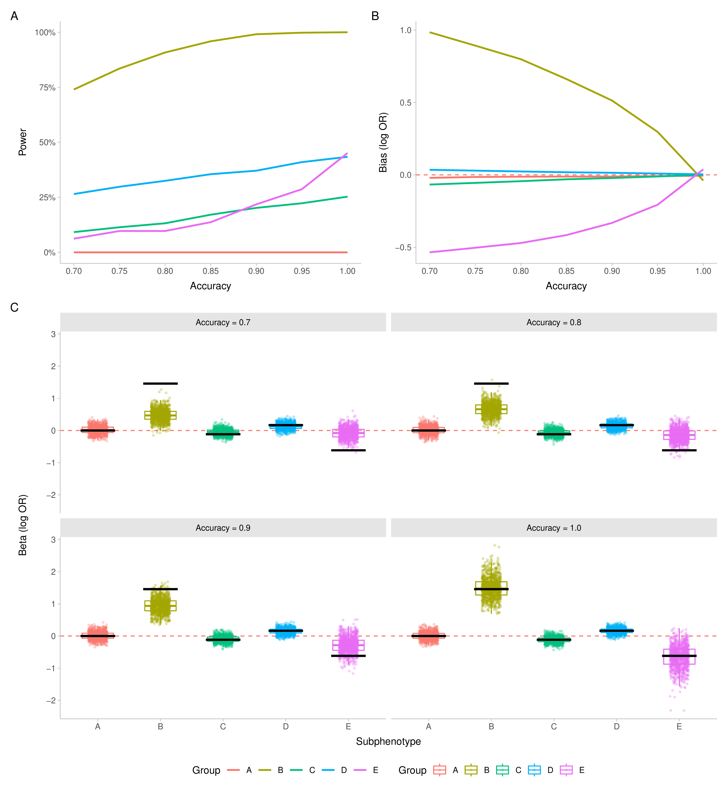

Aim 2: Results are highly conditional on baseline subphenotype prevalence and mortality even with a perfect classifier.
It is important to understand how conditional these estimates are on a specific cohort because sample size calculations are made before the trial starts, and it is not known how much subphenotype prevalence and mortality variation between cohorts might influence outcomes. We therefore reran analyses using recent data from numerous cohorts with differing subphenotype prevalences, but with perfect classification.
These show that for most subphenotypes, the sample size required varied by setting.
These findings establish that even without the challenge of misclassification, post-hoc HTE analyses demand very large clinical trials that are likely impractical, and that predicting the required sample size is itself challenging.
Figure 2: Effects of subphenotype prevalence and mortality on sample-size requirements. A) Subphenotype prevalence by cohort (points are cohorts; boxplots show median, IQR, and 1.5 x IQR whiskers). B) Subphenotype-specific mortality by cohort. C) Heatmap of required N in target subgroup for 80% power. D) Heatmap of required total trial N for 80% power. Abbreviations: SABG-PCS, Staphylococcus aureus Bacteremia Group Prospective Cohort Study; IDISA, Improved Diagnostic Strategies in Staphylococcus aureus bacteremia study.
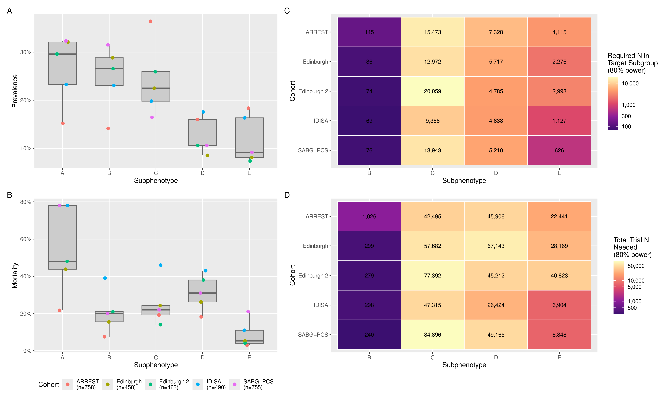

These show that for most subphenotypes, the sample size required varied by setting. In particular, for rarer subphenotypes (E), the required sample size in some settings (SABG-PCS and IDISA) was much lower than elsewhere. This reflects the higher mortality in these settings and the higher prevalence of this subphenotype.

Enriching a real trial (Aim 3)
Above, we demonstrated the magnitude of the subphenotype-specific treatment effect, the frequency of the target subphenotype in the population, and the baseline event rate. We took this further in a hypothetical exercise of ‘screening’ patients with SAB with an imperfect test to randomise them prospectively, as might be considered for a new trial.
We evaluated the impact of five hypothetical diagnostic tests ranging from mediocre to near-perfect accuracy on the number needed to screen (NNS) and number needed to randomize (NNR). For subphenotype B, which has a large treatment effect (OR 4.3) and moderate frequency (13%), enrichment remains feasible even with imperfect tests: NNS ranges from ~7,000 with a near-perfect test (99%/99%) to ~2,800 with a balanced test (80%/80%), with corresponding NNR values of ~140-800 participants (Figure 3 for NNS and NNR). Importantly, and as expected, biased estimates were still present. However, for all other subphenotypes, enrichment is not a feasible strategy even with excellent classifiers.
Type I error in the null subgroup (A) remained close to nominal in the main simulation (n=20,000), ranging from 4.7% at 100% accuracy to 5.9% at 70% accuracy.

Figure 3: Number needed to screen (NNS), number needed to randomize (NNR), and bias across the four non-null subphenotypes. The x-axis shows test-performance scenarios; y-axes show NNS, NNR, or bias. Dashed horizontal reference lines indicate 1,000, 10,000, and 100,000 participants.
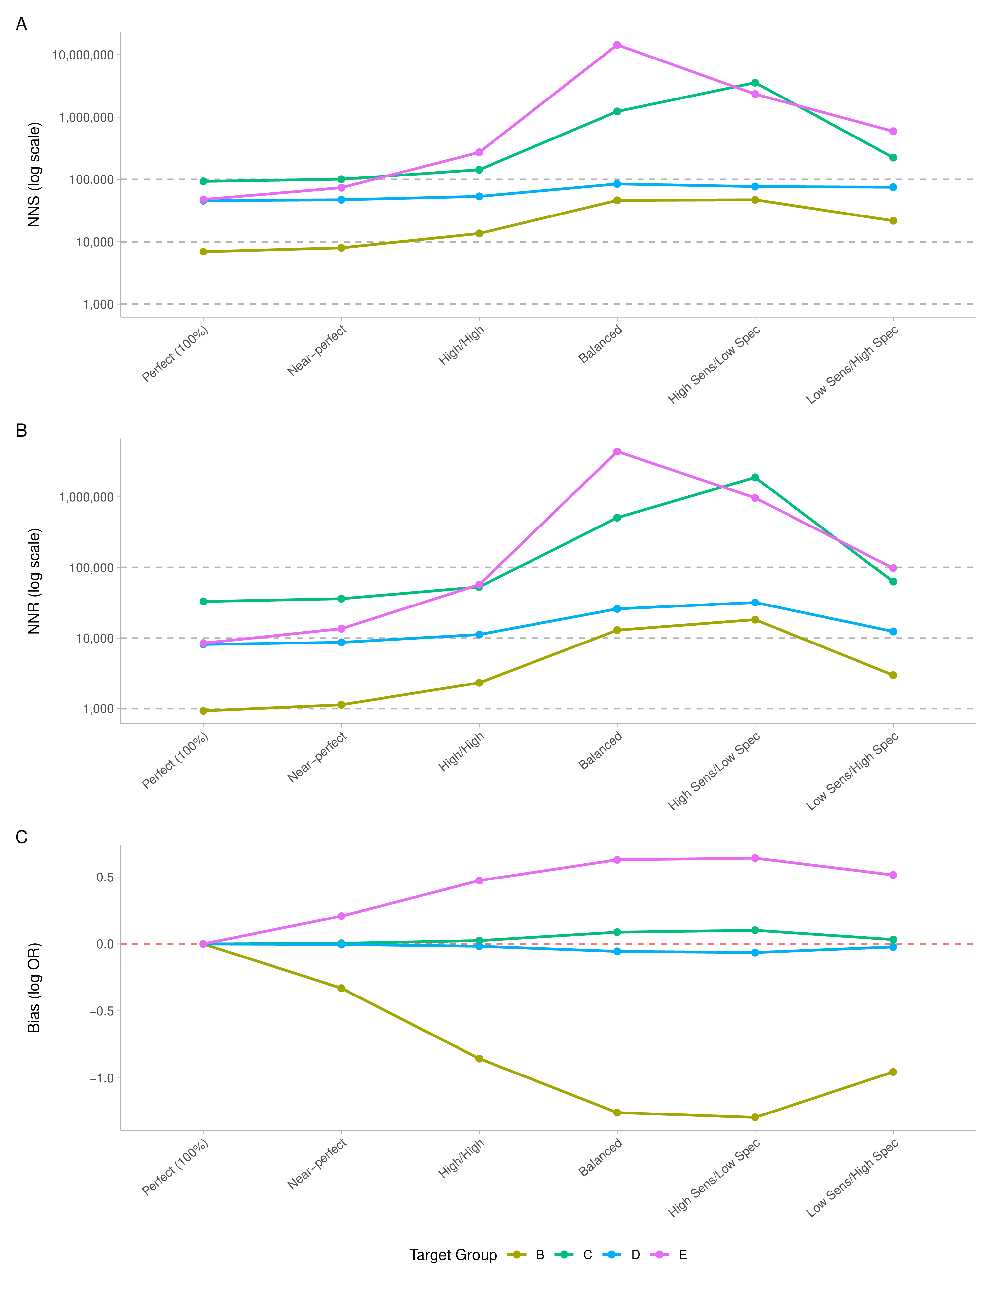

Ordinal outcomes rescue some of the power when correctly specified, but are worse when incorrect
Finally, we tested whether ordinal outcomes could rescue power lost by binary analyses in this setting. We simulated a 6-point ordinal outcome using the same subphenotype setup as in ARREST under two scenarios: (1) a proportional-odds shift across the outcome scale, and (2) a non-proportional death-only effect (treatment changes death odds, with non-death categories rescaled proportionally). The corresponding category shifts for a representative subgroup are shown in Figure 4.
When the ordinal outcome was appropriate (e.g. proportional odds), power was dramatically increased using an ordinal outcome, while type 1 error control was maintained (Figure 5A,5B). The absolute power increase depended on the subphenotype mortality and prevalence. Importantly, and unexpectedly, it was also (generally) less biased when phenotyping was inaccurate. This reflects the non-collapsibility of odds ratios, which occurs when subgroups with very different event rates are mixed. Further explanation of this is given in a supplement, and it is worth noting that this occurs most for rare subphenotypes and would generally but not always reduce bias.

Figure 4: Ordinal outcome category shifts under proportional-odds (A) and non-proportional (death-only) effects (B) for a representative subgroup. Stacked bars show the control and treatment distributions across the six ordered categories (death, ICU, hospital, complications, discharged, recovered). Dashed connectors link matching categories between arms to show how probability mass moves across the outcome scale.
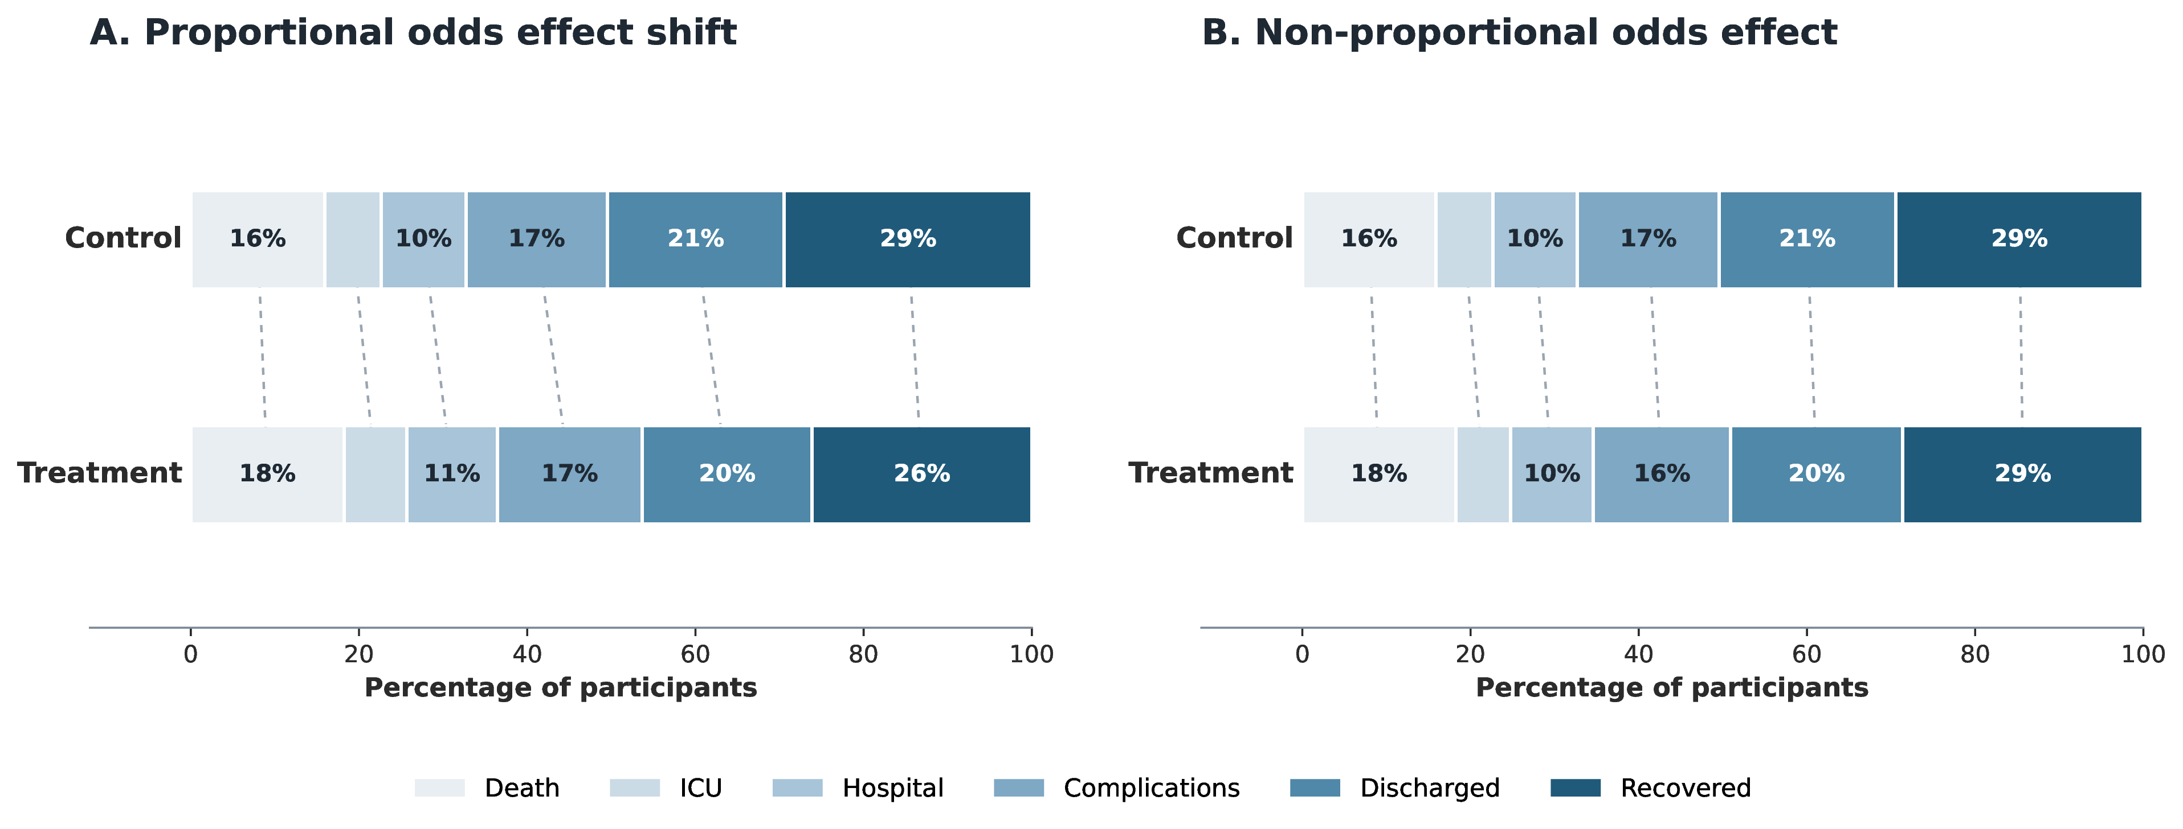

Figure 5: Binary versus ordinal performance under proportional-odds and non-proportional (death-only) ordinal data-generating mechanisms, stratified by classification accuracy. Panels A and C show replicate scaled error at n=20,000; panels B and D show power comparison at n=3,000.
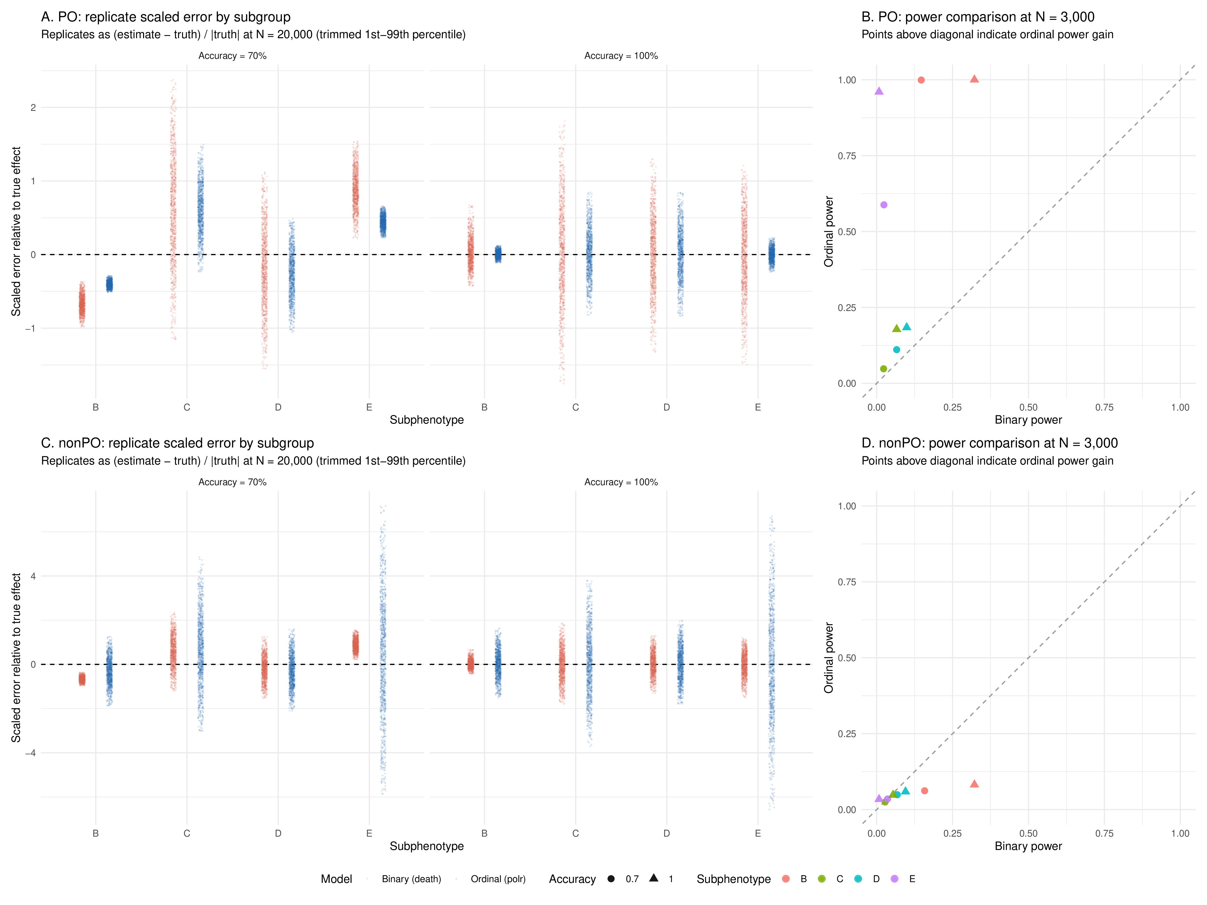

Table 2: Ordinal PO vs non-PO performance at N=3,000, showing power, Type S, Type M, proportional bias, and RMSE for binary (death) and ordinal models under 70% and 100% accuracy.
sample_size | accuracy | dgm | group | model_type | power | type_s | type_m | mean_prop_bias | rmse_log
3000 | 0.7 | PO | B | Binary (death) | 0.147 | 0 | 0.903846634561446 | -0.6398688098758996 | 1.0617177652400571
3000 | 0.7 | PO | B | Ordinal (polr) | 0.999 | 0 | 0.5979974631558277 | -0.4023999027951572 | 0.6120959982924546
3000 | 0.7 | PO | C | Binary (death) | 0.023 | 0.019 | 5.008374459918276 | 0.6383271903904959 | 0.2499255642553304
3000 | 0.7 | PO | C | Ordinal (polr) | 0.048 | 0.004 | 2.319479315436094 | 0.596417539450433 | 0.12813158832710625
3000 | 0.7 | PO | D | Binary (death) | 0.066 | 0.007 | 3.6612928446426296 | -0.265844866576047 | 0.2567802196661905
3000 | 0.7 | PO | D | Ordinal (polr) | 0.111 | 0.003 | 2.195056707773716 | -0.29464419885040716 | 0.1521793144782724
3000 | 0.7 | PO | E | Binary (death) | 0.024 | 0.011 | 1.93368160026442 | 0.8579063769329787 | 0.9084469955598032
3000 | 0.7 | PO | E | Ordinal (polr) | 0.588 | 0 | 0.7158145058913341 | 0.4533567714743797 | 0.321761203579917
3000 | 1 | PO | B | Binary (death) | 0.322 | 0 | 1.3960092604134438 | 1.489671469884607 | 6.085475986363641
3000 | 1 | PO | B | Ordinal (polr) | 1 | 0 | 1.0021823210511056 | 0.00218232105110552 | 0.19122389204525592
3000 | 1 | PO | C | Binary (death) | 0.066 | 0.01 | 4.6397334155755585 | 0.01890564258938777 | 0.23727794443930025
3000 | 1 | PO | C | Ordinal (polr) | 0.178 | 0.001 | 2.382221610185244 | 0.01540446084430831 | 0.11117333661014644
3000 | 1 | PO | D | Binary (death) | 0.099 | 0.004 | 3.468860934852608 | -0.04734200662175368 | 0.23723311558047824
3000 | 1 | PO | D | Ordinal (polr) | 0.184 | 0 | 2.296980057124814 | 0.01415656849173659 | 0.14999773432430988
3000 | 1 | PO | E | Binary (death) | 0.008 | 0 | 3.3652191612845836 | -3.038243674147692 | 6.785248276800712
3000 | 1 | PO | E | Ordinal (polr) | 0.96 | 0 | 1.0192927437115018 | 0.00562000537938734 | 0.16450265762613592
3000 | 0.7 | nonPO | B | Binary (death) | 0.158 | 0 | 0.8942634392890094 | -0.6507957952967871 | 1.081586262405008
3000 | 0.7 | nonPO | B | Ordinal (polr) | 0.062 | 0.003 | 4.093669030322937 | -0.2449902949494266 | 0.1726925244449372
3000 | 0.7 | nonPO | C | Binary (death) | 0.028 | 0.013 | 4.713839134698402 | 0.6922677630039611 | 0.24281028309250768
3000 | 0.7 | nonPO | C | Ordinal (polr) | 0.025 | 0.016 | 9.918608353406286 | 0.6031069606744646 | 0.1097595993866028
3000 | 0.7 | nonPO | D | Binary (death) | 0.068 | 0.008 | 3.6693213981992314 | -0.2769309969602604 | 0.2628564358398401
3000 | 0.7 | nonPO | D | Ordinal (polr) | 0.049 | 0.006 | 4.6211636853569376 | -0.37379168447904265 | 0.14508961056559383
3000 | 0.7 | nonPO | E | Binary (death) | 0.036 | 0.013 | 2.0409301383331706 | 0.8804073914241131 | 0.7438815526938363
3000 | 0.7 | nonPO | E | Ordinal (polr) | 0.035 | 0.036 | 16.725417826150128 | 1.0073792704154458 | 0.1575277911613204
3000 | 1 | nonPO | B | Binary (death) | 0.322 | 0 | 1.3960092604134438 | 1.489671469884607 | 6.085475986363641
3000 | 1 | nonPO | B | Ordinal (polr) | 0.082 | 0.002 | 4.369281627553885 | 0.04333431552626295 | 0.18077207272835463
3000 | 1 | nonPO | C | Binary (death) | 0.054 | 0.005 | 4.834079175237212 | 0.01504508692458758 | 0.2229481390253598
3000 | 1 | nonPO | C | Ordinal (polr) | 0.048 | 0.016 | 10.090131776586114 | 0.04758095038053696 | 0.11101544824460906
3000 | 1 | nonPO | D | Binary (death) | 0.095 | 0.006 | 3.4355635698201072 | -0.0632744423503653 | 0.2400474135796427
3000 | 1 | nonPO | D | Ordinal (polr) | 0.059 | 0.006 | 5.033971450974749 | 0.02784530565640569 | 0.15226960524647148
3000 | 1 | nonPO | E | Binary (death) | 0.008 | 0 | 3.3652191612845836 | -3.038243674147692 | 6.785248276800712
3000 | 1 | nonPO | E | Ordinal (polr) | 0.034 | 0.024 | 17.653398729073235 | 0.3164851041856291 | 0.15870545818382695

At n=3,000 and 100% accuracy, under proportional odds the ordinal model was more powerful than binary in all non-null subgroups: B (1.000 vs 0.322), C (0.178 vs 0.066), D (0.184 vs 0.099), and E (0.960 vs 0.008). Under non-proportional death-only effects, binary death analysis was more powerful for B (0.322 vs 0.082), C (0.054 vs 0.048), and D (0.095 vs 0.059), whereas ordinal was only slightly higher in E (0.034 vs 0.008).
However, when the ordinal outcome was inappropriate (e.g the treatment only affects death but has no effect on other levels), power was much lower with an ordinal outcome compared to a binary outcome. This reflects the binary comparison actually reflecting the treatment effect, while the ordinal measure largely reflects noise. Type 1 error was again well controlled. The use of a non-parametric test (rank-sum) did not substantially differ here, suggesting this simply reflects the outcome containing a lot of noise.
These results clearly show the strengths and weaknesses of ordinal outcomes: when they correctly reflect the treatment effect, they are dramatically more powerful; and surprisingly, less biased. However, if mis-specified, they make the situation much worse.

Discussion
This modelling study demonstrates that the feasibility of detecting HTE in SAB will be dictated not just by the magnitude of a putative treatment effect, but by the interplay of subphenotype prevalence, baseline event rate, and the accuracy of patient classification into subphenotypes.
First, we show the required sample size to robustly identify differential treatment effects in subphenotypes of SAB is dependent on three factors i) the estimated effect size, ii) the prevalence of the subphenotype, and iii) the event rate in that subphenotype. The required sample sizes we identified were larger than many observational cohorts, and certainly larger than any ongoing SAB RCTs. Importantly, subphenotype prevalence and mortality varies greatly across settings, leading to >10 fold variation in the required sample size in different settings. This makes a priori reliable sample size estimation almost impossible.
We then showed this challenge is compounded by inaccurate classification: when the accuracy of identifying a subphenotype reduces, the sample size generally increases by orders of magnitude, making trials infeasible for all those except extremely large, common, and high event rate subphenotypes. Importantly, this effect can lead to biased estimates that can even be in the wrong direction for rarer subphenotypes. This bias is critical and arguably more important than the power issue: in the best-case scenario it biases towards the null, but depending on how classification occurs, it could bias towards a larger effect. This cannot be rescued by screening approaches, which although reducing the number randomised, do not resolve bias.
Finally, we tested ordinal outcomes. For the same effect, when correctly specified, we observed dramatic increases in power, no inflation of type I error, and reduced bias. However, when incorrectly specified (i.e., treatment does not affect all levels), they performed much worse than binary measures and were severely underpowered.

This leads to a number of implications for future trials.
Firstly, the conditions for a therapy for a specific subphenotype being taken forward into a trial are that:
  - There is a high event rate (likely >10%, ideally >15%)
  - The phenotype represents a reasonable proportion of the trial population (likely >15%)
  - the treatment should plausibly have a large effect (likely OR >1.5).

In this setting, inaccurate phenotyping may have a relatively limited effect on bias and power, although we stress that trialists should simulate their specific scenarios thoroughly before embarking on a large trial.
Our results suggest a clear, three-pronged strategy for advancing stratified trials in SAB. The first path is to improve diagnostic classifiers, aiming for near-perfect performance (e.g., >95% sensitivity and specificity) to make even rare or low-event subphenotypes viable targets. A limitation of the latent class analysis performed by Swets et al, which provides the basis for the simulations here, is that all patients are assigned to a subphenotype. In reality, some patients will be unclassifiable, and future work should derive improved assignment models. The second, more pragmatic path, is to focus trial resources on subgroups with favorable prevalence-event characteristics. Attempting to design trials around rare subphenotypes with current technology is likely to fail, as classification errors erode power and introduce bias. Thirdly, trialists should increase power by optimizing outcome measurement and design. A rare binary outcome is statistically inefficient. A validated and clinically relevant ordinal or continuous outcome may improve efficiency, although we caution against naive outcome choice. For example, in CAMERA2, although adding flucloxacillin to vancomycin for MRSA improved a microbiological outcome, it may have worsened clinical outcomes. Variation between settings in Aim 1 also shows that a priori sample-size prediction is difficult; adaptive designs (e.g., Bayesian platform approaches) may therefore be preferable.
In sum, this data should make us somewhat cautious about the reality of ever determining large heterogenous treatment effects in a condition like SAB for some subphenotypes.¹⁶ Measurement error is inevitable, and therefore even in the presence of highly accurate molecular tests, sensitivity and specificity are unlikely to ever be >99%, particularly when the subphenotype does not itself have a clear molecular basis. Notable exceptions might include phenotypes that are driven by specific protein or genetic changes in the pathogen (e.g. mecA carriage), which are likely to have large measurable effects on bacterial phenotype and be detected by molecular tests near perfectly.
Comparison with previous literature
As far as we are aware, no study has specifically quantified sample sizes, bias, and power for SAB subphenotyping, although it is well established that these factors depend on the effect sizes of treatment, event rates, and total sample size. The novelty of this study is that it provides SAB specific effects driven from subphenotyping across numerous clinical cohorts of SAB and where a treatment effect was derived from a randomised trial.

Limitations
Like all simulation studies, we are limited by our input data. We simulate data based on Swets et al 2024 and 2025; although these studies include 5 separate cohorts from the UK, Spain, Netherlands, and USA, a single clustering approach is used. However, we do note that a recent study that attempted to subphenotype SAB in different cohorts identified a largely similar set of subphenotypes. These suggest that the subphenotypes identified by Swets et al likely have validity.
Is another limitation that there is only a single study used to generate the treatment effects, so one population, one intervention, and one outcome? Obviously we cannot do anything about it as there are no other trials to include with different interventions/outcomes.
However, our simulation results would change with differing input values. Secondly, we chose to define both accuracy and sensitivity/specificity simply: participants were either classified to the correct subphenotype or classified as one of the other subphenotypes with the probability depending on the frequency of that subphenotype. This is a simplification; it is highly likely that some tests will specifically misclassify patients to certain Subphenotypes. However, this will not fundamentally change the logic of inaccurate tests but has the potential to lead to even more non-intuitive results, if for example, misclassification swings a participant from a group with high likelihood of benefit to high likelihood of harm with a treatment.
For both Aim 1 and Aim 3 we implemented a closed-form solution for computational efficiency. When performing simulation to confirm these results, we identified very small differences between closed-form and simulated results, particularly when event rates were low as the closed-form can break down. However, these differences were small (<1% difference in estimated power generally) and do not affect the findings of the paper.
Conclusion
Identifying subphenotypes in SAB represents a potential large advance in management of this serious infection. However, realistic sample sizes are extremely high (>20,000 for most plausible effect sizes) and require extremely accurate tests. Researchers should continue to strive for large trials in this common condition while developing accurate tests for subphenotypes, and focus identification of HTE only on common, high event, high effect subphenotypes at present.

