**Online Supplementary Material**

**Table S1**

**Genotyping, imputations and quality control (QC)**

|  |  |  |  |
| --- | --- | --- | --- |
|  | **Discovery cohort** | **Replication cohort** | **Pooled cohort** |
| Illumina BeadChip | HumanOmni2.5-4v1 (Omni2.5) | Infinium HumanOmniExpressExome-8v1 |  |
| No patients genotyped | 3998 | 6015 |  |
| Sample QC | Call rate >98%, duplicates, gender check | |  |
| Samples that passed QC | 3982 | 5996 | 9978 |
| SNP QC for Principal Component analyses | Call rate >98%, MAF >0.01 and HWE (p>1x10-8) | |  |
| Number of SNPs in PCA | 1,586,429 | 125003* | 119547* |
| Pre-Imputation SNP QC | Call rate >98%, MAF >0.001 and HWE (p>1x10-8). | |  |
| Number of SNPs included in the imputations | 1796367 | 705132 |  |
| Number of imputed SNPs | 25030450 | 26719315 |  |
| Post-Imputation QC | MAF>0.005, HWE P-value >10-10, and IMPUTE2 s Info metric >0.3 | |  |
| Imputed SNPs that passed QC | 10962468 | 10891933 | 10,814,307** |
| Clopidogrel patients excluded | | | |
| Samples that passed QC –  Only ticagrelor patients | 1989 | 3001 | 4990 |
| Samples that passed QC with  PK measurements | 1812 | 1941 | 3753 |

* In the replication cohort and in the pooled data, LD pruning (pairwise LD <0.2) were performed prior to PCA.

** SNPs that overlap between the discovery and replication cohort, and pass the QC in the pooled dataset

QC=quality control, SNP=single nucleotide polymorphism, MAF=minor allele frequency, HWE= Hardy-Weinberg Equilibrium, PK=pharmacokinetic, LD=linkage disequilibrium

**Table S2**

**Full list of potential covariates in the analyses**

|  |
| --- |
| **Variable** |
| Age (years)* |
| Sex* |
| Weight (kg)* |
| BMI (kg/m2) |
| Ethnicity |
| Smoking status* |
| History of hypertension* |
| History of dyslipidaemia including hypercholesterolemia |
| History of diabetes mellitus |
| History of angina pectoris |
| History of myocardial infarction |
| Previous PCI |
| Previous CABG* |
| Congestive heart failure |
| Previous transient ischemic attack |
| Previous non-haemorrhagic stroke |
| Peripheral arterial disease |
| Chronic renal disease* |
| Previous episodes of dyspnoea |
| Chronic obstructive pulmonary disease |
| Asthma |
| Previous gout |
| Final diagnosis of index event* |
| TIMI Risk Score STEMI (0-14)/NSTEMI(0-7) |
| Co-administered moderate CYP3A inducer (PK)* |
| Co-administered moderate CYP3A inhibitor* |
| Aspirin on day of randomisation |
| Heparin during index hospitalisation |
| Glycoprotein IIb/IIIa during index hospitalisation |
| Beta blockers on day of randomisation |
| ACE inhibitors on day of randomisation |
| Angiotensin II receptor blocker on day of randomisation |
| Lipid-lowering agent on day of randomisation |
| Calcium channel blocker on day of randomisation |

* These variables were included as covariates in the analyses

BMI=body mass index, PCI=percutaneous coronary intervention CABG=coronary artery bypass grafting STEMI=ST-elevation myocardial infarction, NSTEMI=non-ST-elevation myocardial infarction, PK=pharmacokinetic ACE=angiotensin-converting enzyme

**Table S3**

**Full list of SNPs passing the genome-wide significance threshold of p<1x10-8 in the combined and imputed data for the ticagrelor active metabolite (ARC) AUCss**

| **Chr** | **SNP** | **Pos** | **Gene** | **Alleles**  **(major/minor)** | **MAF** | **N** | **Beta** | **SE(Beta)** | **p-value** | **Info** | **Sift** |
| --- | --- | --- | --- | --- | --- | --- | --- | --- | --- | --- | --- |
| 4 | exm403192 | 69962375 | UGT2B7 | C/T | 0.005 | 3752 | 0.385 | 0.051 | 7.70x10-14 | 0.9126 | 0 |
| 12 | rs113681054 | 21402979 |  | C/T | 0.184 | 3752 | 0.062 | 0.009 | 3.63x10-13 | 0.97257 | NA |
| 12 | rs11045899 | 21395835 | SLCO1B1 | T/A | 0.194 | 3752 | 0.06 | 0.008 | 7.31x10-13 | 0.99962 | NA |
| 12 | *rs12366582 | 21391608 | SLCO1B1 | G/A | 0.194 | 3752 | 0.059 | 0.008 | 8.05x10-13 | 1 | NA |
| 12 | *rs12369881 | 21391352 | SLCO1B1 | A/G | 0.194 | 3752 | 0.059 | 0.008 | 9.99x10-13 | 1 | NA |
| 12 | rs73069032 | 21403491 |  | A/G | 0.194 | 3752 | 0.059 | 0.008 | 1.04x10-12 | 0.99718 | NA |
| 12 | rs59205959 | 21400966 |  | A/G | 0.195 | 3752 | 0.059 | 0.008 | 1.16x10-12 | 0.99926 | NA |
| 12 | rs11519067 | 21412403 |  | T/A | 0.195 | 3752 | 0.059 | 0.008 | 1.21x10-12 | 0.99219 | NA |
| 12 | rs11045909 | 21411206 |  | G/C | 0.195 | 3752 | 0.059 | 0.008 | 1.25x10-12 | 0.99242 | NA |
| 12 | rs73069030 | 21402569 |  | G/A | 0.195 | 3752 | 0.059 | 0.008 | 1.30x10-12 | 0.99771 | NA |
| 12 | rs11519068 | 21412443 |  | C/T | 0.195 | 3752 | 0.059 | 0.008 | 1.32x10-12 | 0.99127 | NA |
| 12 | rs73069028 | 21402439 |  | A/G | 0.195 | 3752 | 0.059 | 0.008 | 1.46x10-12 | 0.99801 | NA |
| 12 | *rs4363657 | 21368722 | SLCO1B1 | C/T | 0.191 | 3752 | 0.06 | 0.008 | 1.46x10-12 | 1 | NA |
| 12 | rs57743625 | 21367633 | SLCO1B1 | A/G | 0.195 | 3752 | 0.059 | 0.008 | 1.62x10-12 | 0.99085 | NA |
| 12 | rs73069037 | 21404866 |  | C/A | 0.194 | 3752 | 0.059 | 0.008 | 1.65x10-12 | 0.99548 | NA |
| 12 | rs2199680 | 21415496 | SLCO1A2 | T/A | 0.198 | 3752 | 0.059 | 0.008 | 1.74x10-12 | 0.97409 | NA |
| 12 | chr12:21369975:D | 21369975 |  | T/D | 0.191 | 3752 | 0.059 | 0.008 | 1.95x10-12 | 0.99727 | NA |
| 12 | rs73069021 | 21399955 |  | A/G | 0.186 | 3752 | 0.06 | 0.008 | 1.99x10-12 | 0.99913 | NA |
| 12 | chr12:21371543:D | 21371543 |  | A/D | 0.191 | 3752 | 0.059 | 0.008 | 2.02x10-12 | 0.99998 | NA |
| 12 | *rs11045879 | 21382619 | SLCO1B1 | C/T | 0.191 | 3752 | 0.059 | 0.008 | 2.08x10-12 | 1 | NA |
| 12 | chr12:21414585:D | 21414585 |  | A/D | 0.188 | 3752 | 0.06 | 0.009 | 2.10x10-12 | 0.98111 | NA |
| 12 | rs58258204 | 21368015 | SLCO1B1 | T/C | 0.191 | 3752 | 0.059 | 0.008 | 2.17x10-12 | 0.99952 | NA |
| 12 | rs4149080 | 21377559 | SLCO1B1 | C/G | 0.191 | 3752 | 0.059 | 0.008 | 2.18x10-12 | 0.99984 | NA |
| 12 | rs58487503 | 21379980 | SLCO1B1 | A/G | 0.191 | 3752 | 0.059 | 0.008 | 2.29x10-12 | 0.99989 | NA |
| 12 | *rs4149081 | 21378021 | SLCO1B1 | A/G | 0.191 | 3752 | 0.059 | 0.008 | 2.51x10-12 | 1 | NA |
| 12 | rs11045883 | 21383516 | SLCO1B1 | A/G | 0.191 | 3752 | 0.059 | 0.008 | 2.59x10-12 | 0.99973 | NA |
| 12 | rs73063122 | 21361213 | SLCO1B1 | C/A | 0.191 | 3752 | 0.059 | 0.008 | 2.68x10-12 | 0.99718 | NA |
| 12 | *rs4149056 | 21331549 | SLCO1B1 | C/T | 0.175 | 3752 | 0.061 | 0.009 | 2.78x10-12 | 1 | 0 |
| 12 | rs12369359 | 21381191 | SLCO1B1 | G/T | 0.191 | 3752 | 0.059 | 0.008 | 3.05x10-12 | 0.99727 | NA |
| 12 | rs7969341 | 21385604 | SLCO1B1 | G/A | 0.192 | 3752 | 0.059 | 0.008 | 3.20x10-12 | 0.99993 | NA |
| 12 | rs58310495 | 21357711 | SLCO1B1 | T/C | 0.183 | 3752 | 0.06 | 0.009 | 3.28x10-12 | 0.99687 | NA |
| 12 | rs55695203 | 21357753 | SLCO1B1 | C/G | 0.184 | 3752 | 0.059 | 0.009 | 3.28x10-12 | 0.99684 | NA |
| 12 | *rs11045885 | 21386018 | SLCO1B1 | G/A | 0.192 | 3752 | 0.058 | 0.008 | 3.30x10-12 | 1 | NA |
| 12 | rs12318075 | 21361587 | SLCO1B1 | G/T | 0.192 | 3752 | 0.058 | 0.008 | 3.47x10-12 | 0.99725 | NA |
| 12 | chr12:21379355:I | 21379355 | SLCO1B1 | D/G | 0.19 | 3752 | 0.059 | 0.009 | 4.00x10-12 | 0.96967 | NA |
| 12 | rs11045886 | 21386493 | SLCO1B1 | C/A | 0.188 | 3752 | 0.059 | 0.008 | 4.20x10-12 | 0.98979 | NA |
| 12 | *rs12317268 | 21352541 | SLCO1B1 | G/A | 0.183 | 3752 | 0.059 | 0.009 | 5.08x10-12 | 1 | NA |
| 12 | rs11519272 | 21362392 | SLCO1B1 | A/C | 0.175 | 3752 | 0.061 | 0.009 | 5.58x10-12 | 0.95462 | NA |
| 12 | rs4149083 | 21380630 | SLCO1B1 | T/A | 0.181 | 3752 | 0.059 | 0.009 | 5.66x10-12 | 0.99603 | NA |
| 12 | rs12367888 | 21347021 | SLCO1B1 | T/G | 0.182 | 3752 | 0.059 | 0.009 | 6.01x10-12 | 0.9955 | NA |
| 12 | chr12:21361048:I | 21361048 |  | D/T | 0.181 | 3752 | 0.059 | 0.009 | 6.07x10-12 | 0.98516 | NA |
| 12 | rs73067080 | 21388829 | SLCO1B1 | C/T | 0.193 | 3752 | 0.057 | 0.008 | 6.14x10-12 | 0.99769 | NA |
| 12 | rs56165099 | 21357731 | SLCO1B1 | T/C | 0.226 | 3752 | 0.055 | 0.008 | 6.24x10-12 | 0.99646 | NA |
| 12 | rs1871395 | 21352315 | SLCO1B1 | G/A | 0.183 | 3752 | 0.058 | 0.009 | 7.29x10-12 | 0.99956 | NA |
| 12 | rs73079476 | 21343833 | SLCO1B1 | C/A | 0.175 | 3752 | 0.06 | 0.009 | 7.89x10-12 | 0.9926 | NA |
| 12 | rs4149067 | 21353911 | SLCO1B1 | G/C | 0.226 | 3752 | 0.055 | 0.008 | 8.03x10-12 | 0.99821 | NA |
| 12 | rs2900478 | 21368797 | SLCO1B1 | A/T | 0.177 | 3752 | 0.06 | 0.009 | 1.24x10-11 | 0.97874 | NA |
| 12 | rs11519274 | 21362819 | SLCO1B1 | T/C | 0.175 | 3752 | 0.06 | 0.009 | 1.73x10-11 | 0.95559 | NA |
| 12 | chr12:21361058:D | 21361058 | SLCO1B1 | G/D | 0.176 | 3752 | 0.059 | 0.009 | 2.28x10-11 | 0.97301 | NA |
| 12 | *rs12371604 | 21391336 | SLCO1B1 | C/T | 0.258 | 3752 | 0.05 | 0.008 | 3.56x10-11 | 0.99967 | NA |
| 12 | rs11045896 | 21393651 | SLCO1B1 | C/A | 0.257 | 3752 | 0.05 | 0.008 | 3.83x10-11 | 0.99988 | NA |
| 12 | rs58989256 | 21401146 |  | A/G | 0.257 | 3752 | 0.05 | 0.008 | 6.08x10-11 | 0.99919 | NA |
| 12 | chr12:21414825:I | 21414825 |  | D/A | 0.265 | 3752 | 0.05 | 0.008 | 6.84x10-11 | 0.96539 | NA |
| 4 | rs188514203 | 70050302 | NA | G/A | 0.015 | 3752 | 0.186 | 0.03 | 7.07x10-10 | 0.86184 | NA |
| 12 | rs77289848 | 21360761 | SLCO1B1 | A/G | 0.13 | 3752 | 0.061 | 0.01 | 1.08x10-09 | 0.95929 | NA |
| 12 | rs67981690 | 21343886 | SLCO1B1 | G/A | 0.148 | 3752 | 0.055 | 0.01 | 9.03x10-09 | 0.9712 | NA |

**\* Theese SNPs passed the genome wide significance level in discovery phase**

**Table S4**

**Full list of SNPs passing the genome-wide significance threshold of p < 1e-8 in the combined and imputed data for ticagrelor AUCss**

|  |  |  |  |  |  |  |  |  |  |  |  |  |  |  |  |  |  |  |  |  |  |  |
| --- | --- | --- | --- | --- | --- | --- | --- | --- | --- | --- | --- | --- | --- | --- | --- | --- | --- | --- | --- | --- | --- | --- |
| **Chr** | | **SNP** | | **Pos** | | **Gene** | | **Alleles (major/minor)** | | **MAF** | **N** | | **Beta** | | **SE(Beta)** | | **p-value** | | **Info** | | **Sift** | |
| 7 | | rs62471956 | | 99421085 | | CYP3A43 | | A/G | | 0.034 | 3751 | | 0.211 | | 0.027 | | 1.07x10-14 | | 0.74551 | | NA | |
| 7 | | rs62471957 | | 99440105 | | CYP3A43 | | G/A | | 0.034 | 3751 | | 0.211 | | 0.027 | | 1.32x10-14 | | 0.74835 | | NA | |
| 7 | | rs35599367 | | 99366316 | | CYP3A4 | | A/G | | 0.035 | 3751 | | 0.207 | | 0.027 | | 1.45x10-14 | | 0.75001 | | NA | |
| 7 | | rs62474460 | | 99463342 | | CYP3A43 | | C/T | | 0.031 | 3751 | | 0.203 | | 0.028 | | 7.97x10-13 | | 0.74561 | | NA | |
| 7 | | rs182639078 | | 99379549 | | CYP3A4 | | C/G | | 0.007 | 3751 | | 0.500 | | 0.071 | | 1.75x10-12 | | 0.55112 | | NA | |
| 7 | | rs188845491 | | 99286639 | |  | | T/C | | 0.007 | 3751 | | 0.495 | | 0.071 | | 3.16x10-12 | | 0.55945 | | NA | |
| 7 | | rs147642358 | | 98932759 | | ARPC1A | | A/G | | 0.022 | 3751 | | 0.250 | | 0.036 | | 5.51x10-12 | | 0.66339 | | NA | |
| 7 | | rs190105372 | | 99379542 | | CYP3A4 | | A/G | | 0.009 | 3751 | | 0.414 | | 0.060 | | 7.49x10-12 | | 0.51847 | | NA | |
| 7 | | rs145197147 | | 99464877 | | CYP3A43-CYP3A52P | | T/C | | 0.009 | 3751 | | 0.425 | | 0.062 | | 9.58x10-12 | | 0.58067 | | NA | |
| 7 | | rs62471929 | | 99274316 | | CYP3A5 | | G/A | | 0.047 | 3751 | | 0.145 | | 0.021 | | 1.54x10-11 | | 0.80286 | | NA | |
| 7 | | rs140607780 | | 100103523 | |  | | A/G | | 0.016 | 3751 | | 0.273 | | 0.041 | | 3.47x10-11 | | 0.67044 | | NA | |
| 7 | | exm638811 | | 99375702 | | CYP3A4 | | T/C | | 0.005 | 3751 | | 0.407 | | 0.063 | | 9.22x10-11 | | 0.74498 | | 0 | |
| 7 | | rs140104968 | | 99543627 | |  | | T/C | | 0.019 | 3751 | | 0.224 | | 0.036 | | 4.35x10-10 | | 0.77376 | | NA | |
| 7 | | rs117038461 | | 99841354 | | GATS | | T/C | | 0.017 | 3751 | | 0.232 | | 0.038 | | 9.40x10-10 | | 0.70939 | | NA | |
| 7 | | rs117789573 | | 99817076 | | STAG3-GATS-PVRIG | | A/G | | 0.017 | 3751 | | 0.231 | | 0.038 | | 1.02x10-09 | | 0.71214 | | NA | |
| 7 | | rs185063157 | | 99888753 | |  | | T/A | | 0.006 | 3751 | | 0.413 | | 0.068 | | 1.19x10-09 | | 0.63463 | | NA | |
| 7 | | chr7:99750855:D | | 99750855 | |  | | G/D | | 0.017 | 3751 | | 0.229 | | 0.038 | | 1.52x10-09 | | 0.72018 | | NA | |
| 7 | | rs117092118 | | 99585045 | | AZGP1P1 | | A/G | | 0.018 | 3751 | | 0.215 | | 0.036 | | 1.74x10-09 | | 0.78336 | | NA | |
| 7 | | rs149037572 | | 98917808 | |  | | A/G | | 0.026 | 3751 | | 0.201 | | 0.034 | | 2.10x10-09 | | 0.65819 | | NA | |
| 7 | | rs117850863 | | 98874576 | | MYH16 | | T/G | | 0.023 | 3751 | | 0.216 | | 0.036 | | 2.40x10-09 | | 0.61827 | | NA | |
| 7 | | rs144431188 | | 99599136 | |  | | T/C | | 0.019 | 3751 | | 0.214 | | 0.036 | | 2.94x10-09 | | 0.76183 | | NA | |
| 7 | | rs181629504 | | 99625240 | | ZKSCAN1 | | A/G | | 0.019 | 3751 | | 0.211 | | 0.036 | | 5.48x10-09 | | 0.74408 | | NA | |
| 7 | | rs76775847 | | 99633582 | | ZKSCAN1 | | A/G | | 0.019 | 3751 | | 0.210 | | 0.036 | | 6.73x10-09 | | 0.74157 | | NA | |
|  |  | |  | |  | |  | |  | | |  | |  | |  | |  | |  | |  | |

**Figure S1**

Manhattan plot of discover (discovery phase) GWAS analysis of ticagrelor active metabolite (ARC) AUCss

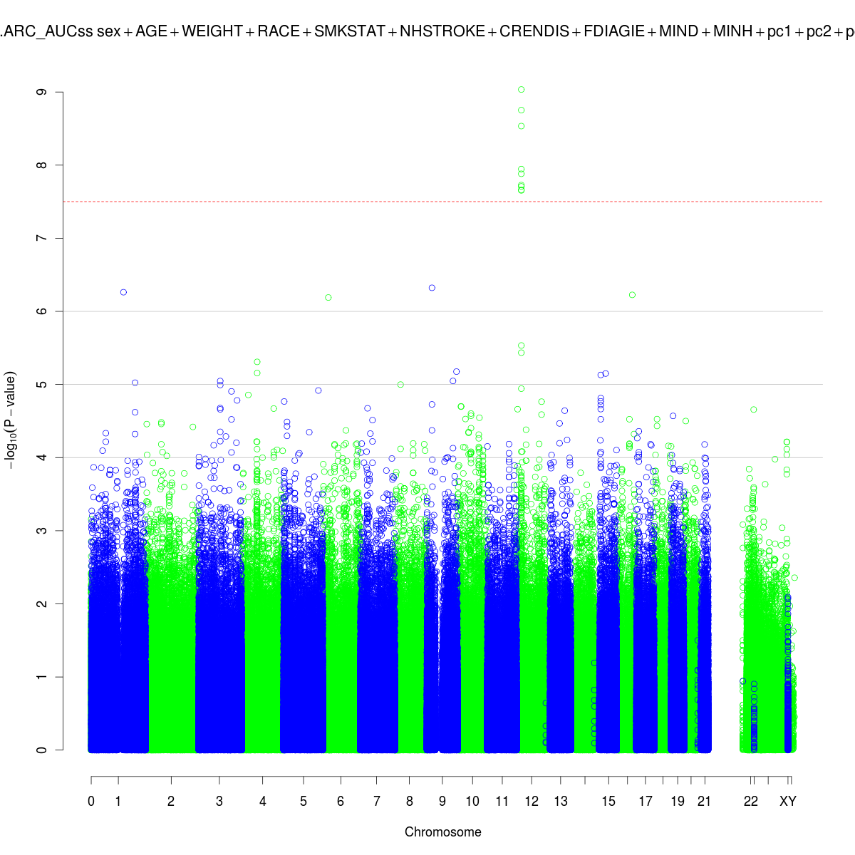

**Figure S2**

Manhattan plot of discover (replication phase) GWAS analysis of ticagrelor AUCss

