Manuscript title: replace with a concise, informative title
First Author¹, Second Author²
¹ Department, Institution, City, Postal code, Country
² Department, Institution, City, Postal code, Country
* Corresponding author: author@example.com

Abstract
Replace this text with a self-contained abstract. This paragraph uses the Normal style: Times New Roman 12 pt, justified, 1.5 line spacing, 6 pt before and after, and no first-line indent.
Keywords: landslide; physical model; monitoring; deformation; uncertainty

1. Introduction
Replace with manuscript text. Preserve an author-year system such as Smith (2024), or an existing numeric citation such as ¹.

1.1 Study context
Use Normal for ordinary narrative paragraphs.

1.1.1 Optional third-level heading
All three heading levels use Times New Roman.

2. Figures
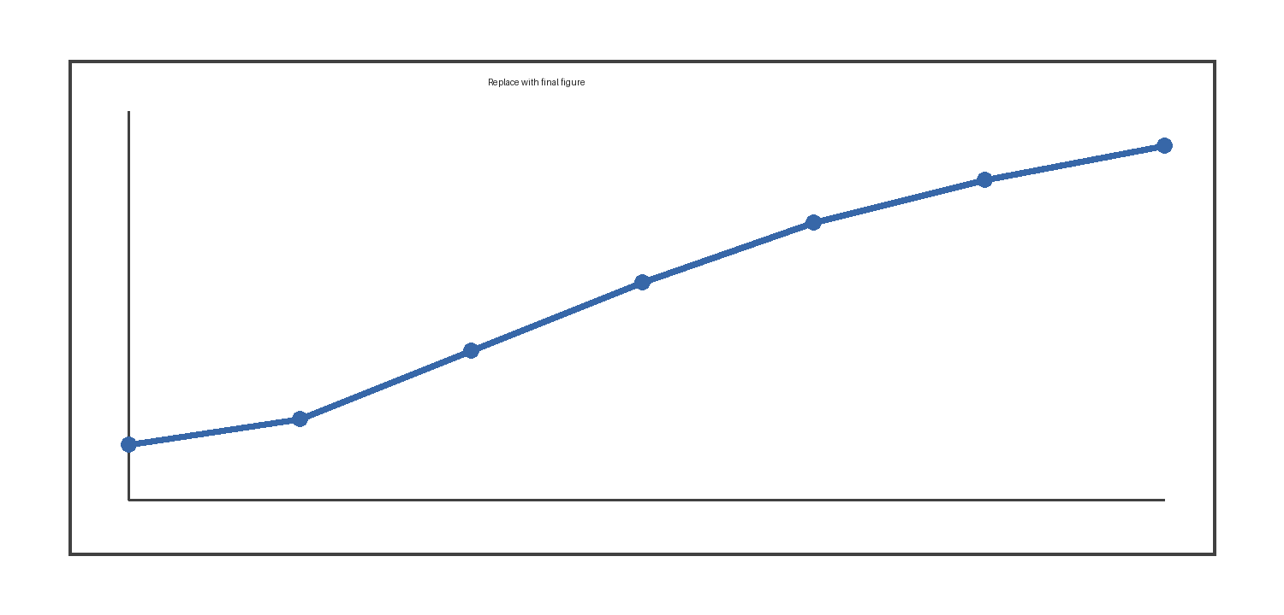
Figure 1. Replace this placeholder with the final inline figure and retain this 12 pt italic, justified caption below the image.

3. Tables
Table 1. Illustrative physical-model test conditions and observed responses.
Model ID | Failure mode | Peak displacement (mm) | Failure time (min)
PM-01 | No failure | 8.4 | >180
PM-02 | Progressive sliding | 18.7 | 146
PM-03 | Toe failure | 36.2 | 93

4. Equations
Use native editable Word equations for mathematical expressions that require equation typesetting.
$v=\frac{Δd}{Δt}$ (1)

5. References
Zhao, B. (2022). First source-position example; preserve this position and its citation mapping.
Adams, C. (2024). Second source-position example; do not alphabetize, reorder, or renumber automatically.

Acknowledgments
Replace with acknowledgments.

Funding
Replace with funding information.

Competing interests
Replace with a competing-interest statement.

Data availability
Replace with a data-availability statement.

Ethics statement
Replace with an ethics statement when applicable.

CRediT authorship contribution statement
First Author: Conceptualization, Methodology, Writing – original draft.

