[Insert manuscript title]
[Author 1]ª, [Author 2]^{a,b}, [Author 3]^{c,*}
ª [Affiliation 1, Department, Institution, City, Country]
^{b} [Affiliation 2, Department, Institution, City, Country]
^{c} [Affiliation 3, Department, Institution, City, Country]
* Corresponding author: name@example.com

Abstract
[Insert the abstract. This paragraph uses the SCI Abstract Body style and the confirmed four-letter first-line indent.]
Keywords: [keyword 1; keyword 2; keyword 3]

1. Introduction
[Insert manuscript text here. Preserve the source citation system, whether it uses author-year citations such as Smith (2024) or numeric citations such as ¹.]

1.1 Study context
[Use SCI Body for ordinary narrative paragraphs. Replace all bracketed guidance before submission.]

2. Figures
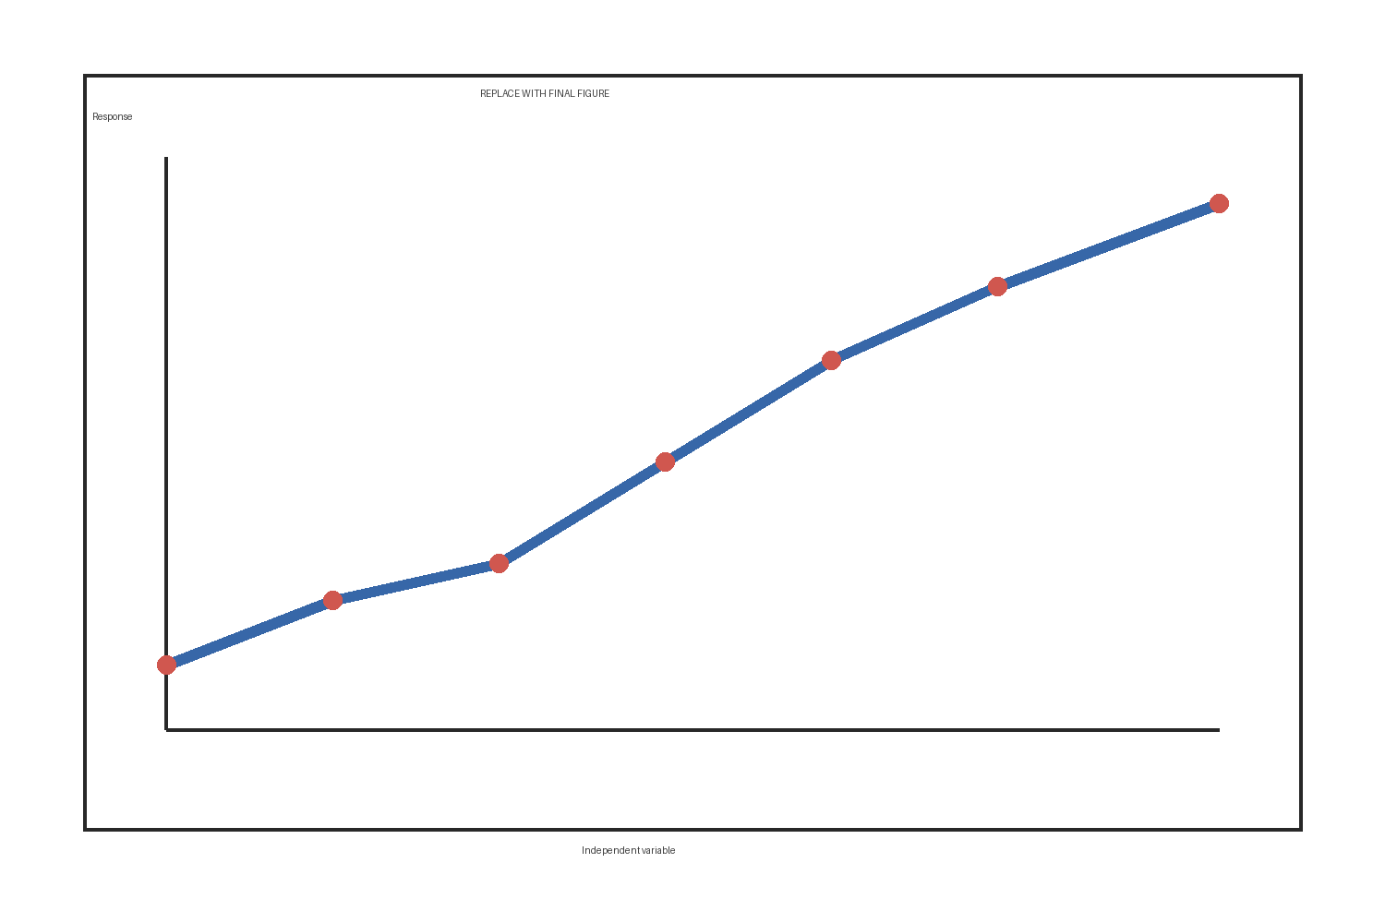
Figure 1. Replace this placeholder with the final inline figure and edit the caption.

3. Tables
Table 1. Illustrative physical-model test conditions and observed responses.
Model ID | Failure mode | Peak displacement (mm) | Failure time (min)
PM-01 | No failure | 8.4 | >180
PM-02 | Progressive sliding | 18.7 | 146
PM-03 | Toe failure | 36.2 | 93

4. Equations
[Use native editable Word equations for mathematical expressions that require equation typesetting.]
$v=\frac{Δd}{Δt}$ (1)

5. References
[Reference entry 1 - preserve its original position, numbering, punctuation, and citation mapping.]
[Reference entry 2 - do not alphabetize, reorder, or renumber unless explicitly requested.]

Acknowledgments
[Insert acknowledgments.]

Funding
[Insert funding information.]

CRediT authorship contribution statement
[Insert author contributions; author names may be bold.]

Competing interests
[Insert competing-interest statement.]

Data availability
[Insert data-availability statement.]

Ethics statement
[Insert ethics statement when applicable.]

