Struts2、Hibernate5、Spring4集成(MySQL)

第1部分 预备步骤：创建数据库

在MySQL中创建数据库ssh
Create database ssh;
Use ssh;
准备表product_， 有3个字段，分别是
主键id(自增长)
字符串格式的name
浮点数格式的price

CREATE TABLE product_ (
id int(11) NOT NULL AUTO_INCREMENT,
name varchar(30) ,
price float ,
PRIMARY KEY (id)
) DEFAULT CHARSET=UTF8;

在表中插入几行数据
insert into product_(name,price) values('produtct1',88.8);
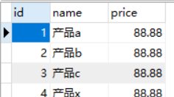

第2部分 创建maven-webapp项目

新建工程
在IDEA中创建工程SSHMySQL，类型为Maven-archetype-webapp 类型，然后在main文件夹中创建java文件夹，并标记为Sources Root；创建resources文件夹并标记为Resources Root。
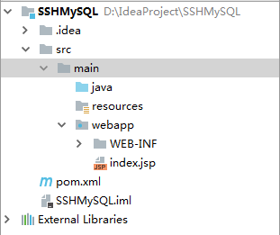

添加依赖包的坐标
在项目的pom.xml中添加MySQL数据库、Struts2框架、Hibernate框架、Spring框架的依赖包的坐标如下：
//pom.xml
<?xml version="1.0" encoding="UTF-8"?>
<project xmlns="http://maven.apache.org/POM/4.0.0" xmlns:xsi="http://www.w3.org/2001/XMLSchema-instance"
xsi:schemaLocation="http://maven.apache.org/POM/4.0.0 http://maven.apache.org/xsd/maven-4.0.0.xsd">
<modelVersion>4.0.0</modelVersion>
<groupId>com.dhu</groupId>
<artifactId>SSHMySQL</artifactId>
<version>1.0-SNAPSHOT</version>
<packaging>war</packaging>
<name>SSHMySQL Maven Webapp</name>
<!-- FIXME change it to the project's website -->
<url>http://www.example.com</url>

<properties>
<project.build.sourceEncoding>UTF-8</project.build.sourceEncoding>
<maven.compiler.source>1.7</maven.compiler.source>
<maven.compiler.target>1.7</maven.compiler.target>
<spring.version>4.3.14.RELEASE</spring.version>
<hibernate.version>5.1.0.Final</hibernate.version>
<struts2.version>2.3.1</struts2.version>
</properties>
<dependencies>
<dependency>
<groupId>junit</groupId>
<artifactId>junit</artifactId>
<version>4.11</version>
<scope>test</scope>
</dependency>
<!-- spring -->
<dependency>
<groupId>org.springframework</groupId>
<artifactId>spring-core</artifactId>
<version>${spring.version}</version>
</dependency>
<dependency>
<groupId>org.springframework</groupId>
<artifactId>spring-context</artifactId>
<version>${spring.version}</version>
</dependency>
<dependency>
<groupId>org.springframework</groupId>
<artifactId>spring-jdbc</artifactId>
<version>${spring.version}</version>
</dependency>
<dependency>
<groupId>org.springframework</groupId>
<artifactId>spring-beans</artifactId>
<version>${spring.version}</version>
</dependency>
<dependency>
<groupId>org.springframework</groupId>
<artifactId>spring-web</artifactId>
<version>${spring.version}</version>
</dependency>
<dependency>
<groupId>org.springframework</groupId>
<artifactId>spring-expression</artifactId>
<version>${spring.version}</version>
</dependency>
<dependency>
<groupId>org.springframework</groupId>
<artifactId>spring-orm</artifactId>
<version>${spring.version}</version>
</dependency>
<dependency>
<groupId>cglib</groupId>
<artifactId>cglib-nodep</artifactId>
<version>2.1_3</version>
</dependency>
<!-- hibernate -->
<dependency>
<groupId>org.hibernate</groupId>
<artifactId>hibernate-core</artifactId>
<version>${hibernate.version}</version>
</dependency>
<!-- struts2 -->
<dependency>
<groupId>org.apache.struts</groupId>
<artifactId>struts2-core</artifactId>
<version>${struts2.version}</version>
</dependency>
<!--config-browser-plugin插件，使用了这个插件之后，就可以很方便的浏览项目中的所有action及其与 jsp view的映射 -->
<dependency>
<groupId>org.apache.struts</groupId>
<artifactId>struts2-junit-plugin</artifactId>
<version>${struts2.version}</version>
<scope>test</scope>
</dependency>
<dependency>
<groupId>org.apache.struts</groupId>
<artifactId>struts2-spring-plugin</artifactId>
<version>${struts2.version}</version>
</dependency>
<!-- 添加对数据库的支持 -->
<dependency>
<groupId>mysql</groupId>
<artifactId>mysql-connector-java</artifactId>
<version>5.0.5</version>
</dependency>
<!-- 添加对数据源（连接池）的支持 -->
<dependency>
<groupId>c3p0</groupId>
<artifactId>c3p0</artifactId>
<version>0.9.1.2</version>
</dependency>
</dependencies>
<build>
<finalName>ssh1</finalName>
<plugins>
<plugin>
<groupId>org.apache.maven.plugins</groupId>
<artifactId>maven-compiler-plugin</artifactId>
<configuration>
<source>1.6</source>
<target>1.6</target>
</configuration>
</plugin>
</plugins>
</build>
</project>

第3部分添加Hibernate功能，进行持久化

IDEA连接MySQL数据库
在项目中添加数据源。
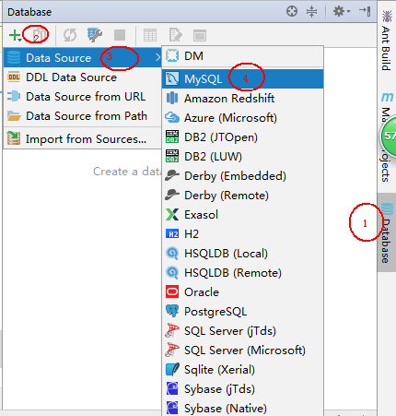

点击”测试链接”，会显示”成功”。如果不进行测试，点击下方 “MySQL”下载MySQL驱动包。

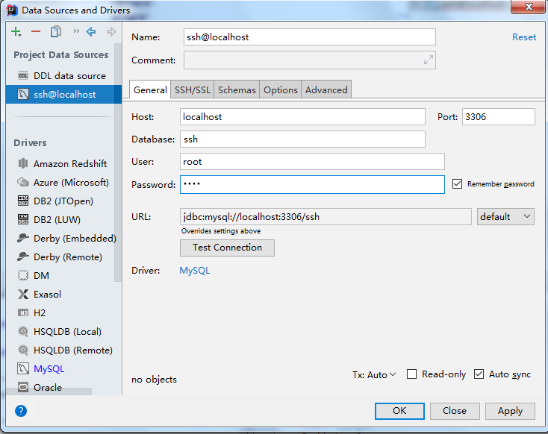

点击完成后，会出现以下页面：

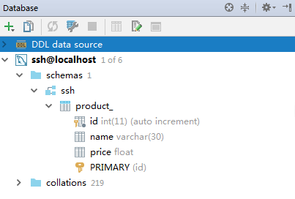

向项目添加hibernate facets
在项目中添加hibernate facets使其具有hibernate功能。
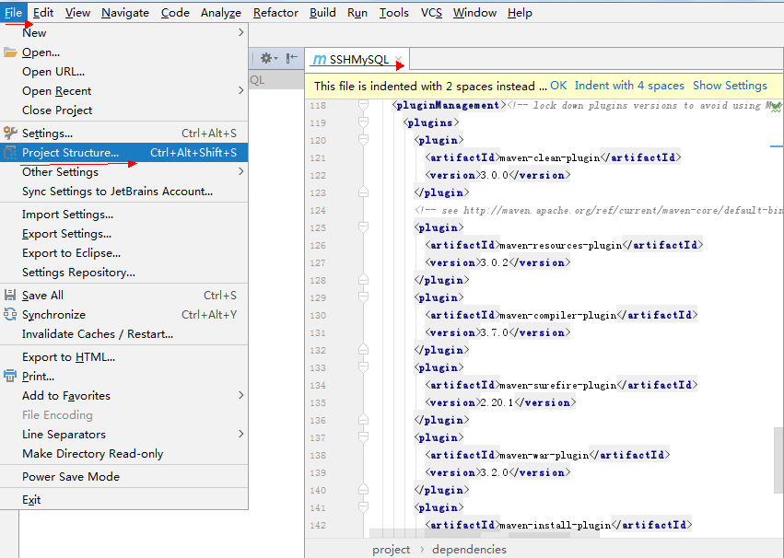
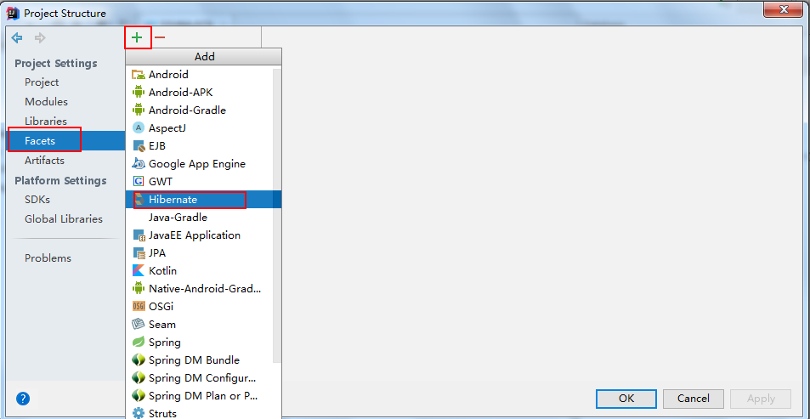
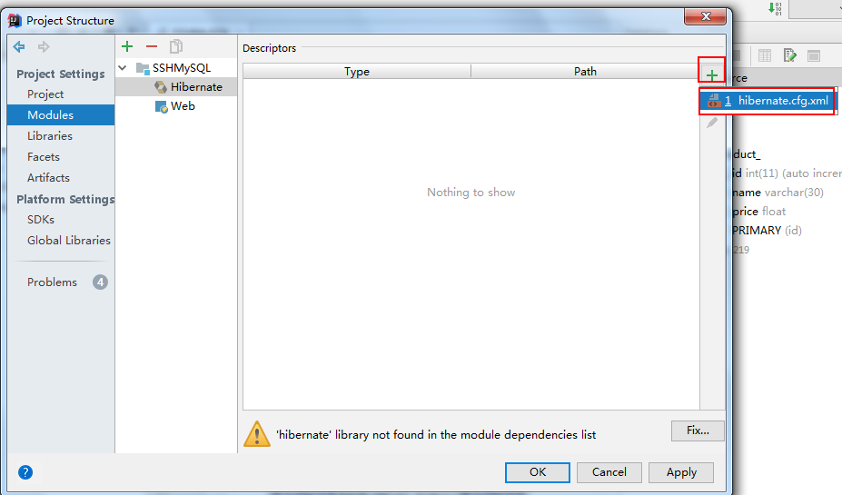

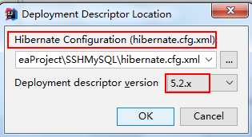

将产生的hibernate.cfg.xml文件移动到resources文件夹中，其代码如下:
//hibernate.cfg.xml
<?xml version='1.0' encoding='utf-8'?>
<!DOCTYPE hibernate-configuration PUBLIC
"-//Hibernate/Hibernate Configuration DTD//EN"
"http://www.hibernate.org/dtd/hibernate-configuration-3.0.dtd">
<hibernate-configuration>
<session-factory>
<property name="connection.url">jdbc:mysql://localhost:3306/ssh </property>
<!-- <property name="connection.username"/> -->
<!-- <property name="connection.password"/> -->
<!-- DB schema will be updated if needed -->
<!-- <property name="hbm2ddl.auto">update</property> -->
</session-factory>
</hibernate-configuration>

其实可以不要改文件！

创建实体类
- 在src/main/java 下新建package com.dhu.pojo
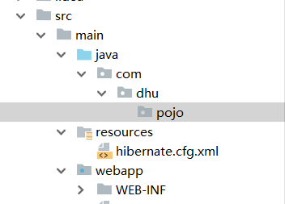
- Hibernate反向工程
从IDEA主窗口进入Persistence
- 选中项目；
- 选择已有的MySQL数据源(ssh@localhost)；
- 右击鼠标，选择“Generate Persistence Mapping”

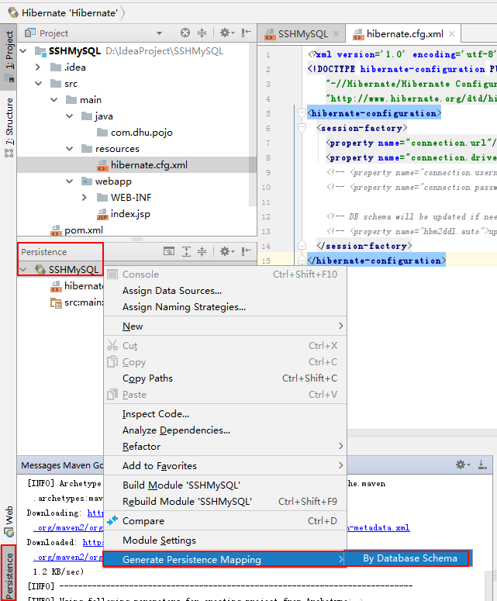
相关的设置如下图所示：
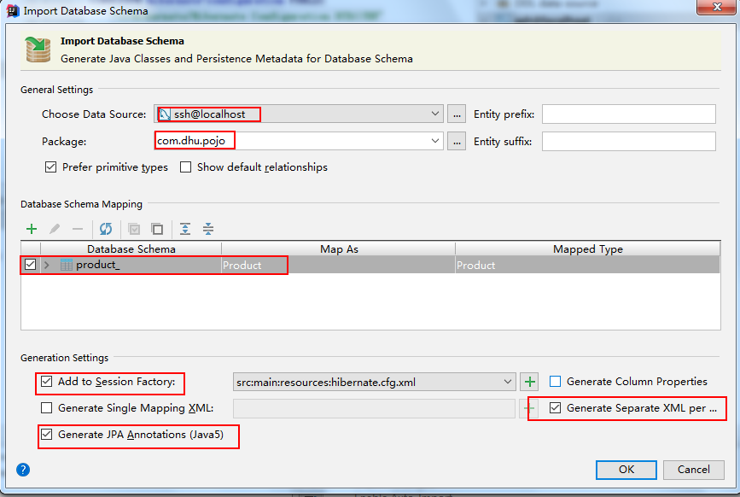
点击确定后，生成的持久化类代码如下：
//Product.java
package com.dhu.pojo;
import javax.persistence.*;
@Entity
@Table(name = "product_", schema = "ssh", catalog = "")
public class Product {
private int id;
private String name;
private Double price;
@Id
@Column(name = "id")
public int getId() {
return id;
}
public void setId(int id) {
this.id = id;
}
@Basic
@Column(name = "name")
public String getName() {
return name;
}
public void setName(String name) {
this.name = name;
}
@Basic
@Column(name = "price")
public Double getPrice() {
return price;
}
public void setPrice(Double price) {
this.price = price;
}
@Override
public boolean equals(Object o) {
if (this == o) return true;
if (o == null || getClass() != o.getClass()) return false;
Product product = (Product) o;
if (id != product.id) return false;
if (name != null ? !name.equals(product.name) : product.name != null) return false;
if (price != null ? !price.equals(product.price) : product.price != null) return false;
return true;
}
@Override
public int hashCode() {
int result = id;
result = 31 * result + (name != null ? name.hashCode() : 0);
result = 31 * result + (price != null ? price.hashCode() : 0);
return result;
}
}

同时在com.dhu.pojo 目录下产生映射文件Product.hbm.xml，将它移动到src/main/resources目录下，还在hibernate.cfg.xml增加相应的标签。

//hibernate.cfg.xml
<?xml version='1.0' encoding='utf-8'?>
<!DOCTYPE hibernate-configuration PUBLIC
"-//Hibernate/Hibernate Configuration DTD//EN"
"http://www.hibernate.org/dtd/hibernate-configuration-3.0.dtd">
<hibernate-configuration>
<session-factory>
<property name="connection.url">jdbc:mysql://localhost:3306/ssh</property>
<mapping resource="Product.hbm.xml"/>
<mapping class="com.dhu.pojo.Product"/>
<!-- <property name="connection.username"/> -->
<!-- <property name="connection.password"/> -->
<!-- DB schema will be updated if needed -->
<!-- <property name="hbm2ddl.auto">update</property> -->
</session-factory>
</hibernate-configuration>
其中的信息可以不要，这些信息会在applicationContext.xml文件中出现。

DAO层
在src/main/java 下新建包 com.dhu.dao ，在其中分别创建ProductDAO接口及其实现如下：
//ProductDAO.java
package com.dhu.dao;
import com.dhu.pojo.Product;
import java.util.List;
public interface ProductDAO {
public List<Product> list();
public void add(Product p);
public Product get(int id);
public void update(Product p);
public void delete(Product p);
}

//ProductDAOImpl.java
package com.dhu.dao;
import com.dhu.pojo.Product;
import org.springframework.orm.hibernate3.HibernateTemplate;
import java.util.List;
public class ProductDAOImpl extends HibernateTemplate implements ProductDAO{
public List<Product> list() {
return (List<Product>) find("from Product");
}
@Override
public void add(Product p) {
super.save(p);
}
@Override
public Product get(int id) {
return (Product)get(Product.class,id);
}
@Override
public void update(Product p) {
super.update(p);
}
@Override
public void delete(Product p) {
super.delete(p);
}
}

Service层
在src/main/java下新建包com.dhu.service，然后在其中创建ProductService接口及其实现类如下：
//ProductService.java
package com.dhu.service;
import com.dhu.pojo.Product;
import java.util.List;
public interface ProductService {
public List<Product> list();
public void add(Product p);
public Product get(int id);
public void update(Product p);
public void delete(Product p);
}

//ProductServiceImpl.java
package com.dhu.service;
import com.dhu.dao.ProductDAO;
import com.dhu.pojo.Product;
import org.springframework.transaction.annotation.Propagation;
import org.springframework.transaction.annotation.Transactional;
import java.util.List;
@Transactional(readOnly = false, propagation = Propagation.REQUIRES_NEW )
public class ProductServiceImpl implements ProductService {
ProductDAO productDAO;
public List<Product> list() {
List<Product> products= productDAO.list();
if(products.isEmpty()){
for (int i = 0; i < 5; i++) {
Product p = new Product();
p.setName("product " + i);
productDAO.add(p);
products.add(p);
}
}
return products;
}
public ProductDAO getProductDAO() {
return productDAO;
}
public void setProductDAO(ProductDAO productDAO) {
this.productDAO = productDAO;
}
@Override
public void add(Product p) {
productDAO.add(p);
}
@Override
public void update(Product p) {
productDAO.update(p);
}
@Override
public void delete(Product p) {
productDAO.delete(p);
}
@Override
public Product get(int id) {
return productDAO.get(id);
}
}

第4部分添加Struts2和Spring功能

添加Struts2功能（Maven已管，以下操作可省略）
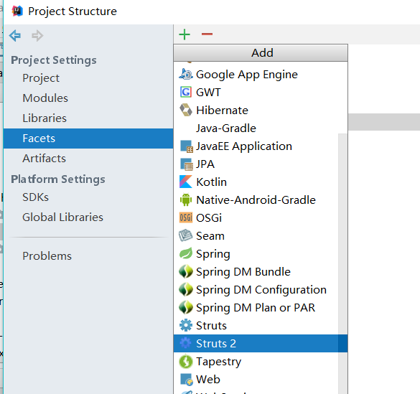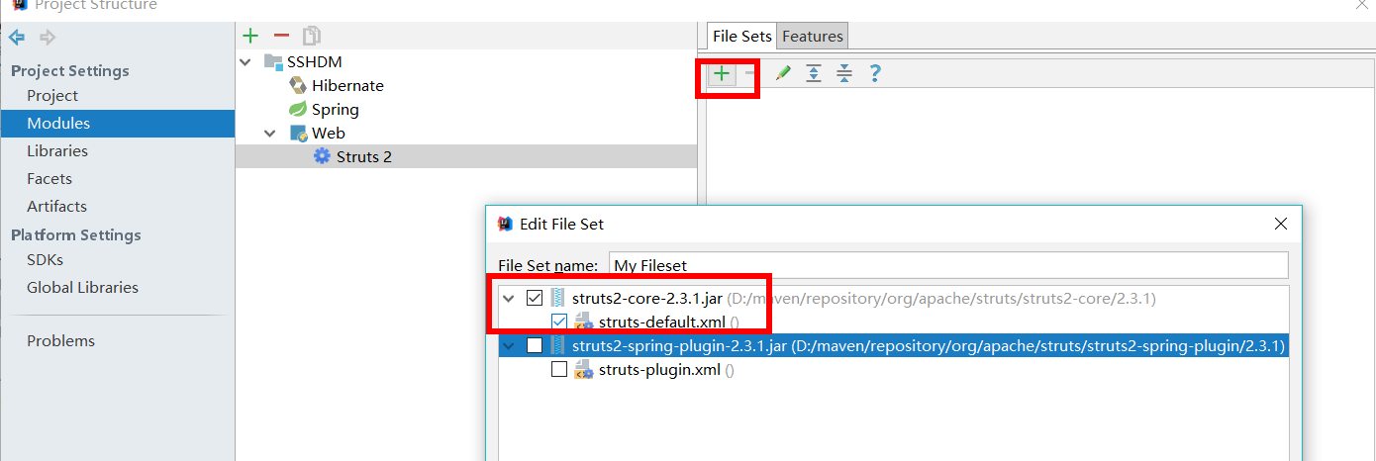

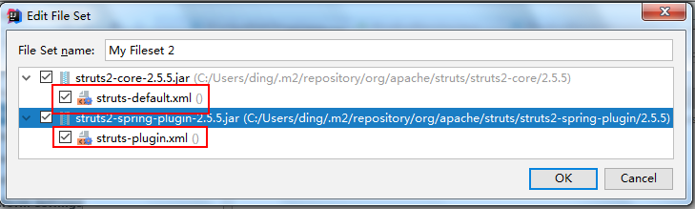

定义核心控制器
配置web.xml，在其中定义核心控制器（过滤器），并设置拦截的URL。
//web.xml
<web-app>
<filter>
<filter-name>struts2</filter-name>
<filter-class>
org.apache.struts2.dispatcher.ng.filter.StrutsPrepareAndExecuteFilter
</filter-class>
</filter>
<filter-mapping>
<filter-name>struts2</filter-name>
<url-pattern>/*</url-pattern>
</filter-mapping>
</web-app>

新建Action
package com.dhu.action;
import com.dhu.pojo.Product;
import com.dhu.service.ProductService;
import java.util.List;
public class ProductAction {
ProductService productService;
List<Product> products;
Product product;
public String list() {
products = productService.list();
return "listProduct";
}
public String add(){
productService.add(product);
return "listProductAction";
}
public String edit(){
product = productService.get(product.getId());
return "editProduct";
}
public String delete(){
productService.delete(product);
return "listProductAction";
}
public String update(){
productService.update(product);
return "listProductAction";
}
public ProductService getProductService() {
return productService;
}
public void setProductService(ProductService productService) {
this.productService = productService;
}
public List<Product> getProducts() {
return products;
}
public void setProducts(List<Product> products) {
this.products = products;
}
public Product getProduct() {
return product;
}
public void setProduct(Product product) {
this.product = product;
}
}

创建struts.xml，配置Action
在resources目录下新建struts的配置文件，注意这里采用Spring的对象工厂。
// struts.xml
<?xml version="1.0" encoding="UTF-8"?>
<!DOCTYPE struts PUBLIC
"-//Apache Software Foundation//DTD Struts Configuration 2.3//EN"
"http://struts.apache.org/dtds/struts-2.3.dtd">
<struts>
<constant name="struts.i18n.encoding" value="UTF-8"></constant>
<constant name="struts.objectFactory" value="spring"/>
<package name="product" namespace="/" extends="struts-default">
<action name="*Product" class="productActionBean" method="{1}">
<result name="listProduct">WEB-INF/jsp/product/listProduct.jsp</result>
<result name="listProductAction" type="redirect">listProduct</result>
<result name="editProduct">WEB-INF/jsp/product/editProduct.jsp</result>
</action>
</package>
</struts>
注意红色的部分能使得通配符有效！
actionBean由Spring管理！{1}指通配第一个“*”。

创建Spring的配置文件applicationContext.xml
对action提供Spring IOC管理，并且在创建action的时候，注入DAO。
在src/main/resources 目录下新建applicationContext容器的配置文件。
//applicationContext.xml
<?xml version="1.0" encoding="UTF-8"?>
<beans xmlns="http://www.springframework.org/schema/beans"
xmlns:xsi="http://www.w3.org/2001/XMLSchema-instance"
xmlns:tx="http://www.springframework.org/schema/tx" xmlns:aop="http://www.springframework.org/schema/aop"
xsi:schemaLocation="http://www.springframework.org/schema/beans
http://www.springframework.org/schema/beans/spring-beans.xsd
http://www.springframework.org/schema/tx
http://www.springframework.org/schema/tx/spring-tx.xsd http://www.springframework.org/schema/aop http://www.springframework.org/schema/aop/spring-aop.xsd">
<!--<bean name="dataSource" class="org.springframework.jdbc.datasource.DriverManagerDataSource">
<bean id="dataSource" class="com.mchange.v2.c3p0.ComboPooledDataSource">
<property name="jdbcUrl" value="jdbc:mysql://localhost:3306/ssh?useUnicode=true&amp;characterEncoding=utf-8"/>
<property name="driverClass" value="com.mysql.jdbc.Driver"/>
<property name="user" value="root"/>
<property name="password" value="root"/>
<!--连接池中保留的最大连接数。Default: 15 -->
<property name="maxPoolSize" value="20"/>
<!--连接池中保留的最小连接数。-->
<property name="minPoolSize" value="2"/>
<!--初始化时获取的连接数，取值应在minPoolSize与maxPoolSize之间。Default: 3 -->
<property name="initialPoolSize">
<value>10</value>
</property>
</bean>
<bean name="sessionFactory" class="org.springframework.orm.hibernate5.LocalSessionFactoryBean">
<property name="dataSource" ref="dataSource"/>
<property name="mappingResources">
<list>
<value>Product.hbm.xml</value>
</list>
</property>
<property name="hibernateProperties">
<value>
hibernate.dialect=org.hibernate.dialect.MySQLDialect
hibernate.show_sql=true
hbm2ddl.auto=update
</value>
</property>
</bean>
<bean name="productDAOImpl" class="com.dhu.dao.ProductDAOImpl">
<property name="sessionFactory" ref="sessionFactory"/>
</bean>
<bean name="productServiceImpl" class="com.dhu.service.ProductServiceImpl">
<property name="productDAO" ref="productDAOImpl"/>
</bean>
<bean name="productActionBean" class="com.dhu.action.ProductAction">
<property name="productService" ref="productServiceImpl"/>
</bean>
<!-- 配置事务管理器，统一管理sessionFactory的事务 -->
<bean id="txManager" class="org.springframework.orm.hibernate5.HibernateTransactionManager">
<property name="sessionFactory" ref="sessionFactory"/>
</bean>
<!--注册基于注释的事务管理驱动 -->
<tx:annotation-driven transaction-manager="txManager"/>
</beans>
这里的事务配置与service类中的事务注释配套完成事务管理。
增加了Struts功能、Spring功能、并定义了使只读模式失效的过滤器之后的web.xml文档为：
//web.xml
<?xml version="1.0" encoding="UTF-8"?>
<web-app xmlns:xsi="http://www.w3.org/2001/XMLSchema-instance" xmlns="http://java.sun.com/xml/ns/javaee"
xsi:schemaLocation="http://java.sun.com/xml/ns/javaee http://java.sun.com/xml/ns/javaee/web-app_2_5.xsd"
id="WebApp_ID" version="2.5">
<context-param>
<param-name>contextConfigLocation</param-name>
<param-value>
classpath:applicationContext.xml
</param-value>
</context-param>
<listener>
<listener-class>
org.springframework.web.context.ContextLoaderListener
</listener-class>
</listener>
<filter>
<filter-name>struts2</filter-name>
<filter-class>
org.apache.struts2.dispatcher.ng.filter.StrutsPrepareAndExecuteFilter
</filter-class>
</filter>
<filter-mapping>
<filter-name>struts2</filter-name>
<url-pattern>/*</url-pattern>
</filter-mapping>
<filter>
<!-- 避免限制对数据的操作为只读（read only）而不能修改! -->
<filter-name>OpenSessionInViewFilter</filter-name> <filter-class>org.springframework.orm.hibernate5.support.OpenSessionInViewFilter</filter-class>
<init-param>
<param-name>singleSession</param-name>
<param-value>true</param-value>
</init-param>
<init-param>
<param-name>flushMode</param-name>
<param-value>AUTO</param-value>
</init-param>
</filter>
<filter-mapping>
<filter-name>OpenSessionInViewFilter</filter-name>
<url-pattern>/*</url-pattern>
</filter-mapping>
</web-app>

第5部分 创建视图
在webapp/WEB-INF目录下新建jsp文件夹，在jsp文件夹中创建product文件夹，并在其中新建editProduct.jsp 和listProduct.jsp

//editProduct.jsp
<%@ page language="java" contentType="text/html; charset=UTF-8"
pageEncoding="UTF-8" isELIgnored="false"%>
<%@ taglib prefix="s" uri="/struts-tags" %>
<div style="margin:0px auto; width:500px">
<form action="updateProduct" method="post">
name: <input name="product.name" value="${product.name}"> <br>
<input name="product.id" type="hidden" value="${product.id}">
<button type="submit">提交</button>
</form>
</div>

// listProduct.jsp
<%@ page language="java" contentType="text/html; charset=UTF-8"
pageEncoding="UTF-8" isELIgnored="false"%>
<%@ taglib prefix="s" uri="/struts-tags" %>
<div style="margin:0px auto; width:500px">
<table cellspacing="0" border="1" width="100%">
<tr>
<td>id</td>
<td>name</td>
<td>编辑</td>
<td>删除</td>
</tr>
<s:iterator value="products" var="p">
<tr>
<td>${p.id}</td>
<td>${p.name}</td>
<td><a href="editProduct?product.id=${p.id}">编辑</a></td>
<td><a href="deleteProduct?product.id=${p.id}">删除</a></td>
</tr>
</s:iterator>
</table>
<br>
<br>
<form action="addProduct" method="post">
name: <input name="product.name"> <br>
<button type="submit">提交</button>
</form>
</div>
整个项目的结构为：
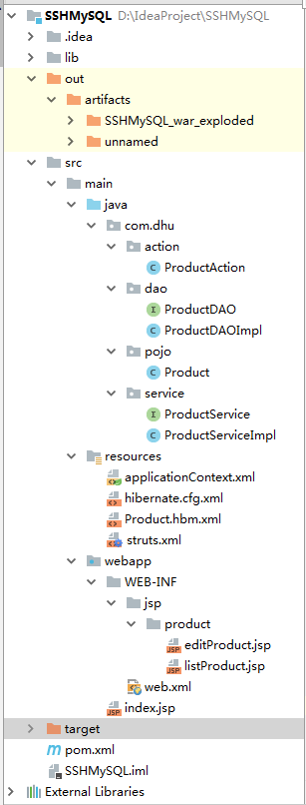

第6部分 部署项目并使用

配置并启动Tomcat
http://localhost:8080/listProduct
