Outreach Analyst Portfolio Project
Gustavo Holguin
Tamarac, Florida
Phone: 954-512-0791
Email: Gustavo.villarreal1989@gmail.com
LinkedIn | Portfolio-Kaggle | GitHub

Outreach Analyst Portfolio Project
Pharmacy-enabled healthcare organization

Business Problem
Payer-sponsored outreach programs within an integrated healthcare services organization focus on identifying preventive care gaps, stratifying high-risk Medicaid populations, and deploying targeted outreach through pharmacy, clinical, and digital modalities. This project simulates a payer-side analytics framework that integrates HEDIS care gap identification with Social Determinants of Health (SDOH) to inform outreach prioritization.

HEDIS Description
The Healthcare Effectiveness Data and Information Set (HEDIS) is a quality improvement tool widely used in the U.S. healthcare market by providers. Including 6 main domains, such as effectiveness of care, access/availability of care, experience of care, utilization and risk-adjusted utilization, health plan descriptive information, and measures reported using electronic clinical data systems. HEDIS delivers for Medicare users a health survey through healthcare insurance and provides the support to manage and report through the NCQA (https://www.ncqa.org/hedis/).

Outreach Objective
Maximize closure of high-impact HEDIS preventive and chronic care gaps using limited outreach resources by prioritizing members based on risk, utilization, and social barriers.

Data Sources & Architecture
Synthetic payer-side datasets were developed to simulate curated data commonly provided to outreach teams operating within an integrated healthcare services model. Data sources include member demographics and enrollment information, claims-derived condition flags, healthcare utilization summaries, HEDIS care gap outputs, pharmacy dispensing activity, laboratory results, outreach interaction records, and area-level Social Determinants of Health (SDOH) derived from publicly available population health datasets.
Data Domain | Description | Analytical Use
Enrollment | Eligibility & coverage | HEDIS compliance
Conditions | Claims-derived flags | Risk stratification
Utilization | ED/IP/OP metrics | Priority scoring
HEDIS Gaps | Open measures | Outreach targeting
Pharmacy | Rx & immunizations | Channel routing
Labs | Clinical values | Measure validation
Outreach | Contact attempts | Effectiveness metrics
SDOH | Area-level risk | Equity analysis

Database-based characteristics
The synthetic database contains 5000 de-identify patient’s information in the Medicaid table, including socio-demographic information such as age, sex, zip-code, plan type, dual eligibility, Primary Care Physician PCP, and enrollment months. The database contains a sex distribution female 55.5% and male 44.4%, and around 61.2% of patient speaks English, followed by 25.3% speaks Spanish, and Haitian and Portuguese 9.3% and 4.14%, respectfully. On the other hand, all of them are enrolled in Medicaid with different enrollment months from 6 to 59 months.
The utilization of the services in the last 12 months is composed of PCP visits, specialist visits, emergency department visits, inpatient services, and urgent care, among others. For instance, PCP visits have a concentration of 10% to 15% between 3 to 4 visits in the last 12 months. On the other hand, the specialist visits around 12-15% of patients go 2-5 times per year, and similar stats have emergency department visits.
The outreach team used different ways to communicate with the patients, including email (25.6%), phone (25.6%), SMS (24.5%), and Mail (24.3%). As a result, 17.3% of the patients did not answer the phone, 17% completed the service gap, 16.7% were reached, 16.5% were scheduled, and finally, 16.4% optout from the service. In this sense, covering the patients who have not completed the gap is the main purpose of the outreach team. One of the reasons why there were patients without completing the service is that most of them were reached at the first time (49.9%), compared with the second (33.3%) and third attempt (16.8%).
Regarding the conditions, almost 50% of the patients were diagnosed with hypertension, and the other non-communicable diseases, such as diabetes, COPD, depression, and obesity, have a rate between 10% to 30%. Most of these patients were reported to have gone to the PCP appointment (26%), family medicine (14.5%), internal medicine (13%), and pediatrics (13%). Other specialties, including endocrinology, OB/GYN, cardiology, pulmonology, behavioral health, and ophthalmology, have a lower rate between 3% to 9%.

Analytical Approach
Members measure weight and risk score to distinguish risk levels within a population. The HEDIS gap database counts the number of unmet HEDIS quality measures per member, representing missed preventive services or chronic care activities. It serves as a tool for outreach teams and care coordinators to create actionable goals because, through the measure weight, it is possible to tier the patient into three levels: standard preventive, high-impact preventive, and chronic / outcome critical.

Weight | Tier | Meaning
2 | Standard Preventive | Important but lower clinical risk
3 | High-Impact Preventive | Meaningful outcome impact
4 | Chronic / Outcome-Critical | Strong clinical & cost impact

Measure name | measure weight assigned
Adult Access to Preventive Care | 2
Annual Wellness Visit | 2
Breast Cancer Screening | 3
Cervical Cancer Screening | 3
Colorectal Cancer Screening | 3
Controlling High Blood Pressure | 3
Diabetic Eye Exam | 4
Flu Immunization | 2
HbA1c Testing (Diabetes) | 4
Tobacco Screening & Cessation | 2

On the other hand, the risk score is a composite measurement that includes opens gaps and measure weight, merging the distinct HEDIS measures affected, represent complexity care, and the more measure, harder to coordinate care. As a product of the risk score, it is possible to group it by cutting in three levels:
Group | Percentile Range | Meaning
Low | 0–70% | Routine monitoring
Medium | 70–90% | Targeted outreach
High | 90–100% | Immediate priority

Outreach Segmentation Strategy
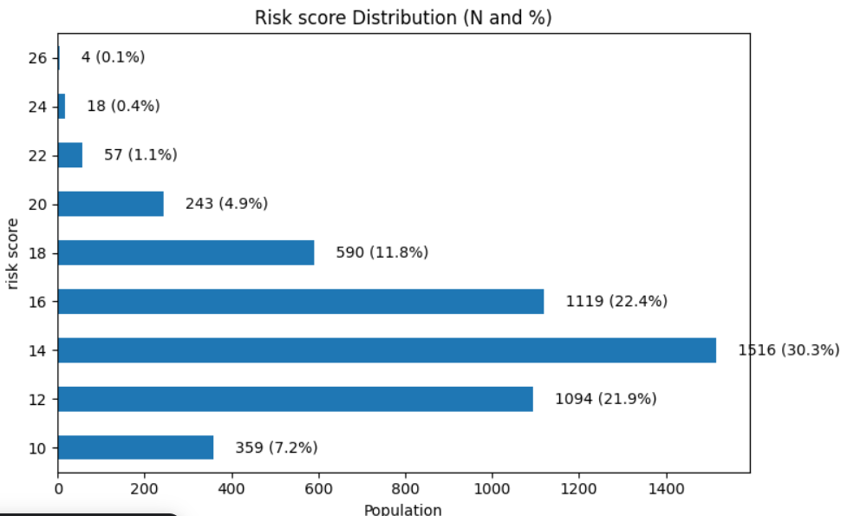
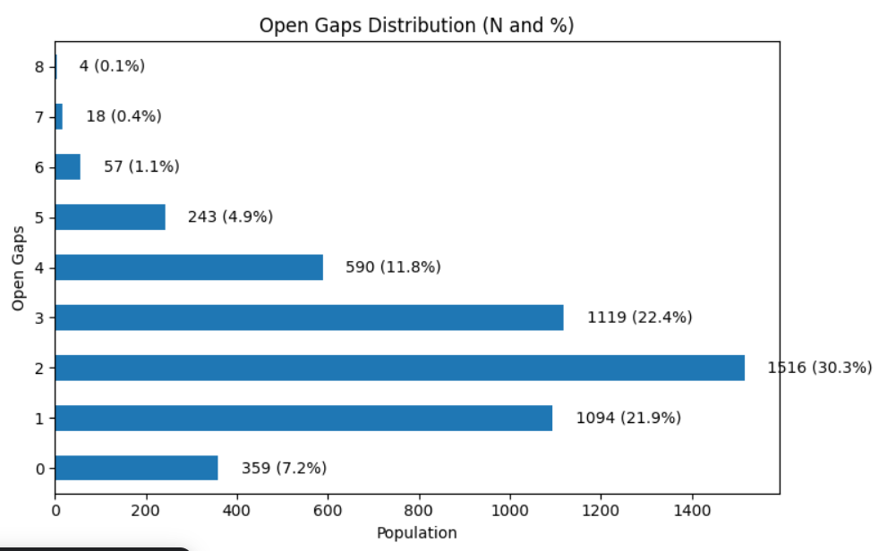
The distribution in the open gaps is strongly concentrated for patients who have 1, 2, or 3 open gaps, getting between 21% to 30%. In this distribution, it is possible to differentiate between patients with no gaps (7.2%) as well as patients with 4 (11.8%), 5 (4.9%), 6 (1.1%), 7 (0.4%), and 8 (0.1%) open gaps. The same distribution is presented in the risk score distribution, where most of the patients with a risk score between 12, 14, and 16 obtained the same percentages, as the patient got 1, 2, or 3 open gaps.

These two visualizations together show a clear, age-related pattern in healthcare utilization and overall risk. On the left, the boxplot of PCP encounters by age group indicates that primary care use generally increases with age: younger groups have fewer encounters and tighter distributions, while older groups—especially ages 60 and above—show higher medians, wider variability, and more high-use outliers, reflecting greater reliance on routine and chronic care management. On the right, the risk score distribution by age demonstrates a parallel trend, with risk scores rising steadily as age increases and becoming more concentrated at higher values among older individuals. Taken together, these plots suggest that aging is associated with both increased primary care engagement and higher clinical risk, reinforcing the need for proactive care coordination and targeted outreach strategies in older populations.
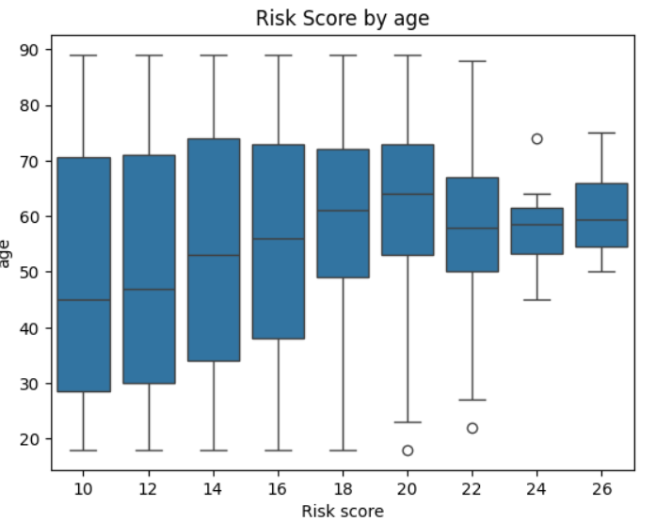
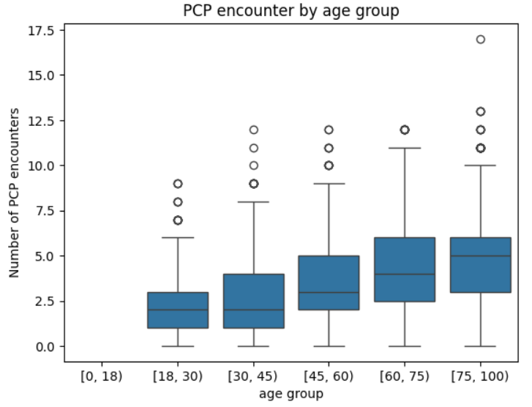

One of the most important predictors to separate unmeet population and patients reached by the outreach team is by identifying the communications channels and their outcomes. For instance, there was approximately an even distribution of 25% for the different types of communications channels used to reach the patients. Including Text messages (SMS), phone, mail, and email. On the other hand, almost 60% of patients were reached once, while approximately 40% of them were reached twice or three times. The results of this strategy show that 17.1% of patients have completed the gap, while the rest of the population left voicemail (15.9%), did not answer the phone (17.0%), opted out (17.1%), reached (17.3%), and scheduled (15.7%). In this sense, focusing in patient with the gaps still open is the main outreach strategy to implement.
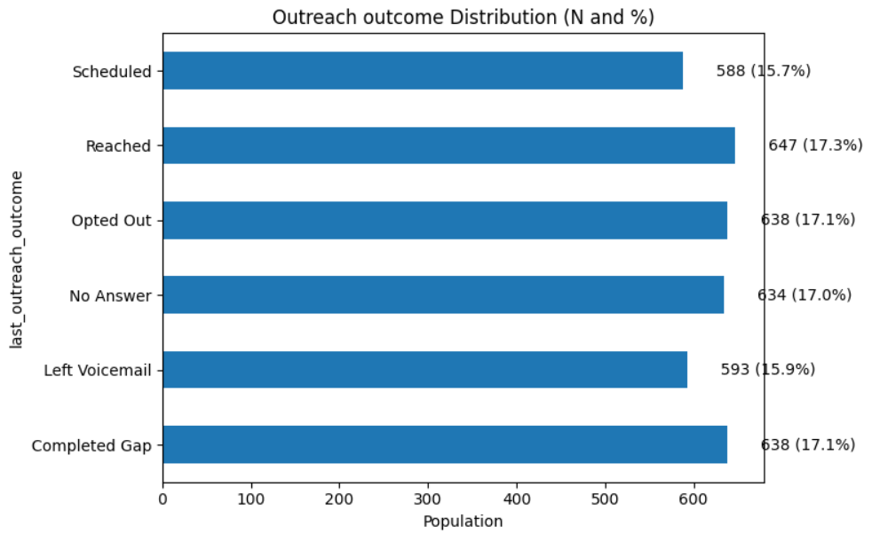
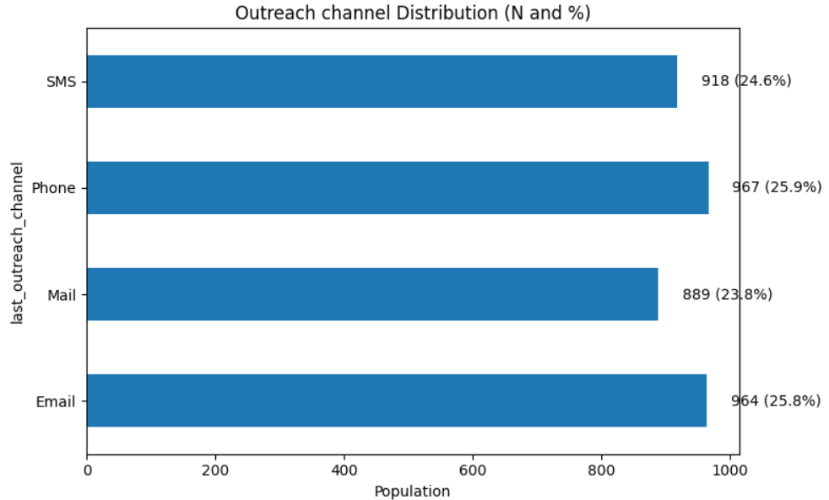

Key Metrics & Evaluation
Addressing patients with unmet needs, it is necessary to separate those with a completed gap from patients who, for various reasons, were not successfully reached. Compared with non-reached populations, 38.2% were reached using email, and 40% using phone and SMS. On the other hand, comparing these two groups of patients, the acute upper respiratory infection led the rate in unreached populations by 61.5%, followed by chronic kidney disease, 64%, and other non-transmissible chronic diseases.
On the other hand, with the increase in open gaps, the unreached population also increases, marking a pattern of focusing outreach interventions on populations with more than one open gap. Regarding the association between diagnosis, risk score, and reach/unreached populations, there is a marked increase in patients with diabetes, hypertension, and acute upper respiratory infection with a risk score between 18 and 24.

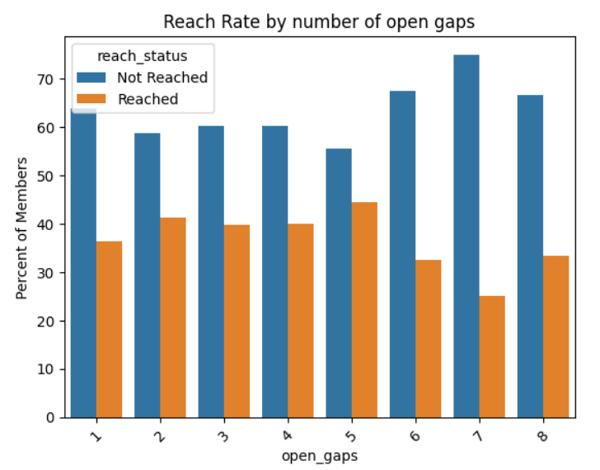

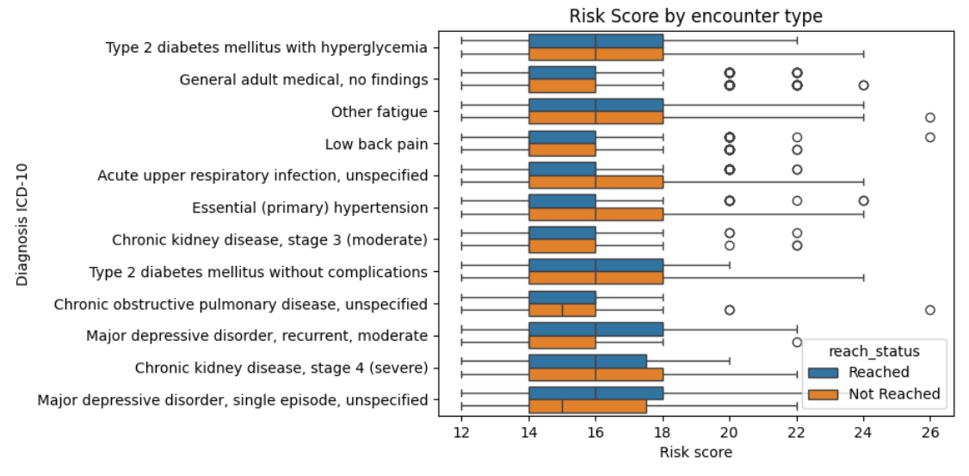

Health Equity Lens
Comparing the values obtained through the current outreach strategy, there was not difference between the CDC Community barriers and the zip code of the patients. For instance, the poverty rate was 20%, high school education (28%), language isolation rate (16%), broadband access rate (75%), cost barrier care rate (24%), diabetes (14%), hypertension (30%), smoking (19%), and physical inactivity (30%). Nonetheless, there is a statistical difference between the means of poverty and broadband access, making these elements one of the most important barriers to access to healthcare services. Regarding language isolation, there is no significant difference between the two groups.

Business/Wellness Recommendations
1. Program recommendations for the unreached patients with cardiometabolic conditions, including diabetes, hypertension, and CKD:
Diabetes & Blood Pressure Check-In Calls: Education on glucose/BP self-monitoring, and Medication adherence coaching.
Nutrition Education Series: Simple meal planning for diabetes & kidney health, and focus on sodium, sugar, and hydration.
Lab Completion Education: Why A1c, kidney labs, and BP checks matter, and How to complete labs with minimal disruption.
2. Program recommendations for unreached patients with COPD, Upper Respiratory Infections, and Chronic Fatigue:
Breathing & Energy Conservation Education: pursed-lip breathing and recognizing early exacerbation signs.
Smoking Cessation & Air Quality Education: short, culturally adapted materials
Low-Impact Physical Activity Guidance: Chair exercises, walking plans.
3. Program recommendations for unreached patients with musculoskeletal pain:
Back-Care Education: stretching and posture basics,
safe Movement Workshops: preventing reinjury during daily activities.
Non-opioid Pain Management Education: Heat/ice, physical therapy benefits
4. Program recommendations for unreached patients with mental health disorders/illnesses:
Mental Wellness Check-Ins: brief PHQ-style conversations
Stress & Sleep Education: sleep hygiene, routine building
Connection to Behavioral Health Resources: tele-mental health when possible

Entity relationship table

