**任务部署书pdf直接复制有差错**

**个人node 这里根据自己的来修改 后续内容里也同理**

**Vector 1.94.60.68**

**Node2 1.94.31.17**

**Node3 1.94.30.211**

**1：**

**mkdir /usr/local/mongodb**

**cd /usr/local/mongodb**

**mkdir -p data/shard11**

**mkdir -p data/shard21**

**mkdir -p data/config**

**touch data/shard11.log**

**touch data/shard21.log**

**2：**

**su – mongodb**

**mkdir /usr/local/mongodb**

**cd /usr/local/mongodb**

**mkdir -p data/shard12**

**mkdir -p data/shard22**

**mkdir -p data/config**

**touch data/shard12.log**

**touch data/shard22.log**

**3.**

**su – mongodb mkdir /usr/local/mongodb cd /usr/local/mongodb**

**mkdir -p data/shard13**

**mkdir -p data/shard23**

**mkdir -p data/config**

**touch data/shard13.log**

**touch data/shard23.log**

**在/usr/local/mongodb的文件夹中运行**

**node1:**

**mongod --shardsvr --replSet shard1 --port 27017 --dbpath /usr/local/mongodb/data/shard11 --oplogSize 2048 --logpath /usr/local/mongodb/data/shard11.log --logappend --bind_ip=0.0.0.0 --fork**

**node2:**

**mongod --shardsvr --replSet shard1 --port 27017 --dbpath /usr/local/mongodb/data/shard12 --oplogSize 2048 --logpath /usr/local/mongodb/data/shard12.log --logappend --bind_ip=0.0.0.0 --fork**

**node3:**

**mongod --shardsvr --replSet shard1 --port 27017 --dbpath /usr/local/mongodb/data/shard13 --oplogSize 2048 --logpath /usr/local/mongodb/data/shard13.log --logappend --bind_ip=0.0.0.0 –fork**

**分开运行**

**mongo localhost:27017**

**分开运行**

**config = {**

**_id: 'shard1',**

**members: [**

**{_id: 0, host: '1.94.60.68:27017'},**

**{_id: 1, host: '1.94.31.17:27017'},**

**{_id: 2, host: '1.94.30.211:27017'}]**

**}**

**分开运行**

**rs.initiate(config);**

**同shard1 shard2：**

**Server1:**

**mongod --shardsvr --replSet shard2 --port 27018 --dbpath /usr/local/mongodb/data/shard21 --oplogSize 2048 --logpath /usr/local/mongodb/data/shard21.log --logappend --bind_ip=0.0.0.0 --fork**

**Server2:**

**mongod --shardsvr --replSet shard2 --port 27018 --dbpath /usr/local/mongodb/data/shard22 --oplogSize 2048 --logpath /usr/local/mongodb/data/shard22.log --logappend --bind_ip=0.0.0.0 --fork**

**Server3:**

**mongod --shardsvr --replSet shard2 --port 27018 --dbpath /usr/local/mongodb/data/shard23 --oplogSize 2048 --logpath /usr/local/mongodb/data/shard23.log --logappend --bind_ip=0.0.0.0 --fork**

**mongo 1.94.31.17:27018**

**config = {**

**_id: 'shard2',**

**members: [**

**{_id: 0, host: '1.94.60.68:27018'},**

**{_id: 1, host: '1.94.31.17:27018'},**

**{_id: 2, host: '1.94.30.211:27018'}]**

**}**

**rs.initiate(config);**

**配置config server**

**mongod --configsvr --replSet config --dbpath /usr/local/mongodb/data/config --port 20000 --logpath /usr/local/mongodb/data/config.log --logappend --bind_ip=0.0.0.0 –fork**

**分开运行**

**mongo 1.94.30.211:20000**

**分开运行**

**config = {**

**_id: 'config',**

**members: [**

**{_id: 0, host: '1.94.60.68:20000'},**

**{_id: 1, host: '1.94.31.17:20000'},**

**{_id: 2, host: '1.94.30.211:20000'}]**

**}**

**rs.initiate(config);**

**7.配置mongos**

**mongos --configdb config/1.94.60.68:20000,1.94.31.17:20000,1.94.30.211:20000 --port 30000 --logpath /usr/local/mongodb/data/mongos.log --logappend --bind_ip=0.0.0.0 --fork**

**8.使用mongos**

**mongo 1.94.60.68:30000**

**use admin;**

**db.runCommand({**

**addshard: "shard1/1.94.60.68:27017,1.94.31.17:27017,1.94.30.211:27017",**

**name: "s1",**

**maxsize: 20480**

**});**

**db.runCommand({**

**addshard: "shard2/1.94.60.68:27018,1.94.31.17:27018,1.94.30.211:27018",**

**name: "s2",**

**maxsize: 20480**

**});**

**Shard1**

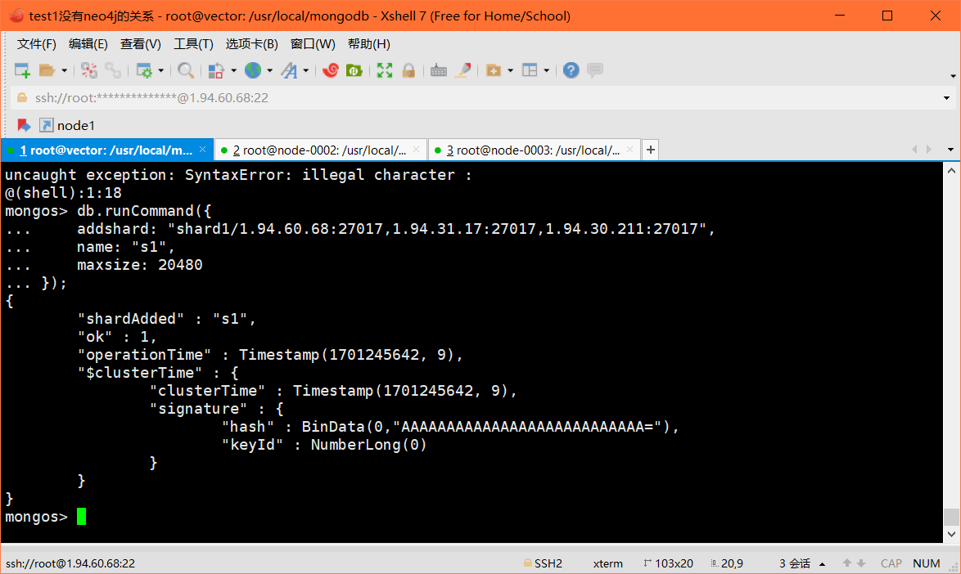

**Shard2**

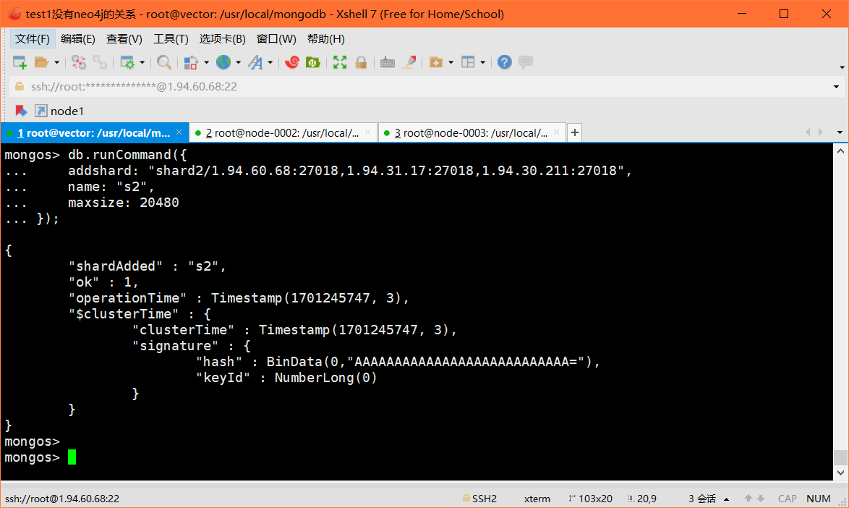

**sh.enableSharding(“testdb”)**

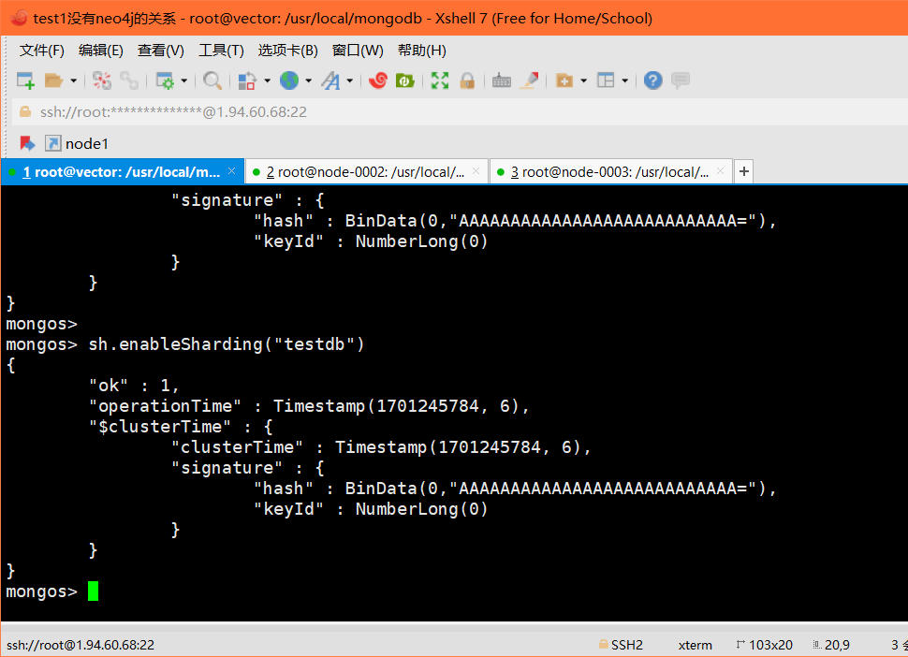

**Showstatus:**

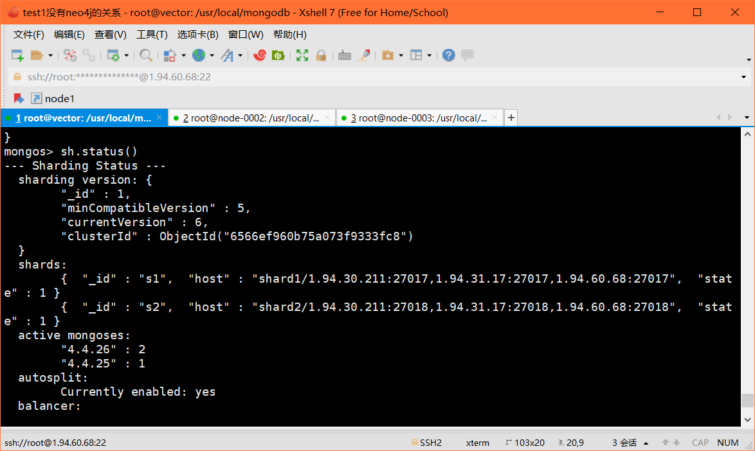

**sh.shardCollection("数据库名.集合名", {"分片键": 1})**

**以下为 MongoDB 事务相关的命令：**

**session.commitTransaction();**

**use test;**

**db.user.insertOne({“name”:“john”});**

**db.user.insertOne({“name”:“cindy”});**

**db.user.insertOne({“name”:“bob”});**

**db.user.find();**

**var session = db.getMongo().startSession();**

**// 启动一个新的事务session.startTransaction();**

**var coll =session.getDatabase('test').getCollection("user");**

**// 事务内修改数据 这里根据自己的来修改**

**coll.updateOne({"_id": ObjectId("65670110a056f94ae5634e4b")},{"$set":{"name":"jerry"}});**

**// 事务内查看数据**

**coll.find();**

**// 事务外查看数据**

**db.user.find()**

**// 事务提交**

**session.commitTransaction();**

