mkdir lab

mkdir -p ./lab/src/main/scala

vim ./lab/src/main/scala/TriangleCountingApp.scala

name := "TCapp"

version := "1.0"

scalaVersion := "2.12.18"

libraryDependencies ++= Seq( "org.apache.spark" %% "spark-core" % "3.5.1", "org.apache.spark" %% "spark-graphx" % "3.5.1" )

/usr/local/sbt/sbt package

/usr/local/spark/bin/spark-submit --class "TriangleCountingApp" ~/lab/target/scala-2.12/tcapp_2.12-1.0.jar

OK

正常没有优化的情况下，如下所示：

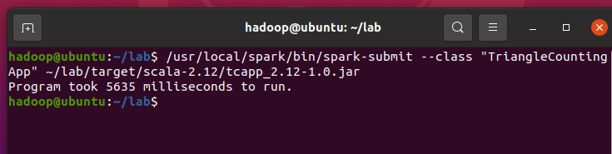

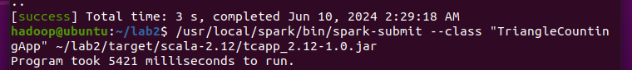

soc-LiveJournal1.txt