CS 148 Database Design for the Web

Gus Johnson

Final Project

Gus’s Online Skate Shop

Version <1.0>

|  |  |  |  |
| --- | --- | --- | --- |
| Time Log | | | |
| Date | Time Spent (in hours) | Description | Author |
| 11.3.13 | 2.5 | Created E-R diagram, schema, data dictionary, and story board. Estimated time for completion: 20 hrs. | Gus Johnson |
|  |  |  |  |
|  |  |  |  |
|  |  |  |  |
|  |  |  |  |
|  |  |  |  |
|  |  |  |  |
|  |  |  |  |
|  |  |  |  |
|  |  |  |  |
|  |  |  |  |
|  |  |  |  |
|  |  |  |  |
|  |  |  |  |
|  |  |  |  |
|  |  |  |  |
|  |  |  |  |
|  |  |  |  |
|  |  |  |  |
|  |  |  |  |
|  |  |  |  |
|  |  |  |  |
|  |  |  |  |
|  |  |  |  |
|  |  |  |  |
|  |  |  |  |
|  |  |  |  |
|  |  |  |  |
|  |  |  |  |

Table Of Contents

Software Requirements Specifications 4

Introduction 4

Purpose 4

Definitions, acronyms, and abbreviations 4

Overview 4

Overall Description 5

Data Dictionary 5

E-R Diagram 5

Schema 5

Story Board 5

Specific requirements 5

# Software Requirements Specifications

## Introduction

### Purpose

The purpose of this document is to describe the requirement specification for the web site “Gus’s Online Skate Shop.”

The intended audience for this document is web developers. The goal being that you can give this document to someone and they can make the site without having to ask any questions.

### Definitions, acronyms, and abbreviations

HTML – Hypertext markup language – used to define your conent.

PHP – Personal Home Page – language that helps to customize html.

CSS – Cascading Style Sheets – used to define the look of a web site.

W3 Validation – refers to both Html and CSS validation tool provided by the W3c.org. the html validator is located at:

<http://validator.w3.org/>

with the CSS validator located at:

<http://jigsaw.w3.org/css-validator/>

### Overview

The rest of this document contains an overall description of “Gus’s Online Skate Shop”.

## Overall Description

The purpose of this document is to showcase the E-R diagram, schema, and data dictionary of the website “Gus’s Online Skate Shop”.

The intended audience for this website is skateboarders. Like any machine, the skateboard breaks down quite frequently. I intend to make an online store that stocks skateboard parts of all types. Decks, trucks, and wheels are all different skateboard parts.

### Data Dictionary

|  |  |  |  |  |  |  |
| --- | --- | --- | --- | --- | --- | --- |
| **TABLE** | **COLUMN** | **TYPE** | **PRECISION** | **SCALE** | **PK** | **DESCRIPTION** |
| User | UserID | INT | 11 |  | Yes | Unique ID given to every user. |
| User | Email | VARCHAR | 65 |  | No | User’s Email. |
| User | DateJoined | TIMESTAMP |  |  | No | Time of user’s registration. |
| User | Confirmed | TINYNT | 1 |  | No | Confirmation of registration. |
| User | Approved | TINYINT | 4 |  | No | Approval of registration. |
| User | FirstName | CHAR | 30 |  | No | User’s first name. |
| User | LastName | CHAR | 30 |  | No | User’s last name. |
| User | Street | CHAR | 30 |  | No | User’s street. |
| User | City | CHAR | 30 |  | No | User’s city. |
| User | State | CHAR | 3 |  | No | User’s state. |
| User | Zip | CHAR | 7 |  | No | User’s zipcode. |
| User | Phone | CHAR | 10 |  | No | User’s phone number. |
| Order | OrderNumber | CHAR | 20 |  | Yes | Order number. |
| Order | OrderPrice | DECIMAL | 5 | 2 | No | Order price. |
| Order | OrderDate | TIMESTAMP |  |  | No | Time of order. |
| Order | UserID | INT | 11 |  | No | User’s ID. |
| Wheels | WheelsID | CHAR | 30 |  | Yes | Wheel’s ID. |
| Wheels | WheelDesc | CHAR | 200 |  | No | Description of wheels. |
| Wheels | WheelCo | CHAR | 30 |  | No | Wheel company. |
| Wheels | WheelSize | CHAR | 5 |  | No | Wheel size. |
| Wheels | OrderNumber | CHAR | 20 |  | No | Order number. |
| Trucks | TruckID | CHAR | 30 |  | Yes | Truck ID. |
| Trucks | TruckDesc | CHAR | 200 |  | No | Truck description. |
| Trucks | TruckCo | CHAR | 30 |  | No | Truck company. |
| Trucks | TruckSize | CHAR | 5 |  | No | Truck size. |
| Trucks | OrderNumber | CHAR | 20 |  | No | Order number. |
| Decks | DeckID | CHAR | 30 |  | Yes | Deck ID. |
| Decks | DeckDesc | CHAR | 200 |  | No | Deck description. |
| Decks | DeckCo | CHAR | 30 |  | No | Deck company. |
| Decks | DeckSize | CHAR | 10 |  | No | Deck size. |
| Decks | OrderNumber | CHAR | 20 |  | No | Order number. |

### E-R Diagram

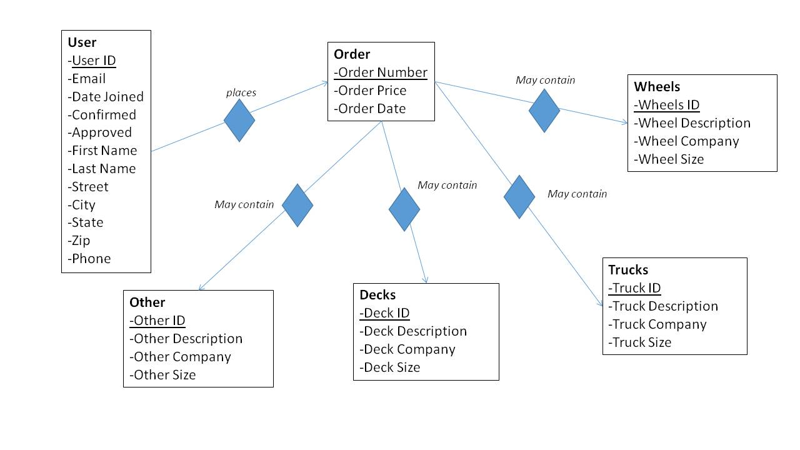

### Schema

CREATE TABLE tblUser(

-> pkUserID INT(11) PRIMARY KEY,

-> fldEmail VARCHAR(65),

-> fldDateJoined TIMESTAMP default CURRENT_TIMESTAMP,

-> fldConfirmed TINYINT(1),

-> fldApproved TINYINT(4),

-> fldFirstName CHAR(30),

-> fldLastName CHAR(30),

-> fldStreet CHAR(30),

-> fldCity CHAR(30),

-> fldState CHAR(3),

-> fldZip CHAR(7),

-> fldPhone CHAR(10),

-> );

--------------------------------------------------------------------------------------------------

CREATE TABLE tblOrder(

-> pkOrderNumber CHAR(20) PRIMARY KEY,

-> fldOrderPrice DECIMAL(5,2),

-> fldOrderDate TIMESTAMP default CURRENT_TIMESTAMP,

-> fkUserID INT(11) not null references tblUser(pkUserID),

-> );

--------------------------------------------------------------------------------------------------

CREATE TABLE tblWheels(

-> pkWheelsID CHAR(30) PRIMARY KEY,

-> fldWheelDesc CHAR(200),

-> fldWheelCo CHAR(30),

-> fldWheelSize CHAR(5),

-> fkOrderNumber CHAR(20) not null references tblOrder(pkOrderNumber),

-> );

--------------------------------------------------------------------------------------------------

CREATE TABLE tblTrucks(

-> pkTruckID CHAR(30) PRIMARY KEY,

-> fldTruckDesc CHAR(200),

-> fldTruckCo CHAR(30),

-> fldTruckSize CHAR(5),

-> fkOrderNumber CHAR(20) not null references tblOrder(pkOrderNumber),

-> );

--------------------------------------------------------------------------------------------------

CREATE TABLE tblDecks(

-> pkDeckID CHAR(30) PRIMARY KEY,

-> fldDeckDesc CHAR(200),

-> fldDeckCo CHAR(30),

-> fldDeckSize CHAR(10),

-> fkOrderNumber CHAR(20) not null references tblOrder(pkOrderNumber),

-> );

--------------------------------------------------------------------------------------------------

CREATE TABLE tblOther(

-> pkOtherID CHAR(30) PRIMARY KEY,

-> fldOtherDesc CHAR(200),

-> fldOtherCo CHAR(30),

-> fldOtherSize CHAR(15),

-> fkOrderNumber CHAR(20) not null references tblOrder(pkOrderNumber),

-> );

### Story Board

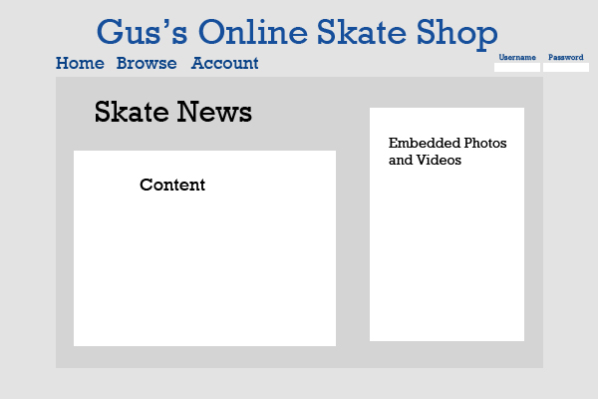

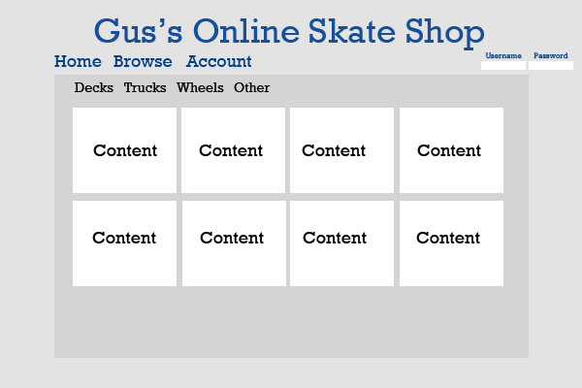

## Specific requirements

Here is just a list of things I will require you really need to write the specific requirements as they relate to your project.

1. *Location* – all files will be located in the public folder of your uvm account. The assignment web page and the submit process will detail the exact location. Failure to have your site located in the correct folder by the due dates will result in a zero on the assignment. Be sure to pay attention to the lowercase letters.
2. *Html Validation* – All pages will pass W3C Html validation for html 5.
3. *CSS Validation* – All pages will pass W3C 3.0 CSS validation.
4. *Meta Information* – All pages will contain a proper title tag, Meta tags (author, character set and description).
5. *CSS* – all pages will have a linked style sheet.
6. *Navigation* – All pages will contain navigation to all other pages on the site using an ordered list. Be sure to enclose the navigation in the correct element.
7. *Content* – Each page will have a minimum of 150 words not counting titles, lists or links. Be sure to use the correct elements to hold your content.
8. *Browser compatibility* - This site will be checked on Firefox, Safari, Chrome and Internet Explorer.
9. *File Names* – the main home page will be called home.php with the rest of the file names up to you (be sure to use .php, .css for the respective files).