Eduteca user manual
August 21 of 2012

Table of contents
1 What Eduteca is? 3
2 Requirements 3
3 Installation 3
4 User manual 6
4.1 Search and download contents 6
4.2 Register in Eduteca 7
4.3 Upload contents 8
4.4 Edit the user data 9
4.5 Delete the user 10
5 User manual (Mobile web) 11
5.1 Search and download contents 11
5.2 Register in Eduteca 13
6 Administrator manual 14
6.1 Add a course 15
6.2 Manages existing courses 15
6.3 Add a content 16
6.4 Manage existing contents 16
6.5 Add a user 18
6.6 Manage existing users 18
7 Advanced Topics 19
1.1 How to modify the mime types allowed 19
1.2 How to change the maximum size of the documents 20
1.3 How to delete the cache 20
1.4 How to change the texts of the web (desktop only) 20
1.5 I have lost the password of the admin user ¿What can I do? 20
1.6 I want to do a backup. What should I know? 21
1.7 I running out of space. What can I do? 21
1.8 There is a problem in the Eduteca. How can I get more information? 21

What Eduteca is?

Eduteca is a tiny web platform to share contents freely among a community of users. The platform is based in 3 environemts:

- Desktop users. The can register, browse and upload contents in Eduteca.
- Mobile users. The can do the same as desktop users except for uploading contents.
- Administrator. The manage the platform and validates the contents uploaded by the regulars users.

Requirements

Eduteca requires:

- Apache web server
- PHP 5.3.2 or above
- Apache configured with mod_php or cgi/fast cgi interface to run PHP scripts
- A database. Tested on Mysql, although any database with supported by PDO and identity primary keys generation should work fine.
- A browser with the following requirements:

 | Web | Administration
Internet Explorer | 7 or above | 6 or above
Google Chrome | 14 or above | 10 or above
Apple Safari | 5 or above | 5 or above
Mozilla Firefox | 5 ot above | 4 or above

For mobile users, they can use any browser with HTML 5 any javascript features activated.

Installation

Eduteca was developed using Symfony 2 framework. To run Eduteca all requirements of Symfony must be met. The url:

http://localhost/eduteca/web/config.php

Can give you more details in case of troubles.

- Edit the php.ini file.

  - Set the property “date.timezone”. Example: “date.timezone = "Europe/Madrid"”
  - Uncomment the following extensions:
- extension=php_fileinfo.dll
- extension=php_gd2.dll
- extension=php_intl.dll
- extension=php_mbstring.dll
- extension=php_pdo_mysql.dll (in case of MySQL)
- extension=php_pdo_sqlite.dll

- Copy Eduteca in your document root as is.

- Edit the file eduteca\app\config\parameters.ini. Specify your database server.
- database_driver = (in MySQL is pdo_mysql)
- database_host
- database_port (in case of blank, it will be the default port)
- database_name
- database_user
- database_password

- Open a shell and move to the $DOCUMENT_ROOT/eduteca. Execute the following command to create the database (not the tables!!)

php app/console doctrine:database:create

- In the same shell windows, create the tables with the command:

php app/console doctrine:schema:update --force

Database you have the following structure:

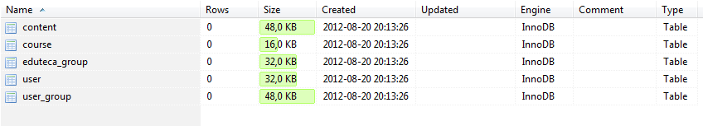

- Now go to the url:

http://localhost/eduteca/web/app.php/about

You should be see a screen like this:

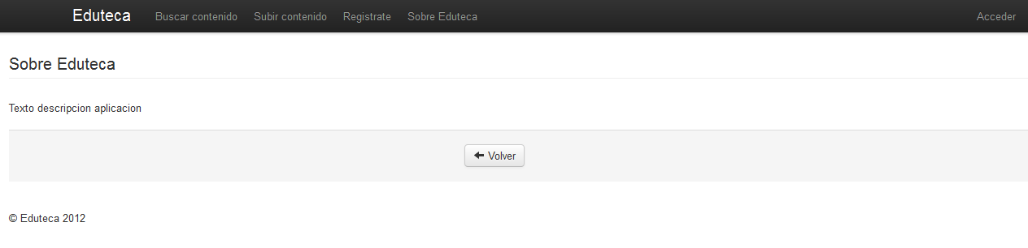
Congratulations. You have your Eduteca up and running.

Recommended, but not mandatory is to make the url of Eduteca more frienly, for example creating rewritten them in Apache.

Web | Url
Desktop | http://yourserver:port/eduteca/web/app.php/
Administration | http://yourserver:port/eduteca/web/app.php/admin
Mobile | http://yourserver:port/eduteca/web/app.php/mobile

User manual
To access to the regular desktop web go to:

http://localhost/eduteca/web/app.php/

Regular users are allowed to:

- Search and download contents without authentication
- Register in Eduteca
- Upload contents previous log in

Search and download contents
In the home page, select the option “Search content” from the main menu.
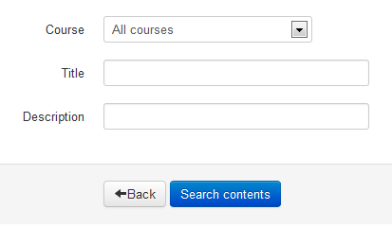
Introduce the criteria to search (if any) and press the button “Search contents”.

NOTE: Only approved contents are shown

The contents which meet you criterial will be shown in a list.
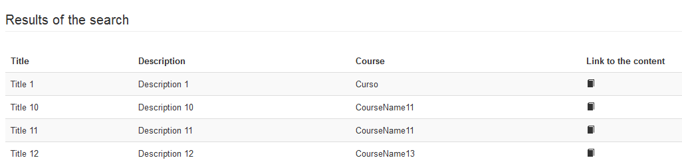

In case you want to download it, just press the icon

Register in Eduteca
To register in Eduteca select the option “Join us!” from the upper menu. Fill the form
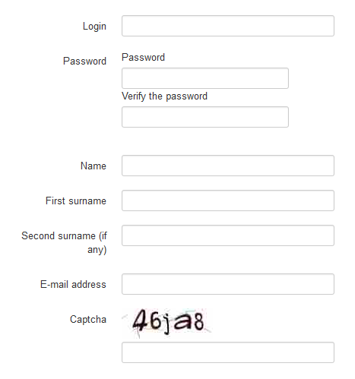
And press the button “Register user”.

NOTE: After finishing the registration process you user will not be enabled until an administrator validates it

Upload contents
From any place of Eduteca select the option “Upload content” from the main menu. If case you are not still logged the login form will be shown.
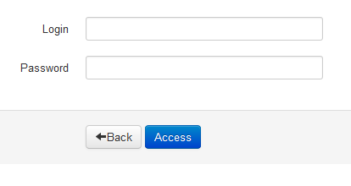
After login fill the form with the new content.

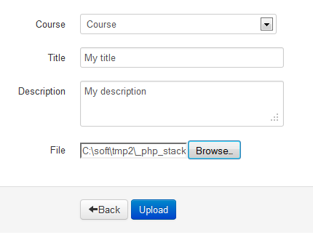

NOTE: The size and file types of the contents allowed are limited by administrators

Press the button “Upload” from upload the new content in Eduteca. Once the content is uploaded, this will not be show from the “Search content” option. This due to the content have to be validated by administrators.

Edit the user data
In case a user want to change its profile, first the use must log in in Eduteca. To login, press the option “Login” from upper menu.
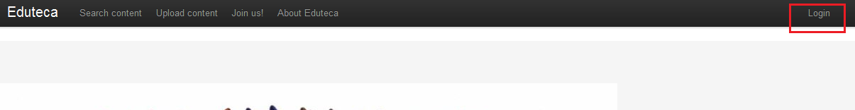
After login, the “Login” option changes to “Options”.
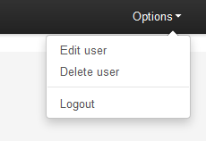
Select the option “Edit user”. New capture show the form in which user's details can be modified.
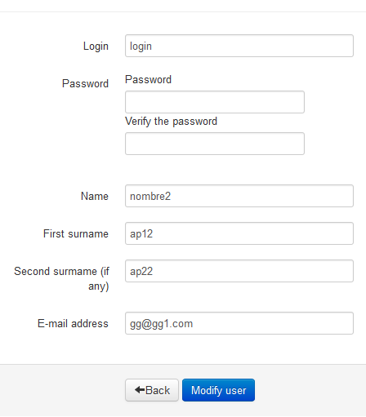

Delete the user
In case an user wish to be deleted, they can delete themselves after log in. In the menu “Options”
Select the option “Delete user”.

NOTE: After deleting an user, it cannot be restore even for administrators

User manual (Mobile web)

There is a special web adapted to mobile devices, phones and tablets. The user is:

http://localhost/eduteca/web/app.php/mobile

From there, user can do most of what it could be done from the desktop web with the exception of upload content, delete and modify user's details.

NOTE: This web is only available in Spanish. The main problem is there is not official support for multi language in Sencha Touch 2.0

Search and download contents
Press the icon
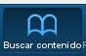
From the bottom toolbar. Introduce the filters to apply in your search.

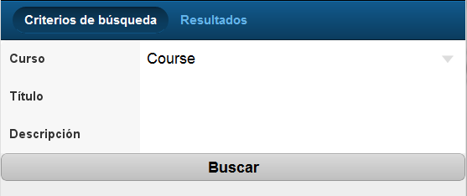
Press the button “Buscar” for searching. The contents will appear in the tab titled “Resultados”.

Each entry of the list is a link from which the content can be downloaded.

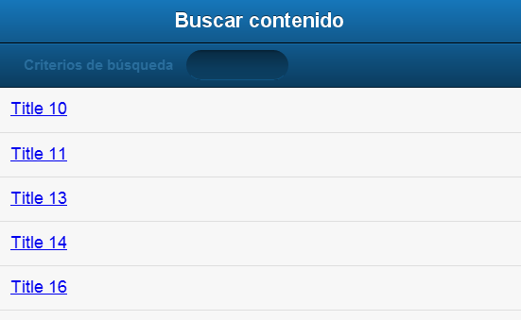
If you want to change your criteria press over the title of the tab “Criterios de búsqueda”.

NOTE: For any mistery unknown for me (the delevoper), the second tab has a weird behabiour not showing correctly the title of the tab. It can be solve if the list is not scrollable what it means you (the user) will not be able to see all those contents beyond the screen.

Register in Eduteca
To register in Eduteca from your mobile device press the icon:
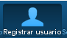
User registered from the desktop website are the same as registered from the mobile counterpart. If you already have an user, request another one is worthless.
Fill the form and press the button “Registrarse”
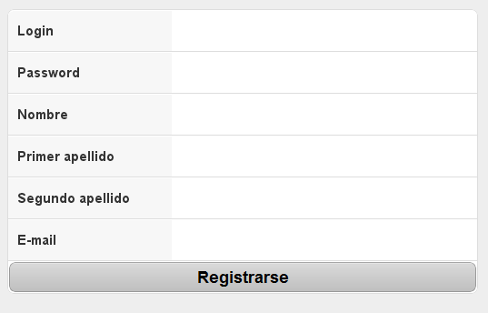
Your user will be created but you could not log in until an administrator validates your profile.

Administrator manual

Administrators are those users with the responsibility of keep in good shape Eduteca. They can do what regular user can do plus:

- Manage courses
- Manage contents
- Manage users. This include approve them or make the administrators

NOTE: This web is only available in Spanish. The main problem is there is not official support for multi language in ExtJs 4

To access the admin web site just type:

localhost/eduteca/web/app.php/admin

The default administrator user is “admin” and the password is “admin”. You can change it with the option “Usuarios->Modificar”

After login you will the main page.

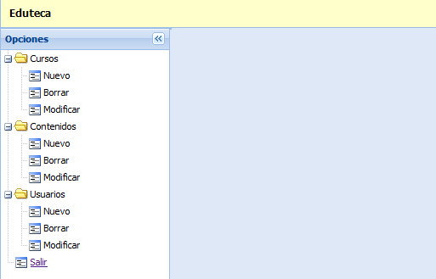

Add a course
Add a new content is as easy as click over the option “Cursos->Nuevo”

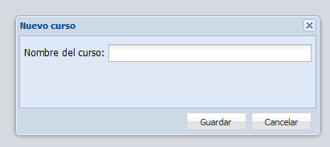
And supply the name of the course.

Manages existing courses
Delete / Modify or inspect can be done by either “Cursos->Borrar” or “Cursos->Modificar” options. First find the course to modify/delete with the upper filter or paging support.

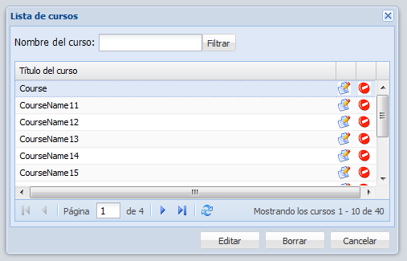

Once found, select the course and press:
or the button “Editar” | For modifying / viewing the details of the course.
or the button “Borrar” | For deleting the course.

Add a content
Add new content is as easy as press the option “Contenidos->Nuevo”. Fill the new windows with the appropriate data.
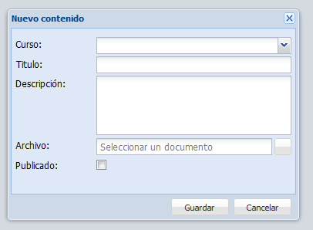
NOTE: If the option “Publicado” is not checked the content will not be browsable for regular users

Be careful with this option due to administrators can upload any kind of contents without size restriction.

Manage existing contents
Like courses, consult, modifications and removals can be done with the options “Contenidos->Borrar” or “Contenidos->Modificar”.
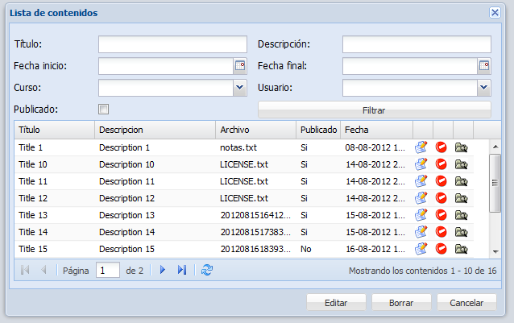
In this screen you can filter by several criteria:
- Title (by proximity)
- Description (by proximity)
- Date range when the content was created
- By user
- By course

For each you can:
or the button “Editar” | Edit / View the content. The creation data cannot be modified.
or the button “Borrar” | Delete the content
 | Download the content

Add a user
New user can be created with the option “Usuarios->Nuevo”. By the default the mark “Aprovado” is checked what it means, once created are ready to be used.

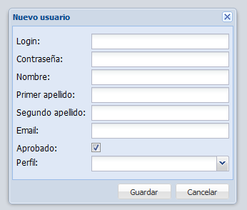
The are two possible profiles:
- Regular user (Usuarios)
- Administrators (Administradores)
Administrator profile inherit from regular users. In other words, administrators extends the features of regulars users.

Manage existing users
The management of users followa the same procedure of courses and contents. Select the option “Usuarios->Borrar” or “Usuarios->Modificar”.

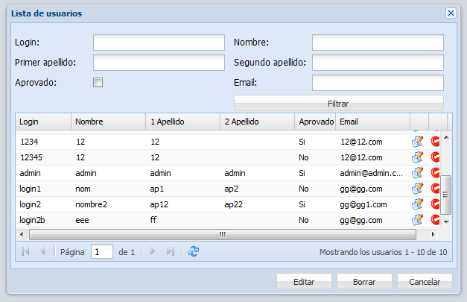
Find the user to modify and then:
or the button “Editar” | For modifying / viewing the details of the user.
or the button “Borrar” | For deleting the user.

Advanced Topics

How to modify the mime types allowed
Regular user can allowed to upload only certain types of files. This measure prevents from uploading contents in formats difficult to be used for other members of the community. In case you want to widen the list edit the file:

eduteca\src\Eduteca\EdutecaBundle\Entity\Content.php

Search the string “mimeTypes”. This property contains a list the mime types allowed. The list of supported mime types is in http://www.iana.org/assignments/media-types/index.html

How to change the maximum size of the documents
Like mime types, you can set the size of the files. Edit the file:

eduteca\src\Eduteca\EdutecaBundle\Entity\Content.php

And find the text “maxSize”. This property indicated the maximum size (in bytes) allowed to be uploaded.

How to delete the cache
In case you modify Eduteca, for example, you will need to remove the cache. PHP scripts are compiled for performance reasons. To delete it you can:

- Delete with the command from $DOCUMENT_ROOT/eduteca

php app/console cache:clear --env=pro –no-debug

- And / or delete the folder $DOCUMENT_ROOT/eduteca/app/cache/prod

How to change the texts of the web (desktop only)
By default the text are in Spanish, Catalan and English. If you want to customize them, edit the files $DOCUMENT_ROOT/eduteca/src/Eduteca/EdutecaBundle/Resources/translations/messages.XX.xliff with the appropriate text.
Remember to delete the cache before testing the changes!

I have lost the password of the admin user. What can I do?
Follow the next steps:
- Go to the database and change the login (database parameters are in $DOCUMENT_ROOT/app/config/parameters.ini)
- Go to the table “User” and change the login (colum “login”) “admin” for another (ex: 'adminBack')
- Go to the url “http://localhost/eduteca/web/app.php/about”
- A new user in the table users will be created with the default password
- Replace the values “password” and “salt” FROM the new admin INTO the old admin (“adminBack”)
- Login to the administration web with “adminBack” and password “admin”
- [Optional] Delete the “admin” user and change the login “adminBack” to “admin”.

I want to do a backup. What should I know?
There tree thing to take into considerations:
- Your Apache configuration (PHP configuration and url rewrites)
- The database
- All the directory $DOCUMENT_ROOT/eduteca. This directory contains the application and the contents uploaded.

I running out of space. What can I do?
Most of the space required by Eduteca is spent storing contents. All of then by default are saved in the folder $DOCUMENT_ROOT/uploads/documents. From here on you can follow few techniques:
- Add a new hard disk, mount it (via /etc/fstab) and move all files and create a symbolic link (ln -s documents /new/path/documents)
- Move your upload/document directory into a remote filesystems. Export it via NFS and mount it via /etc/fstab. Then move all files and create a symbolic link (ln -s documents /new/path/documents)

There is a problem in the Eduteca. How can I get more information?
First of all you need access to the server and a browser. Then reproduce the steps which lead you a problem using the url:
http://localhost/eduteca/web_dev.php/
http://localhost/eduteca/web_dev.php/admin
http://localhost/eduteca/web_dev.php/mobile

These development urls are only accessible from localhost users. Moreover, take a look at the log in $DOCUMENT_ROOT/eduteca/app/logs

The complete list of supported browsers is available in https://github.com/twitter/bootstrap/wiki/Browser-Compatibility
http://symfony.com/

