Instituto Tecnológico y de Estudios Superiores de Monterrey
Campus Guadalajara

TC3002B — Computer Science Advanced Applications Development
Module #3: Compilers — Step I
Lexical Analysis Phase for the Triton GPU Kernel Language
A scanner built with UNIX lex, integrated with a yacc parser

Student: Gustavo Ortiz
Learning Unit Leader: Dr. Salvador Hinojosa
June 10, 2026

Table of Contents

1. Introduction

1.1 Summary
This report documents the analysis, design, implementation, and verification of the lexical analysis phase of a compiler front end for the Triton GPU kernel language. Triton is a Python-like domain-specific language developed by OpenAI for writing high-performance GPU kernels. The scanner is implemented with the UNIX lex tool (flex) as required, without any regular-expression library or Python ast module, and it produces the two outputs required for this phase: the sequence of tokens of the scanned source file and the symbol table for the tokens that require it. The scanner is additionally integrated with a yacc parser through the shared token-definition header y.tab.h, so the token identifiers documented in this report are the exact integers exchanged between both phases. The implementation was validated against a corpus of 135 LLM-generated Triton programs, reaching a 94.5% acceptance rate on the 55 files that contain Triton kernels, with every remaining failure traced to a documented, deliberate scope decision.
Section 1.2 introduces the notation and the development model. Section 2 (Analysis) states the informal lexical specification and its formal counterpart as regular expressions, together with the token identifiers and the error messages. Section 3 (Design) presents the automata, the transition tables, and the symbol-table data structures and algorithms, all traceable to the analysis. Section 4 (Implementation) provides the complete printout of the lex file and of the scanner driver, explained section by section. Section 5 presents verification and validation, including the test-case design and the snapshots of the scanner outputs. Section 6 contains the work plan.

1.2 Notation and development model
Regular expressions (RE). A regular expression is a finite formula that denotes a regular language: the set of strings it matches. REs are built from single characters, concatenation, alternation (|), and repetition (the Kleene star * and the positive closure +), plus the abbreviations used by lex such as character classes [a-z] and optionality (?). REs are the formal specification language of this phase: every kind of token in Section 2 is defined by one RE.
Finite state machines (FSM/DFA). A deterministic finite automaton is a 5-tuple (Q, Σ, δ, q0, F): a finite set of states, an input alphabet, a transition function δ: Q × Σ → Q, an initial state, and a set of accepting states. A DFA recognizes exactly the regular languages, which is why every RE of the analysis can be implemented by a DFA of the design. lex performs this construction mechanically (RE → NFA → DFA by subset construction, then state minimization), which is the central justification for using it.
Transition tables. A transition table is the tabular form of δ: one row per state, one column per input symbol or character class, and the accepting states annotated. The tables in Section 3 are written over character classes (letter, digit, quote, operator characters) instead of the 256 raw input characters; this is the same equivalence-class compression that flex applies internally and it is what makes the tables compact and efficient.
Development model. The project follows the classic phase model — Analysis, Design, Implementation, Verification and Validation — executed as a short waterfall with one measured feedback iteration. The model fits this problem because the deliverables form a strict chain: the informal specification fixes the token set, the REs formalize it, the automata and tables realize the REs, the lex file transcribes the automata, and the tests check the lex file against the specification. One controlled iteration occurred when corpus-level validation (Section 5.4) revealed that triple-quoted docstrings were mis-lexed; the analysis and design were extended (states T0–T3 of Figure #4) and the implementation was updated accordingly. The iteration is documented rather than hidden because it shows the V&V process doing exactly its job.
Why lex. The course restriction requires the scanner to be generated by UNIX lex, and the tool is also the technically correct choice: lex takes the REs of the analysis directly as its rules section, builds the minimized DFA automatically, applies the maximal-munch (longest match) policy that Section 3 depends on, and resolves ties by rule order, which is how keywords win over identifiers. No regular-expression library, API, or Python ast module is used anywhere in the project.

2. Analysis
The goal of this phase is to recognize every lexeme that occurs in real Triton GPU kernels — the decorated Python functions that TritonBench programs define with @triton.jit — and to reject everything else with a precise error message. The requirements below follow the deliverables required for the scanner: the informal lexical description (2.1), the formal specification as regular expressions (2.2), the tokens and their identification (2.3), and the error messages (2.4). Each requirement is labeled R1–R8 so that the design (Section 3) and the implementation (Section 4) can be traced back to it.

2.1 Informal lexical specification
A Triton kernel file is a sequence of Python-like logical lines containing imports, decorators, function headers, assignments, and expressions over tensor operations. Reading real kernels (the add/matmul/softmax families of TritonBench) yields the following lexeme categories. Only the lexemes needed for the goal are included; everything outside the table is, by specification, a lexical error. Table #1 is the informal lexical specification of the language.
Req. | Category | Description | Examples
R1 | Identifiers | names of variables, functions, modules and attributes: a letter or underscore followed by letters, digits or underscores | pid, tl, BLOCK_SIZE, _mask
R2 | Keywords | 35 reserved words of the Python subset: 26 used by kernel constructs and 9 reserved for future phases | def, return, if, for, in, not, import, lambda
R3 | Integer literals | decimal digit sequences | 0, 42, 1024
R3 | Float literals | digits with a decimal point and/or a scientific exponent; the leading-dot form is included | 3.14, .5, 1e6, 2.5e-3
R4 | String literals | single-line strings in double or single quotes, and triple-quoted strings (docstrings) that may span lines | "mask", 'x', """doc"""
R5 | Operators | arithmetic, comparison, bitwise, and the 13 assignment operators, with multi-character forms lexed as one token | +, **, //, <=, !=, <<=, ->, @
R5 | Delimiters | grouping and punctuation symbols | ( ) [ ] { } , : . ; ...
R6 | Comments | from # to the end of the line; consumed, no token | # one block per program
R6 | Whitespace | spaces, tabs, carriage returns and newlines; consumed, no token (layout-free design)
R7 | Invalid symbols | any character not covered above produces the ERROR token and a message | $, ?, a lone !
Table #1: Informal lexical specification of the Triton kernel language.
Two decisions in Table #1 deserve justification. First, the newline is consumed like any whitespace (R6): the project adopts a layout-free token stream, so the parser never receives layout tokens; this removes the need for an indentation stack in the scanner and is documented at length in the grammar design (grammar.md). Second, nine keywords (lambda, try, except, finally, with, class, yield, async, await) are recognized and reserved even though no grammar rule uses them yet: reserving them now guarantees they can never be captured as identifiers by user code, which would make adding those constructs later a breaking change.

2.2 Formal specification: regular expressions
Table #2 gives the regular expression for each kind of token, in exactly the notation that appears in the rules section of the lex file (Section 4), using the three named definitions DIGIT = [0-9], LETTER = [a-zA-Z_], and EXPONENT = [eE][+-]?{DIGIT}+. Each expression is explained and justified below the table.
Token kind | Regular expression | Token(s)
Identifier | {LETTER}({LETTER}|{DIGIT})* | NAME
Keyword | one literal RE per word: "def", "return", ... | DEF, RETURN, ... (35)
Integer | {DIGIT}+ | INTEGER
Float (forms 1-3) | {DIGIT}+\.{DIGIT}*{EXPONENT}? | \.{DIGIT}+{EXPONENT}? | {DIGIT}+{EXPONENT} | FLOAT
String (single-line) | \"[^\"\n]*\" | '[^'\n]*' | STRING
String (triple-quoted) | \"\"\" ... \"\"\" via start conditions TRIPLE_D / TRIPLE_S | STRING
Operators / delimiters | one literal RE per lexeme: "+", "**", "<<=", "->", "...", ... | PLUS, DOUBLE_STAR, ... (45)
Comment | #[^\n]* | (consumed)
Whitespace | [ \t\r\n]+ | (consumed)
Anything else | . | ERROR
Table #2: Regular expressions of the formal lexical specification.
Identifiers (R1) start with a letter or underscore so that 1x cannot be an identifier, and the underscore is a letter because Triton code uses names such as x_ptr and _mask. Keywords (R2) are spelled as literal REs and placed before the identifier rule: lex prefers the longest match and, on ties, the earliest rule, so def is the keyword DEF while define is one NAME — both behaviors are required. The three float forms (R3) cover every shape found in real kernels: 3.14 and 1. (form 1), .5 (form 2), and 1e6 (form 3); the EXPONENT abbreviation makes the optional sign and mandatory exponent digits explicit, so a string like 1e is correctly split into INTEGER(1) NAME(e) by backtracking. Single-line strings (R4) exclude the newline so that an unterminated quote cannot silently swallow the rest of the file; the multi-line docstring case is handled by a dedicated automaton (Section 3.2, Figure #4) because no single lex pattern can both span newlines and fail cleanly at end of file. Every operator and delimiter (R5) is its own literal RE so that maximal munch assembles <<= as one token instead of three. The final rule, the dot, implements R7: any character that no other rule can start is returned as the ERROR token, which keeps the scanner total — it never crashes on bad input.

2.3 Tokens and their identification
Every token kind is identified by an integer Token ID. The IDs are not invented by hand: they are generated by yacc from the %token declarations of the companion grammar (newparser.y) into the header y.tab.h, and the lex file includes that header. This is a deliberate analysis decision with two consequences. First, the scanner and the parser can never disagree about a token number, eliminating an entire class of integration defects. Second, the numbering starts at 257 because yacc reserves 0–255 for single characters, 256 for its internal error token — which is also why the project's ERROR token receives its own number above 257 instead of colliding with 256, a defect that existed in an early version of the lexer and was removed during design. The complete list is given in Table #4 (Section 3.3) next to the transition tables that produce each token.

2.4 Error messages
The scanner reports two lexical error situations, both with the line number provided by lex's yylineno facility. They are specified in Table #3 and exercised by test cases T3 and T4 of Section 5. The recovery policy is panic-free: the offending character is consumed, the ERROR token is emitted, and scanning continues, so a single run reports every lexical error in the file instead of stopping at the first one. When the scanner runs under the parser, the ERROR token has no grammar rule, so the parser rejects the file at exactly that position — the same defect is caught in both configurations.
Situation | Message (stderr) | Justification
Invalid symbol (R7): a character no RE accepts, e.g. $ ? or a lone ! | lexical error at line N: invalid symbol 'c' | Identifies the exact character and line; scanning continues so all errors are reported in one pass.
Unterminated triple-quoted string: EOF reached inside TRIPLE_D/TRIPLE_S | ERROR token at EOF (parser: syntax error at the line of the opening quotes) | An unclosed docstring would otherwise swallow the file silently; the explicit EOF rule makes the failure visible and locatable.
Table #3: Lexical error messages and their justification.

3. Design

3.1 Architecture
Figure #1 shows the architecture. The lex specification newlexer.l is compiled by flex into lex.yy.c, a table-driven DFA scanner exposing yylex(). Two drivers consume it: newscanner (scanner_main.c) produces this phase's deliverables — the token sequence and the symbol table — and newparser (the yacc grammar) consumes the same yylex() for syntax analysis. The shared header y.tab.h (dashed arrows) carries the Token IDs to both, implementing the design decision of Section 2.3. This architecture satisfies traceability by construction: there is exactly one lexical definition for the whole front end.
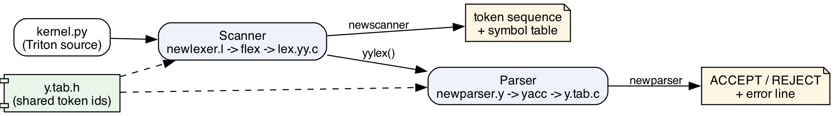
Figure #1: Architecture of the lexical phase and its integration with the parser.

3.2 Automata
The scanner is the union of five class automata, one per requirement group. Splitting the design by class keeps every automaton small and readable, while flex computes the single combined DFA mechanically from their union — the construction seen in class, applied by the tool. In every figure the initial state is S0, double circles are accepting states, and the token produced is written next to them. Each figure is paired with its transition table in Section 3.3; figures and tables are generated from one single machine-readable definition (make_figures.py), so they cannot disagree with each other.
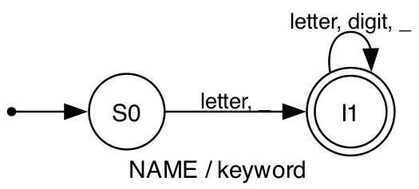
Figure #2: DFA for identifiers and keywords (R1, R2).
Figure #2 recognizes identifiers. Keywords deliberately share this automaton: a keyword is lexically an identifier, and the keyword/identifier decision is made by lex's tie-break rule (earlier rule wins on equal length), not by a larger automaton. This is the most efficient design: 2 states instead of a trie of 35 keywords with ~150 states.
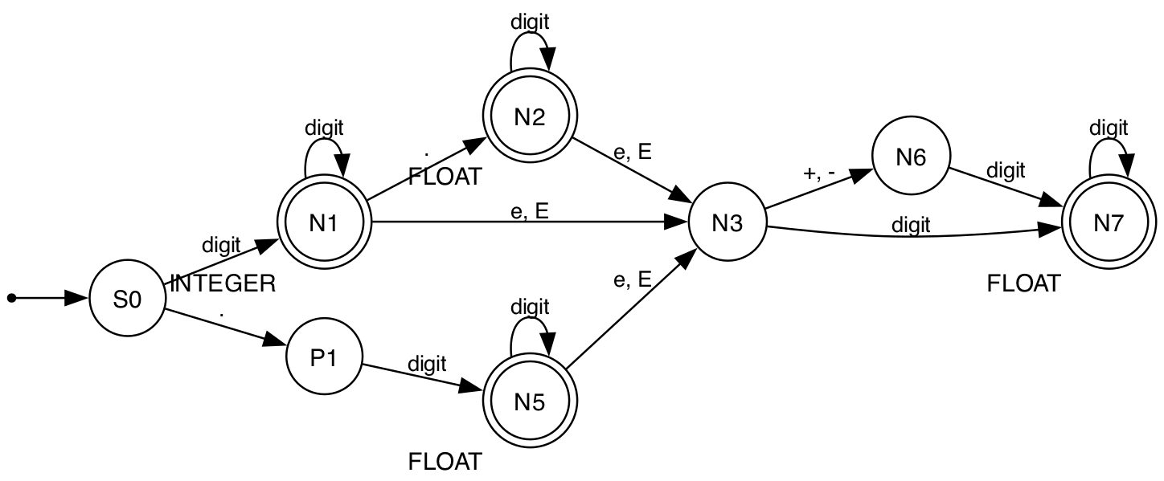
Figure #3: DFA for numeric literals (R3).
Figure #3 recognizes INTEGER and the three FLOAT forms with seven states. States P1, N3 and N6 are not accepting on purpose: they represent a lone dot, a dangling exponent marker, and a dangling exponent sign. If the input ends there, maximal munch backtracks to the last accepting state, which yields exactly Python's behavior (1e ⇒ INTEGER NAME, 1.e3 ⇒ FLOAT(1.) NAME(e3) DOT-free, and a lone dot falls to the operator automaton as DOT).
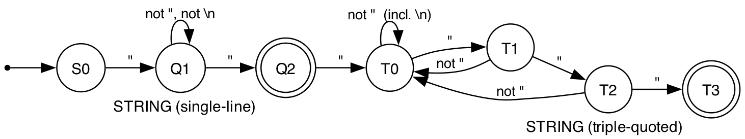
Figure #4: DFA for string literals, including triple-quoted docstrings (R4).
Figure #4 is the automaton added in the documented design iteration (Section 1.2). Q1–Q2 recognize single-line strings. Q2 is accepting and has an outgoing edge: on a third quote, maximal munch continues into T0 instead of returning the empty string, which is precisely how """doc""" is one token while "" remains valid. The T-states accept any character including newlines until three consecutive quotes close the string. In the implementation the T-states are the lex start conditions TRIPLE_D and TRIPLE_S — a start condition is the lex mechanism for giving the scanner explicit DFA states — and yymore() accumulates the full lexeme. Reaching end of file inside a T-state triggers the unterminated-string error of Table #3.
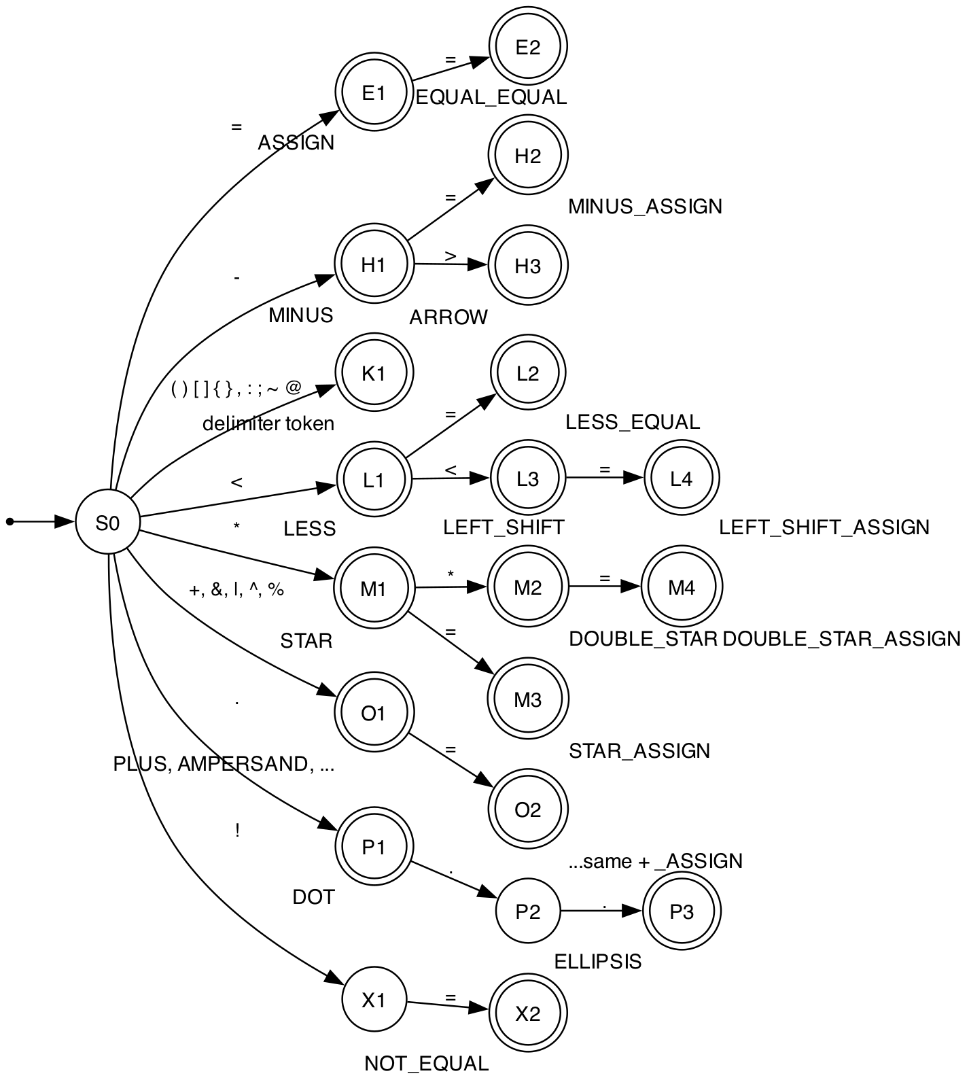
Figure #5: DFA for operators and delimiters, maximal-munch chains (R5).
Figure #5 shows the operator chains. Multi-character operators are paths: < to LESS, <= to LESS_EQUAL, << to LEFT_SHIFT, <<= to LEFT_SHIFT_ASSIGN; the GREATER and SLASH families are shape-identical to LESS and STAR and are therefore drawn once (the transition table in Section 3.3 lists them all). Two states are intentionally non-accepting: X1, because a lone ! is not a lexeme of the language (only != is), and P2, because .. is not one either — both fall through to the error and backtracking rules. State K1 collects the ten single-character delimiters, and O1/O2 generalize the simple op / op= pairs (+, &, |, ^, %).
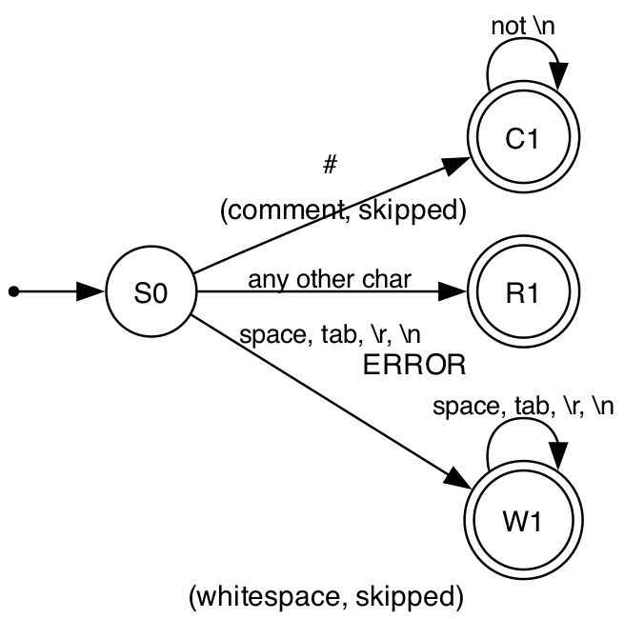
Figure #6: Comments, whitespace and the error catch-all (R6, R7).
Figure #6 closes the union: comments are consumed to end of line without producing a token, all whitespace including the newline is consumed (the layout-free decision of Section 2.1), and the catch-all edge to R1 is the implementation of requirement R7 — every character not claimed by Figures #2 to #5 becomes the ERROR token.

3.3 Transition tables and Token IDs
Tables #5 to #9 are the transition tables of Figures #2 to #6, generated from the same definitions. Efficiency argument: the columns are character classes rather than raw characters, which compresses the alphabet from 256 columns to at most ten per table — the same equivalence-class technique flex applies when it emits its internal tables — and the per-class split keeps the whole design at 30 explicit states. A dash means 'no transition': the scanner then either accepts (if the state is accepting), backtracks to the last accepting configuration (maximal munch), or, only in S0, takes the error edge of Figure #6.
state | letter, _ | letter, digit, _ | accepts
S0 | I1 | - | -
I1 | - | I1 | NAME / keyword
Table #5: Transition table — Identifiers and keywords.
Keywords use this same automaton; the lex rule order decides: keyword rules are listed before the NAME rule, so on an equal-length match the keyword wins (flex tie-break).
state | digit | . | e, E | +, - | accepts
S0 | N1 | P1 | - | - | -
N1 | N1 | N2 | N3 | - | INTEGER
N2 | N2 | - | N3 | - | FLOAT
N3 | N7 | - | - | N6 | -
N5 | N5 | - | N3 | - | FLOAT
N6 | N7 | - | - | - | -
N7 | N7 | - | - | - | FLOAT
P1 | N5 | - | - | - | -
Table #6: Transition table — Numeric literals (INTEGER and FLOAT).
P1, N3, N6 are not accepting: if the exponent or fraction never arrives, flex backtracks to the last accepting state (maximal munch), e.g. `1e` is INTEGER(1) NAME(e) and a lone `.` is handled by the operator automaton (DOT).
state | \" | not \", not \\n | not \" (incl. \\n) | not \" | accepts
S0 | Q1 | - | - | - | -
Q1 | Q2 | Q1 | - | - | -
Q2 | T0 | - | - | - | STRING (single-line)
T0 | T1 | - | T0 | - | -
T1 | T2 | - | - | T0 | -
T2 | T3 | - | - | T0 | -
T3 | - | - | - | - | STRING (triple-quoted)
Table #7: Transition table — String literals (single-line and triple-quoted).
Q2 is accepting AND has an outgoing edge: maximal munch makes a third quote continue into the triple-quoted automaton instead of returning the empty string. The same shape applies to '...'. In the lex file the T-states are the start conditions TRIPLE_D / TRIPLE_S, with yymore() accumulating the lexeme; EOF inside a T-state returns ERROR (unterminated string).
state | < | = | * | ! | - | > | . | +, &, | , ^, % | ( ) [ ] { } , : ; ~ @ | accepts
S0 | L1 | E1 | M1 | X1 | H1 | - | P1 | O1 | K1 | -
E1 | - | E2 | - | - | - | - | - | - | - | ASSIGN
E2 | - | - | - | - | - | - | - | - | - | EQUAL_EQUAL
H1 | - | H2 | - | - | - | H3 | - | - | - | MINUS
H2 | - | - | - | - | - | - | - | - | - | MINUS_ASSIGN
H3 | - | - | - | - | - | - | - | - | - | ARROW
K1 | - | - | - | - | - | - | - | - | - | delimiter token
L1 | L3 | L2 | - | - | - | - | - | - | - | LESS
L2 | - | - | - | - | - | - | - | - | - | LESS_EQUAL
L3 | - | L4 | - | - | - | - | - | - | - | LEFT_SHIFT
L4 | - | - | - | - | - | - | - | - | - | LEFT_SHIFT_ASSIGN
M1 | - | M3 | M2 | - | - | - | - | - | - | STAR
M2 | - | M4 | - | - | - | - | - | - | - | DOUBLE_STAR
M3 | - | - | - | - | - | - | - | - | - | STAR_ASSIGN
M4 | - | - | - | - | - | - | - | - | - | DOUBLE_STAR_ASSIGN
O1 | - | O2 | - | - | - | - | - | - | - | PLUS, AMPERSAND, ...
O2 | - | - | - | - | - | - | - | - | - | ...same + _ASSIGN
P1 | - | - | - | - | - | - | P2 | - | - | DOT
P2 | - | - | - | - | - | - | P3 | - | - | -
P3 | - | - | - | - | - | - | - | - | - | ELLIPSIS
X1 | - | X2 | - | - | - | - | - | - | - | -
X2 | - | - | - | - | - | - | - | - | - | NOT_EQUAL
Table #8: Transition table — Operators and delimiters (maximal munch chains).
The chains for > (GREATER family) and / (SLASH family) are identical in shape to < and *. X1 and P2 are not accepting: a lone `!` is a lexical ERROR, and `..` backtracks to DOT, DOT. Maximal munch is why `<<=` is one token and not three.
state | # | not \\n | space, tab, \\r, \\n | any other char | accepts
S0 | C1 | - | W1 | R1 | -
C1 | - | C1 | - | - | (comment, skipped)
R1 | - | - | - | - | ERROR
W1 | - | - | W1 | - | (whitespace, skipped)
Table #9: Transition table — Comments, whitespace and the error catch-all.
Layout-free design: \\n is ordinary whitespace, the parser never sees layout. Anything no automaton accepts is returned as the ERROR token with its line number.
Table #4 lists the complete Token ID assignment extracted from the generated y.tab.h, fulfilling the deliverable 'Tokens and their identification'. The ERROR token closes the list; identifiers and literals additionally carry their lexeme into the symbol table of Section 3.4.
Token | ID | Token | ID | Token | ID
NAME | 258 | DEL | 287 | RIGHT_SHIFT | 316
INTEGER | 259 | LAMBDA | 288 | ASSIGN | 317
FLOAT | 260 | TRY | 289 | PLUS_ASSIGN | 318
STRING | 261 | EXCEPT | 290 | MINUS_ASSIGN | 319
DEF | 262 | FINALLY | 291 | STAR_ASSIGN | 320
RETURN | 263 | WITH | 292 | SLASH_ASSIGN | 321
IF | 264 | CLASS | 293 | PERCENT_ASSIGN | 322
ELIF | 265 | YIELD | 294 | AMPERSAND_ASSIGN | 323
ELSE | 266 | ASYNC | 295 | PIPE_ASSIGN | 324
FOR | 267 | AWAIT | 296 | CARET_ASSIGN | 325
WHILE | 268 | PLUS | 297 | LEFT_SHIFT_ASSIGN | 326
IN | 269 | MINUS | 298 | RIGHT_SHIFT_ASSIGN | 327
AND | 270 | STAR | 299 | DOUBLE_STAR_ASSIGN | 328
OR | 271 | DOUBLE_STAR | 300 | DOUBLE_SLASH_ASSIGN | 329
NOT | 272 | SLASH | 301 | OPEN_PARENTHESIS | 330
IS | 273 | DOUBLE_SLASH | 302 | CLOSE_PARENTHESIS | 331
TRUE | 274 | PERCENT | 303 | OPEN_BRACKET | 332
FALSE | 275 | AT | 304 | CLOSE_BRACKET | 333
NONE | 276 | LESS | 305 | OPEN_BRACE | 334
IMPORT | 277 | LESS_EQUAL | 306 | CLOSE_BRACE | 335
FROM | 278 | GREATER | 307 | COMMA | 336
AS | 279 | GREATER_EQUAL | 308 | COLON | 337
PASS | 280 | EQUAL_EQUAL | 309 | DOT | 338
RAISE | 281 | NOT_EQUAL | 310 | SEMICOLON | 339
ASSERT | 282 | AMPERSAND | 311 | ARROW | 340
BREAK | 283 | PIPE | 312 | ELLIPSIS | 341
CONTINUE | 284 | CARET | 313 | ERROR | 342
GLOBAL | 285 | TILDE | 314
NONLOCAL | 286 | LEFT_SHIFT | 315
Table #4: Token IDs as generated into y.tab.h (yacc numbering, starting at 257).

3.4 Symbol table: data structure and algorithm
The symbol table records every distinct lexeme of the four token kinds that carry a value — NAME, INTEGER, FLOAT and STRING — because those are the tokens later phases must look up; keywords and operators are fully identified by their Token ID and would only duplicate information. Each entry is the record of Table #10.
Field | Type | Meaning
id | int | symbol number, assigned consecutively on first appearance
token | int | Token ID from y.tab.h (NAME, INTEGER, FLOAT or STRING)
lexeme | char[64] | the lexeme; lexemes longer than 63 characters (docstrings) are stored truncated with an ellipsis mark
first_line | int | line of the first appearance (from yylineno)
count | int | number of occurrences
Table #10: Symbol-table record (struct symbol in scanner_main.c).
The algorithm is insert-or-count: for every value-carrying token the driver searches the table for an entry with the same token kind and lexeme; if found, its counter is incremented, otherwise a new entry is appended with the next id and the current line. The pseudocode is:
symtab_insert(token, lexeme, line):
key = truncate(lexeme, 63)
for each entry e in symtab: # linear search
if e.token == token and e.lexeme == key:
e.count += 1
return
symtab.append( id=n+1, token, lexeme=key,
first_line=line, count=1 )
The lookup is a linear search over an array, an O(n) choice made deliberately: measured kernel files declare a few dozen distinct symbols (test T1 yields 22), so a hash table would add complexity without measurable benefit at this scale. The decision is encapsulated — symtab_insert() is the only function that touches the array — so upgrading to hashing is a one-function change, which is noted in the source. The table is printed after EOF, sorted by construction in order of first appearance, which makes the output deterministic and easy to diff in regression tests.

3.5 Traceability to the analysis
Table #11 maps every requirement of Section 2 to its design artifact, to the exact rules of the implementation, and to the test case that verifies it. This is the acid-test property demanded of the design: a developer who never saw this project can go from any row to the code and back.
Req. | Analysis (RE) | Design | Implementation (newlexer.l) | Verified by
R1 identifiers | Table #2 row 1 | Fig. #2 / Table #5 | IDENTIFIERS rule | T1, T2
R2 keywords | Table #2 row 2 | Fig. #2 + rule order | KEYWORDS block (35 rules) | T1, T2
R3 numbers | Table #2 rows 3-4 | Fig. #3 / Table #6 | LITERALS block, 4 numeric rules | T2
R4 strings | Table #2 rows 5-6 | Fig. #4 / Table #7 | LITERALS block + %x TRIPLE_D, TRIPLE_S | T1, T2, T4
R5 operators/delimiters | Table #2 row 7 | Fig. #5 / Table #8 | OPERATORS .. DELIMITERS blocks (45 rules) | T2
R6 comments/whitespace | Table #2 rows 8-9 | Fig. #6 / Table #9 | COMMENT and LAYOUT rules | T1
R7 invalid symbols | Table #2 row 10, Table #3 | Fig. #6 / Table #9 | final '.' rule; ERROR token | T3, T4
R8 outputs (tokens + symbol table) | Section 2.3 | Section 3.4 / Table #10 | scanner_main.c (driver) | T1-T4, corpus
Table #11: Traceability matrix from requirements to code and tests.

4. Implementation
The scanner consists of two source files plus the build script: newlexer.l (the lex specification — the deliverable required to be implemented with UNIX lex) and scanner_main.c (the driver that turns the generated analyzer into the deliverable program). The complete printout of the lex file follows, explained by its three constituent sections; no regular expression library or API is involved anywhere — flex generates the entire matching engine from the rules below.

4.1 Definitions section
The definitions section configures the generated scanner and declares the named sub-expressions used by the rules. #include "y.tab.h" imports the Token IDs of Table #4 (the integration decision of Section 2.3). The options remove the unused input/unput helpers, enable yylineno for error messages, and declare the two exclusive start conditions %x TRIPLE_D TRIPLE_S that realize the T-states of Figure #4. The three named definitions DIGIT, LETTER and EXPONENT are the building blocks of Table #2.
%{
#include "y.tab.h"
%}

%option noyywrap
%option yylineno
%option noinput nounput

/* exclusive states for triple-quoted strings (docstrings) */
%x TRIPLE_D TRIPLE_S

DIGIT [0-9]
LETTER [a-zA-Z_]
EXPONENT [eE][+-]?{DIGIT}+
%%

4.2 Rules section
The rules section is the formal specification of Section 2.2, transcribed rule by rule: each line is one RE of Table #2 with the action that returns its Token ID. The order is load-bearing and matches the design: keywords precede the identifier rule (tie-break of Figure #2); the triple-quote openers precede the single-line string rules (longest match prefers them anyway, the placement documents the intent); inside the start conditions, yymore() accumulates the docstring so the token carries its complete lexeme; and the final dot rule is the error edge of Figure #6 — it must be last because lex prefers earlier rules on ties, and everything is a tie of length one against the dot.

/* ----------------- COMMENT ----------------- */
"#"[^\n]* { /* skip comments */ }

/* ----------------- KEYWORDS ----------------- */
/* must appear before the NAME rule */
"def" { return DEF; }
"return" { return RETURN; }
"if" { return IF; }
"elif" { return ELIF; }
"else" { return ELSE; }
"for" { return FOR; }
"while" { return WHILE; }
"in" { return IN; }
"and" { return AND; }
"or" { return OR; }
"not" { return NOT; }
"is" { return IS; }
"True" { return TRUE; }
"False" { return FALSE; }
"None" { return NONE; }
"lambda" { return LAMBDA; }
"import" { return IMPORT; }
"from" { return FROM; }
"as" { return AS; }
"try" { return TRY; }
"except" { return EXCEPT; }
"finally" { return FINALLY; }
"pass" { return PASS; }
"raise" { return RAISE; }
"assert" { return ASSERT; }
"with" { return WITH; }
"class" { return CLASS; }
"break" { return BREAK; }
"continue" { return CONTINUE; }
"yield" { return YIELD; }
"global" { return GLOBAL; }
"nonlocal" { return NONLOCAL; }
"del" { return DEL; }
"async" { return ASYNC; }
"await" { return AWAIT; }

/* ----------------- LITERALS ----------------- */
{DIGIT}+\.{DIGIT}*{EXPONENT}? { return FLOAT; }
\.{DIGIT}+{EXPONENT}? { return FLOAT; }
{DIGIT}+{EXPONENT} { return FLOAT; }
{DIGIT}+ { return INTEGER; }

/* triple-quoted strings: may span lines, lexed as one STRING token. */
/* yymore() accumulates the pieces so yytext holds the whole lexeme. */
/* (longest match beats the empty two-quote string "" below) */
\"\"\" { yymore(); BEGIN(TRIPLE_D); }
''' { yymore(); BEGIN(TRIPLE_S); }
<TRIPLE_D>\"\"\" { BEGIN(INITIAL); return STRING; }
<TRIPLE_S>''' { BEGIN(INITIAL); return STRING; }
<TRIPLE_D>[^\"\n]+ { yymore(); }
<TRIPLE_S>[^'\n]+ { yymore(); }
<TRIPLE_D>\" { yymore(); }
<TRIPLE_S>' { yymore(); }
<TRIPLE_D,TRIPLE_S>\n { yymore(); }
<TRIPLE_D,TRIPLE_S><<EOF>> { BEGIN(INITIAL); return ERROR; }

\"[^\"\n]*\" { return STRING; }
'[^'\n]*' { return STRING; }

/* ----------------- IDENTIFIERS ----------------- */
{LETTER}({LETTER}|{DIGIT})* { return NAME; }

/* ----------------- OPERATORS ----------------- */
"+" { return PLUS; }
"-" { return MINUS; }
"*" { return STAR; }
"**" { return DOUBLE_STAR; }
"/" { return SLASH; }
"//" { return DOUBLE_SLASH; }
"%" { return PERCENT; }
"@" { return AT; }

/* ----------------- COMPARISONS ----------------- */
"<" { return LESS; }
"<=" { return LESS_EQUAL; }
">" { return GREATER; }
">=" { return GREATER_EQUAL; }
"==" { return EQUAL_EQUAL; }
"!=" { return NOT_EQUAL; }

/* ----------------- BITWISE ----------------- */
"&" { return AMPERSAND; }
"|" { return PIPE; }
"^" { return CARET; }
"~" { return TILDE; }
"<<" { return LEFT_SHIFT; }
">>" { return RIGHT_SHIFT; }

/* ----------------- ASSIGNMENT ----------------- */
"=" { return ASSIGN; }
"+=" { return PLUS_ASSIGN; }
"-=" { return MINUS_ASSIGN; }
"*=" { return STAR_ASSIGN; }
"/=" { return SLASH_ASSIGN; }
"%=" { return PERCENT_ASSIGN; }
"&=" { return AMPERSAND_ASSIGN; }
"|=" { return PIPE_ASSIGN; }
"^=" { return CARET_ASSIGN; }
"<<=" { return LEFT_SHIFT_ASSIGN; }
">>=" { return RIGHT_SHIFT_ASSIGN; }
"**=" { return DOUBLE_STAR_ASSIGN; }
"//=" { return DOUBLE_SLASH_ASSIGN; }

/* ----------------- DELIMITERS ----------------- */
"(" { return OPEN_PARENTHESIS; }
")" { return CLOSE_PARENTHESIS; }
"[" { return OPEN_BRACKET; }
"]" { return CLOSE_BRACKET; }
"{" { return OPEN_BRACE; }
"}" { return CLOSE_BRACE; }
"," { return COMMA; }
":" { return COLON; }
"." { return DOT; }
";" { return SEMICOLON; }
"->" { return ARROW; }
"..." { return ELLIPSIS; }

/* ----------------- LAYOUT ----------------- */
/* layout-free: newlines are skipped like any other whitespace */
[ \t\r\n]+ { /* skip all whitespace */ }
<<EOF>> { return 0; }

/* anything else is a lexical error */
. { return ERROR; }
%%

4.3 User code section and the driver
The user code section of the lex file is intentionally a single comment: the project links the same lex.yy.c under two different mains, so the driver lives outside the lex file. scanner_main.c, printed below, contains the three components explained in the design: token_name() (the inverse of Table #4, for readable output), the symbol table of Section 3.4 (struct symbol, symtab_insert, symtab_print), and main(), the loop that calls yylex() until EOF, prints each token of the sequence with its lexeme and line, feeds value-carrying tokens to the symbol table, and implements the recover-and-continue error policy of Table #3. The display() helper escapes newlines so that multi-line docstring lexemes do not break the tabular output — tokens themselves are unaffected.
/*
* scanner_main.c - standalone driver for the Triton scanner (newlexer.l)
*
* This driver turns the lex-generated analyzer into the deliverable scanner:
* 1. prints the SEQUENCE OF TOKENS (token name, lexeme, line number)
* 2. builds and prints the SYMBOL TABLE for the tokens that require it
* (NAME identifiers and INTEGER / FLOAT / STRING literals)
* 3. reports LEXICAL ERRORS (invalid symbols) with their line number,
* and keeps scanning so every error in the file is reported.
*
* Token numbers come from y.tab.h, the same header the parser uses, so the
* scanner and the parser can never disagree about a token id.
*
* Build: make newscanner (cc lex.yy.c scanner_main.c)
* Usage: ./newscanner kernel.py or ./newscanner < kernel.py
*/
#include <stdio.h>
#include <stdlib.h>
#include <string.h>
#include "y.tab.h"

extern int yylex(void);
extern char *yytext;
extern int yylineno;
extern FILE *yyin;

/* ------------------------------------------------ token id -> token name */
static const char *token_name(int t)
{
switch (t) {
case NAME: return "NAME";
case INTEGER: return "INTEGER";
case FLOAT: return "FLOAT";
case STRING: return "STRING";
case DEF: return "DEF"; case RETURN: return "RETURN";
case IF: return "IF"; case ELIF: return "ELIF";
case ELSE: return "ELSE"; case FOR: return "FOR";
case WHILE: return "WHILE"; case IN: return "IN";
case AND: return "AND"; case OR: return "OR";
case NOT: return "NOT"; case IS: return "IS";
case TRUE: return "TRUE"; case FALSE: return "FALSE";
case NONE: return "NONE"; case IMPORT: return "IMPORT";
case FROM: return "FROM"; case AS: return "AS";
case PASS: return "PASS"; case RAISE: return "RAISE";
case ASSERT: return "ASSERT"; case BREAK: return "BREAK";
case CONTINUE: return "CONTINUE"; case GLOBAL: return "GLOBAL";
case NONLOCAL: return "NONLOCAL"; case DEL: return "DEL";
case LAMBDA: return "LAMBDA"; case TRY: return "TRY";
case EXCEPT: return "EXCEPT"; case FINALLY: return "FINALLY";
case WITH: return "WITH"; case CLASS: return "CLASS";
case YIELD: return "YIELD"; case ASYNC: return "ASYNC";
case AWAIT: return "AWAIT";
case PLUS: return "PLUS"; case MINUS: return "MINUS";
case STAR: return "STAR"; case DOUBLE_STAR: return "DOUBLE_STAR";
case SLASH: return "SLASH"; case DOUBLE_SLASH: return "DOUBLE_SLASH";
case PERCENT: return "PERCENT"; case AT: return "AT";
case LESS: return "LESS"; case LESS_EQUAL: return "LESS_EQUAL";
case GREATER: return "GREATER"; case GREATER_EQUAL: return "GREATER_EQUAL";
case EQUAL_EQUAL: return "EQUAL_EQUAL";
case NOT_EQUAL: return "NOT_EQUAL";
case AMPERSAND: return "AMPERSAND";
case PIPE: return "PIPE"; case CARET: return "CARET";
case TILDE: return "TILDE"; case LEFT_SHIFT: return "LEFT_SHIFT";
case RIGHT_SHIFT: return "RIGHT_SHIFT";
case ASSIGN: return "ASSIGN";
case PLUS_ASSIGN: return "PLUS_ASSIGN";
case MINUS_ASSIGN: return "MINUS_ASSIGN";
case STAR_ASSIGN: return "STAR_ASSIGN";
case SLASH_ASSIGN: return "SLASH_ASSIGN";
case PERCENT_ASSIGN: return "PERCENT_ASSIGN";
case AMPERSAND_ASSIGN: return "AMPERSAND_ASSIGN";
case PIPE_ASSIGN: return "PIPE_ASSIGN";
case CARET_ASSIGN: return "CARET_ASSIGN";
case LEFT_SHIFT_ASSIGN: return "LEFT_SHIFT_ASSIGN";
case RIGHT_SHIFT_ASSIGN: return "RIGHT_SHIFT_ASSIGN";
case DOUBLE_STAR_ASSIGN: return "DOUBLE_STAR_ASSIGN";
case DOUBLE_SLASH_ASSIGN: return "DOUBLE_SLASH_ASSIGN";
case OPEN_PARENTHESIS: return "OPEN_PARENTHESIS";
case CLOSE_PARENTHESIS: return "CLOSE_PARENTHESIS";
case OPEN_BRACKET: return "OPEN_BRACKET";
case CLOSE_BRACKET: return "CLOSE_BRACKET";
case OPEN_BRACE: return "OPEN_BRACE";
case CLOSE_BRACE: return "CLOSE_BRACE";
case COMMA: return "COMMA"; case COLON: return "COLON";
case DOT: return "DOT"; case SEMICOLON: return "SEMICOLON";
case ARROW: return "ARROW"; case ELLIPSIS: return "ELLIPSIS";
case ERROR: return "ERROR";
default: return "UNKNOWN";
}
}

/* --------------------------------------------------------- symbol table */
/* One entry per distinct lexeme of a symbol-table token (NAME, INTEGER, */
/* FLOAT, STRING). Linear search is enough at kernel-file scale; the */
/* lookup function is the single place to swap in hashing later. */
#define MAX_SYMBOLS 4096
#define MAX_LEXEME 64 /* long docstrings are truncated for display */

struct symbol {
int id; /* symbol id, assigned on first appearance */
int token; /* token id from y.tab.h */
char lexeme[MAX_LEXEME];
int first_line;
int count;
};

static struct symbol symtab[MAX_SYMBOLS];
static int n_symbols = 0;

static void symtab_insert(int token, const char *lexeme, int line)
{
char key[MAX_LEXEME];
int i;

strncpy(key, lexeme, MAX_LEXEME - 1);
key[MAX_LEXEME - 1] = '\0';
if (strlen(lexeme) >= MAX_LEXEME) /* mark truncation */
strcpy(key + MAX_LEXEME - 4, "...");

for (i = 0; i < n_symbols; i++) {
if (symtab[i].token == token && strcmp(symtab[i].lexeme, key) == 0) {
symtab[i].count++;
return;
}
}
if (n_symbols < MAX_SYMBOLS) {
symtab[n_symbols].id = n_symbols + 1;
symtab[n_symbols].token = token;
strcpy(symtab[n_symbols].lexeme, key);
symtab[n_symbols].first_line = line;
symtab[n_symbols].count = 1;
n_symbols++;
}
}

static void symtab_print(void)
{
int i;
printf("\n================== SYMBOL TABLE ==================\n");
printf("%-5s %-9s %-32s %-11s %s\n",
"ID", "TOKEN", "LEXEME", "FIRST_LINE", "COUNT");
for (i = 0; i < n_symbols; i++)
printf("%-5d %-9s %-32s %-11d %d\n",
symtab[i].id, token_name(symtab[i].token),
symtab[i].lexeme, symtab[i].first_line, symtab[i].count);
printf("(%d distinct symbols)\n", n_symbols);
}

/* ------------------------------------------------------- lexeme display */
/* Multi-line lexemes (docstrings) would break the table layout, so the */
/* printed form escapes newlines and tabs. Tokens are unaffected. */
static const char *display(const char *lexeme)
{
static char buf[2 * MAX_LEXEME];
int i = 0;
while (*lexeme && i < (int)sizeof(buf) - 3) {
if (*lexeme == '\n') { buf[i++] = '\\'; buf[i++] = 'n'; }
else if (*lexeme == '\t') { buf[i++] = '\\'; buf[i++] = 't'; }
else { buf[i++] = *lexeme; }
lexeme++;
}
buf[i] = '\0';
return buf;
}

/* ----------------------------------------------------------------- main */
int main(int argc, char **argv)
{
int token, lexical_errors = 0;

if (argc > 1) {
yyin = fopen(argv[1], "r");
if (!yyin) {
perror(argv[1]);
return 2;
}
}

printf("================= TOKEN SEQUENCE =================\n");
printf("%-22s %-32s %s\n", "TOKEN", "LEXEME", "LINE");
while ((token = yylex()) != 0) {
if (token == ERROR) {
lexical_errors++;
printf("%-22s %-32.32s %d <-- LEXICAL ERROR: invalid symbol\n",
"ERROR", display(yytext), yylineno);
fprintf(stderr, "lexical error at line %d: invalid symbol '%s'\n",
yylineno, yytext);
continue;
}
printf("%-22s %-32.32s %d\n", token_name(token), display(yytext), yylineno);
if (token == NAME || token == INTEGER ||
token == FLOAT || token == STRING)
symtab_insert(token, display(yytext), yylineno);
}
printf("EOF\n");

symtab_print();

if (lexical_errors) {
printf("\n%d lexical error(s) found.\n", lexical_errors);
return 1;
}
printf("\nNo lexical errors.\n");
return 0;
}

4.4 Build
The Makefile builds both programs from the single lexical definition. yacc -d -v generates y.tab.c, y.tab.h (the Token IDs) and y.output; flex generates lex.yy.c; cc links the scanner driver and the parser driver separately:
# Triton-Python recognizer: flex lexer + yacc parser (see grammar.md)
CC = cc

all: newparser newscanner

newparser: y.tab.c lex.yy.c
$(CC) -o newparser y.tab.c lex.yy.c

# standalone scanner: token sequence + symbol table (lexical phase deliverable)
newscanner: scanner_main.c lex.yy.c
$(CC) -o newscanner lex.yy.c scanner_main.c

# yacc -d writes y.tab.h (token numbers, shared with the lexer)
# yacc -v writes y.output (the LALR automaton + conflict report)
y.tab.c y.tab.h: newparser.y
yacc -d -v newparser.y

lex.yy.c: newlexer.l y.tab.h
flex newlexer.l

test: newparser
./newparser example_kernel.py

clean:
rm -f newparser newscanner y.tab.c y.tab.h y.output lex.yy.c

.PHONY: all test clean

5. Verification and Validation

5.1 Test model
Verification asks whether the product was built right (does the scanner conform to the specification of Section 2?); validation asks whether the right product was built (does it scan real Triton kernels?). The test model therefore has two levels. Verification: five designed test files (T1–T5), each targeting specific requirements, with expected outputs recorded under tests/expected/ and compared on every build. Validation: the full corpus of 135 LLM-generated Triton programs from the TritonBench experiments, executed by the run_corpus.py harness. The scanner must also pass the professor's test cases; the designed set was chosen to cover every requirement so that any input exercising the specification falls on an already-tested path.

5.2 Test case design
Case | Purpose (requirements) | Input | Expected output | Result
T1 | happy path: a complete real kernel (R1-R6, R8) | tests/t1_valid_kernel.py | full token sequence, 22-entry symbol table, no errors; parser: ACCEPT | PASS
T2 | every literal form and all 45 operators (R3-R5) | tests/t2_literals_operators.py | all token kinds appear; no errors | PASS
T3 | invalid symbols (R7) | tests/t3_invalid_symbols.py | 3 ERROR tokens with messages for $, ?, !; scanning continues; exit code 1 | PASS
T4 | unterminated docstring (R4, R7) | tests/t4_unterminated_string.py | ERROR at EOF; exit code 1 | PASS
T5 | lexically valid, syntactically invalid (integration) | tests/t5_syntax_error.py | scanner: clean token sequence; parser: REJECT with line | PASS
Corpus | validation on real generated programs | experiments/.../call_acc (135 files) | all 55 kernel-bearing files scan; 52/55 parse (94.5%) | PASS
Table #12: Test-case design.

5.3 Snapshots of the scanner outputs
Snapshot 1 — T1, the deliverable outputs. The token sequence (excerpt) shows the decorator, the function header, and the docstring carried as a single STRING token whose lexeme is the whole string with escaped newlines; the symbol table follows, with the 22 distinct symbols of the kernel, their Token kind, first line and occurrence count. The input file is the add_kernel of Section 2.
================= TOKEN SEQUENCE =================
TOKEN LEXEME LINE
IMPORT import 1
NAME triton 1
IMPORT import 2
NAME triton 2
DOT . 2
NAME language 2
AS as 2
NAME tl 2
AT @ 4
NAME triton 4
DOT . 4
NAME jit 4
DEF def 5
NAME add_kernel 5
OPEN_PARENTHESIS ( 5
NAME x_ptr 5
COMMA , 5
NAME y_ptr 5
... (114 more lines)

================== SYMBOL TABLE ==================
ID TOKEN LEXEME FIRST_LINE COUNT
1 NAME triton 1 3
2 NAME language 2 1
3 NAME tl 2 7
4 NAME jit 4 1
5 NAME add_kernel 5 1
6 NAME x_ptr 5 2
7 NAME y_ptr 5 2
8 NAME out_ptr 5 2
9 NAME n 5 2
10 NAME BLOCK_SIZE 5 3
11 NAME constexpr 5 1
12 STRING """Adds two vectors, one block per program.""" 6 1
13 NAME pid 7 2
14 NAME program_id 7 1
15 INTEGER 0 7 2
16 NAME offs 8 5
17 NAME arange 8 1
18 NAME mask 9 7
19 NAME x 10 2
20 NAME load 10 2
21 NAME y 11 2
22 NAME store 12 1
(22 distinct symbols)

No lexical errors.

Snapshot 2 — T3, error reporting. All three invalid symbols are reported with their line, scanning continues after each one, and the process exit code is 1:
================= TOKEN SEQUENCE =================
TOKEN LEXEME LINE
NAME x 1
ASSIGN = 1
INTEGER 3 1
NAME y 2
ASSIGN = 2
NAME x 2
ERROR $ 2 <-- LEXICAL ERROR: invalid symbol
INTEGER 2 2
NAME z 3
ASSIGN = 3
ERROR ? 3 <-- LEXICAL ERROR: invalid symbol
NAME w 4
ASSIGN = 4
NAME x 4
ERROR ! 4 <-- LEXICAL ERROR: invalid symbol
INTEGER 1 4
EOF

================== SYMBOL TABLE ==================
ID TOKEN LEXEME FIRST_LINE COUNT
1 NAME x 1 3
2 INTEGER 3 1 1
3 NAME y 2 1
4 INTEGER 2 2 1
5 NAME z 3 1
6 NAME w 4 1
7 INTEGER 1 4 1
(7 distinct symbols)

3 lexical error(s) found.

stderr:
lexical error at line 2: invalid symbol '$'
lexical error at line 3: invalid symbol '?'
lexical error at line 4: invalid symbol '!'
Snapshot 3 — T4, unterminated docstring. The ERROR token carries the accumulated lexeme and the exit code is 1, per Table #3:
================= TOKEN SEQUENCE =================
TOKEN LEXEME LINE
NAME x 1
ASSIGN = 1
ERROR 2 <-- LEXICAL ERROR: invalid symbol
Snapshot 4 — T2 (excerpt). The literal forms of Table #2 each produce the designed token; the full output is tests/expected/t2_literals_operators.scanner.out:
================= TOKEN SEQUENCE =================
TOKEN LEXEME LINE
NAME i 2
ASSIGN = 2
INTEGER 42 2
NAME f1 3
ASSIGN = 3
FLOAT 3.14 3
NAME f2 4
ASSIGN = 4
FLOAT .5 4
NAME f3 5
ASSIGN = 5
FLOAT 1e6 5
NAME f4 6
ASSIGN = 6
FLOAT 2.5e-3 6
NAME s1 7
ASSIGN = 7
STRING "double" 7
NAME s2 8
ASSIGN = 8
STRING 'single' 8
NAME s3 9
...

5.4 Validation on the TritonBench corpus
The harness run_corpus.py runs the front end over the 135 generated programs of the prompt12/haiku45 experiment in three stages and writes CORPUS_REPORT.md. Stage 1 measures scope, not quality: every file starts with the same try/except host boilerplate, which is outside the kernel language by specification (and 80 of the 135 files contain no Triton kernel at all). Stage 2 is the design target — the extracted @triton.jit kernels — and stage 3 is a control with docstrings stripped. Table #13 summarizes the measurement, including the documented iteration: before the docstring automaton of Figure #4 existed, stage 2 stood at 70.9%; after it, stages 2 and 3 coincide at 94.5%, proving the docstring failure class is closed. The three remaining rejections are parser-level scope decisions documented in the grammar design (the bare-return guard pattern, twice, and one conditional expression), not lexical defects.
Stage | Files | Accepted | Rate
1. Full files (host + kernel code) | 135 | 0 | 0% (out-of-scope host constructs)
2. Extracted @triton.jit kernels — before docstring automaton | 55 | 39 | 70.9%
2. Extracted @triton.jit kernels — final scanner | 55 | 52 | 94.5%
3. Control: kernels with docstrings stripped | 55 | 52 | 94.5%
Table #13: Corpus validation results (135 generated TritonBench programs).

6. Work Plan
The plan follows the development model of Section 1.2; each phase ends at a verifiable artifact, and the V&V phase feeds one controlled iteration back into design and implementation, recorded in Table #14.
Phase | Dates (2026) | Activities | Artifact
Analysis | Jun 7 - 8 | informal lexical spec from real kernels; REs; token set; error policy | Section 2; Table #1-#3
Design | Jun 8 - 9 | class automata; transition tables; token-id scheme via y.tab.h; symbol-table design; grammar design for integration | Figures #1-#6; Tables #4-#11; grammar.md
Implementation | Jun 9 - 10 | newlexer.l; scanner_main.c; newparser.y; Makefile | Section 4 sources
Verification | Jun 10 | test cases T1-T5 with expected outputs | tests/, Table #12
Validation + iteration | Jun 10 | corpus run (70.9%); docstring automaton added (Fig. #4); corpus re-run (94.5%) | run_corpus.py, CORPUS_REPORT.md, Table #13
Report | Jun 10 | this document, generated from the live artifacts | make_report.js
Table #14: Work plan and produced artifacts.

