NUMERICAL ASPECTS OF PREDICTION OF DOUBLE RETROGRADE VAPORIZATION IN TERNARY AND QUATERNARY MIXTURES USING AN EQUATION OF STATE

G. M. Platt
Departamento de Modelagem Computacional, Instituto Politécnico, Universidade do Estado do Rio de Janeiro, Nova Friburgo-RJ, Brazil

Abstract
Double retrograde vaporization is a thermodynamic phenomenon where, instead of an ordinary dew point curve, the locus of dew points can exhibit two domes, at temperatures slightly above to the critical temperature of the more volatile component (under specified pressure), and has an S-shape, at temperatures slightly below to referred critical temperature. These facts imply, respectively, in the existence of four or three roots of the nonlinear system that describes phase coexistence. In the present work, we investigate double retrograde vaporization in some ternary mixtures: methane + n-butane + n-pentane, methane + ethane + n-butane and methane + propane + n-butane. Dew point surfaces were obtained using bubble point calculations.
In order to evaluate regions of convergence/nonconvergence, we construct basins of attraction for the roots of the nonlinear system that describes dew point calculations. These diagrams indicate a fractal behaviour arising from application of Newton's method in this problem.

1. INTRODUCTION
Double retrograde vaporization was firstly reported by Chen et al. (1974a) for methane-n-butane system. This thermodynamic phenomenon is characterized by the existence of three dew-point pressures for a specified composition of vapor phase, at temperatures closely below the critical temperature of methane. These facts produce a dew-point locus with a S-shaped structure when the mixture is enriched in methane. The same authors (Chen et al., 1974b) present dew-point loci for methane-n-pentane system at temperatures above the critical temperature of methane. In this case, the dew-point locus shows a double-dome aspect. Recently, Alfradique and Castier (2005) indicate, by numerical calculations, that many hydrocarbon systems can show double retrograde vaporization, including the system \textit{n}-butane + hexadecane and mixtures with aromatic compounds (like naphtalene).

In this work, calculations of vapor-liquid coexistence in some ternary mixtures were presented. Raeissi and Peters (....) predict double retrograde vaporization in the system carbon dioxide + limonene + linalool, using Peng-Robinson equations of state. On the other hand, this thermodynamic behaviour was experimentally identified by

In this work, we present calculations dew point surfaces in (P-x-y) space for some ternary mixtures. This problem is represented by a system of nonlinear algebraic equations, which is solved by Newton's method with numerical derivatives (using forward finite differences). For each initial estimate, Newton's method can converge to a particular solution of the problem. Thus, we construct basins of attraction, which indicate the attraction region for each root of the nonlinear system and the region where there is no convergence. One can point that dew point curves can be produced by bubble point calculations or even flash calculations. But there are some situations where dew point problem must be solved: (i) when experimental data are measured for vapor phase at high pressures (for instance, in parameter estimation) and (ii) if the thermodynamic system has more than two components, the shape of dew point curve cannot be showed in a two-dimensional diagram. Therefore, a computational tool to determine all solutions for an specified vapor phase composition can be useful.

Basins of attraction are commonly used in nonlinear dynamical systems \cite{soliman}, particularly in complex discrete dynamical systems. However, this kind of diagram can be applied to numerical analysis, in order to predict convergence problems for nonlinear systems of equations (mainly if the system shows more than one root) and can exhibit a fractal behaviour, as showed by Spedicato and Huang \cite{huang}. These authors indicate that Newton's method and some \textit{quasi}-Newton methods present different basins of attraction and, consequently, regions of convergence/nonconvergence. In chemical engineering context, Green et al. \cite{green} showed that fractal response can be obtained in phase stability problem calculations. In fluid phase equilibrium, there are some problems which can exhibit several solutions (roots). As example, we can cite double azeotropy \cite{gaw,chaikao,aslam1,aslam2}, double critical point \cite{nelio,lea}, triple critical point \cite{nelio}, parameter estimation \cite{gau, dominguez} and double retrograde vaporization \cite{castier}. In this work, basins of attraction are constructed for the binary systems ethane + limonene and \textit{n}-butane + hexadecane, in order to indicate that some roots cannot be easily calculated by standard numerical methods as Newton's method. All computational routines are developed in Scilab 4.1.2.

2. THERMODYNAMIC MODELS

3. DEW POINT CALCULATIONS

4. NUMERICAL RESULTS
4.1. Methane + n-butane + n-pentane system
As mentioned previoulsy, both methane + n-butane and methane + n-pentane systems present double retrograde vaporization, as demonstrated experimentally [ ] and by vapor-liquid coexistence calculations [ ]. By the phase rule, for ternary mixtures, the dew point locus appears as a surface (instead of a simple dew point curve, as for binary systems). The shape of the domain for bubble or dew point calculations is a triangle, where axes represent two molar fractions (the third one must obeys the relationship 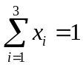). Thus, a prismatic form
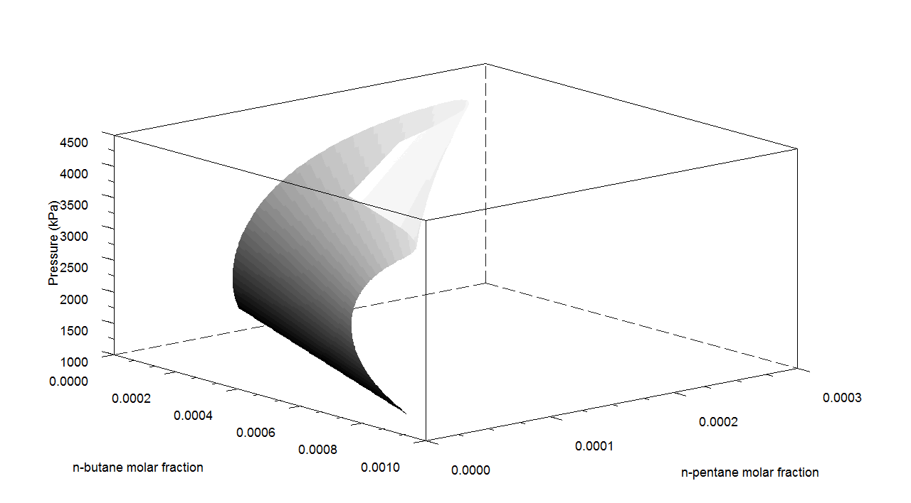
Figure 1. Dew point surface for methane + n-butane + n-pentane system at T = 189.06 K.

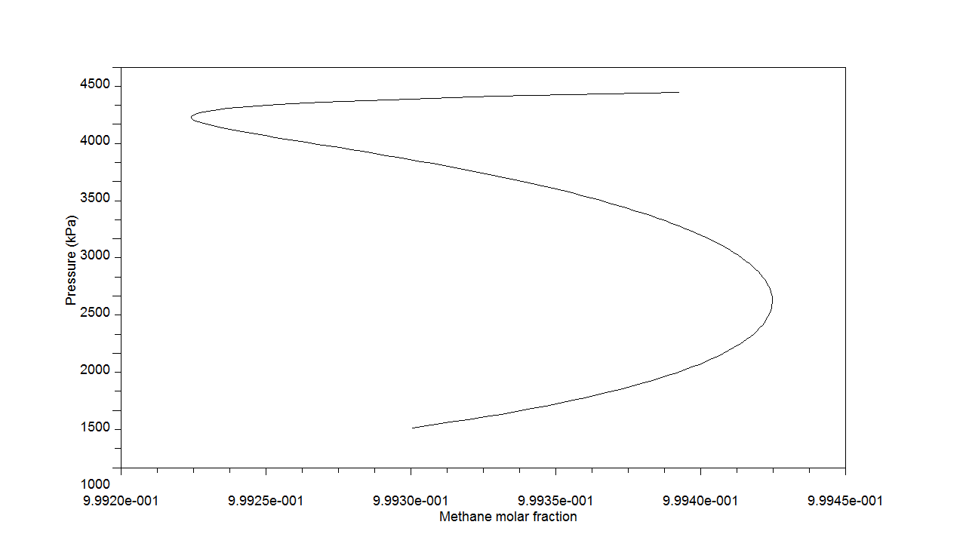
Figure 2. Dew points for methane + n-butane + n-pentane system at T = 189.06 K.
Vapor compositions are produced by bubble point calculations with molar fractions for methane and n-butane in the range: 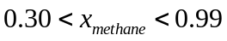, with step 0.05 and 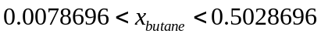 with step –0.0035869 (i.e., the methane molar fraction increases and n-butane molar fraction decreases in the loop).
One can note that the previous figures are produced not by dew point calculations, but performing bubble point calculations and plotting vapor compositions against pressures. In some situations, dew point calculations cannot be avoided. In such cases, we have three (or four) roots for the nonlinear system that characterizes vapor-liquid coexistence. In this context, a computational study of convergence for dew point calculations in ternary mixtures was conducted. Using classical Newton’s method (a common tool in chemical engineering context), dew point calculation are performed for a set of initial estimates. For the ternary mixture studied, three initial estimates are necessary for the solution of the problem: molar fractions for two components and pressure. Then, a three-dimensional basins of attraction can be constructed. For practical purpouses, this diagram is not convenient. Instead, a two-dimensional diagram is presented in Figure ...
Molar fraction for n-pentane was fixed in 0.01, and methane molar fraction is in the range 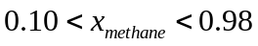 (and, obviously, 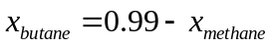). Pressures are in the range 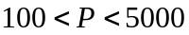. In the basins of attraction, each root is represented by a color. Dark points represent nonconvergence condition (more than 200 iterations for Newton’s method), dark gray poins are low pressure root, gray points are medium pressure root, white points represent high pressure root and light gray points are only trivial solutions. As referred previously, a fractal behaviour is clearly demonstrated. In this sense, amplifications of some regions of this figure maintain the same charachteristics of the original figure. The fractal response for this kind of problem is not surprising, as pointed by Green et al. (1993). However, some roots show small regions of attraction. In this context, DRV can be considered (mainly if it occurs in multicomponent system – large number of equations) a “hard” problem and can be used as a benchmark problem for stochastic optimization procedures (for instance).
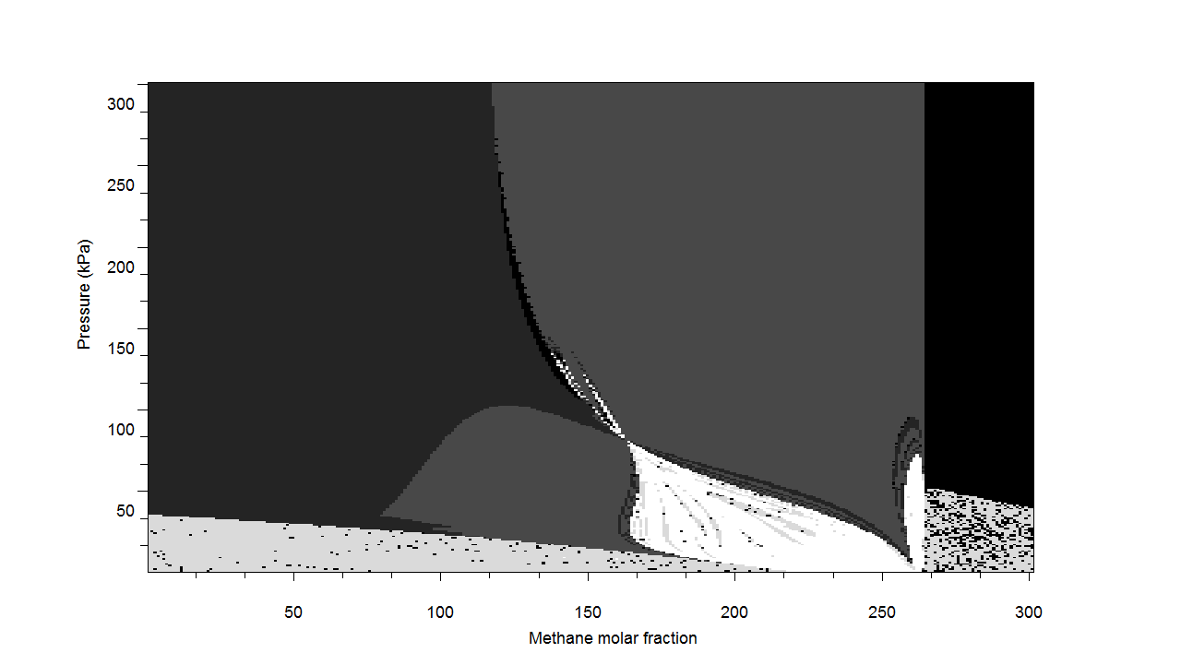
Figure 3. Basins of attraction for dew point calculations in methane + n-butane + n-pentane system (T = 189.06 K).
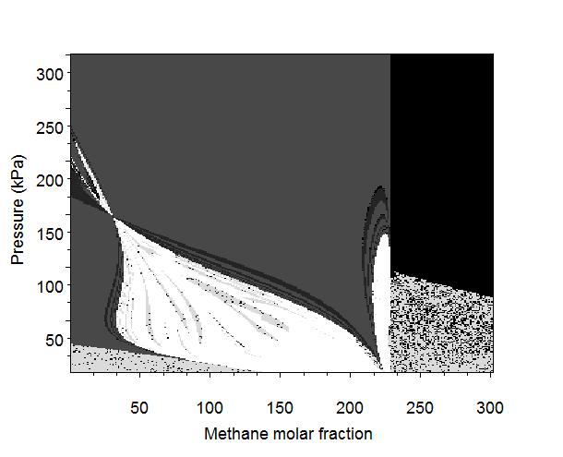
Figure 4. Amplification of basins of attraction for dew point calculations in methane + n-butane + n-pentane system (T = 189.06 K).

4.2. Methane + ethane + n-butane system

4.3. Methane + propane + n-butane system
Composição do vapor onde há VRD = [0.9991497 ; 0.0000116 ; 0.0008388]
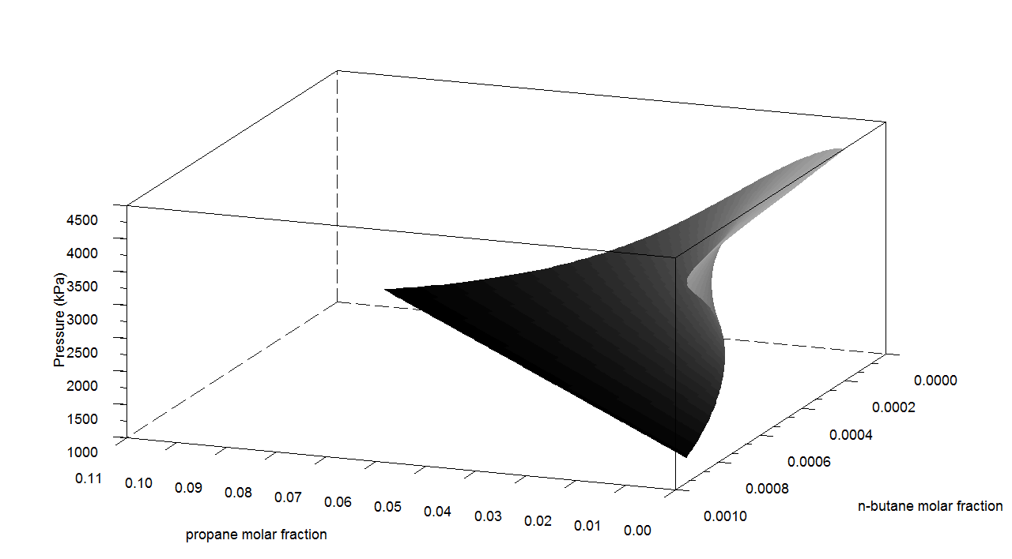
Figure 1. Dew point surface for methane + propane + n-butane system at T = 189.06 K.

As expected, without propane (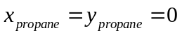), the “S”-shape as experimentally predicted by Chen et al. (1974a) is obtained. On the other hand, in the binary system methane-propane (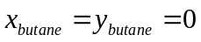) there is no double retrograde vaporization.

5. CONCLUSIONS

References
Chen, R. J. J., Chappelear, P. S., and Kobayashi, R. (1974a). Dew point loci metane-butane binary system, J. Chem. Eng. Data, 19 (1), 53-57.

Chen, R. J. J., Chappelear, P. S., and Kobayashi, R. (1974b). Dew point loci metane-n-pentane binary system, J. Chem. Eng. Data, 19 (1), 58-61.

Alfradique, M. A., and Castier, M. (2005). Predição do fenômeno de vaporização retrógrada dupla em misturas de hidrocarbonetos. In: Anais do 3º Congresso Brasileiro de Pesquisa e Desenvolvimento em Petróleo e Gás, Salvador-Brasil. Instituto Brasileiro do Petróleo (in portuguese).

Soliman, M. S. (1995). Fractal erosion of basins of attraction in coupled nonlinear-systems, Journal of Sound and Vibration, 182, 729-740.

Spedicato, E., and Huang, Z. (1997). Numerical experience with Newton-like methods for nonlinear algebraic systems. Computing, 58, 69–89.

Green, K. A., Zhou, S., and Luks, K. D. (1993). The fractal response of robust solution techniques to the stationary point problem, Fluid Phase Equilibria, 84, 49-78.

Lucia, A., Guo, X., Richey, P. J., and Derebail, R. (1990). Simple process equations, fixed-point methods, and chaos, AIChE Journal, 36, 641-654.

Gaw, W. J., and Swinton, F. L. (1966). Occurence of a double azeotrope in binary system hexafluorobenzene + benzene, Nature, 212, 283.

[8] C. P. Chaikao, M. E. Paulaitis, A. Yokozeki, Fluid Phase Equilibr. 127 (1997)
191203.
[9] N. Aslam, A. K. Sunol, Fluid Phase Equilibr. 224 (2004a) 97.
[10] N. Aslam, A. K. Sunol, Chem. Eng. Sci. 59 (2004b) 599-609.
[11] N. Henderson, L. Freitas, G. M. Platt, AIChE J. 50 (2004) 1300-1314.
[12] L. Freitas, G. M. Platt, N. Henderson, Fluid Phase Equilibr. 225C (2004) 29-37.
[13] C. Y. Gau, J. F. Brennecke, M. A. Stadtherr, Fluid Phase Equilibr. 168 (2000)
1-18.
[14] A. Dominguez, J. Tojo, M. Castier, Computers Chem. Engnr. 26 (2002) 1473-
1479.
[15] M. F. Alfradique, M. Castier, Fluid Phase Equilibr. 230 (2005) 1-8.
[16] D. Y. Peng, D. B. Robinson, Ind. Eng. Chem. Fundam. 15 (1976) 59-64.
[17] F. Çilingir, Chaos, Solitons and Fractals 32 (2007) 471-479.
[18] W. C. Rheinboldt, Methods for Solving Systems of Nonlinear Equations, 3rd
Edition, SIAM, 1987.

