**COMP4321 - Search Engine for Web data**

**Final Report**

Spring 2019 - Group 25

AU, Ho Leong ([hlauac@connect.ust.hk](mailto:hlauac@connect.ust.hk)) 20260060

KIM, Hyun Gyu ([hgkim@connect.ust.hk](mailto:hgkim@connect.ust.hk)) 20375138

CHEUNG, Ka Ho ([khcheungap@connect.ust.hk](mailto:khcheungap@connect.ust.hk)) 20465294

## Overall design

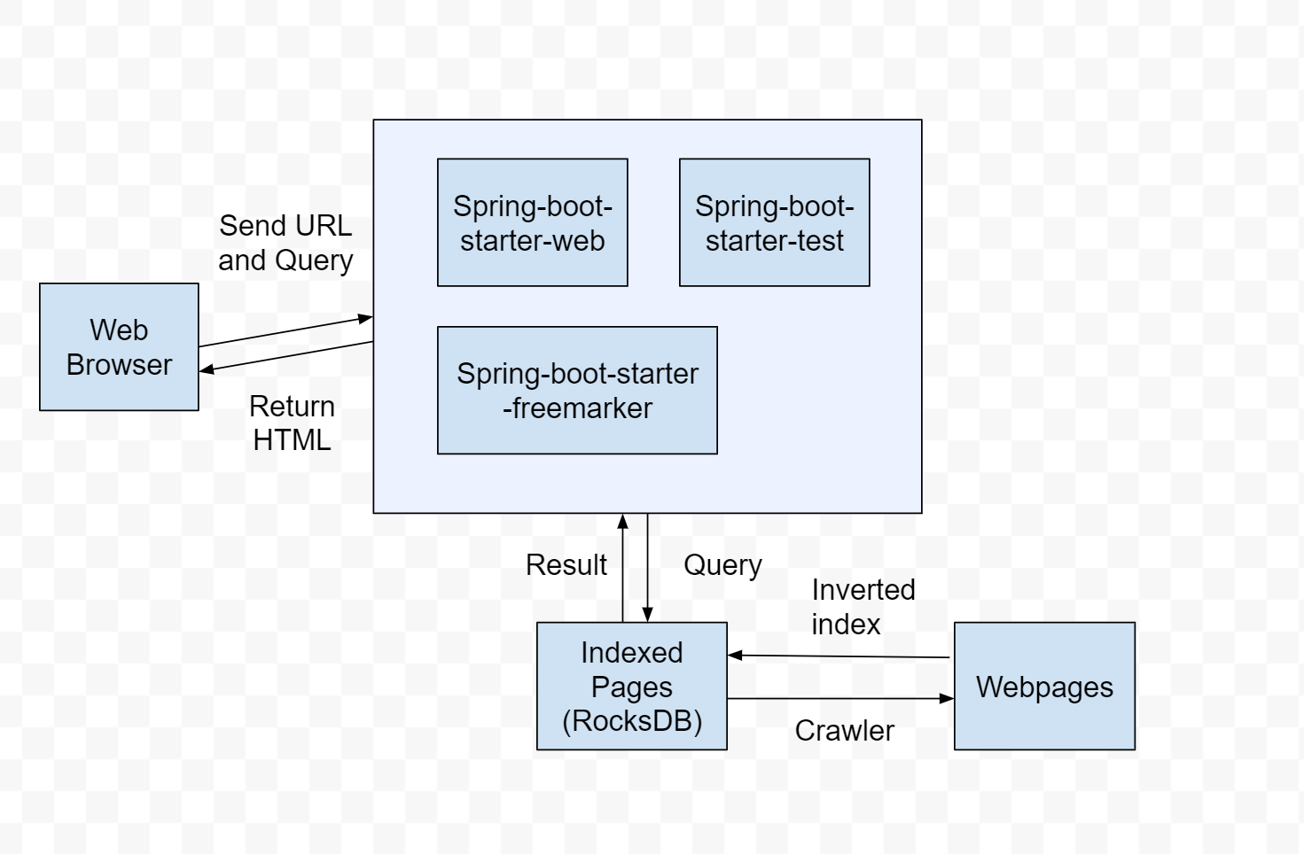

### CRWALER and indexer

The crawler fetches the pages in [www.cse.ust.hk](http://www.cse.ust.hk) recursively. 11 RocksDBs are created when the program is running. Stop-word Removal and Stemming are processing towards the words in a webpage.

### search engine

After getting the indexed pages from the database and the queries from web interface, the page scores of queries are calculated according to tfidf and cosine similarity. The sorting results will be sent to the web interface.

### Web Interface

There are two webpages written in html which serves as a user interface, which is ‘index’ and ‘result’. Index page allows user to input their queries. The result page shows the search result to the user.

## File structure

The source code of the whole environment are;

|  |  |  |  |
| --- | --- | --- | --- |
| src/main/ | kotlin/ | main/ | SpiderMain.kt  TfidfMain.kt |
|  |  | Spring/ | Application.kt  Web.kt  WebController.kt |
|  |  | util/ | CSVParser.kt  HTMLParser.kt  Porter.kt  Ranker.kt  RocksDB.kt |
|  | resources/ | templates/ | index.html  result.html |
|  |  | application.yml |  |
|  |  | favicon.ico |  |
|  |  | stopwords.txt |  |

The database includes 11 different indexes in different RocksDB.

|  |  |  |  |  |
| --- | --- | --- | --- | --- |
| DB | Key | datatype | Content | datatype |
| URL_DB | Web url | String | Web id | Int |
| URL_INFO_DB | Web id | Int | Triple(Title, Date-Modified,  Size) | (String, Long, Int) |
| URL_CHILD_DB | Web id | Int | Child Web id | List(Int) |
| URL_PARENT_DB | Web id | Int | Parent Web id | List(Int) |
| WORD_DB | Word | String | Word id | Int |
| SPIDER_DB | Word id | Int | List(Web id, Word Location) | List(Int, Int) |
| URL_WORDS_DB | Web id | Int | List(WordID) | List(Int) |
| PAGE_RANK_DB | Web id | Int | PageRank | Long |
| URL_WORD_COUNT_DB | Web id | Int | List(wordID, count) | List(Int, Int) |
| TF_IDF_DB | Web id | Int | TF-IDF | Long |
| URL_LENGTH_DB | Web id | Int | Length | Long |

## Algorithms used

### Links

To get links as much as possible, the algorithm is recursively crawling the child links. However, the increase of time required is exponential after more than 2,000 links are crawled. We decide to stop the crawler after finishing 2,000 crawling.

### Keywords

To perform stemming and stop-word removal, the Porter’s algorithm is used.

### Queries

After user submits their queries, the queries are being processed by stop-word removal and stemming. The queries are transformed to the search engine and it applies tfidf and cosine similarity with pages.

### Web application

We use Spring Boot and WebJars. Sprint Boot provides a good platform for Java/Kotlin developers to develop a stand-alone and production-grade spring application that you can just run. Many of the steps found on the [Spring Guides](https://spring.io/guides) for creating a RESTful service can be followed verbatim for Kotlin.

WebJars are client-side web libraries packaged into JAR files. It can explicitly and easily manage the client-side dependencies in JVM-based web applications

## Installation procedure

(it could be as simple as “Type make in the project directory”)

## Fatures beyond the required specification

## Testing

Testing 1:

|  |  |  |
| --- | --- | --- |
| Query | | faculty member course |
| #1 | Score: 0.033792 | Honors Courses and Independent Work | HKUST CSE  <https://www.cse.ust.hk/ug/honors/>  Last-Modified: 2014-01-23 00:00:00  Size: 24823 Bytes |
| #2 | Score: 0.021239 | Enrichment Opportunities | HKUST CSE  <https://www.cse.ust.hk/ug/enrichment/>  Last-Modified: 2018-03-08 00:00:00  Size: 24530 Bytes |

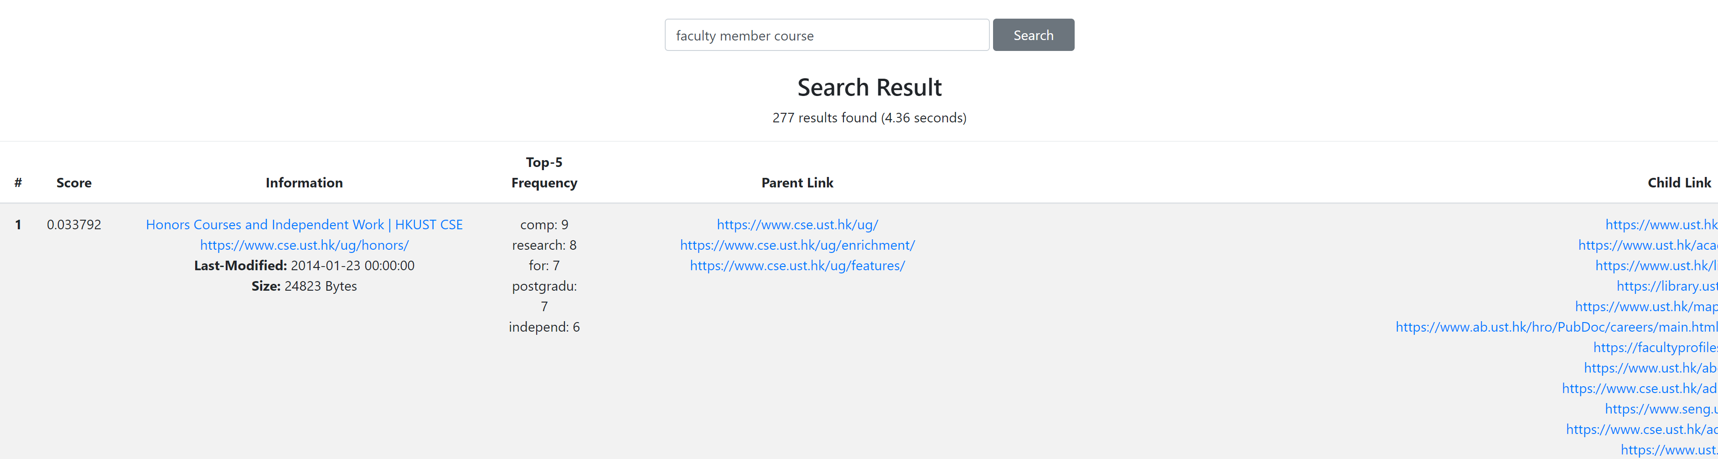

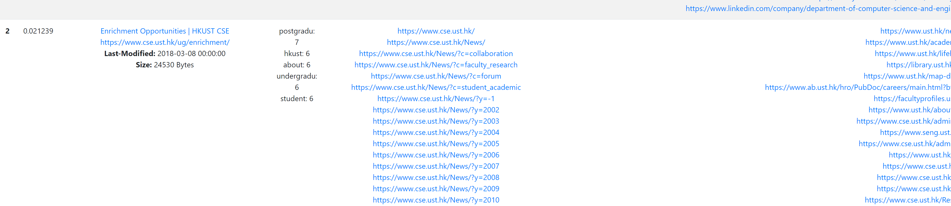

Testing 2:

|  |  |  |
| --- | --- | --- |
| Query | | dik lee professor |
| #1 | Score: 0.052340 | Dik-Lun LEE | HKUST CSE  <https://www.cse.ust.hk/admin/people/faculty/profile/dlee>  Last-Modified: 2018-01-16 00:00:00  Size: 27919 Bytes |
| #2 | Score: 0.037488 | Faculty | HKUST CSE  <https://www.cse.ust.hk/admin/people/faculty/>  Last-Modified: 2019-03-27 00:00:00  Size: 190581 Bytes |

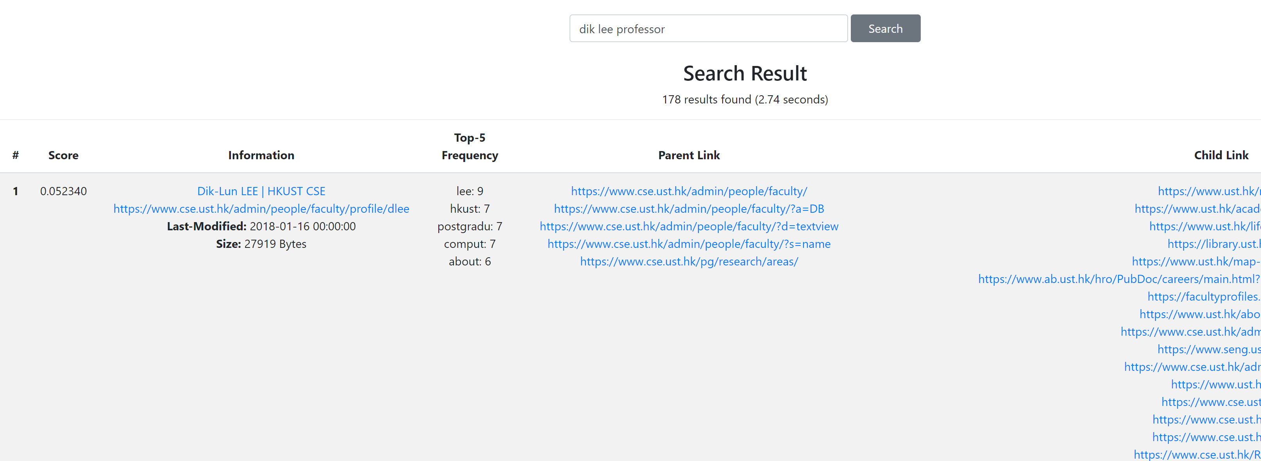

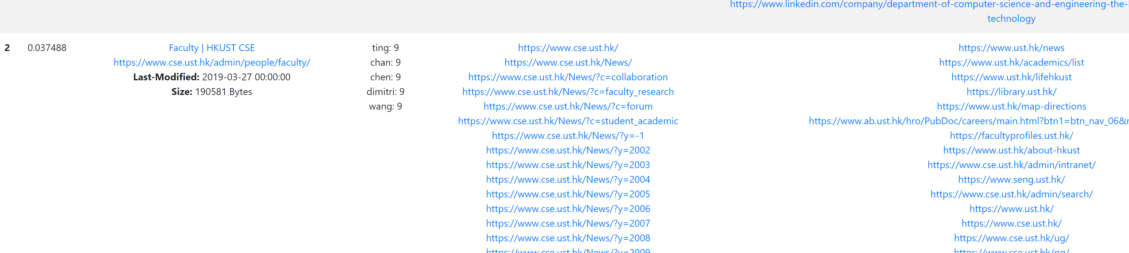

## Conclusion

### Strengths and weaknesses

At the time we crawled [www.cse.ust.hk](http://www.cse.ust.hk) , the memory gets full and swapping occurs. The increase of time required of crawling is exponential. We decided to crawl the first 2000 pages in cse department first.

Some links that we have crawled are restricted to faculty member, they are encrypted so we cannot access in those webpages. By default, those webpages’ title, last-modified date and size are ‘unauthorized’, ‘1990-01-01 00:00:00’ and 0 bytes respectively.

### Improvement

To improve the search engine, we can provide phrase search with specified in double quotes.

### Interesting features to add

For ranking function, tfidf and cosine similarity weighting are not enough. We hope we can use more advanced algorithm along with other personalizations.

There are many Chinese words in the webpages, we hope we can handle the Chinese word processing if we had more time.