

SONIC AWE
Trädgårdsgatan 8
753 09 Uppsala, Sweden
sonicawe@reep.se
www. sonicawe.reep.se

 | Product Summary | February 2011
>> SONIC AWE
The height map shows the result of the Sonic AWE analysis of a recorded sound sample with time progression from left to right and frequencies from bottom to top.
The black signal on the top of the graph is the traditional waveform of the analyzed sound. The green waveform shows the translation back from the height map.
The sound analyzed for this example may be downloaded here :
http://data.sonicawe.com/data/0.2.4/tvatre.wav
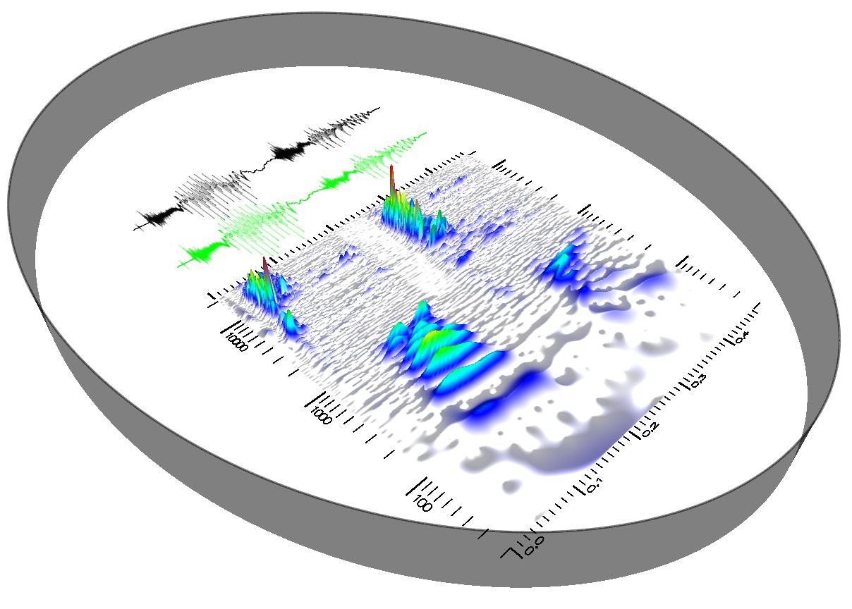

Sonic AWE offers a new way of working with sound editing and design.
The point is that in traditional software there is no intuitive link between the sound visualization and what the hearing record. Sonic AWE's unique representation of sound creates this link allowing a whole new approach to sound analysis. In addition to providing a powerful analysis tool, Sonic AWE includes a set of tools for manipulating audio directly in this representation. This altogether enabling a world of possibilities in sound analysis.

Sonic AWE offers new ways of working creatively with sound.
The sound, a one-dimensional signal, becomes in Sonic AWE a two-dimensional image, where the signal is divided into different frequencies, or tones.
For example, to remove an interference, the user can identify it in the time-frequency representation and "rub it off" with minimal side effects and artifacts.

Compared with traditional representations Sonic AWE provides a quick overview of what sound contains.

>> UNIQUE PROPERTIES

Besides a powerful analytical tool Sonic AWE offers a new way to perform complex and powerful manipulations and produce immediate feedback.

> Scalable time-frequency representation - quick overview of long signals and high resolution zooms.
> 3D navigation – the heightmap can be rotated and then becomes a landscape, where strong frequencies are mountains and ridges.
> Filtering – Paint freely to increase or attenuate frequencies intensity directly on the height map.
> Time-Stretch - stretch the regions in time.
> Pitch shift - moving regions of the pitch.
> Super-Band Compressor - compress the audio, arbitrarily over time and frequency.
> Vertex-based selection - simply select a region of the signal using an arbitrary shape.
> "Smart" Selection - automatically adapts to
individual signal components.
> Stock-based history - saves all the selections and
operations like stock in image processing.
> Integration in studio environments – as standalone or as extern editor in other programs.
> Export to Matlab (for advanced users).
>> FILTERING EXAMPLES

The original sound represented by the black waveform below is from a growling truck engine. The heightmap shows the intensity of frequencies in the range 20-20000 Hz over time 0.0-0.52 s. Using the selection tool, with an ellipse shape, the resulting waveform is shown in green.
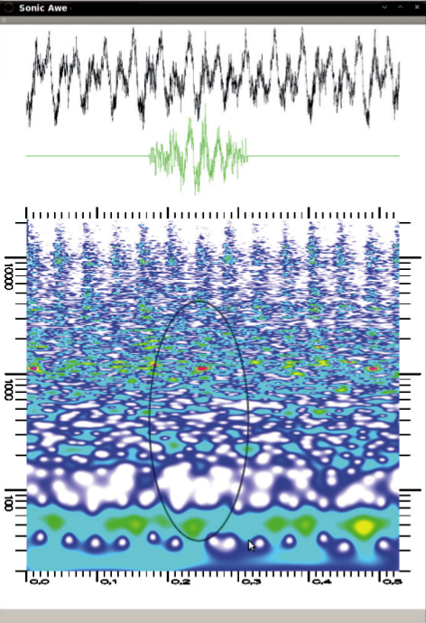

This waveform can be exported to a standard .wav file and then imported again. Resulting in the center figure. This demonstrates the kind of “surgical” procedures that can be done using Sonic AWE.

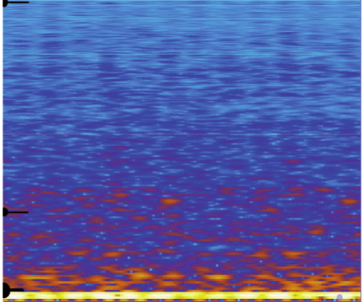
The heightmap can be compared to a traditional spectrogram calculated by STFT (Short-Time Fourier Transform) to the right. The three black bars in the picture's left edge is equal to 100, 1000 and 10 000 Hz which shows that the heightmap produced by Sonic AWE gives a more accurate picture both in time and frequency for high frequencies and it becomes most obvious for low-frequency signals.
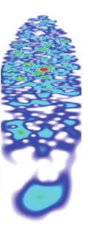
>> ABOUT US

Sonic AWE is developed by Reep. Currently, there are four people from Reep who actively work with Sonic AWE. Development is also supported by Reep's other resources.

Ulf Hammarqvist is a sound designer who worked with music and sound since his childhood. He conceived the idea of working with sound in a heightmap. With Sonic AWE Ulf concluded his education in Engineering Physics.

Christian Lönnholm has worked as project leader at
Helenius Engineering Bureau, designing and quality-assuring business for Visma Software AS. He has also worked on major projects around the world for various governmental agencies.

Matthias Nyberg studying Engineering Physics and specializes in scientific computing and graphics. He has previously worked on image analysis of large data volumes and optimized the calculations for the video card.

Johan Gustafsson is also a student in engineering Physics. Beisdes this, he works as a consultant for Addiva Consulting. He has been using Cuda to the visualization of medical data, estimation in bioinformatics, imaging and special effects for games, at the Shanghai Jia Tong University and Uppsala University.

>> PARTNERS

Luleå University of Technology, studying how well Sonic AWE provides an intuitive perception of sound.

Uppsala University, supports the development, including a thesis about Sonic AWE's tools for signal processing.

>> REQUIREMENTS

CUDA-compatible Hardware. The program is tested on Windows XP, Windows 7, Windows Server 2008, OS X 10.5.8, OS X 10.6 and from Ubuntu 9.04 to 10.10.

>> TECHNICAL REFERENCES

Sonic AWE uses a wavelet spectrogram
built of Morlet wavelets. The technique is similar to a very large filter bank - with a filter for each frequency as described in the representation. The calculation is both cumbersome and memory intensive. To create the heightmap in real time, Sonic AWE uses the GPU chipset.

Wavelets have been used to plot spectrograms before, we go through some different time-frequency distributions. For details see the following page:
http://sonicawe.com/time-frequency-distributions.html

References :

http://en.wikipedia.org/wiki/Wavelet
http://en.wikipedia.org/wiki/Morlet_wavelet
http://en.wikipedia.org/wiki/CUDA

>> DATA

Video of Sonic AWE:
http://data.sonicawe.com/sonicawe-0.2.3.avi

The sound that was used as input to both the spectro-
program and heightmap:
http://data.sonicawe.com/0.2.4/scania.wav
http://data.sonicawe.com/0.2.5/skalogram.png
http://data.sonicawe.com/0.2.5/spektrogram_stft.png

The exported selection:
http://data.sonicawe.com/0.2.5/scania_selection.wav

Please visit us at
www.sonicawe.com

