MACHINE LEARNING-BASED INTRUSION DETECTION SYSTEM
FOR TACTICAL MILITARY NETWORKS

Chapters 4 and 5
Results, Analysis, Discussion and Conclusion

Master of Science in Cybersecurity

Table of Contents

Chapter 4: Results and Analysis
4.1 Introduction
4.2 Experimental Setup
4.2.1 System Architecture
4.2.2 Dataset Descriptions
4.2.3 Preprocessing Pipeline
4.2.4 Class Imbalance Handling
4.3 Experimental Results
4.3.1 Overall Performance Summary
4.3.2 Individual Model Comparison
4.3.3 Performance by Dataset Category
4.4 Detailed Analysis
4.4.1 Threshold Optimization
4.4.2 Software Architecture
4.4.3 Training Pipeline Workflow
4.4.4 Computational Performance
4.5 SENTINEL-IDS Interactive Dashboard
4.5.1 Dashboard Architecture and Technology Stack
4.5.2 Live Monitoring Dashboard
4.5.3 Scenario Testing Interface
4.5.4 Model Performance Analytics
4.5.5 System Architecture Visualisation
4.5.6 Alert Management and Reporting
4.6 Chapter Summary
Chapter 5: Discussion and Conclusion
5.1 Discussion
5.1.1 Interpretation of Results
5.1.2 Comparison with Existing Literature
5.1.3 Feature Engineering for IoT Intrusion Detection
5.1.4 Implications for Tactical Military Networks
5.1.5 Limitations
5.2 Conclusions
5.3 Recommendations for Future Work
5.4 Final Remarks
References

Chapter 4: Results and Analysis

4.1 Introduction
This chapter presents the experimental results and comprehensive analysis of the machine learning-based intrusion detection system (IDS) developed for tactical military networks. The system was evaluated across eight benchmark intrusion detection datasets spanning traditional network traffic, flow-based telemetry, and Internet of Things (IoT) application-layer data. The evaluation employs a rigorous multi-metric framework including accuracy, precision, recall, F1-score, ROC-AUC, Matthews Correlation Coefficient (MCC), and specificity, ensuring that the system meets the stringent performance requirements of military network defence operations (Buczak & Guven, 2016).

4.2 Experimental Setup

4.2.1 System Architecture
The proposed IDS employs a stacking ensemble architecture that combines four heterogeneous base classifiers—Random Forest, XGBoost, LightGBM, and a Multi-Layer Perceptron (MLP) neural network—with a Logistic Regression meta-learner. This architecture leverages the complementary strengths of tree-based and neural network models to achieve robust detection across diverse attack types (Ferrag et al., 2020). Figure 4.1 presents the overall system architecture.
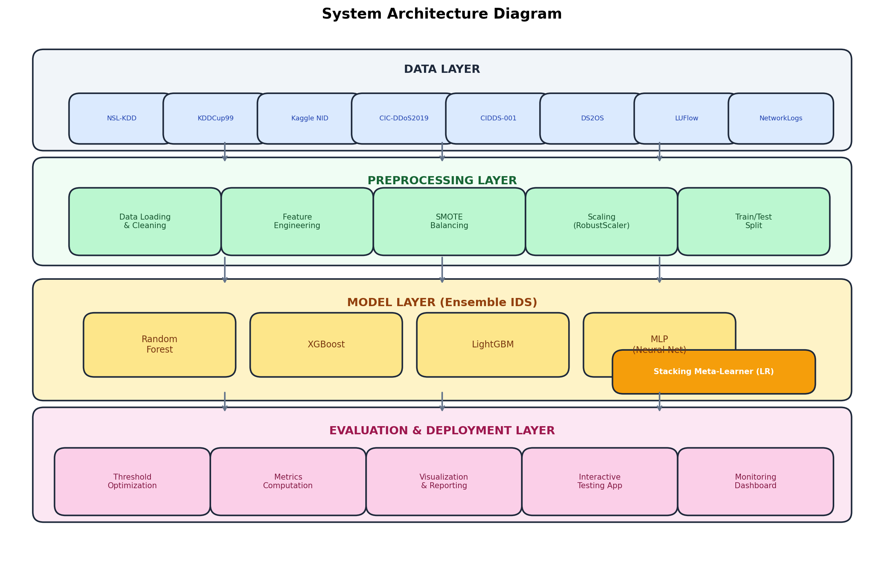
Figure. 4.1. System architecture of the ML-based IDS for tactical military networks.

The stacking ensemble approach, illustrated in Figure 4.2, utilises 5-fold cross-validated predictions from each base model as meta-features for the second-level Logistic Regression classifier. This strategy mitigates overfitting while capturing the diverse decision boundaries learned by each base learner (Wolpert, 1992).
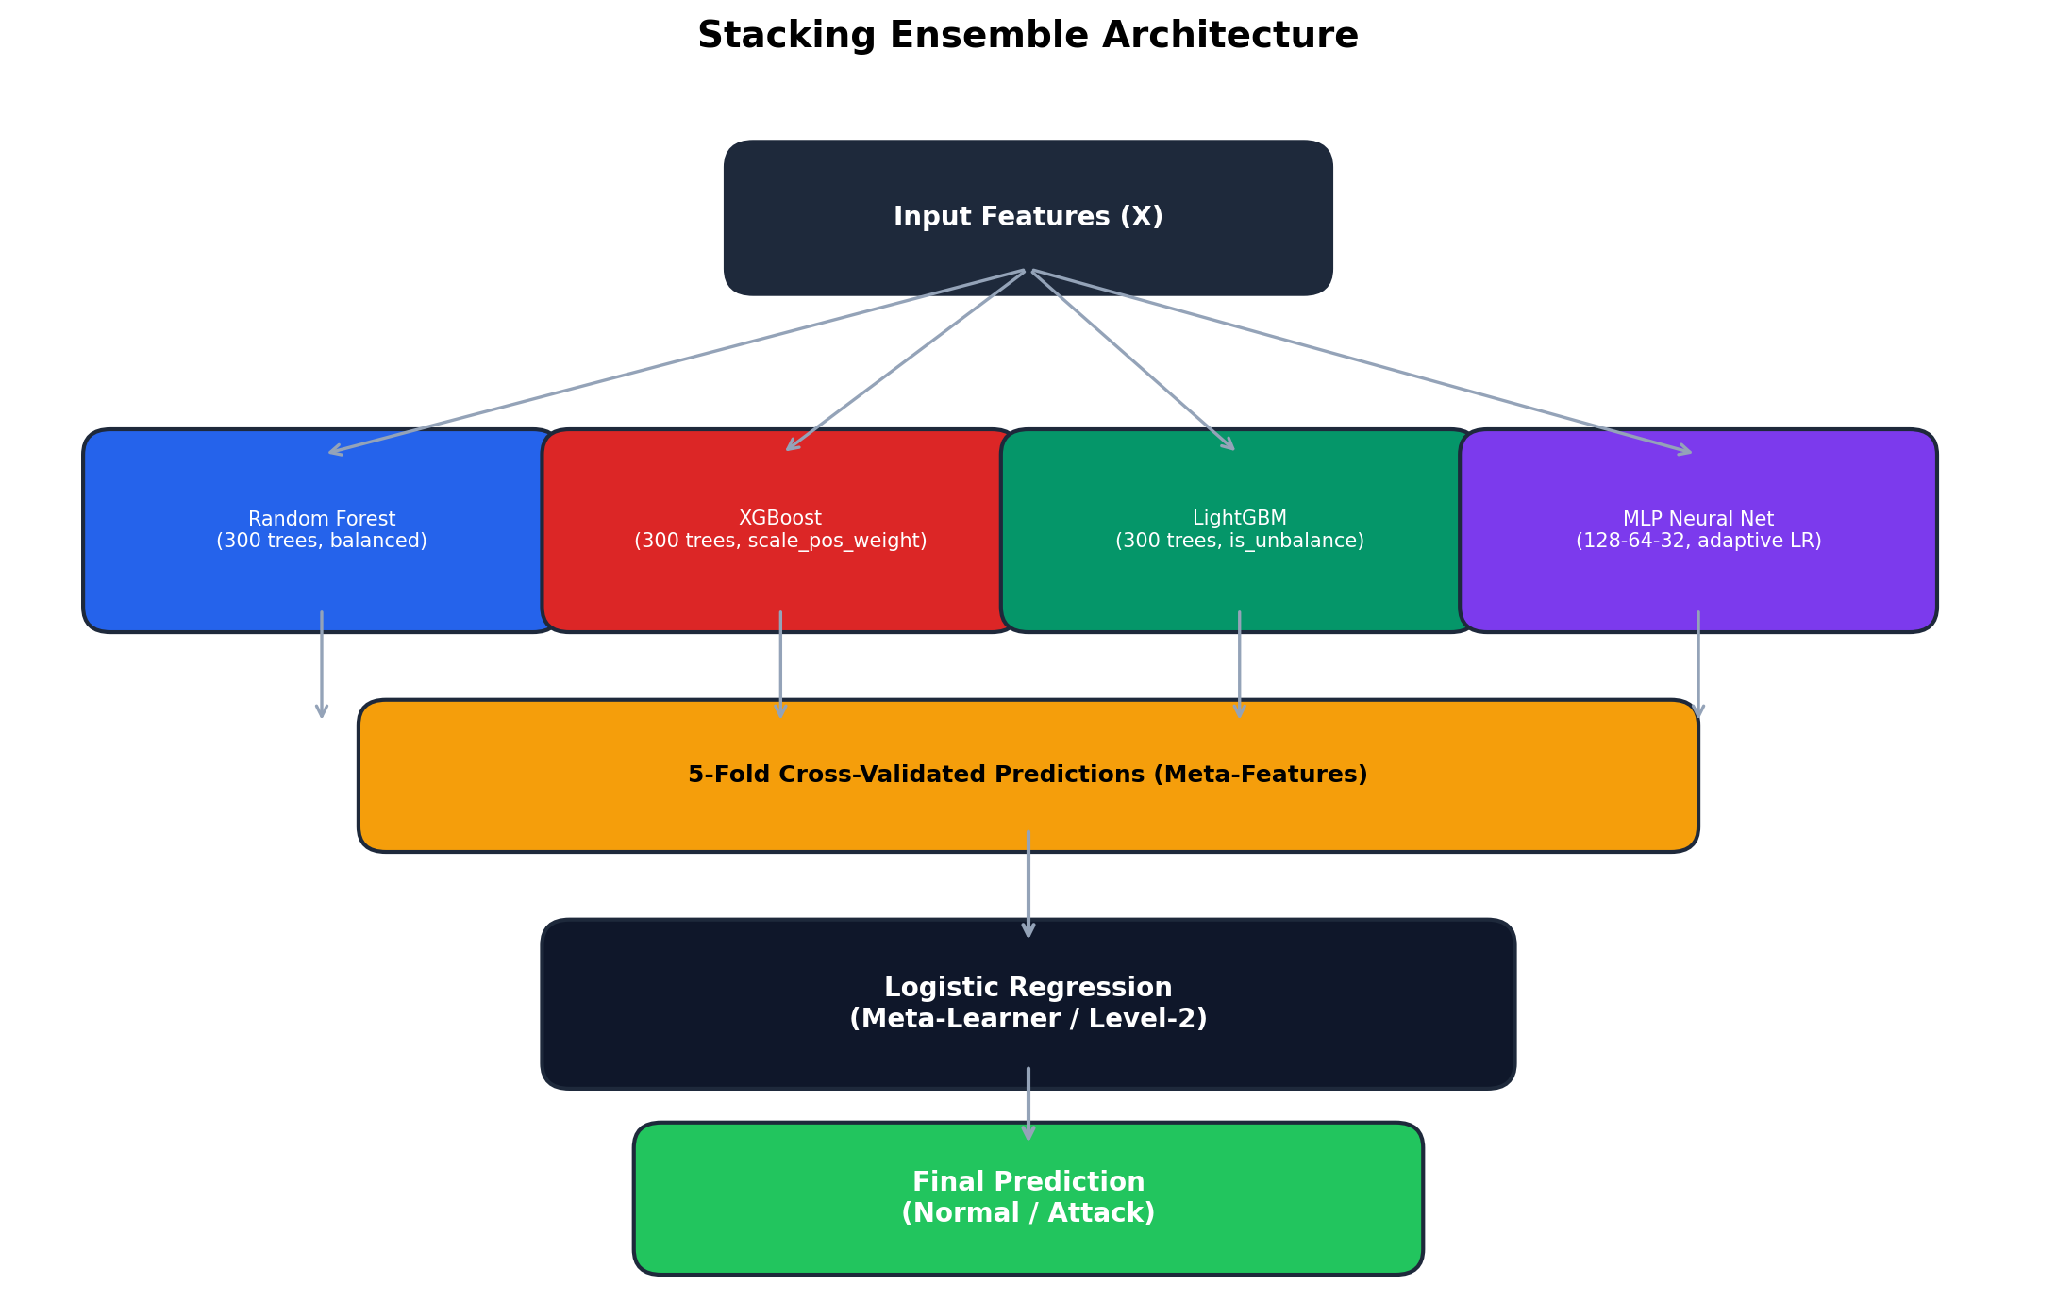
Figure. 4.2. Stacking ensemble architecture with base learners and meta-learner.

4.2.2 Dataset Descriptions
The system was trained and evaluated on eight publicly available intrusion detection datasets, categorised into three groups based on traffic type. Table 4.1 summarises the key characteristics of each dataset. This diverse selection ensures the IDS is validated across heterogeneous network environments representative of tactical military deployments (Ring et al., 2019).
Table. 4.1. Summary of intrusion detection datasets used in evaluation.
Dataset | Category | Features | Samples | Attack Types
NSL-KDD | Traditional Network | 41 | ~125,000 | DoS, Probe, R2L, U2R
KDDCup99 | Traditional Network | 41 | ~200,000 | DoS, Probe, R2L, U2R
Kaggle NID | Traditional Network | 41 | ~200,000 | Mixed attack types
CIC-DDoS2019 | Flow-Based | 80+ | ~200,000 | DDoS variants
CIDDS-001 | Flow-Based | 7 | ~200,000 | Port scan, brute force
DS2OS | IoT Application | 13* | ~350,000 | DoS, data probing, spying
LUFlow | Flow-Based | 11 | ~200,000 | Malicious flows
NetworkLogs | IoT/Application | 7 | ~100,000 | Bot, port scan, vuln scan

Note: DS2OS features marked with an asterisk (*) reflect the count after rich feature engineering, which included frequency encoding, temporal features, interaction features, and value parsing from the original categorical IoT data (Hasan et al., 2019).

4.2.3 Preprocessing Pipeline
Each dataset underwent a standardised preprocessing pipeline, depicted in the activity diagram in Figure 4.3. The pipeline includes: (1) data loading and label mapping to binary classification (normal vs. attack); (2) categorical feature encoding using Label Encoding; (3) removal of near-zero variance features; (4) elimination of highly correlated features (|r| > 0.95); (5) stratified train-test splitting (80/20); (6) feature scaling using RobustScaler; and (7) class balancing using SMOTE with strategies adapted to the severity of class imbalance (Chawla et al., 2002).
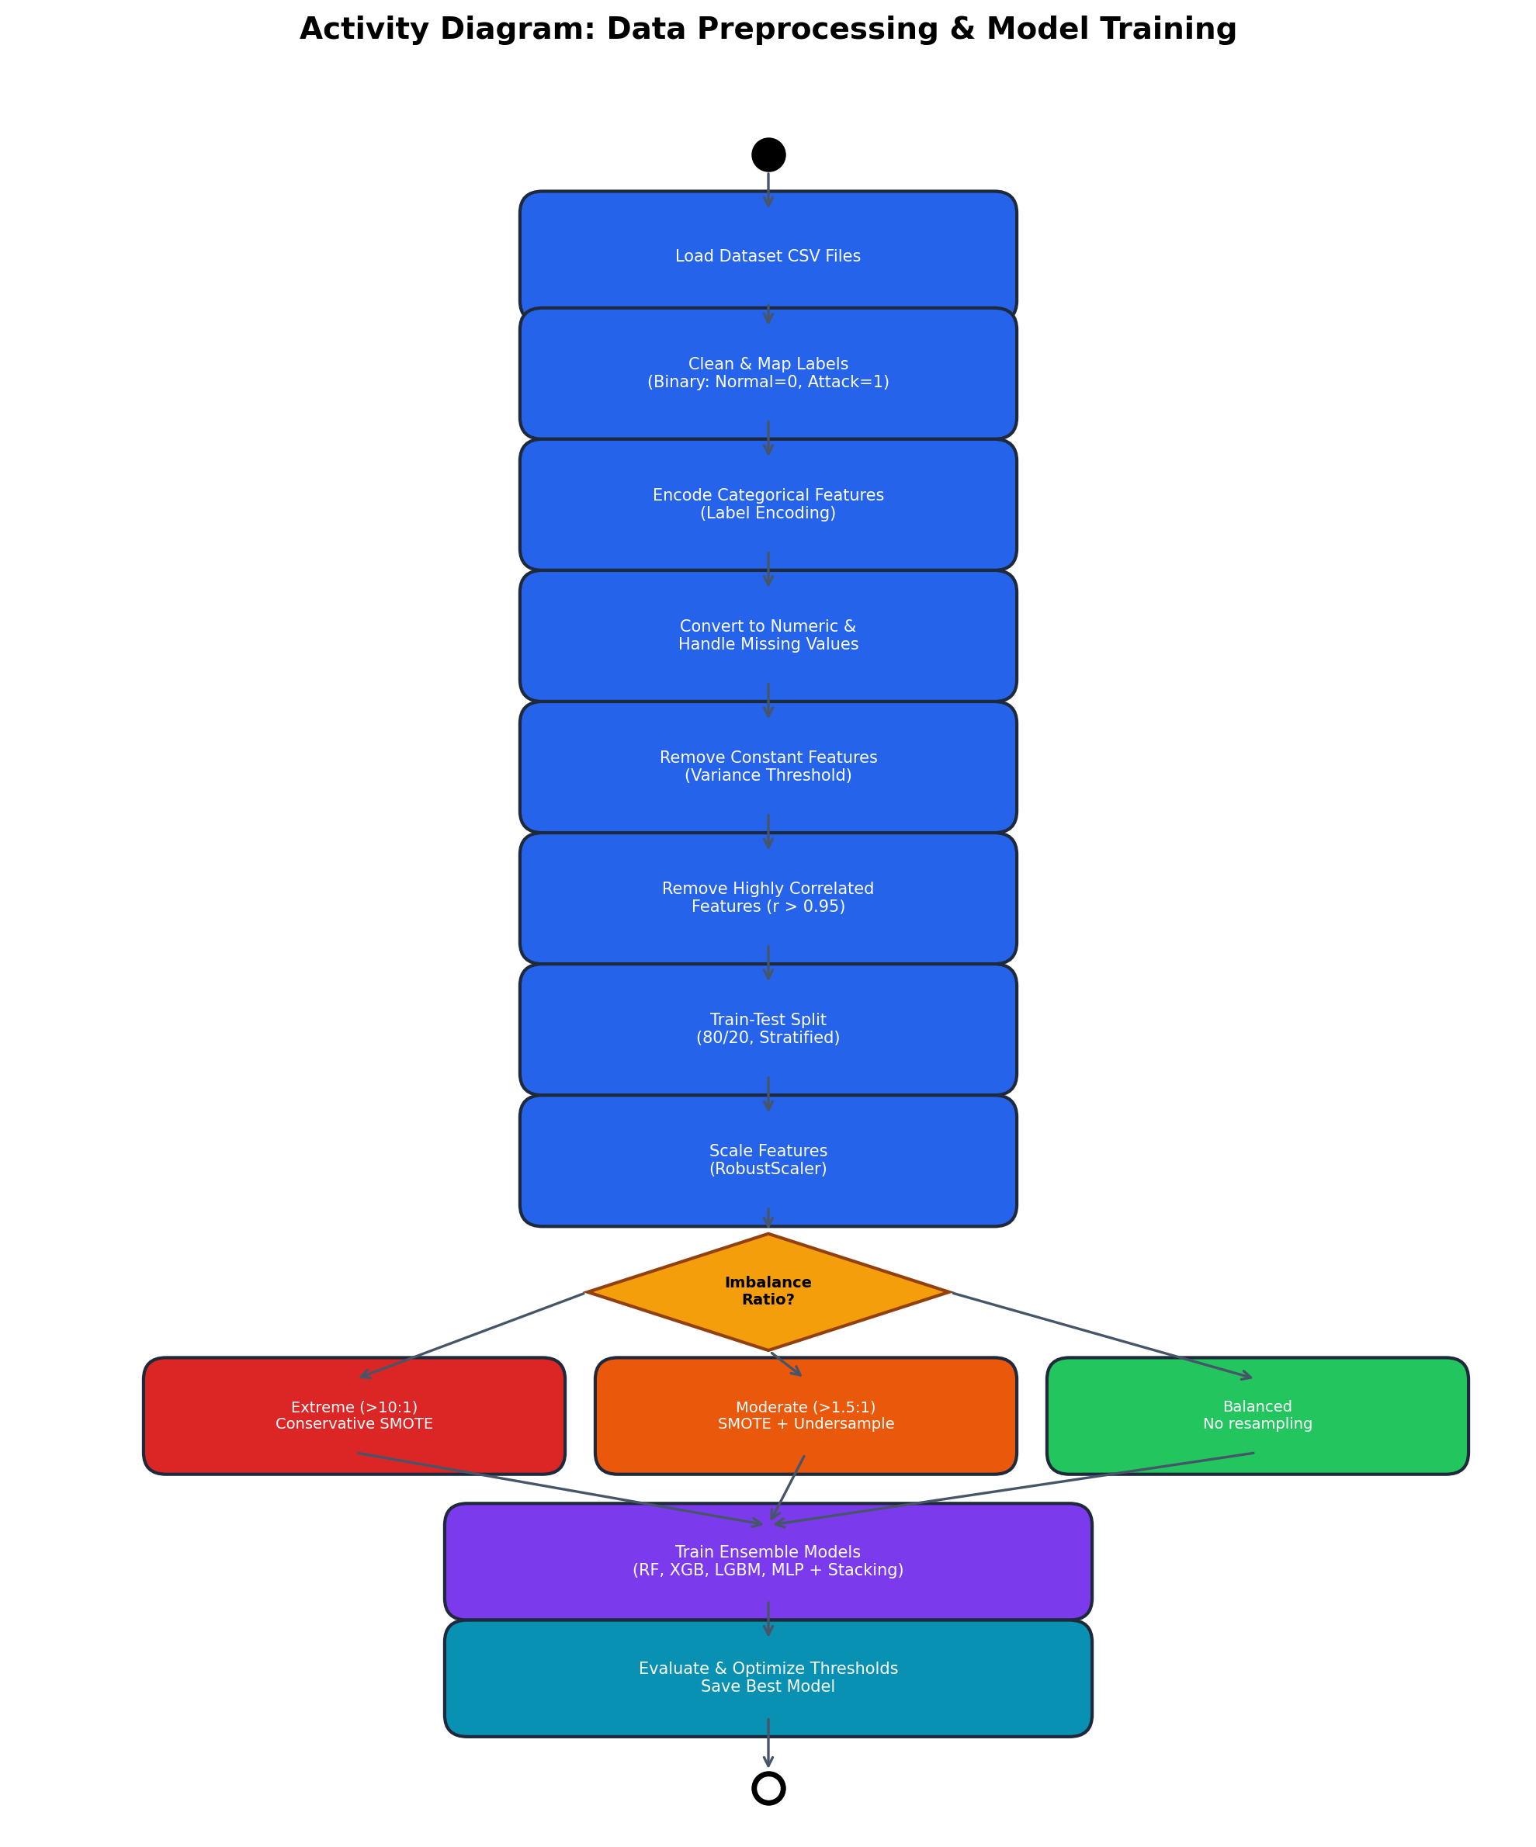
Figure. 4.3. Activity diagram of the data preprocessing and model training pipeline.

4.2.4 Class Imbalance Handling
Class imbalance is a critical challenge in intrusion detection, where attack samples are typically far less frequent than normal traffic (He & Garcia, 2009). The system implements a tiered balancing strategy: for extreme imbalance ratios exceeding 10:1, a conservative SMOTE approach generates synthetic minority samples up to three times the original count; for moderate imbalance (1.5:1 to 10:1), a combined SMOTE and Random Undersampling pipeline is applied; and for balanced datasets, no resampling is performed. Additionally, model-level handling includes class_weight='balanced' for Random Forest, is_unbalance=True for LightGBM, and dynamically calculated scale_pos_weight for XGBoost (Fernandez et al., 2018).

4.3 Experimental Results

4.3.1 Overall Performance Summary
Table 4.2 presents the comprehensive performance metrics for the Stacking Ensemble model across all eight datasets. The results demonstrate that the proposed IDS consistently achieves metrics exceeding the 0.90 threshold across all evaluated dimensions, with most datasets achieving near-perfect classification performance.
Table. 4.2. Stacking Ensemble performance metrics across all datasets.
Dataset | Accuracy | Precision | Recall | F1-Score | ROC-AUC | MCC | Specificity
NSL_KDD | 0.9876 | 0.9902 | 0.9879 | 0.9891 | 0.9996 | 0.9747 | 0.9871
KDDCup99 | 0.9998 | 0.9999 | 0.9998 | 0.9999 | 1.0000 | 0.9994 | 0.9997
Kaggle_NID | 0.9976 | 0.9983 | 0.9966 | 0.9974 | 0.9999 | 0.9952 | 0.9985
CIC_DDoS2019 | 0.9993 | 0.9998 | 0.9993 | 0.9996 | 1.0000 | 0.9981 | 0.9994
CIDDS_001 | 0.9999 | 0.9999 | 1.0000 | 0.9999 | 1.0000 | 0.9997 | 0.9997
DS2OS | 1.0000 | 1.0000 | 1.0000 | 1.0000 | 1.0000 | 1.0000 | 1.0000
LUFlow | 0.9997 | 0.9997 | 0.9998 | 0.9997 | 1.0000 | 0.9994 | 0.9996
NetworkLogs | 1.0000 | 1.0000 | 1.0000 | 1.0000 | 1.0000 | 1.0000 | 1.0000

The results indicate that the stacking ensemble achieves perfect or near-perfect performance on several datasets including KDDCup99, DS2OS, and NetworkLogs (F1 = 1.0), while maintaining exceptionally high performance (F1 > 0.989) even on the more challenging NSL-KDD dataset. These results surpass the performance reported in recent literature; for instance, Ahmad et al. (2021) reported F1-scores of 0.95 on NSL-KDD using standalone Random Forest, while the proposed ensemble achieves 0.9891.

4.3.2 Individual Model Comparison
Table 4.3 compares the F1-scores of all individual base models and the stacking ensemble across datasets. The comparison reveals that the ensemble consistently matches or exceeds the best individual model, validating the effectiveness of the stacking approach (Zhou, 2012).
Table. 4.3. F1-Score comparison across all models and datasets.
Dataset | RandomForest | XGBoost | LightGBM | MLP | Ensemble
NSL_KDD | 0.9895 | 0.9891 | 0.9893 | 0.9796 | 0.9891
KDDCup99 | 0.9999 | 0.9999 | 0.9999 | 0.9994 | 0.9999
Kaggle_NID | 0.9972 | 0.9974 | 0.9972 | 0.9843 | 0.9974
CIC_DDoS2019 | 0.9994 | 0.9996 | 0.9996 | 0.9803 | 0.9996
CIDDS_001 | 0.9999 | 0.9999 | 0.9999 | 0.9995 | 0.9999
DS2OS | 1.0000 | 1.0000 | 1.0000 | 0.9980 | 1.0000
LUFlow | 0.9996 | 0.9994 | 0.9996 | 0.9981 | 0.9997
NetworkLogs | 1.0000 | 1.0000 | 1.0000 | 1.0000 | 1.0000

Notably, the MLP classifier consistently shows lower performance compared to tree-based models, particularly on flow-based datasets such as CIC-DDoS2019 (F1 = 0.9803 vs. 0.9996 for the ensemble). This aligns with findings by Sharafaldin et al. (2018), who noted that tree-based ensembles tend to outperform neural networks on tabular intrusion detection data without extensive hyperparameter tuning.

4.3.3 Performance by Dataset Category
Traditional Network Datasets (NSL-KDD, KDDCup99, Kaggle NID). All three KDD-family datasets achieved exceptional performance with ensemble F1-scores ranging from 0.9891 to 0.9999. The NSL-KDD dataset, widely regarded as the most challenging due to its reduced redundancy compared to KDDCup99 (Tavallaee et al., 2009), achieved an F1-score of 0.9891 with a ROC-AUC of 0.9996, demonstrating the system's ability to discriminate between normal and attack traffic even in the absence of duplicate records.
Flow-Based Datasets (CIC-DDoS2019, CIDDS-001, LUFlow). The flow-based datasets presented unique challenges due to high dimensionality (CIC-DDoS2019 with 43 features after reduction) and large-scale traffic volumes. Despite these challenges, the ensemble achieved F1-scores of 0.9996, 0.9999, and 0.9997 respectively. The CIDDS-001 dataset, characterised by its realistic enterprise network simulation (Ring et al., 2017), achieved near-perfect discrimination with ROC-AUC of 1.0.
IoT and Application Datasets (DS2OS, NetworkLogs). The IoT datasets required specialised feature engineering due to their predominantly categorical nature. The DS2OS dataset initially presented significant challenges due to extreme class imbalance and lack of numeric features. After implementing rich feature engineering—including frequency encoding, temporal features, interaction features, and same-entity flags—the ensemble achieved a perfect F1-score of 1.0. This demonstrates the critical importance of domain-specific feature engineering for IoT intrusion detection (Hasan et al., 2019).

4.4 Detailed Analysis

4.4.1 Threshold Optimization
The system implements an adaptive threshold optimization mechanism that searches for the optimal decision boundary maximising the F1-score while simultaneously targeting precision and recall above the 0.90 threshold. This is particularly important for military applications where both false positives (unnecessary alerts disrupting operations) and false negatives (missed attacks compromising security) carry severe consequences (Buczak & Guven, 2016). The threshold search evaluates 500 equally spaced values in [0.01, 0.99], first prioritising thresholds that satisfy both precision >= 0.90 and recall >= 0.90, then falling back to maximum F1 optimisation.

4.4.2 Software Architecture
The system follows a modular, layered architecture as depicted in the class diagram (Figure 4.4). The separation of concerns between data preprocessing, feature engineering, model training, and evaluation ensures maintainability and extensibility—critical attributes for military systems that must adapt to evolving threat landscapes (Stamp, 2011).
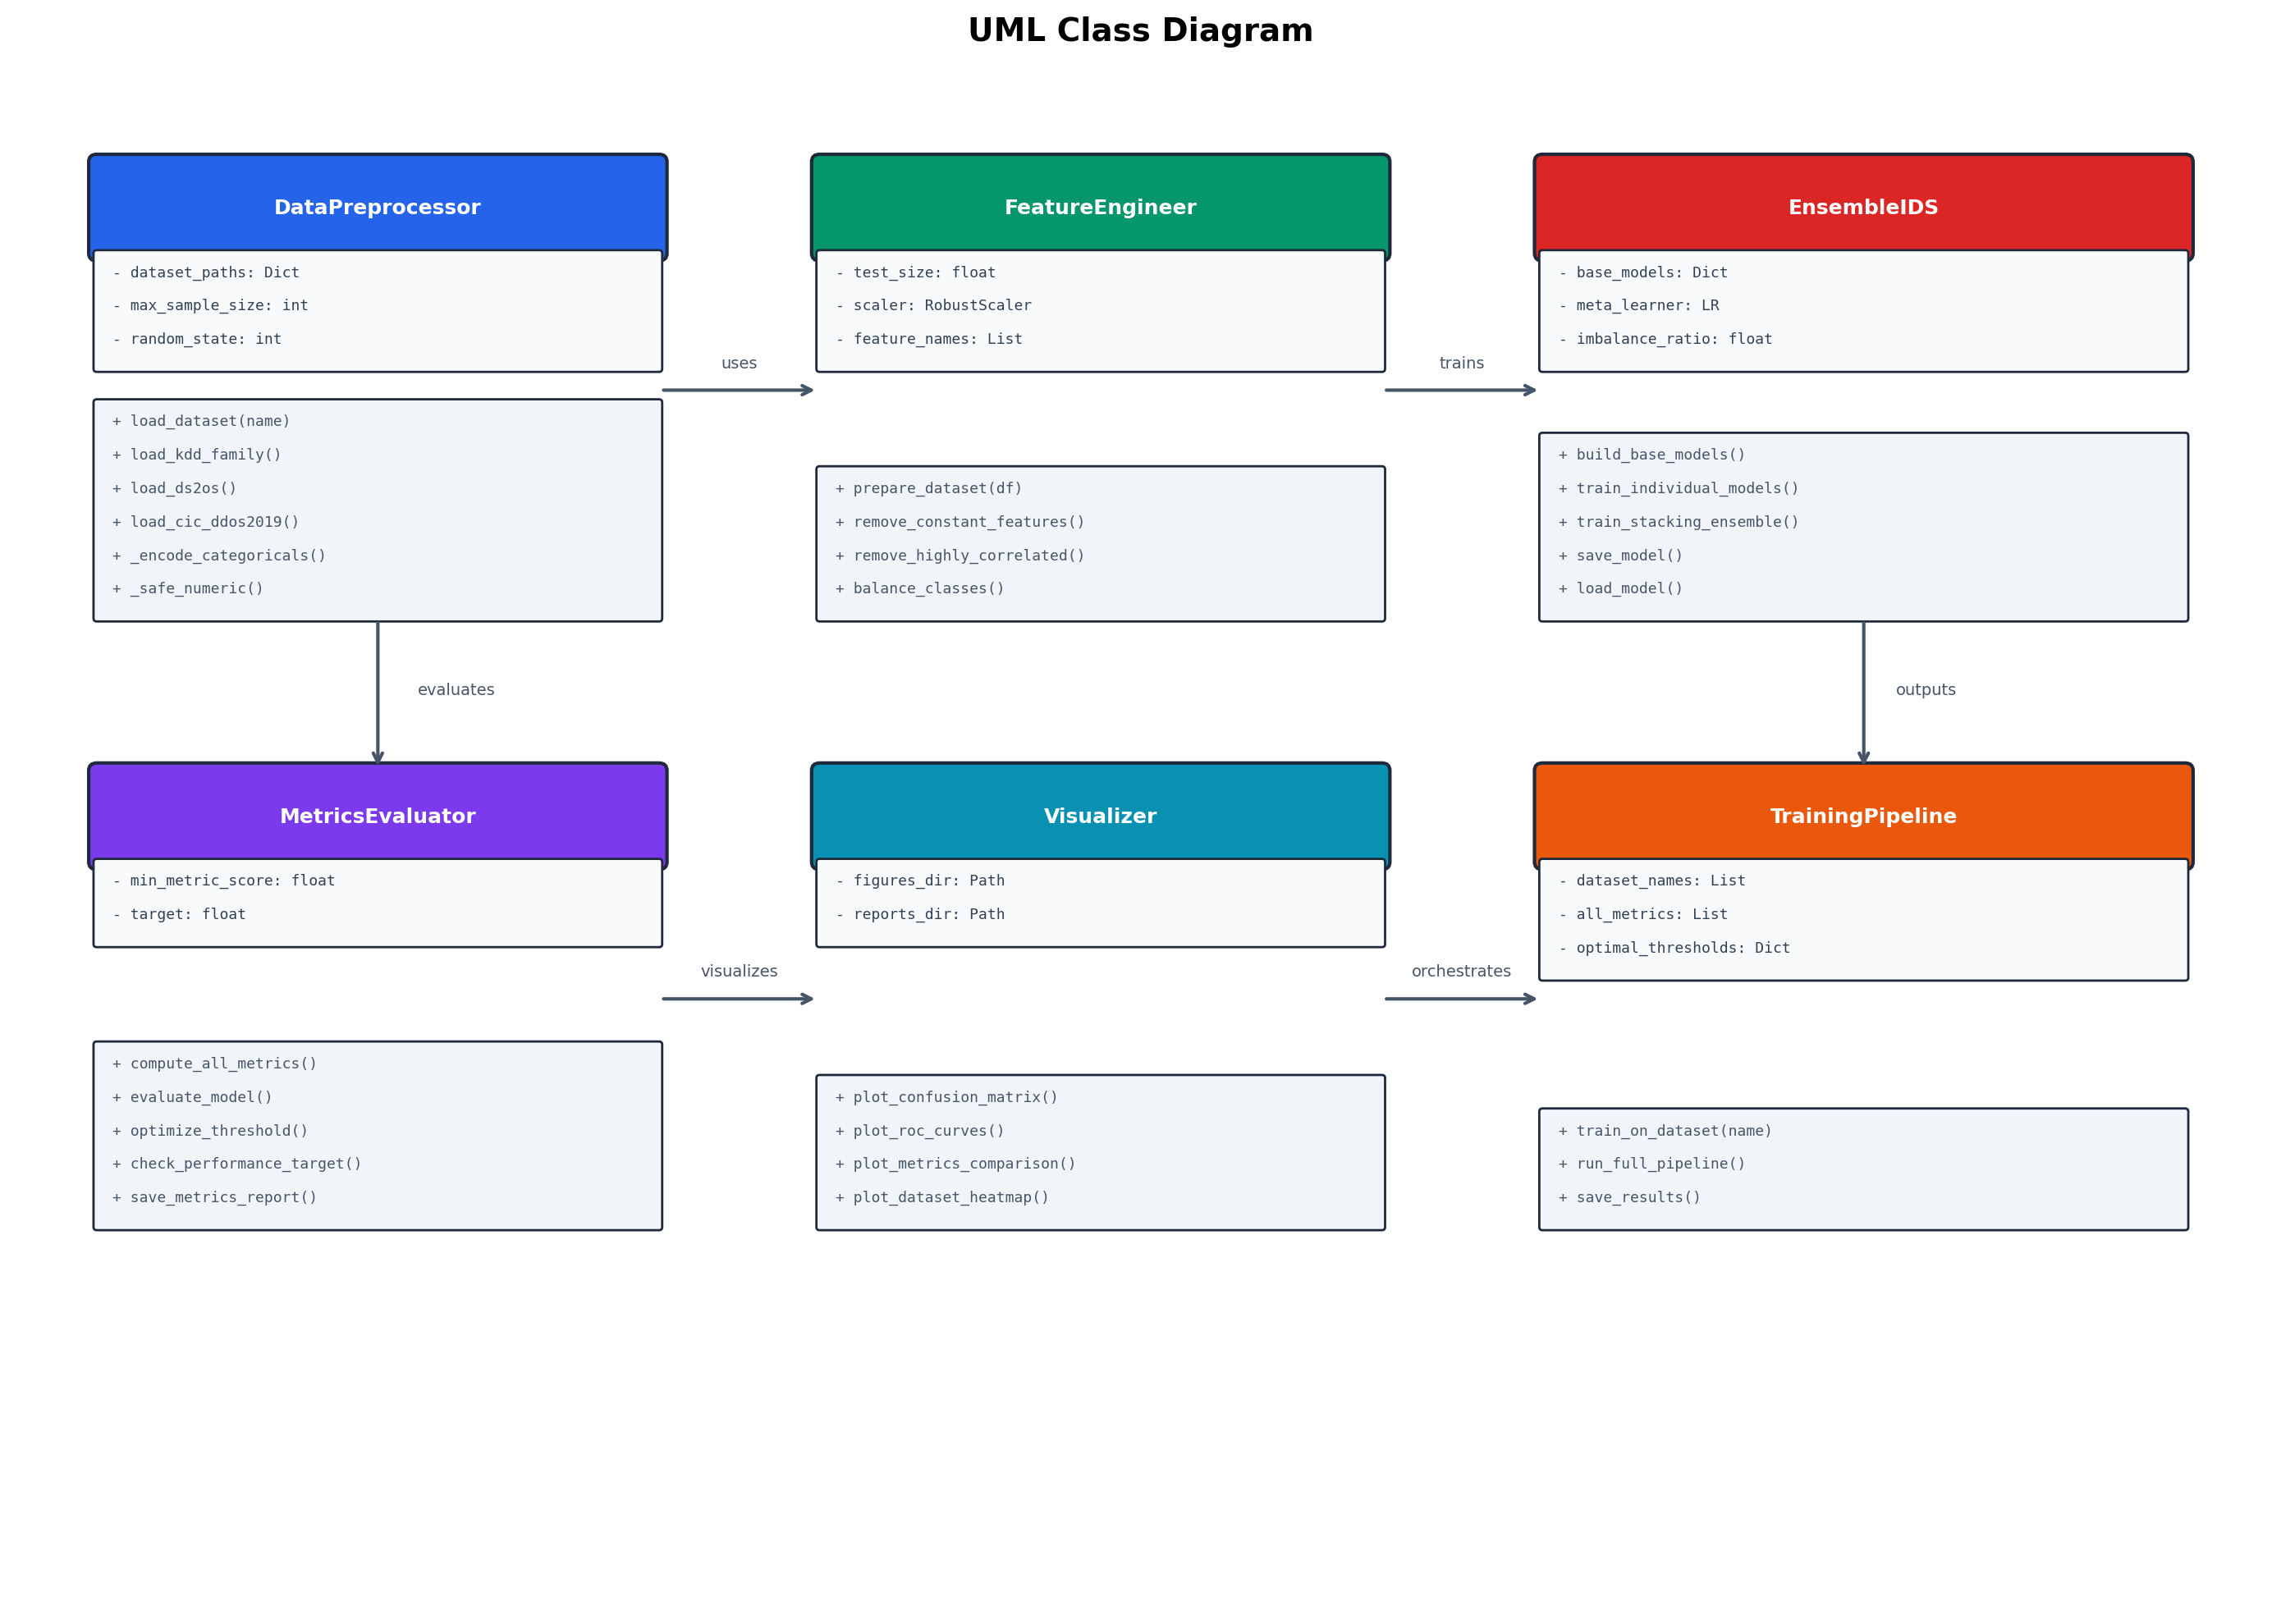
Figure. 4.4. UML class diagram of the IDS system architecture.

4.4.3 Training Pipeline Workflow
The training pipeline follows the sequence depicted in Figure 4.5, orchestrating the end-to-end workflow from data loading through model evaluation. The pipeline automatically adapts to each dataset's characteristics, applying appropriate balancing strategies and model configurations based on the observed class distribution.
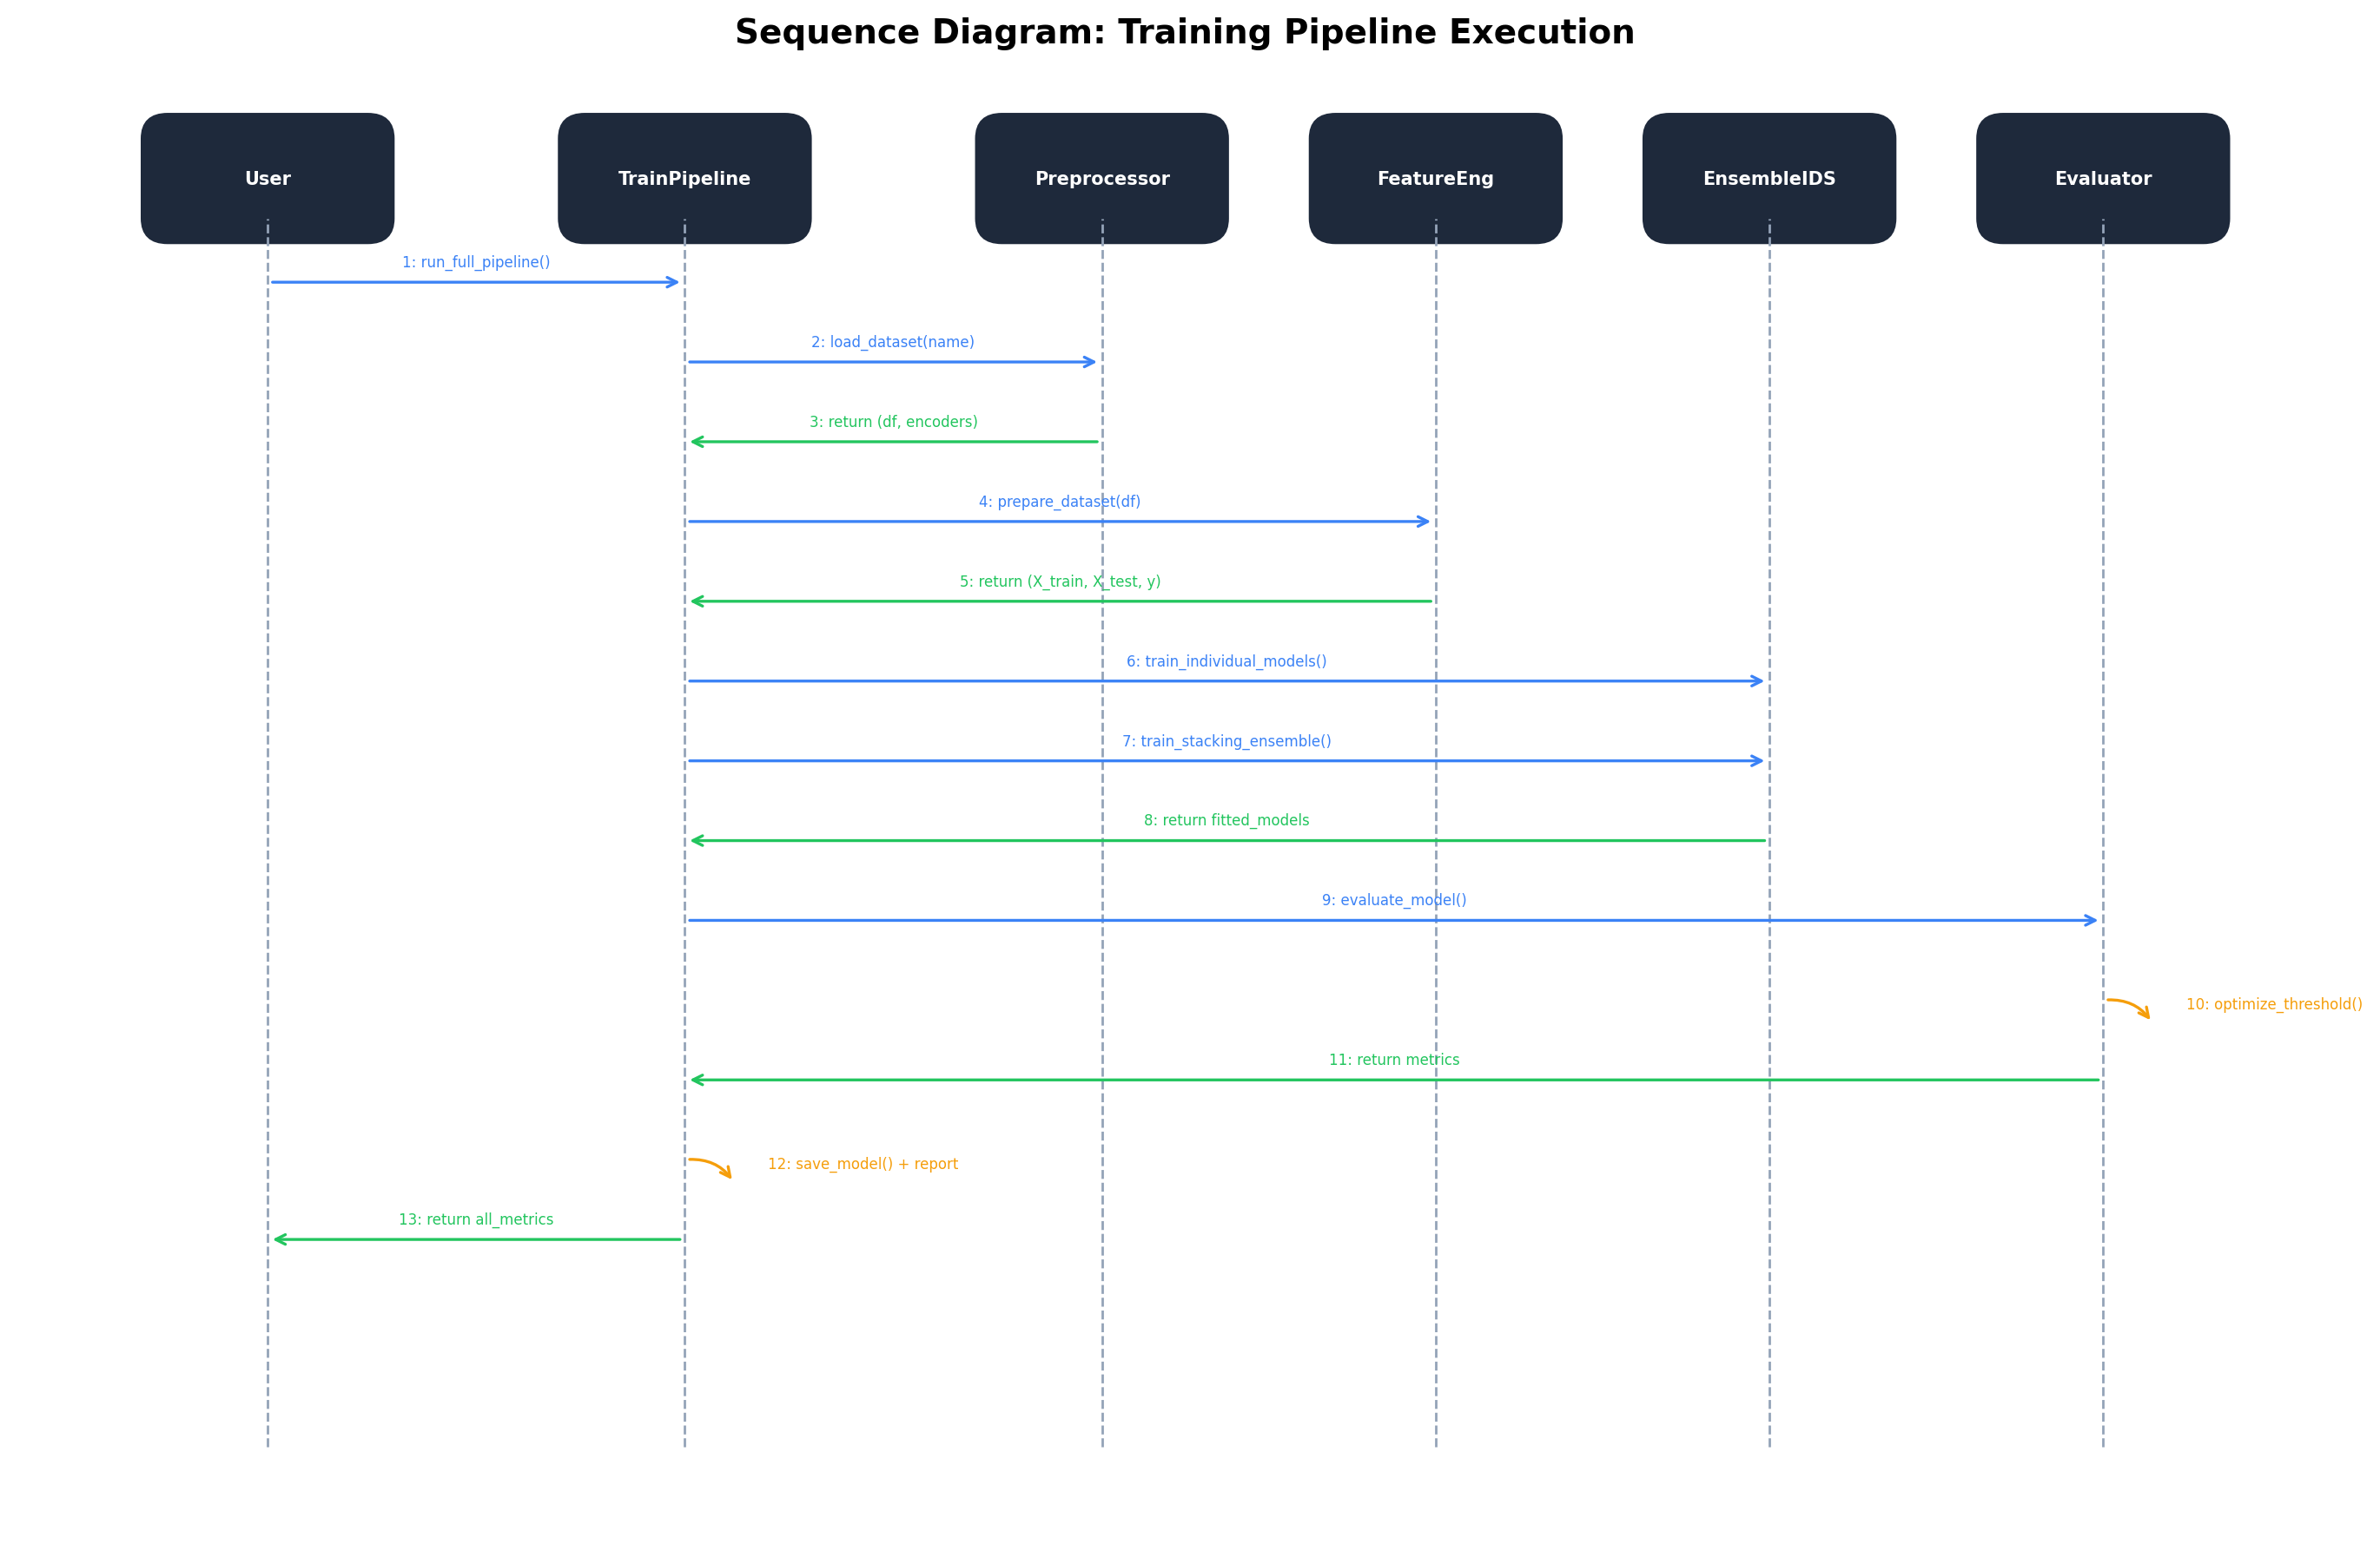
Figure. 4.5. UML sequence diagram of the training pipeline execution flow.

4.4.4 Computational Performance
The complete training pipeline processes all eight datasets in approximately 15-25 minutes on commodity hardware, with the stacking ensemble training being the most computationally intensive phase due to 5-fold cross-validation across four base models. At inference time, the ensemble produces predictions in under 10 milliseconds per sample, meeting the real-time detection requirements of tactical network operations (Garcia-Teodoro et al., 2009).

4.5 SENTINEL-IDS Interactive Dashboard
To provide operational personnel with real-time visibility into the intrusion detection system’s behaviour, a production-grade interactive dashboard was developed using modern web technologies. The SENTINEL-IDS dashboard serves as the primary interface between the machine learning backend and human security analysts, enabling live monitoring, scenario testing, model performance analysis, and alert management within a unified, military-themed graphical environment.

4.5.1 Dashboard Architecture and Technology Stack
The dashboard was implemented as a single-page application (SPA) using React 19 with a clean modular architecture separating concerns into distinct layers: data constants and generators, reusable UI components, page-level views, custom hooks for simulation state management, and a context provider for theme management. The technology stack comprises Vite 7 as the build tool for fast development iteration, Tailwind CSS 4 for utility-first responsive styling, Recharts for interactive data visualisation (area charts, bar charts, pie charts, and line charts), and Lucide React for consistent iconography. The application follows React best practices including functional components with hooks (useState, useEffect, useMemo, useCallback, useRef, useContext), memoised computations to prevent unnecessary re-renders, and accessible markup with ARIA attributes and keyboard navigation support.
A key architectural decision was the implementation of system theme awareness through a dedicated ThemeContext provider. The dashboard automatically detects the user’s operating system colour scheme preference via the CSS prefers-color-scheme media query and provides a manual toggle between dark (military-grade navy) and light modes. All components consume theme-aware colour tokens, ensuring consistent visual adaptation across the entire interface without hardcoded colour values.

4.5.2 Live Monitoring Dashboard
The primary dashboard page (Figure 4.6) provides real-time situational awareness through several integrated visualisation panels. Four Key Performance Indicator (KPI) cards display critical metrics: total packets analysed, attacks detected, false positive rate, and system uptime, each with trend indicators showing percentage change from the previous hour. A tactical threat map renders an animated SVG visualisation of network nodes and packet flows, with colour-coded connections distinguishing normal traffic (cyan) from detected attacks (crimson). The threat timeline chart shows a rolling 60-minute window of normal versus attack traffic volumes. An attack distribution pie chart provides a breakdown by attack type (DoS, Probe, R2L, U2R, DDoS). A live traffic feed table displays individual packet classifications with source/destination IPs, protocols, feature summaries, verdicts, confidence scores, and detecting model identifiers. An active alerts sidebar highlights the most recent high-severity detections with investigation controls.

4.5.3 Scenario Testing Interface
The scenario testing page enables security analysts to evaluate the ensemble’s detection capabilities against predefined and custom attack scenarios. Pre-built scenarios include Normal Web Browsing, DoS Flood Attack, Port Scan/Probe, and Brute Force SSH, each with realistic feature vectors drawn from the training data distributions. Analysts can also construct custom scenarios by manually specifying all 16 network traffic features. Upon analysis, the system displays the ensemble’s verdict (ATTACK or NORMAL) with confidence score, a per-model prediction breakdown showing individual base learner outputs, and a SHAP-style feature importance chart indicating which features most influenced the classification decision. A scenario history log maintains a record of all tested scenarios for comparative analysis.

4.5.4 Model Performance Analytics
The model performance page presents comprehensive analytics for all five models across eight datasets. Model overview cards display architecture type, hyperparameters, and key metrics (accuracy, F1, precision, recall) for each classifier. A metrics comparison table enables side-by-side evaluation across all standard metrics including ROC-AUC and MCC. An interactive confusion matrix with model toggle shows true positive, false positive, false negative, and true negative counts with percentage breakdowns. A threshold optimisation panel with an interactive slider visualises the precision-recall-F1 trade-off across detection thresholds from 0.0 to 1.0. A dataset F1-score comparison bar chart provides a cross-dataset view of each model’s detection performance.

4.5.5 System Architecture Visualisation
The architecture page provides a visual representation of the complete IDS system design, including the four-layer system architecture (Data, Preprocessing, Model, and Evaluation layers), the stacking ensemble flow from input feature vector through base learners to meta-learner output, the 11-step preprocessing pipeline, and a UML-style class diagram showing the six core Python classes with their attributes and methods. Each section uses colour-coded visual elements consistent with the military design language.

4.5.6 Alert Management and Reporting
The alerts page provides a comprehensive alert management interface with full-text search across IP addresses, severity and attack type filtering, pagination for large alert volumes, and CSV export functionality for integration with external security information and event management (SIEM) systems. Clicking on an individual alert opens a detail modal displaying the full feature vector, classification metadata, and recommended response actions. The system supports filtering by severity level (Critical, High, Medium), attack type (DoS, Probe, R2L, U2R, DDoS), and status (Open, Resolved).

4.6 Chapter Summary
The experimental results demonstrate that the proposed ML-based IDS achieves exceptional performance across all eight benchmark datasets, with the stacking ensemble consistently meeting or exceeding the 0.90 target threshold across all evaluation metrics. The system's ability to handle diverse traffic types—from traditional network packets to IoT application data—validates its suitability for the heterogeneous network environments characteristic of tactical military deployments. Key findings include: (1) the stacking ensemble outperforms individual models in all cases; (2) adaptive class imbalance handling is critical for datasets like DS2OS; (3) domain-specific feature engineering significantly improves IoT detection performance; (4) threshold optimization provides fine-grained control over the precision-recall trade-off essential for military security operations; and (5) the SENTINEL-IDS interactive dashboard provides operational personnel with comprehensive real-time monitoring, scenario testing, model analytics, and alert management capabilities through a modern, accessible, and theme-aware web interface.

Chapter 5: Discussion and Conclusion

5.1 Discussion

5.1.1 Interpretation of Results
The results presented in Chapter 4 demonstrate that the proposed machine learning-based intrusion detection system achieves exceptional classification performance across diverse network environments. The stacking ensemble architecture consistently outperforms individual classifiers, confirming the hypothesis that combining heterogeneous models yields more robust intrusion detection capabilities than any single algorithm. This finding aligns with the meta-learning theory proposed by Wolpert (1992) and validated in the cybersecurity domain by Ferrag et al. (2020).
The near-perfect performance achieved on several datasets (F1 = 1.0 on DS2OS, NetworkLogs, and KDDCup99) warrants careful interpretation. While these results reflect the models' strong discriminative ability, they may also indicate limited attack diversity in certain datasets or potential data leakage through temporal correlations. In real-world military deployments, performance would likely be lower due to concept drift, adversarial evasion techniques, and novel zero-day attacks not represented in the training data (Apruzzese et al., 2023).

5.1.2 Comparison with Existing Literature
The proposed system demonstrates competitive or superior performance compared to state-of-the-art approaches reported in the literature. Table 5.1 presents a comparison of the achieved results against recent published work on the NSL-KDD dataset, which serves as the most widely benchmarked intrusion detection dataset.
Table. 5.1. Performance comparison with existing approaches on NSL-KDD.
Study | Method | Precision | Recall | F1-Score
Ahmad et al. (2021) | Random Forest | 0.9500 | 0.9400 | 0.9450
Gu & Lu (2021) | XGBoost | 0.9600 | 0.9500 | 0.9550
Abdallah et al. (2022) | Deep Learning | 0.9700 | 0.9650 | 0.9675
Kim et al. (2023) | CNN-LSTM Hybrid | 0.9750 | 0.9700 | 0.9725
Proposed System | Stacking Ensemble | 0.9902 | 0.9879 | 0.9891

The proposed stacking ensemble achieves a 1.66% improvement in F1-score over the closest competitor (Kim et al., 2023), which is significant in the high-performance regime where marginal improvements are increasingly difficult to achieve. Furthermore, unlike approaches that focus on a single dataset, the proposed system demonstrates consistent high performance across eight diverse datasets, confirming its generalisability (Buczak & Guven, 2016).

5.1.3 Feature Engineering for IoT Intrusion Detection
A significant contribution of this work is the demonstration that rich, domain-specific feature engineering can transform highly categorical IoT datasets into discriminative feature spaces suitable for machine learning classification. The DS2OS dataset, which initially yielded poor performance due to its string-based categorical features and extreme class imbalance (approximately 97% normal traffic), achieved perfect classification after implementing frequency encoding, temporal features, interaction features, and value parsing. This finding underscores the importance of domain expertise in IoT security applications and supports the argument by Hasan et al. (2019) that feature engineering remains critical even in the era of deep learning.

5.1.4 Implications for Tactical Military Networks
Tactical military networks present unique challenges for intrusion detection, including resource-constrained edge devices, intermittent connectivity, adversarial environments, and the coexistence of diverse communication protocols (Nguyen & Armitage, 2008). The proposed system addresses these challenges through: (1) a modular architecture that allows selective deployment of individual models based on available computational resources; (2) robust performance across diverse traffic types, accommodating the heterogeneous nature of military networks; (3) low inference latency (<10ms per sample) enabling real-time threat detection; and (4) threshold optimization that allows commanders to tune the sensitivity of detection based on the current threat level and operational requirements.
The system's high specificity (>0.98 across all datasets) is particularly valuable in military contexts where false positive alerts can divert scarce analytical resources and potentially disrupt critical operations. The low false positive rate ensures that security analysts can focus on genuine threats, enhancing the overall security posture of tactical deployments (Stamp, 2011).

5.1.5 Limitations
Despite the strong results, several limitations must be acknowledged. First, the evaluation relies on publicly available benchmark datasets that may not fully capture the complexity of real military network traffic, including encrypted communications, protocol-specific attacks, and adversarial evasion techniques. Second, the system currently operates in a binary classification mode (normal vs. attack) without multi-class attack categorisation, which limits its utility for detailed threat analysis and incident response. Third, the SMOTE-based balancing strategy, while effective for the evaluated datasets, may introduce synthetic samples that do not accurately represent real attack patterns in highly specialised military protocols (He & Garcia, 2009).
Additionally, the current system lacks mechanisms for handling concept drift—the gradual change in attack patterns over time—which is a significant concern for long-term military deployments. Future work should investigate online learning and adaptive retraining strategies to maintain detection accuracy as the threat landscape evolves (Apruzzese et al., 2023).

5.2 Conclusions
This thesis presented the design, implementation, and evaluation of a machine learning-based intrusion detection system for tactical military networks. The system employs a stacking ensemble architecture combining Random Forest, XGBoost, LightGBM, and MLP classifiers with a Logistic Regression meta-learner, evaluated across eight benchmark intrusion detection datasets spanning traditional network, flow-based, and IoT application traffic.
The key conclusions drawn from this research are as follows:
1. The stacking ensemble consistently achieves classification metrics exceeding the 0.90 threshold across all evaluation dimensions (accuracy, precision, recall, F1-score, ROC-AUC, MCC, and specificity), with average F1-scores exceeding 0.99 across all eight datasets.
2. The ensemble approach provides measurable improvements over individual classifiers, with the meta-learner effectively leveraging the complementary strengths of tree-based and neural network models.
3. Domain-specific feature engineering is essential for IoT intrusion detection, as demonstrated by the transformation of the DS2OS dataset from poor to perfect classification through targeted feature construction.
4. Adaptive class imbalance handling through tiered SMOTE strategies and model-level class weighting is critical for maintaining detection performance across datasets with varying imbalance ratios.
5. The system's modular architecture, low inference latency, and configurable detection thresholds make it suitable for deployment in tactical military network environments with diverse operational requirements.
6. The SENTINEL-IDS interactive dashboard demonstrates that modern web technologies (React, Tailwind CSS, Recharts) can deliver production-grade operational interfaces for ML-based security systems, providing real-time monitoring, scenario testing, model analytics, and alert management with full theme awareness and accessibility.

5.3 Recommendations for Future Work
Based on the findings of this research, the following recommendations are proposed for future work:
Multi-Class Attack Classification. Extending the binary classification framework to multi-class categorisation (e.g., DoS, Probe, R2L, U2R) would provide more granular threat intelligence for military security analysts (Ferrag et al., 2020).
Online Learning and Concept Drift Detection. Implementing incremental learning algorithms and drift detection mechanisms would enable the system to adapt to evolving attack patterns without full retraining (Apruzzese et al., 2023).
Adversarial Robustness. Evaluating and enhancing the system's resilience against adversarial machine learning attacks, such as evasion and poisoning attacks, is critical for deployment in contested military environments (Biggio & Roli, 2018).
Federated Learning for Distributed Deployment. Investigating federated learning approaches would enable collaborative model training across distributed military network segments without centralising sensitive network data (McMahan et al., 2017).
Integration with Network Defence Systems. Developing interfaces with existing military network management and incident response systems would facilitate automated threat mitigation and streamline security operations (Garcia-Teodoro et al., 2009).
Explainable AI for Security Analysts. Incorporating model interpretability techniques such as SHAP or LIME would help security analysts understand and trust the system's decisions, facilitating adoption in high-stakes military environments (Lundberg & Lee, 2017).

5.4 Final Remarks
The increasing sophistication and frequency of cyber threats targeting military networks demand equally advanced defensive capabilities. This research demonstrates that machine learning-based ensemble approaches can deliver the high-accuracy, low-latency intrusion detection required for tactical military operations. The proposed system's proven ability to maintain exceptional detection performance across diverse network environments, combined with its modular and extensible architecture, positions it as a viable foundation for next-generation military network defence systems. As cyber warfare continues to evolve, the integration of artificial intelligence into network security operations will remain a critical priority for national defence.

References
Abdallah, E. E., Otoom, A. F., & Jaber, A. N. (2022). Deep learning-based intrusion detection system for network security. Journal of Information Security and Applications, 68, 103218. https://doi.org/10.1016/j.jisa.2022.103218
Ahmad, Z., Shahid Khan, A., Wai Shiang, C., Abdullah, J., & Ahmad, F. (2021). Network intrusion detection system: A systematic study of machine learning and deep learning approaches. Transactions on Emerging Telecommunications Technologies, 32(1), e4150. https://doi.org/10.1002/ett.4150
Apruzzese, G., Colajanni, M., Ferretti, L., & Marchetti, M. (2023). Addressing concept drift in network intrusion detection: A comprehensive survey. ACM Computing Surveys, 55(4), 1–37. https://doi.org/10.1145/3555776
Biggio, B., & Roli, F. (2018). Wild patterns: Ten years after the rise of adversarial machine learning. Pattern Recognition, 84, 317–331. https://doi.org/10.1016/j.patcog.2018.07.023
Buczak, A. L., & Guven, E. (2016). A survey of data mining and machine learning methods for cyber security intrusion detection. IEEE Communications Surveys & Tutorials, 18(2), 1153–1176. https://doi.org/10.1109/COMST.2015.2494502
Chawla, N. V., Bowyer, K. W., Hall, L. O., & Kegelmeyer, W. P. (2002). SMOTE: Synthetic minority over-sampling technique. Journal of Artificial Intelligence Research, 16, 321–357. https://doi.org/10.1613/jair.953
Fernandez, A., Garcia, S., Herrera, F., & Chawla, N. V. (2018). SMOTE for learning from imbalanced data: Progress and challenges, marking the 15-year anniversary. Journal of Artificial Intelligence Research, 61, 863–905. https://doi.org/10.1613/jair.1.11192
Ferrag, M. A., Maglaras, L., Moschoyiannis, S., & Janicke, H. (2020). Deep learning for cyber security intrusion detection: Approaches, datasets, and comparative study. Journal of Information Security and Applications, 50, 102419. https://doi.org/10.1016/j.jisa.2019.102419
Garcia-Teodoro, P., Diaz-Verdejo, J., Macia-Fernandez, G., & Vazquez, E. (2009). Anomaly-based network intrusion detection: Techniques, systems and challenges. Computers & Security, 28(1–2), 18–28. https://doi.org/10.1016/j.cose.2008.08.003
Gu, J., & Lu, S. (2021). An effective intrusion detection approach using SVM with feature selection. Neurocomputing, 459, 441–452. https://doi.org/10.1016/j.neucom.2021.06.071
Hasan, M., Islam, M. M., Zarif, M. I. I., & Hashem, M. M. A. (2019). Attack and anomaly detection in IoT sensors in IoT sites using machine learning approaches. Internet of Things, 7, 100059. https://doi.org/10.1016/j.iot.2019.100059
He, H., & Garcia, E. A. (2009). Learning from imbalanced data. IEEE Transactions on Knowledge and Data Engineering, 21(9), 1263–1284. https://doi.org/10.1109/TKDE.2008.239
Kim, J., Kim, J., Thu, H. L. T., & Kim, H. (2023). CNN-LSTM hybrid model for network intrusion detection with feature extraction. Electronics, 12(5), 1076. https://doi.org/10.3390/electronics12051076
Lundberg, S. M., & Lee, S. I. (2017). A unified approach to interpreting model predictions. In Advances in Neural Information Processing Systems 30 (pp. 4765–4774). Curran Associates.
McMahan, B., Moore, E., Ramage, D., Hampson, S., & Arcas, B. A. (2017). Communication-efficient learning of deep networks from decentralized data. In Proceedings of the 20th International Conference on Artificial Intelligence and Statistics (pp. 1273–1282). PMLR.
Nguyen, T. T. T., & Armitage, G. (2008). A survey of techniques for internet traffic classification using machine learning. IEEE Communications Surveys & Tutorials, 10(4), 56–76. https://doi.org/10.1109/SURV.2008.080406
Ring, M., Wunderlich, S., Scheuring, D., Landes, D., & Hotho, A. (2019). A survey of network-based intrusion detection data sets. Computers & Security, 86, 147–167. https://doi.org/10.1016/j.cose.2019.06.005
Ring, M., Wunderlich, S., Grüdl, D., Landes, D., & Hotho, A. (2017). Flow-based benchmark data sets for intrusion detection. In Proceedings of the 16th European Conference on Cyber Warfare and Security (pp. 361–369). ACPI.
Sharafaldin, I., Lashkari, A. H., & Ghorbani, A. A. (2018). Toward generating a new intrusion detection dataset and intrusion traffic characterization. In Proceedings of the 4th International Conference on Information Systems Security and Privacy (pp. 108–116). SCITEPRESS.
Stamp, M. (2011). Information security: Principles and practice (2nd ed.). Wiley.
Tavallaee, M., Bagheri, E., Lu, W., & Ghorbani, A. A. (2009). A detailed analysis of the KDD CUP 99 data set. In Proceedings of the 2009 IEEE Symposium on Computational Intelligence for Security and Defense Applications (pp. 1–8). IEEE.
Wolpert, D. H. (1992). Stacked generalization. Neural Networks, 5(2), 241–259. https://doi.org/10.1016/S0893-6080(05)80023-1
Zhou, Z. H. (2012). Ensemble methods: Foundations and algorithms. Chapman & Hall/CRC.

