4/10/2013

|  |
| --- |
| [Type the document subtitle] | Akodiat |

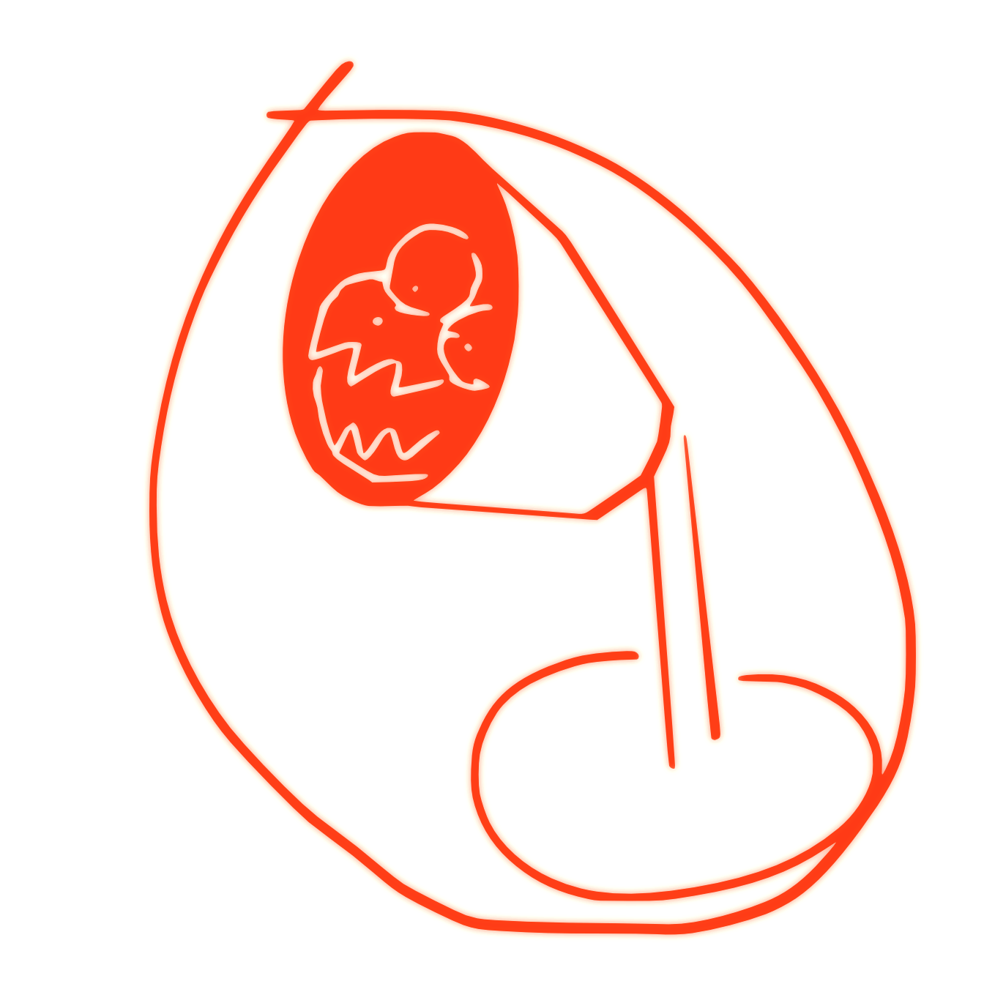

|  |  |
| --- | --- |
| Chalmers | Sentimentalizer - LampMonster |