**Target journal: Journal of Animal Ecology** – [“How to…”](https://wol-prod-cdn.literatumonline.com/pb-assets/hub-assets/besjournals/1365-2656_animal_ecology/JAE%20How%20to___%20Guidelines%20incl_%20guidance%20for%20reviewers-1510754185273.pdf) article type

**How to: Building multispecies size spectrum models for real-world applications**

Julia L. Blanchard, Gustav Delius, Romain Forestier, Camilla Novaglio, Asta Audzijoynte, Anna Gardmark, Max, Jon Reum, Phoebe, Mike Spence, Naj, Beth, Kristen, Rowan, Chongliang, Cody, Nis, OTHERS? & Ken H. Andersen

[e.g. add co-authors in middle who are contributing calibrated models/examples to mizer]

**Summary**

1. To understand the impacts of human activities on communities and marine ecosystems a wide range of mathematical models are used in ecology.

2. Multispecies size spectrum models of fish and fisheries have emerged as a useful tool because they capture many important intra- and inter-specific size-dependent processes known to influence the vital rates and interactions of individuals that give rise to population and community dynamics.

3. Using the R package mizer, we provide a detailed guide for parametrising, calibrating and evaluating multispecies size spectrum models for real systems. We emphasise the role of i) iterative model improvement, ii) clear criteria for assessing the level of model skill required for your study, and iii) visualisation methods for “sense checking” model outputs using a combination of theory and data.

4. To illustrate all of the steps in this guide we re-parameterise, re-calibrate and test a model for the heavily fished North Sea, using a combination of fisheries catch and survey data. Introducing a new library of calibrated models (mizerExamples), we show how the models can be cross-compared for benchmarking and for comparative ecosystem-based assessment.

5. We provide R tutorials for all of the basic steps to implement mizer models, along with common pitfalls and proposed solutions to them. We discuss the wide and growing range of extensions of this approach, along with strengths and limitations, for future development and applications.

**Introduction**

There is growing recognition that the body size of individuals governs vital rates and ecological interactions thereby giving rise to population, community and food-web dynamics. A useful and rapidly emerging tool to address this is size spectrum models. Size spectrum models stem from early empirical observations of regularity in the biomass and abundance patterns observed from bacteria to whales, from many different types of ecosystems. The conjecture of invariant biomass across logarithmic body sizes motivated mathematical theory to explain these phenomena (Sheldon et al. 1977). Originally based on particle size distributions, irrespective of species identity, modern size spectrum theory now captures species and traits embedded within the community size spectrum (Andersen 2019). Multispecies size spectrum models are formulated around the role of individual processes primarily dictated by body size but also represent differences in species’ specific traits, such as asymptotic and maturation size but also functional traits related to foraging, activity and behaviour (REFS).

Practical use of this theory has been main driver of many multispecies applications in aquatic food web and fisheries ecology. Several recent uses include predicting ontogenetic shifts in food webs, fisheries management scenarios, climate change (REFS), trophic cascades (REFS), bioeconomic models (REF), ecosystem recovery dynamics (REFS), life-history ecology and evolution (REF), etc. While fairly fish-centric, several extensions also exist, including development beyond fish communities to more explicit inclusion of zooplankton (REFS), benthic invertebrates (REFS), and marine mammals (REFS), biogeochemical models, and other types of ecosystems (REFS). To apply size spectrum models to multispecies systems requires confronting model assumptions, equations, and parameters to data. As these models are growing in their use, a “best practice” guide to enable first-time users to parameterise, fit and verify models with data is needed but currently lacking. In addition, data availability, type and quality differ among systems, and may limit the types of questions that are appropriate for this approach.

While this modelling framework can integrate substantial amount of data, specific to each species, because the trait-based model is its core, it can also be parameterised for systems “low to intermediate complexity”, which can be set up and used with modest effort and varying data sources, data-poor situations, or broad-scale ecosystem comparison (Jacobsen et al. 2014). Recent advances with size spectrum models are also applicable to and draw on achievements with other mechanistic ecological models (integral projection models, marine ecosystem and multispecies models, physiologically structured models, epidemiological models). Given recent advances and recognition of size structured dynamics across other ecological settings, it is therefore timely to apply, test, and further develop size spectrum models to a wider range of ecological contexts and whole ecosystems as well as draw on diverse data streams and statistical techniques that are emerging.

Here, we provide a practical guide for applying multispecies size spectrum models through worked examples using the popular open source R package “mizer v 2.0”. Through our combined experience in developing and applying mizer, we recommend approaches for tackling common issues and pitfalls that tend to arise. We develop a protocol for getting started with multispecies models in mizer. We demonstrate using R code a simple calibration technique and, using a library of calibrated model examples, how to evaluate and use these for real-world ecological applications. We then outline key areas of ongoing extensions to help inspire future accessibility and application of this approach.

**Key assumptions and processes**

The generalsize spectrum model is centred around the premise that the biological rates and of an individual organism in a community is strongly related to two size-related traits: individual size and asymptotic body size (Hartvig, Andersen, REFS). In size spectrum models we are concerned with tracking how the abundance of organisms, in a particular size bracket, changes through time as a result of individual physiological and ecological processes. These processes begin with size-dependent feeding interactions that result in the creation of new biomass (through the assimilation and allocation of energy into maintenance, somatic growth, and production of offspring) and the destruction of biomass associated with death from predation and other background sources (disease, old-age, fishing).

These processes are used to calculate the growth, reproduction, and mortality of individual organisms as a functions of their size. This information is scaled up the level of population size spectra bythe McKendrick-von Foerster equation (equation 1) used by a wide range of age and size-structured models in ecology (IPMs, matrix).

While relatively straightforward to solve when growth and mortality are known, size spectrum models have been developed to describe the growth, death, and reproduction processes centred around certain “size-based rules” (Andersen, 2019):

Rule 1. In general, even within a species, larger predators prefer to feed on prey sizes a function of the ratio of their sizes (beta, sigma).

Rule 2. Larger organisms encounter more food, through their allometric search rates

Rule 3. Larger organisms have greater metabolic demands and higher maximum consumption rates, both based on known allometries (typically “metabolic” scaling).

Rule 4. Larger organisms have greater potential reproductive output

Rule 5. Organisms of a particular size allocate energy into reproduction according to their maturation size, which is a fraction of their asymptotic size

Rule 6. Species with smaller asymptotic sizes have higher background mortality rates and high maximum recruitment rates

Rule 7. Species may potentially interact with each other differently according to an interaction matrix

Rule 8., There is at least one background resource…etc etc

Etc

….. (need to check book, link each of these with parameters, need to put equations and parameters somewhere)

The size spectrum models come in a range of flavours with different data needs. The most “data-poor” is the trait-based model. This version does not include any information about the specific species present. The next level is species-based size-spectrum models which requires some information about the actual species present. The focus of this howto is the species-based size-spectum model.

Thus, multispecies size spectrum models are focussed on *particular* real systems and aim to use data available to undertake system-specific ecosystem-based assessments and multispecies model scenarios. The steps in this paper have been developed to guide first-time users to build mizer models for their study system, calibrate models using data typically available and test models based on a combination of theory, heuristics, and/or independent data (e.g. not used in the calibration process). As a companion to this paper we provide and prefer to three R tutorials (Supplement) where you can reproduce and modify all steps of our worked example yourself. We also point to the mizer website (https://sizespectrum.org/mizer/) which provides detailed resources including model descriptions, R commands for analysis and plotting, as well as extension capabilities for more advanced users and developers. As a basic entry level introduction on the general size spectrum modelling approacl we suggest you *readXXX/watch this vide “what is a size spectrum?”* : <https://vimeo.com/360486042> before starting the below tutorials..

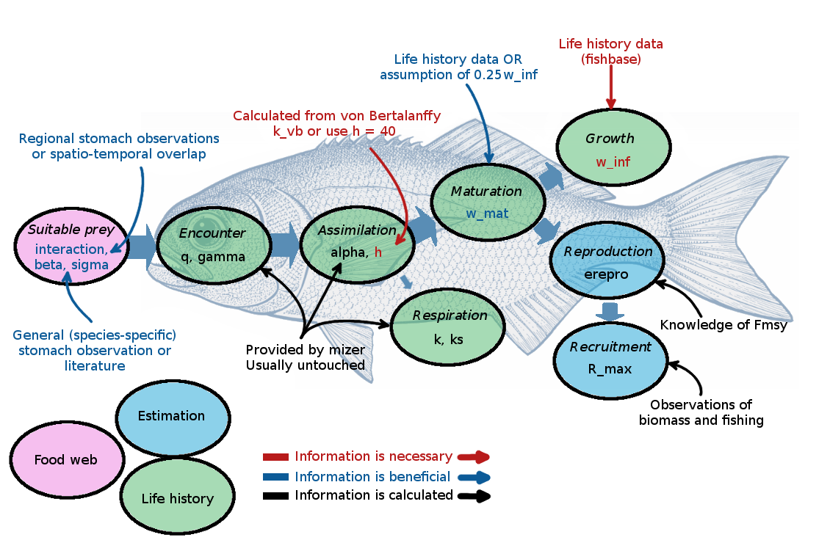

Figure 1: Caption: Illustration of the parameters needed (blue boxes) and calibrated (green boxes) by Mizer. The need for data is hierarchical: a model can be setup and calibrated with the information in red: knowledge of the asymptotic size and observations of biomass and fishing. The calibration can be refined by adding further information in life history parameters and by using knowledge of Fmsy to calibrate the reproductive efficiency (orange). Additional refinement can be done by specifying the interaction matrix, theta (blue). Other parameters can be adjusted but they are rarely known accurately on a species-by-species basis (black).

**Part 1: Parameterisation**

The main difference between a trait based and a multispecies mizer model is that several key parameters, assumed to be the same for all species in the trait-based model, instead can be parametrised to capture known species-specific differences informed from study system data. These include life -history parameters that are widely available or can be estimated using information on Fishbase (asymptotic size, maturation size).

Food-web parameters, such as the preferred predator-prey size ratio, and interaction matrix that can be estimated from basic heuristic ecological knowledge, diet data, or species distributional information. By default some species specific parameters are automatically calculated in mizer if they are missing ( h, gamma), but can be provide if they are known. Other missing or highly uncertain species-specific parameters can either be held as defaults ( e.g. trait-based model) or estimated through calibration (Section X).

Mizer stores all of these parameters in an object that we will work with a lot - mizerParams(). This next section describes all of the steps involved in setting up the parameters for the mizerParam object and the data required to carry out a simple calibration through iterative evaluation.

***Getting started with your study system***

To create a mizerParams object you first need some information from your system. As a first step you need to know – which species will be included? (if you are using functional groups – see section X). Which species to include in your system to will depend on the geographical and ecological boundaries of your system. We assume you already know this and have a study system in mind with some form of data available, a species list at a minimum (for what to do if not see Section X). Perhaps you have a very long species list and are unsure which species to include. This depends on the questions you have – do you want to capture the most abundant and perhaps commercially important species, are you focussing on fish communities, or do you want to include rare species? Are you using the model to test target and non-target effects of harvesting species? Suppose you are focussing on the most abundant species in your system – you may wish to include species that comprise most of the biomass or abundance. Previous work has considered the number of species that capture 80 or 90% of the biomass or abundance (Refs), whereas others or more focussed on a small set of interactions between particular species (Refs).

***North Sea case study***

The parameterisation steps are best described through an example case study: the North Sea. .Our original North Sea model was parameterised for 12 fish species using data available from ICES and Cefas that enabled estimation of life history , feeding, and spatial encounter parameters (Blanchard et al. 2014). What are these parameters and how do I calculate these you ask?

First we need data on life-history and feeding parameters. Box 1 describes the all steps for one of the iconic species in this system – Atlantic cod, which can be repeated for all species in your model. Although we used data from ICES, a search of FishBase or RFishbase provides lots of information including *Growth, length-weight, maturity* will allow you to get started with enough information to inform life-history parameters (wmat,winf,h). Data on predator-prey sizes can provide information for prey size selectivity parameters (beta, sigma, Box 1). The combination of species-specific parameters you use depends on the data available for your system and species. At the very minimum we need to know the asymptotic size (Figure 1). The calibration can be started with minimum parameters and refined iteratively as more data are introduced.

Before we go through the steps of setting up these parameters in mizer, there are a couple of additional important concepts we need to cover.

The species interaction matrix, theta (Reum et al.), controls the extent to which species can encounter each other, and if necessary, can be used to exclude predator-prey interactions between some species pairs (setting to 0). For the North Sea, we assumed theta reflected the co-occurrence of each species and life stage pairs, which implicitly captured differences in the spatial distribution. To do this we used survey data and calculated an index of co-occurrence (Blanchard et al. 2014). Other methods include vertical overlap, to capture the extent of shared benthic -pelagic habitat use (refs), diet preference (Reum), and/ or behaviour influencing availability or vulnerability to predators, which could be based on life history attributes (Jacobsen et al). In the simplest case, if you do not have this information you could assume all species could potentially interact with each other by setting all entries in the matrix to 1.

The units and resource carrying capacity of the system need to be decided a priori. This is an important consideration when calibrating the model as the same unit need to be used for the model output and data used for calibration. For the case study, we chose the volume of the North Sea the corresponded to spatial extent of the International Bottom Trawl Survey an average depth of 50 metres. This facilitated calibration and comparison with fisheries dependent and independent survey data. We recommend you choose the spatial scale that is meaningful and relevant for the data you have.

The carrying capacity of the resource spectrum (kappa) ultimately sets ceiling of available food from the smallest sizes. As a rough first estimate, you could use information from satellite or biogeochemical models to work out the intercept and slope of the phytoplankton community and assume this extends to larger sizes, and possible also including benthic organisms (more than one resource is also possible – see later XX). For the North Sea we started with an initial guess from the literature of XX of primary production per m^3*system_volume and then later refined this parameter through calibration. You could use spatially and temporally averaged information on chlorophyll to estimate the phytoplankton size spectrum as a first guess (Heneghan et al ). If you have direct data on phytoplankton or zooplankton size spectra this could be used to further refine this parameter in more detail, but we do not cover this option below.

Density dependence – describe Rmax and erepro here.

Finally, we need information about the species’ biomasses and fishing pressure to calibrate the carrying capacity of each species (Rmax). If this system is fished, fisheries data can provide information on species catches which are often more readily available than biomass. If there are fisheries independent surveys and/or stock assessments, information on biomass, fishing mortality rates, and selectivity parameters can also be used (more later in Section X, see also mizer website XXX).

***Setting up the mizer params***

Once you have a spreadsheet with the list of species and species-specific parameters you have available (Box 1) and an interaction matrix you can set up the model in mizer using

newMultispeciesParams(). For the North Sea, we had access to very detailed data to obtain the parameters (see North Sea template for where these data come from).

***Running the model to the steady state***

To run the model the mizerParam object is passed to a function called project() which solves the dynamical equations.

Here we can introduce the mizerSim object

Using project()

How to achieve coexistence at steady state

***Key diagnostic plots and what they mean***

Explain the summary plot and what we are looking for :

Species coexistence – biggest problem

Feeding level – getting enough food

**Emphasis point: Iterative model improvement. illustrative flowchart showing how we parameterise -> check assumptions & data -> calibrate least known parameters -> re-check**

**Part 2: Calibration: A Protocol**

Time-averaged Model calibration steps here

**Part 3: Time series fitting**

Statistical parameter estimation

* Simple least squares/MLE example
* Why optimisation sometimes works
* Reducing parameter space with key criteria (history matching)
* Pattern-oriented calibration
* Visualisation (RShiny example)

Running with Dynamics

* Forcing models with time-varying input (annual, seasonally)
* Model fitting and estimation
* Stochasticity

Predictive skill

* Splitting data for different aspects (parametrisation, fitting, verification, predictive skill)

**Part 4: Comparative bench-marking and ecosystem-based assessment**

=======

**Evaluation with Example Models**

Examples – using mizerExamples

Show what can be learned from metanalysis of mizer calibrated models?

Testing assumptions / informing macroecological patterns

*No, instead focus on examples of what a good model should look like, following the protocal*

Table 1. MizerExamples: model examples and their key focus

|  |  |  |  |  |  |  |
| --- | --- | --- | --- | --- | --- | --- |
| Model name in library | Focal Study System | Number of species | Type of Parameterisation | Calibration type | Calibration method | Reference |
|  |  |  |  |  |  | Jacobsen |
|  |  |  |  |  |  | Jacobsen |
|  |  |  |  |  |  | Jacobsen |
|  |  |  |  |  |  | Jacobsen |
|  |  |  |  |  |  | Blanchard |
|  |  |  |  |  |  | Spence |
|  |  |  |  |  |  |  |
|  |  |  |  |  |  |  |
|  |  |  |  |  |  |  |
|  |  |  |  |  |  |  |
|  |  |  |  |  |  |  |
|  |  |  |  |  |  |  |
|  |  |  |  |  |  |  |
|  |  |  |  |  |  |  |

**New applications and extensions**

Use of existing features to relax assumptions

* Example Southern Ocean – feeding kernel, or plankton-anchovy, Chilean?

Building Extensions to Develop New features

* Example of showing how to build extension

Table 2 Recent and ongoing extensions to mizer

|  |  |  |  |
| --- | --- | --- | --- |
| Name | Description | Reference | Source |
| StarvationMortality |  |  |  |
| Thermizer |  |  |  |
| MizerEvolution |  |  |  |
| FleetDynamics |  |  |  |
| ZooMizer |  |  |  |
| temperature-extension? |  |  |  |
| Seasonality? |  |  |  |
| Diets? |  |  |  |
| planktonnutrients |  |  |  |
| dbpm-mizer |  |  |  |
| HabitatComplexity |  |  |  |
|  |  |  |  |
|  |  |  |  |
|  |  |  |  |

How to write an extension to mizer – example R code.

Example Use of extension: climate forcing for fishmip (north sea only or multiple models?)

**Key areas for future research**

Ensembles – require common protocals and can build on through use of what has been presented here

Experimental validation

Model Informed Monitoring

Whole ecosystems

Coupling - Climate projections

Other systems - soils

**Conclusion**

Other notes form old outline:

Designing the model system (and questions)

– drawing the conceptual model and links to data Area, species to represent? Key processes to ignore or include all depend on questions and context

What defines a “good” model?

– defining this early, depends on questions, decision tree/flow chart (Figure 1)

Which data for what?

Table of parameters with common data sources

Alternatives ways to represent these

Issues with some that are not directly measured

Box 1:

The following steps describe how species-specific parameters were derived for Atlantic cod in the North Sea model (Blanchard et al. 2014), and how this could be done in a data poor situation, using FishBase and/or the literature. See also Rmarkdown for this model in mizerExamples.

Life-history parameters:

winf - size-at-age data was downloaded from ICES and the equation was fit…

(note upper 95th percentile used because of h….)

wmat

k_vb

Feeding parameters:

beta

sigma

Fishing parameters:

catches

fisheries selectivity

Biomass (if used):