Beatrix Kiddo
Kill Bill

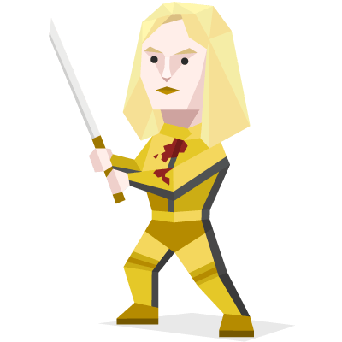

Beatrix Michelle Kiddo, also known as The Bride and also the daughter of her married parents Marc and Michelle Kiddo, is the main protagonist in the "Kill Bill" movie series. Once a member of the Deadly Viper Assassination Squad, known by her code- name Black Mamba, Beatrix was romantically involved with Bill.

She is seen to have stealth abilities, noteworthy agility, strength, speed, reflexes, coordination, and balance. Beatrix is fluent in both Japanese and Mandarin Chinese; she also knows some Cantonese and Spanish.

Only Once after a round:
If you have lost, you can join again.

You live in a colorful, sensual world, inspired by connections with people and ideas. You take joy in reinterpreting these connections, reinventing and experimenting with both yourself and new perspectives. No other explores and experiments in this way more. This creates a sense of spontaneity, making you seem unpredictable, even to your close friends and loved ones.

Kate Austen
Lost



Kate is one of the survivors from the crash of Oceanic Flight 815. Before the crash, Kate had spent many years fleeing the law after killing her abusive father. To achieve her goals, she would commit several other crimes and would turn to bank robbery, assault and seduction.

On the Island, she became an integral member of the survivors' society, forming strong bonds and eventually romantic relationships with Jack and Sawyer and also becoming close with Claire and Sun. Resourceful, quick-witted and mysteriously reclusive, she participated in many missions while attempting to hide her troubled past from the rest of the survivors.

Only Once after a round:
If you have lost, you can join again.

You live in a colorful, sensual world, inspired by connections with people and ideas. You take joy in reinterpreting these connections, reinventing and experimenting with both yourself and new perspectives. No other explores and experiments in this way more. This creates a sense of spontaneity, making you seem unpredictable, even to your close friends and loved ones.

Thea Queen
Arrow

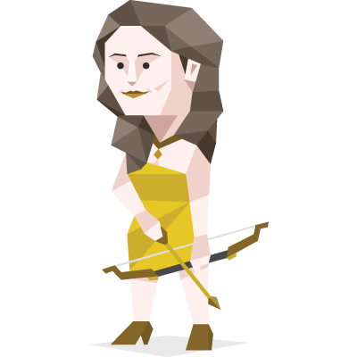

Impulsive and immature, Thea Queen (Willa Holland) is the 18- year-old daughter of Moira Queen and the late Robert Queen and the younger sister of Oliver Queen. As a child, Thea idolized Oliver and was traumatized when he was presumed dead. Oliver gave her the nickname Speedy since she always used to chase after him when she was younger.

She also has a good heart and often tries to do the right thing, and looks up to Oliver. When she meets Roy Harper, a young criminal, she quickly forms a strong romantic attraction, and she is shown to be extremely devoted to him, repeatedly bailing him out of jail.

Only Once after a round:
If you have lost, you can join again.

You live in a colorful, sensual world, inspired by connections with people and ideas. You take joy in reinterpreting these connections, reinventing and experimenting with both yourself and new perspectives. No other explores and experiments in this way more. This creates a sense of spontaneity, making you seem unpredictable, even to your close friends and loved ones.

Jesse Pinkman
Breaking Bad


He is the former partner of Walter White in the methamphetamine drug trade. Jesse was a small-time methamphetamine user, manufacturer, and dealer. He was also an inattentive student in Walter White's chemistry class, leading to his dropping out. In his mid-20s, Jesse became Walt's business partner in the meth trade.

Jesse is impulsive and hedonistic, but also personable and possesses street-smarts. Jesse is a crazy, unpredictable, neurotic, loyal and chivalrous womanizer who likes the kids, and a great student who is a drug user. A great guy to party with. He is not good managing his money and doesn’t have any idea what to do with it.

Only Once after a round:
If you have lost, you can join again.

You live in a colorful, sensual world, inspired by connections with people and ideas. You take joy in reinterpreting these connections, reinventing and experimenting with both yourself and new perspectives. No other explores and experiments in this way more. This creates a sense of spontaneity, making you seem unpredictable, even to your close friends and loved ones.

