James Wilson
House M.D.


Dr. James Evan Wilson is the head of the Department of Oncology at Princeton-Plainsboro Teaching Hospital. He is one of three brothers from a Jewish household.

Wilson is by all standards one of the nicest people you could meet, as he has an unbelievable bedside manner and knows exactly how to talk to people. He also cares deeply about others, sometimes even more than he cares about himself. Patients have been known to thank him after he tells them that they're dying.

While Wilson is normally a calm, serious person, he does have a humorous and playful side, as well. This especially happens when he is in a good emotional state, and/or when people play pranks with him.

If your group can‘t agree on a winner, you decide who wins.

You indeed share a unique combination of traits: though soft-spoken, you have very strong opinions and will fight tirelessly for an idea you believe in. You are decisive and strong-willed, but will rarely use that energy for personal gain – you will act with creativity, imagination, conviction and sensitivity not to create advantage, but to create balance. Egalitarianism and karma are very attractive ideas to Advocates, and you tend to believe that nothing would help the world so much as using love and compassion to soften the hearts of tyrants.

Jon Snow
The Game of Thrones

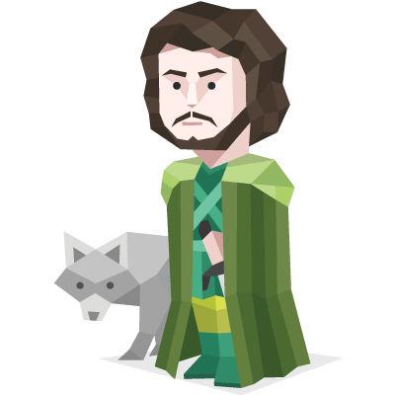
From infancy, Jon is presented as the bastard son of Lord Eddard Stark, Lyanna's brother, and raised by Eddard alongside his lawful children at Winterfell but his true parentage is kept secret from everyone, including Jon himself.

Because he was raised by Ned Stark at Winterfell, Jon has adopted a clear moral compass and a true sense of honor, which he tries his hardest to abide by even when he must make a difficult decision.

His bastard status has also made Jon something of a loner, solemn and somber with a desire to prove himself to society and to his father. Despite his introverted demeanor, Jon is very compassionate and protective of his fellow outcasts such as Samwell Tarly, Grenn, and Pyp.

If your group can‘t agree on a winner, you decide who wins.

You indeed share a unique combination of traits: though soft-spoken, you have very strong opinions and will fight tirelessly for an idea you believe in. You are decisive and strong-willed, but will rarely use that energy for personal gain – you will act with creativity, imagination, conviction and sensitivity not to create advantage, but to create balance. Egalitarianism and karma are very attractive ideas to Advocates, and you tend to believe that nothing would help the world so much as using love and compassion to soften the hearts of tyrants.

Rose Bukater
Titanic



Rose DeWitt-Bukater is the protagonist in the film Titanic and the love interest of Jack Dawson and widow of Mr. Calvert.

She is polite (most of the time; there were a few incidents in which she refused to be polite), mainly because she was forced to be. She is very smart and well-educated. She is also very passionate. Rose is incredibly brave. She is also an extremely talented actress, a talent no doubt practiced through long years of skilfully pretending to be happy, patient, polite, ladylike - whatever Ruth (or Cal) wanted her to be. She could be feisty and strong willed, and at other times carefree and did not shy away from rude habits.

If your group can‘t agree on a winner, you decide who wins.

You indeed share a unique combination of traits: though soft-spoken, you have very strong opinions and will fight tirelessly for an idea you believe in. You are decisive and strong-willed, but will rarely use that energy for personal gain – you will act with creativity, imagination, conviction and sensitivity not to create advantage, but to create balance. Egalitarianism and karma are very attractive ideas to Advocates, and you tend to believe that nothing would help the world so much as using love and compassion to soften the hearts of tyrants.

Aragorn
The Lord of the Rings
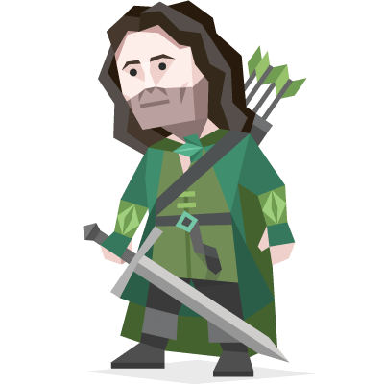

Aragorn II, the son of Arathorn II and Gilraen, also known as Elessar as well as Strider. 16th Chieftain of the Dúnedain of the North; he was later crowned King Elessar Telcontar.

Aragorn possessed Elven wisdom due to his childhood in Rivendell with Elrond and the foresight of the Dúnedain. He was also a skilled healer. He was also a mighty warrior and an unmatched commander.

Though there is no indication of his ever doubting his role and destiny as the future king of the Reunited Kingdom, he was not immune to self-doubt, as he doubted the wisdom of his decisions while leading the Fellowship after the loss of Gandalf in Moria, and blamed himself for many of their subsequent misfortunes, which stands for deep responsibility and compassion.

If your group can‘t agree on a winner, you decide who wins.

You indeed share a unique combination of traits: though soft-spoken, you have very strong opinions and will fight tirelessly for an idea you believe in. You are decisive and strong-willed, but will rarely use that energy for personal gain – you will act with creativity, imagination, conviction and sensitivity not to create advantage, but to create balance. Egalitarianism and karma are very attractive ideas to Advocates, and you tend to believe that nothing would help the world so much as using love and compassion to soften the hearts of tyrants.

