Tony Soprano
The Sopranos

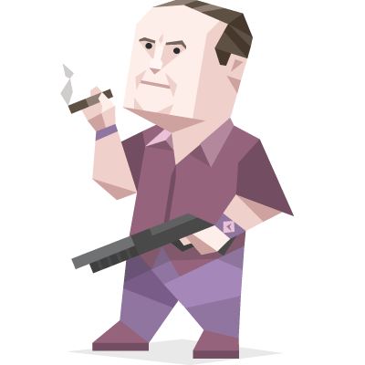
Tony has to juggle northern New Jersey's most powerful criminal organization, keeping it functioning properly and keeping dissonance to a minimum.

Tony is an avid animal lover, and enjoys feeding the ducks which visit his pool. He has a sentimental attachment towards animals, as he had been traumatized by the loss of his childhood dog, whose name was "Tippy". He is also a gun enthusiast and is shown to have an arsenal in his home.

Tony tells Dr. Melfi about a dream he had wherein a screw in his belly button, when removed, causes his penis to fall off. He tries to find a car mechanic (who had worked on his Lincoln when Tony drove Lincolns) to put it back on, but a duck swoops down and snatches it from his hand.

Only Once:
You can shoot another character and kick him out of the game.

Your time is limited, so don’t waste it living someone else’s life. Don’t be trapped by dogma — which is living with the results of other people’s thinking. Don’t let the noise of others’ opinions drown out your own inner voice. And most important, have the courage to follow your heart and intuition. They somehow already know what you truly want to become. Everything else is secondary.

David Palmer
24


David Palmer serves as a United States senator from Maryland. He is the frontrunner to become the Democratic candidate for president when he is threatened by scandal and assassination. He is married to Sherry, his childhood sweetheart, and the two have two children: Keith and Nicole.
Palmer is smart, good-hearted and no-nonsense -- not afraid to make tough, quick decisions for the good of his family and of the nation. Like many, he is suspicious of Jack at first, but the two eventually come to be something close to friends. More than once, it is his influence and dedication to CTU and Jack that are the difference between life and death for the agents as well as many American citizens.

Only Once:
You can shoot another character and kick him out of the game.

Your time is limited, so don’t waste it living someone else’s life. Don’t be trapped by dogma — which is living with the results of other people’s thinking. Don’t let the noise of others’ opinions drown out your own inner voice. And most important, have the courage to follow your heart and intuition. They somehow already know what you truly want to become. Everything else is secondary.

Malcolm Merlyn
Arrow


Malcolm Merlyn is the father of Tommy Merlyn and the husband of the late Rebecca Merlyn. He is CEO of Merlyn Global Group and a renowned businessman in Starling City. He was friends with the late Robert Queen and with Moira Queen. After his wife died, he abandoned his son for two years. HIs wife's death changed him and Malcolm is cold and calculating. He will destroy anyone who gets in his way. He is adept with an arrow and a sword and often successful in hand-to-hand combat. He has many secrets he is trying to protect and is a great enemy of Arrow.

Only Once:
You can shoot another character and kick him out of the game.

Your time is limited, so don’t waste it living someone else’s life. Don’t be trapped by dogma — which is living with the results of other people’s thinking. Don’t let the noise of others’ opinions drown out your own inner voice. And most important, have the courage to follow your heart and intuition. They somehow already know what you truly want to become. Everything else is secondary.

Francis J. Underwood
House of Cards


Raised in impoverished circumstances, he found his hometown 'suffocating' at the time. Frank attended military college at "The Sentinel" in Charleston, South Carolina and then graduated from Harvard Law School. Frank was elected as U.S. Representative from South Carolina's 5th congressional district for 11 terms before moving on to become House Majority Whip. Rep. Underwood is married to Claire Underwood, yet they have no children. Frank is known for his straight-forward yet complex, often 'lacking emotion', approach to certain situations. Underwood helped President Garrett Walker, also a democrat, to win the presidential election. His figure is deemed as one of the most dark and complex characters in the 'House Of Cards' series, even though he is the main character of the story.

Only Once:
You can shoot another character and kick him out of the game.

Your time is limited, so don’t waste it living someone else’s life. Don’t be trapped by dogma — which is living with the results of other people’s thinking. Don’t let the noise of others’ opinions drown out your own inner voice. And most important, have the courage to follow your heart and intuition. They somehow already know what you truly want to become. Everything else is secondary.

