Captain Jack Sparrow
Pirates of the Caribbean

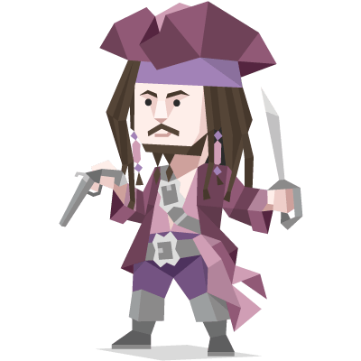

A pirate ahead of his time in many ways, Jack Sparrow likes to consider himself as the epitome of a free spirit. He swishes his way through life with a slightly odd, but strangely wise attitude.

He is perhaps a bit crazy, for we learn he may have been overbaked in the sun while marooned once. But he still is smart enough to survive in a tough world without resorting to force to get what he wants.

In fact he once said, "Why fight when you can negotiate?" This leads to some people seeing him as a coward and truth be told Jack is not heroic in the straightforward sense. He watches and reads people and gladly manipulates them for his own ingenious ends.

You can say: „I have another idea …“ and discuss it.

Follow the path of the unsafe, independent thinker. Expose your ideas to the dangers of controversy. Speak your mind and fear less the label of ’crack-pot’ than the stigma of conformity. And on issues that seem important to you, stand up and be counted at any cost.

Felicity Smoak
Arrow



Smart, tech savvy and brave, Felicity Smoak is an employee in the IT department of Queen Consolidated. Felicity is very curious and not one to back away from danger. She is proficient with all technology and Oliver often needs her assistance.

Felicity talks a lot and has a habit of unintentionally saying inappropriate things. When she is nervous, she babbles even more than usual. She can sometimes come across as socially awkward. Oliver, in particular makes her nervous, because she has a crush on him. Felicity has a great sense of humor.

You can say: „I have another idea …“ and discuss it.

Follow the path of the unsafe, independent thinker. Expose your ideas to the dangers of controversy. Speak your mind and fear less the label of ’crack-pot’ than the stigma of conformity. And on issues that seem important to you, stand up and be counted at any cost.

Dr. Emmet Brown
Back to the Future

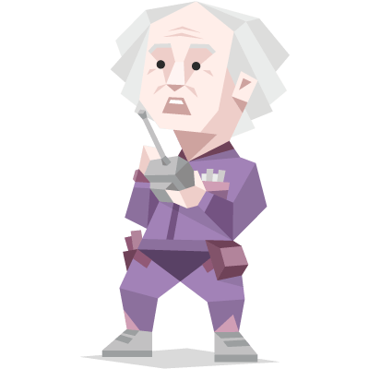
Doc devoted most of his life to science, but achieved little success in his work. He is indisputably a scientific genius, but was sloppy with little things and never seemed to concentrate his research on one area for long.
In addition to being a student of many sciences, Doc is also a hopeless romantic. He dreamed to live a serene rural life at the time of Old West. Failing that, he acquired a Colt .45 revolver and carried it with him, though he never loaded it.

In 1985 he achieved his dream of time travel.

You can say: „I have another idea …“ and discuss it.

Follow the path of the unsafe, independent thinker. Expose your ideas to the dangers of controversy. Speak your mind and fear less the label of ’crack-pot’ than the stigma of conformity. And on issues that seem important to you, stand up and be counted at any cost.

Tyrion Lannister
Game of Thrones
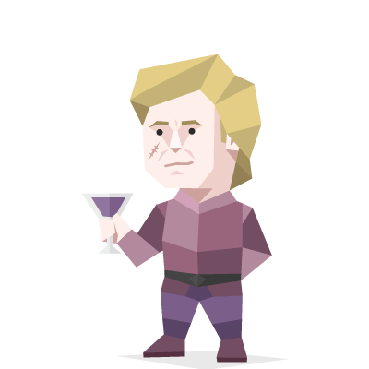

Because of his unusual stature Tyrion has been a victim of mockery his entire life, with people overlooking his noble birth in order to tease and taunt him.

Often underestimated because of his size Tyrion is actually one of the smartest, craftiest members of his family and wishes he was taken more seriously as an advisor. He is easily the kindest, understanding better than others those that have suffered hardship in their lives. He longs for true companionship and love since both have been withheld from him most of his life.

You can say: „I have another idea …“ and discuss it.

Follow the path of the unsafe, independent thinker. Expose your ideas to the dangers of controversy. Speak your mind and fear less the label of ’crack-pot’ than the stigma of conformity. And on issues that seem important to you, stand up and be counted at any cost.

