Samwise Gamgee
The Lord of the Rings

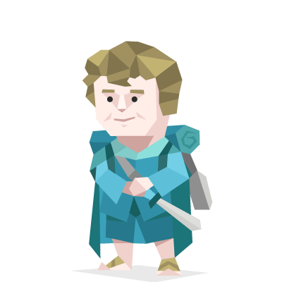
Samwise Gamgee also known as Sam is a Hobbit of the Shire. He is Frodo Baggins's gardener and his companion on his journey to Mount Doom. When Gandalf comes to the Shire to tell Frodo the truth about the ring he inherited from his uncle Bilbo, he catches Sam eavesdropping, and orders him to go with Frodo on his journey.
Sam's humbleness and "plain speaking" is frequently emphasized in contrast to Frodo's "gentility", and he often shows deference to Frodo, calling him "Mister Frodo". At the same time, a strong bond of love and trust grows between them, portrayed most poignantly during the events of Cirith Ungol, where Sam vows to return to his (apparently) dead master, to be reunited with Frodo in death.

Once per round:
Prevent that someone gets kicked out.
If that character wins, you‘ll win too (can kept secret).

The challenge for you is ensuring that what you do is noticed. You have a tendency to underplay your accomplishments, and while your kindness is often respected, more cynical and selfish people are likely to take advantage of your dedication and humbleness by pushing work onto you and then taking the credit. You need to know when to say no and stand up for yourself if you are to maintain your confidence and enthusiasm.

Dr. Watson
Sherlock Holmes

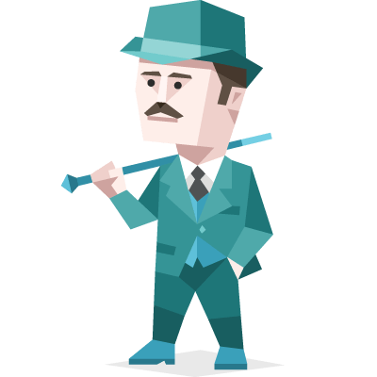
Dr. James Watson is a veteran who served as an Army medic in Afghanistan and is traumatized by what he saw. The two meet when Watson is looking for a place to rent and Sherlock is looking for a roommate. Unlike most people, Watson is fascinated by Sherlock and finds him brilliant.

John is extremely brave, resourceful and practical. He is extremely loyal to Sherlock, and will usually, but not always, do what Sherlock asks him to, and cares a great deal about his well-being.

He is adept at reading people through facial expressions, whilst Sherlock relies on his surroundings, on clothing and personality displays to read people.

Once per round:
Prevent that someone gets kicked out.
If that character wins, you‘ll win too (can kept secret).

The challenge for you is ensuring that what you do is noticed. You have a tendency to underplay your accomplishments, and while your kindness is often respected, more cynical and selfish people are likely to take advantage of your dedication and humbleness by pushing work onto you and then taking the credit. You need to know when to say no and stand up for yourself if you are to maintain your confidence and enthusiasm.

Will Turner
Pirates of the Carribean

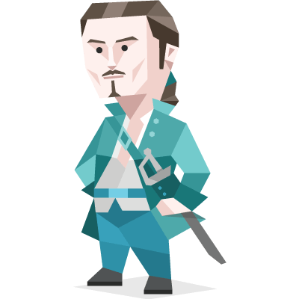
The son of William "Bootstrap Bill" Turner, Will Turner was an accomplished blacksmith by trade, an excellent swordsman by pursuit and a budding pirate by fate. Until he met Jack Sparrow, swordsmith Will Turner was a simple craftsman.

In his life, Will Turner was a very brave and noble man who was willing to risk his life for people he cared about. He was extremely loyal, especially to Elizabeth Swann and he claimed that he would die for her if he had to. William was polite and humble to those higher ranked than himself but he was rarely congratulated or complimented during his time as a blacksmith.

Will was willing to break the law if he felt it was necessary. For example he freed Jack Sparrow from prison after Elizabeth was captured by pirates and later saved Jack from being executed.

Once per round:
Prevent that someone gets kicked out.
If that character wins, you‘ll win too (can kept secret).

The challenge for you is ensuring that what you do is noticed. You have a tendency to underplay your accomplishments, and while your kindness is often respected, more cynical and selfish people are likely to take advantage of your dedication and humbleness by pushing work onto you and then taking the credit. You need to know when to say no and stand up for yourself if you are to maintain your confidence and enthusiasm.

Vito Corleone
The Godfather
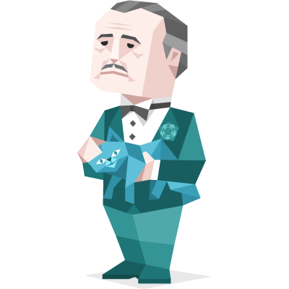

In 1901, his father, Antonio was murdered by a Sicilian Mafia boss named Don Ciccio because he refused to pay tribute to him. His older brother, Paolo, swore revenge, but was himself murdered soon after.

Vito was known to be very loyal to his friends and allies, but would turn on them if betrayed. He was also a very loving and caring father and husband to his family. Vito was very handy with a gun, and knew how to disperse with one. He was very smart and logical as a mafioso, always knowing when to take a deal or not, and how to go about doing so. Vito had the foresight of a master chess player, able to predict the ramifications and possible opportunities from seemingly random events years in advance and was known to use reason to solve problems and only use violence as the last possible resort.

Once per round:
Prevent that someone gets kicked out.
If that character wins, you‘ll win too (can kept secret).

The challenge for you is ensuring that what you do is noticed. You have a tendency to underplay your accomplishments, and while your kindness is often respected, more cynical and selfish people are likely to take advantage of your dedication and humbleness by pushing work onto you and then taking the credit. You need to know when to say no and stand up for yourself if you are to maintain your confidence and enthusiasm.
Catelyn Stark
Game of Thrones
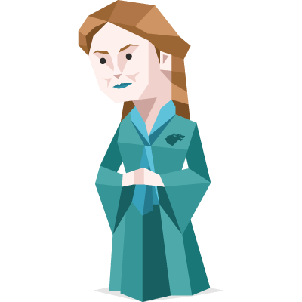

Catelyn was born into House Tully and married into House Stark. Her husband, Eddard Stark, is the Lord Paramount of the North. Catelyn operates entirely on her knowledge and experiences in all things; she is very proud of her heritage and the Stark family home, as well as respectful of the traditions of the north even if she doesn’t always agree with them.

She shies away from violence and often wants to negotiate a more peaceful compromise rather than extend threats in order to get others to comply. She is capable of using charm to win others to her side, and appealing to their emotions to get them to do what she wants.

Once per round:
Prevent that someone gets kicked out.
If that character wins, you‘ll win too (can kept secret).

The challenge for you is ensuring that what you do is noticed. You have a tendency to underplay your accomplishments, and while your kindness is often respected, more cynical and selfish people are likely to take advantage of your dedication and humbleness by pushing work onto you and then taking the credit. You need to know when to say no and stand up for yourself if you are to maintain your confidence and enthusiasm.

