Boromir
The Lord of the Rings

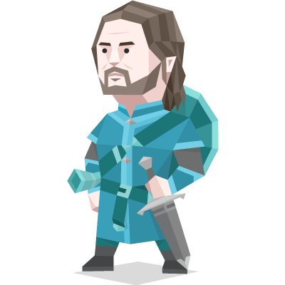
Boromir was a valiant warrior known in Gondor for his greatness, having already achieved great merit in Gondor prior to the Council of Elrond.

Boromir was above all else exceedingly valiant and steadfast, and was held in great esteem by the fighting men of many nations. He was selfless and bold, but he took little interest in the books and scrolls that his brother so often read, having little interest in lore. However, his desire to protect his people, and his inability to do so, left him vulnerable to the predations of the One Ring. This eventually caused him to attempt to take it from Frodo, though he deeply regretted this almost immediately after it occurred. His world after Sauron's defeat was one of peace and security, where he used the Ring to rule with wisdom and generosity.

If a purple character wins, you win too.

You are aware of your surroundings and live in a world of clear, verifiable facts – the surety of your knowledge means that even against heavy resistance, you stick to your principles and push an unclouded vision of what is and is not acceptable. Your opinions aren’t just empty talk either, you are more than willing to dive into the most challenging projects, improving action plans and sorting details along the way, making even the most complicated tasks seem easy and approachable.

Robb Stark
Game of Thrones

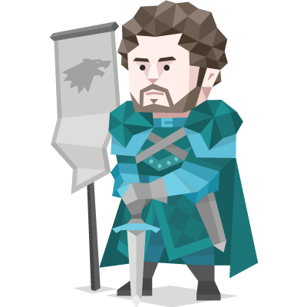

Robb Stark is the eldest son of Ned and Catelyn Stark and the heir to Winterfell and the North.
Robb is a brave young man and skilled fighter committed to defending his family and upholding his father's code of ethics.
When Ned leaves for King's Landing to become Hand of the King to Robert Baratheon, Robb becomes Lord of Winterfell.

He has trained since childhood to wield a sword and wear armor and is highly proficient with both for his age. In addition to his physical skills, Robb has inherited his father's sense of honor, strategic smarts, and leadership qualities.

If a purple character wins, you win too.

You are aware of your surroundings and live in a world of clear, verifiable facts – the surety of your knowledge means that even against heavy resistance, you stick to your principles and push an unclouded vision of what is and is not acceptable. Your opinions aren’t just empty talk either, you are more than willing to dive into the most challenging projects, improving action plans and sorting details along the way, making even the most complicated tasks seem easy and approachable.

Porthos
The Three Musketeers



A loyal and devoted Musketeer himself, he often puts himself in needless danger to protect his friends and family.

Porthos predominantly has a spirited character. His actions are based on what he feels like and whether he's in the right mood. He enjoys a challenge, and often heads directly for the front line to get a fight, because he's passionate about being a Musketeer. Fearless, even in precarious positions, he finds himself enjoying the experience and learning new tricks.

At times, Porthos does show a deeper wisdom, which he can often present when giving advice for another friend.

If a purple character wins, you win too.

You are aware of your surroundings and live in a world of clear, verifiable facts – the surety of your knowledge means that even against heavy resistance, you stick to your principles and push an unclouded vision of what is and is not acceptable. Your opinions aren’t just empty talk either, you are more than willing to dive into the most challenging projects, improving action plans and sorting details along the way, making even the most complicated tasks seem easy and approachable.

Ana Lucia Cortez
Lost
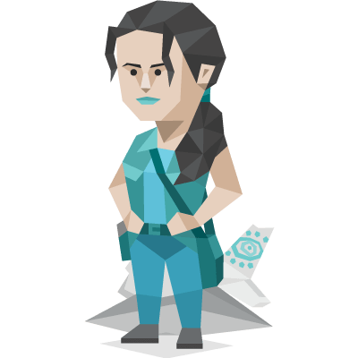

Ana Lucia Cortez was the leader of the tail section survivors, an ex-police officer with deep-seated emotional issues.

Before the Island, she'd suffered a shooting that killed her unborn child. She killed her attacker afterward in revenge and subsequently resigned from the police force.

On the Island, early clashes with the Others heightened her mistrust, and she responded with aggression, culminating in accidentally killing Shannon.

Ana Lucia is somebody who does not want to be a victim. She was a victim once and she swore to herself she would never be a victim again". She is pretty much always aware and suspicious. She is "street smart" and has a "speak-her-mind quality".

If a purple character wins, you win too.

You are aware of your surroundings and live in a world of clear, verifiable facts – the surety of your knowledge means that even against heavy resistance, you stick to your principles and push an unclouded vision of what is and is not acceptable. Your opinions aren’t just empty talk either, you are more than willing to dive into the most challenging projects, improving action plans and sorting details along the way, making even the most complicated tasks seem easy and approachable.

