Lance Sweets
Bones



Lance Sweets iss a psychologist to Seeley Booth and Temperance Brennan. His presence provided a bit of comic relief, as he was often the target of insults from both Booth and Brennan. His youth and inexperience with police work also proved to be a challenge for him, while his psychoanalysis of Booth and Brennan was typically quite accurate.

Sweets was a caring character who was well-liked, although his personality could be a contrast to the scientific, analytical personalities of the squints. He could be seen as immature sometimes

You win if a blue character wins.

You are a true idealist, always looking for the hint of good in even the worst of people and events, searching for ways to make things better. While you may be perceived as calm, reserved, or even shy, you have an inner flame and passion that can truly shine. But when you find like-minded people to spend your time with, the harmony you feel will be a fountain of joy and inspiration.

Amélie Poulain
Amélie

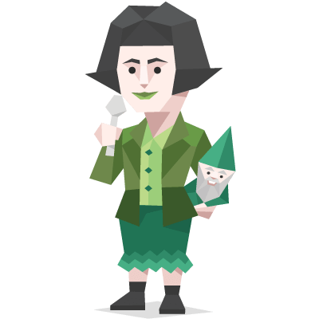

Amélie Poulain (Tautou) is born in February 1974 and raised by eccentric parents who – incorrectly believing that she has a heart defect – decide to home school her. To cope with her loneliness, Amélie develops an active imagination and a mischievous personality. When Amélie is six, her mother, Amandine, is killed when a suicidal Canadian tourist jumps from a church roof and lands on her. As a result, her father Raphaël's withdrawal from society worsens. Amélie leaves home at the age of 18 and becomes a waitress at the Café des 2 Moulins in Montmartre, which is staffed and frequented by a collection of eccentrics.

You win if a blue character wins.

You are a true idealist, always looking for the hint of good in even the worst of people and events, searching for ways to make things better. While you may be perceived as calm, reserved, or even shy, you have an inner flame and passion that can truly shine. But when you find like-minded people to spend your time with, the harmony you feel will be a fountain of joy and inspiration.

Fox Mulder
X-Files

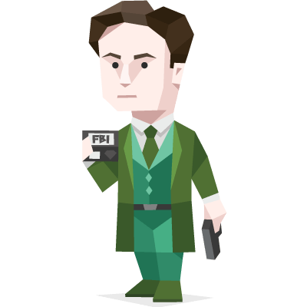

Fox William "Spooky" Mulder is a highly skilled FBI Special Agent who brought his often-criticized method of formulating unconventional theories to the X-files.

Mulder, on the other hand, is far more open to obscure, abstract, and downright “spooky” interpretations of the events that they investigate. He always “wants to believe” in potential paranormal explanations, due to his childhood experiences in which his sister was (supposedly) abducted by aliens. For Mulder, the crazier and more unlikely the theory, the better.

You win if a blue character wins.

You are a true idealist, always looking for the hint of good in even the worst of people and events, searching for ways to make things better. While you may be perceived as calm, reserved, or even shy, you have an inner flame and passion that can truly shine. But when you find like-minded people to spend your time with, the harmony you feel will be a fountain of joy and inspiration.

Frodo Baggins
The Lord of the Rings
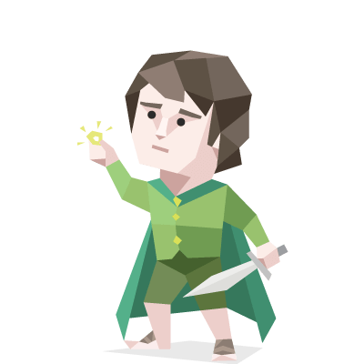

Frodo Baggins is a Hobbit of the Shire. Although not well-known nside the Shire, Frodo is legendary elsewhere in Middle Earth or his task in destroying the One Ring of power, and thus estroying the evil lord Sauron in the process.

Frodo, as described by Gandalf, was "taller than some and fairer than most, (with) a cleft in his chin: perky chap with a bright eye." His curiosity of the outside world, fascination with Elves and faraway places did not fit the general content personality of most Hobbits. He was very kind and compassionate, pitying Gollum and allowing him to guide him and Sam to Mordor despite Sam's distrust of the creature. This act of kindness later proved to be a factor in the quest's success in destroying the Ring.

You win if a blue character wins.

You are a true idealist, always looking for the hint of good in even the worst of people and events, searching for ways to make things better. While you may be perceived as calm, reserved, or even shy, you have an inner flame and passion that can truly shine. But when you find like-minded people to spend your time with, the harmony you feel will be a fountain of joy and inspiration.

