Seeley Booths
Bones



Special Agent Seeley Joseph Booth is a Special Agent with the FBI and the current FBI liaison to the Jeffersonian. What began as a consultation with Dr. Temperance Brennan, a forensic anthropologist with the Jeffersonian Institute, turned into a meaningful partnership and later on a marriage and family.

When it comes to solving crime he prefers a more human, interpersonal and intuitive set of methods. While he finds the information Dr. Brennan and her team uncover valuable evidence, he often finds their means overly convoluted and restrictive, and adds his intuition and knowledge of people on top of it. He is world-wise, socially at ease with people, and apparently at ease with women.

Only Once:
You can leave the group and create a new one with yourself.

People are drawn to strong personalities, and you radiate authenticity, concern and altruism, unafraid to stand up and speak when you feel something needs to be said. You find it natural and easy to communicate with others, especially in person, and your Intuitive trait helps to reach every mind, be it through facts and logic or raw emotion. You easily see people’s motivations and seemingly disconnected events, and are able to bring these ideas together and communicate them as a common goal with an eloquence that is nothing short of mesmerizing.

Elizabeht Bennet
Pride and Prejudice


Elizabeth Bennet is the female protagonist of Jane Austen's Pride and Prejudice. She is the daughter of Mr. and Mrs. Bennet. Elizabeth is the second of five sisters and her father's favourite, and is described by him by having "something more of quickness than her sisters"; though she is often distressed and embarrassed by the behaviour of her mother and of her younger sisters.

Elizabeth is an intelligent young woman who is described as having "a lively, playful disposition, which delighted in any thing ridiculous". She often presents a playful good natured impertinence that does not offend but rather endears. Early in the novel she is depicted as being personally proud of her mental quickness and her accuracy in judging the social behaviour and intentions of others.

Only Once:
You can leave the group and create a new one with yourself.

People are drawn to strong personalities, and you radiate authenticity, concern and altruism, unafraid to stand up and speak when you feel something needs to be said. You find it natural and easy to communicate with others, especially in person, and your Intuitive trait helps to reach every mind, be it through facts and logic or raw emotion. You easily see people’s motivations and seemingly disconnected events, and are able to bring these ideas together and communicate them as a common goal with an eloquence that is nothing short of mesmerizing.

Skyler White
Breaking Bad


Skyler White is the wife of Walter White. Skyler and Walter have a teenage son, Walter White Jr., and an infant daughter, Holly White. Skyler cares for Walter very much, but their marriage becomes increasingly strained due to his unexplained absences and bizarre behavior, ultimately leading to no spoiler.

She appeared to be the one wearing the pants in their marriage - making most of their decisions herself without any regard for Walt's own opinions - ranging from their financial decisions to things as trivial as dinner, likely adding to Walt's feelings of emasculation and inadequacy. She was very capable and willing to get her way in every matter that concerned the family and Walt personally, even planning an all-family intervention- style talk with Walter to utilize family pressure to convince him to undergo treatment and acting up when the talk didn't quite go her way

Only Once:
You can leave the group and create a new one with yourself.

People are drawn to strong personalities, and you radiate authenticity, concern and altruism, unafraid to stand up and speak when you feel something needs to be said. You find it natural and easy to communicate with others, especially in person, and your Intuitive trait helps to reach every mind, be it through facts and logic or raw emotion. You easily see people’s motivations and seemingly disconnected events, and are able to bring these ideas together and communicate them as a common goal with an eloquence that is nothing short of mesmerizing.

The Oracle
The Matrix


She is a program with such insight into human psychology that he has clairvoyant abilities. She was initially created to interpret aspects the human psyche and was responsible for the key principles behind the third "current" version of the Matrix. After having served her purpose, she went into Exile and aided the Resistance in the Machine War; she ultimately is responsible for ending the war through her manipulation of key members within the Resistance, including Neo.

Only Once:
You can leave the group and create a new one with yourself.

People are drawn to strong personalities, and you radiate authenticity, concern and altruism, unafraid to stand up and speak when you feel something needs to be said. You find it natural and easy to communicate with others, especially in person, and your Intuitive trait helps to reach every mind, be it through facts and logic or raw emotion. You easily see people’s motivations and seemingly disconnected events, and are able to bring these ideas together and communicate them as a common goal with an eloquence that is nothing short of mesmerizing.

Morpheus
The Matrix


Morpheus is a Zion operative who serves in the city's defense force against attack from the Machines. His hovercraft, the Nebuchadnezzar, has far less armament than its sister craft.

Morpheus was known to to be a truly inspirational leader and teacher to many people, particularly the majority of his crew, to the extent that Tank commented that Morpheus was a father to them, as well as a leader. It may also be noted that he tends to keep his emotions.

Despite his strong faith, Morpheus still showed some rationality in dangerous situations rather than blindly relying on his beliefs to see him through the current crisis.

Only Once:
You can leave the group and create a new one with yourself.

People are drawn to strong personalities, and you radiate authenticity, concern and altruism, unafraid to stand up and speak when you feel something needs to be said. You find it natural and easy to communicate with others, especially in person, and your Intuitive trait helps to reach every mind, be it through facts and logic or raw emotion. You easily see people’s motivations and seemingly disconnected events, and are able to bring these ideas together and communicate them as a common goal with an eloquence that is nothing short of mesmerizing.

Daenerys Targaryen
Game of Thrones
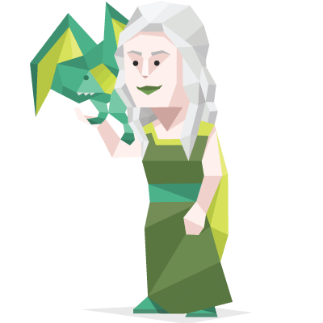

Daenerys is the only daughter and youngest child of King Aerys II Targaryen, the "Mad King", and his sister-wife, Rhaella. Her father died during the Sack of King's Landing, before she was even born.

Daenerys is polite and well-spoken, but filled with quiet determination. She used to be cowed by her brother's ambitions and his occasional cruel rages, but her time amongst the Dothraki has taught her pride, confidence and skills of command. She is still somewhat naive of the world due to being young and living her life as an exile, but she is intelligent and quick to understand now that she is free to pursue her own path.

Only Once:
You can leave the group and create a new one with yourself.

People are drawn to strong personalities, and you radiate authenticity, concern and altruism, unafraid to stand up and speak when you feel something needs to be said. You find it natural and easy to communicate with others, especially in person, and your Intuitive trait helps to reach every mind, be it through facts and logic or raw emotion. You easily see people’s motivations and seemingly disconnected events, and are able to bring these ideas together and communicate them as a common goal with an eloquence that is nothing short of mesmerizing.

Laurel Lance
Arrow
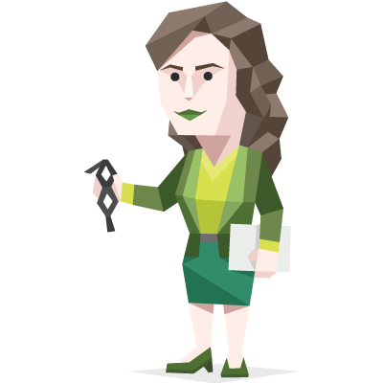

Laurel is the eldest daughter of Quentin Lance and Dinah Lance, the older sister of Sara Lance, and the on/off romantic interest and longtime friend of Oliver Queen.

Laurel was idealistic, intelligent, hard-working, and fights hard to get what she wants. She was a competent, upstanding lawyer and works to stand up for the innocent and what was right, despite the corruption in Starling City. She can be stubborn, feisty, and independent and doesn't like to be told what to do.

However, Laurel shows she had a big heart, being open- minded and inquisitive, having a tendency to see the best in the people around her.

Only Once:
You can leave the group and create a new one with yourself.

People are drawn to strong personalities, and you radiate authenticity, concern and altruism, unafraid to stand up and speak when you feel something needs to be said. You find it natural and easy to communicate with others, especially in person, and your Intuitive trait helps to reach every mind, be it through facts and logic or raw emotion. You easily see people’s motivations and seemingly disconnected events, and are able to bring these ideas together and communicate them as a common goal with an eloquence that is nothing short of mesmerizing.

