Angus MacGuyver
MacGuyver

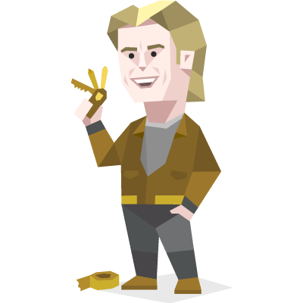

He lost his parents as a young boy, so he grew up being very close with his grandfather Harry Jackson, and did brilliant studies, having a natural nack for science and technology.

His ability to repair, craft or sabotage almost anything from a household appliance to a nuclear reactor in no time, using whatever lies around, however uncomfortable the conditions, even dangling at dizzling heights, is legendary, giving rise to the term MacGyverism in the real world.

The charming, cheeky but ever curtous and helpfull gentleman has had many girlfriends but never stuck with one, the call of some adventure usually got in the way. Yet he discovers that he probably has an adolescent son.

Once per round:
You always manages somehow to get out of tricky situations. Switch to another group.

While your mechanical tendencies can make you appear simple at a glance, You are actually quite enigmatic. Friendly but very private, calm but suddenly spontaneous, extremely curious but unable to stay focused on formal studies, You can be a challenge to predict, even by your friends and loved ones. You can seem very loyal and steady for a while, but you tend to build up a store of impulsive energy that explodes without warning, taking your interests in bold new directions.

Indiana Jones
Indiana Jones



Indy is a professor, archaeologist, and adventurer. During the ensuing chase, Indy Develops his fear of Snakes and quickly masters a Bull-whip as he goes face to face with a Lion on a circus train.

Though a man seemingly made hard-heartedly cynical by his traumatic experiences in World War I and his estrangement from his father, Indy consistently maintained a steadfast sense of honor and compassion learnt through his meeting of Doctor Albert Schweitzer.

Once per round:
You always manages somehow to get out of tricky situations. Switch to another group.

While your mechanical tendencies can make you appear simple at a glance, You are actually quite enigmatic. Friendly but very private, calm but suddenly spontaneous, extremely curious but unable to stay focused on formal studies, You can be a challenge to predict, even by your friends and loved ones. You can seem very loyal and steady for a while, but you tend to build up a store of impulsive energy that explodes without warning, taking your interests in bold new directions.

James Bond
James Bond

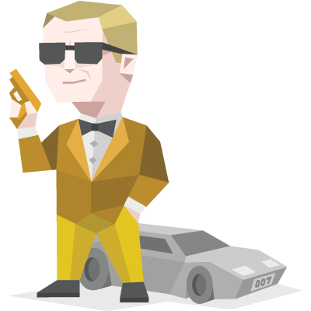
Commander James Bond is a Senior Operational Officer of the 'Double-O' ('00') branch, an ultra-covert Black Ops unit within the British Secret Intelligence Service. As an agent of MI6, Bond holds code number "007". The 'Double-O' prefix indicates his discretionary licence to kill in the performance of his duties.

The stereotype of a spy, detective, martial artist and assassin, Bond is a highly unique individual. He appears to be of sound mind and strong spirit. He is highly intelligent, exceedingly cunning and diabolically independent. He is also extremely sensible, calm, mature and sly. He professes to have never fallen in love. He maintains no friendships from before his parents’ death and only the most irregular contact with friends from his late teens.

Once per round:
You always manages somehow to get out of tricky situations. Switch to another group.

While your mechanical tendencies can make you appear simple at a glance, You are actually quite enigmatic. Friendly but very private, calm but suddenly spontaneous, extremely curious but unable to stay focused on formal studies, You can be a challenge to predict, even by your friends and loved ones. You can seem very loyal and steady for a while, but you tend to build up a store of impulsive energy that explodes without warning, taking your interests in bold new directions.

John McClane
Die Hard
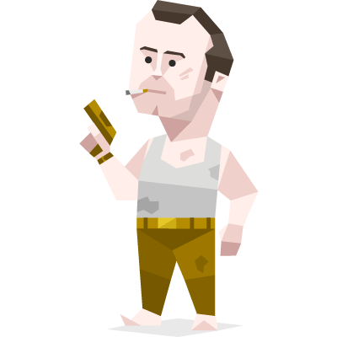

John is an average American man still stuck in the 20th century. With his cocky nature, McClane is able to stir up friendships quite easily, as seen by his interaction with an airplane passenger in the first film. However, this cocky nature also lands him in trouble with other authority figures.

Wisecracking and a smirk whenever he talks to someone, McClane held a very laid-back and cool approach to dealing with the people around him, this ease would quickly disappear, however, when faced with life-threatening occurrences.

Once per round:
You always manages somehow to get out of tricky situations. Switch to another group.

While your mechanical tendencies can make you appear simple at a glance, You are actually quite enigmatic. Friendly but very private, calm but suddenly spontaneous, extremely curious but unable to stay focused on formal studies, You can be a challenge to predict, even by your friends and loved ones. You can seem very loyal and steady for a while, but you tend to build up a store of impulsive energy that explodes without warning, taking your interests in bold new directions.

Arya Stark
Game of Thrones
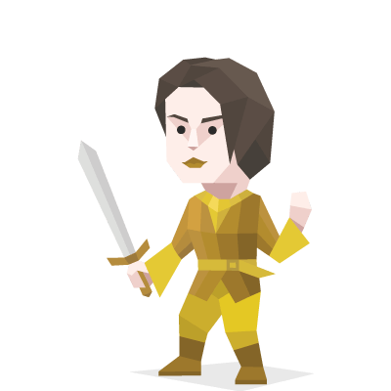

Princess Arya Stark is the third child and second daughter of Lord Eddard Stark and his wife, Lady Catelyn Stark. After narrowly escaping the persecution of House Stark at the hands of House Lannister, Arya is trained as a Faceless Man at the House of Black and White in Braavos, and uses her new skills to bring those who have wronged her family to justice.

Arya is curious about everything around her. She fails to understand tradition and desires to have no part of it. She is on a constant quest for knowledge and quick to point out the truths and inconsistencies of others. Her attentive observance of the world around her helps her figure out what is going on, who to trust and who not to trust.

Once per round:
You always manages somehow to get out of tricky situations. Switch to another group.

While your mechanical tendencies can make you appear simple at a glance, You are actually quite enigmatic. Friendly but very private, calm but suddenly spontaneous, extremely curious but unable to stay focused on formal studies, You can be a challenge to predict, even by your friends and loved ones. You can seem very loyal and steady for a while, but you tend to build up a store of impulsive energy that explodes without warning, taking your interests in bold new directions.

